Product Performance Analysis

Abstract:
The purpose of this project is to analyze product performance using sales data to identify key trends, top-performing products, and opportunities for improvement. The analysis was carried out using Microsoft Excel and Power BI. Excel was used for initial data cleaning and preparation, while Power BI was used for interactive data visualization and insights generation. The final report provides clear visual representations of product sales, revenue, and performance patterns to support data-driven business decisions.

Introduction:

Every business needs to understand how its products perform in the market. Product performance analysis helps track which products are generating the most revenue, which categories are in demand, and how sales fluctuate over time.
In this project, sales data was collected from a company database containing product details such as product name, category, units sold, unit price, revenue, and date of sale. Using Excel and Power BI, this data was analyzed to identify sales trends, profitable products, and areas that need attention.

Objectives:
- To analyze sales data to determine top-performing and low-performing products.
- To understand sales trends over time (month-wise and day-wise).
- To visualize product category performance.
- To identify factors influencing sales growth or decline.
- To provide insights for improving sales and business strategies.

Tools and Technologies Used:

Microsoft Excel: For data cleaning, formatting, and basic analysis (formulas, pivot tables, charts).

Microsoft Power BI: For building interactive dashboards and visualizations.

Methodology:

Here are some steps how we followed in this Projects.

Step 1: Data Collection
The dataset was obtained from a company database and exported into Excel for further processing.
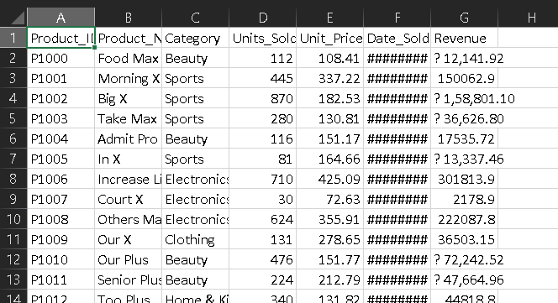
Pic: Data from the database

Step 2: Data Cleaning (Excel)
- Removed duplicates, totally found 5 duplicates and those five duplicates was removed.
- Added missing values based on the average calculations by category wise.
- Ensured date formats were consistent.
- Created a new column for price range (Low, Medium, High) based on Unit_Price.
- Created new column for Date, Month and Year for different data analysis.
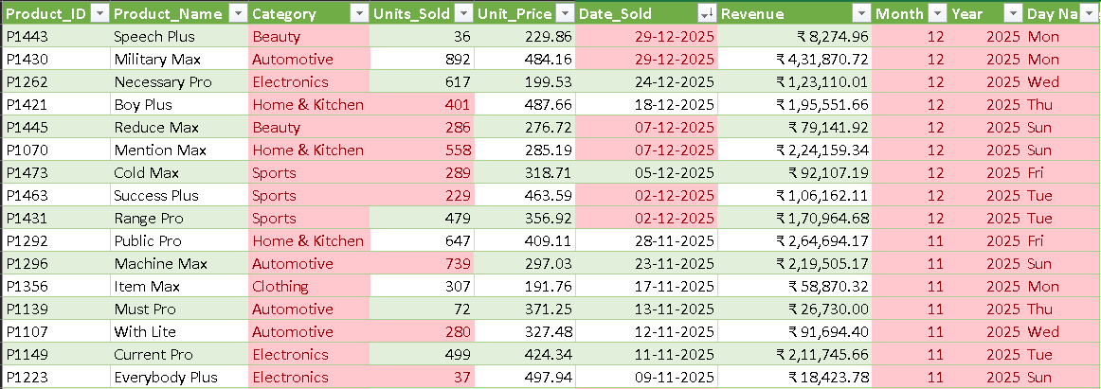
Pic: Example pic after Data Cleaning

Step 3: Data Analysis (Excel)
- Used Pivot Tables to summarize sales by Category and Product.
- Applied Conditional Formatting to highlight top-selling products.
- Created charts to show trends and patterns before importing into Power BI.
Here some Pictures of the some Pivot tables
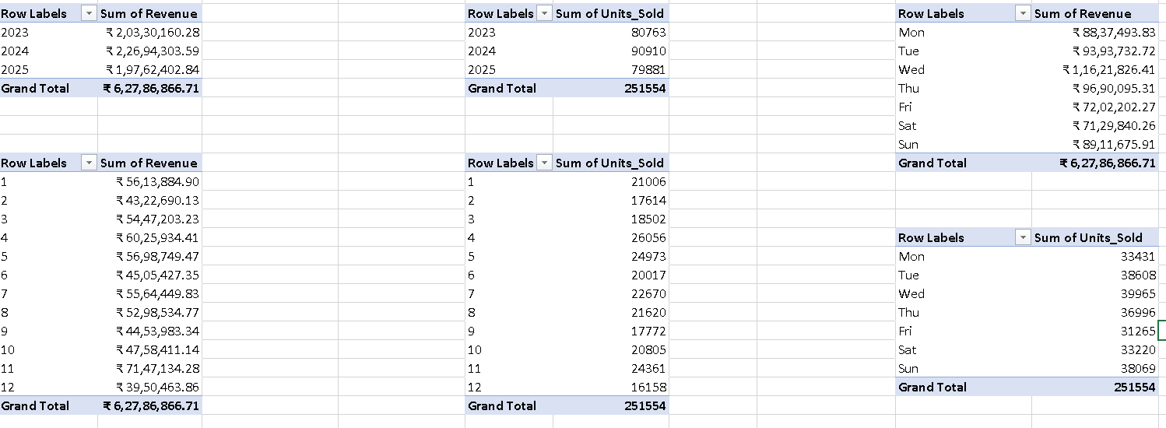
Pic: Pivot Tables in Excel

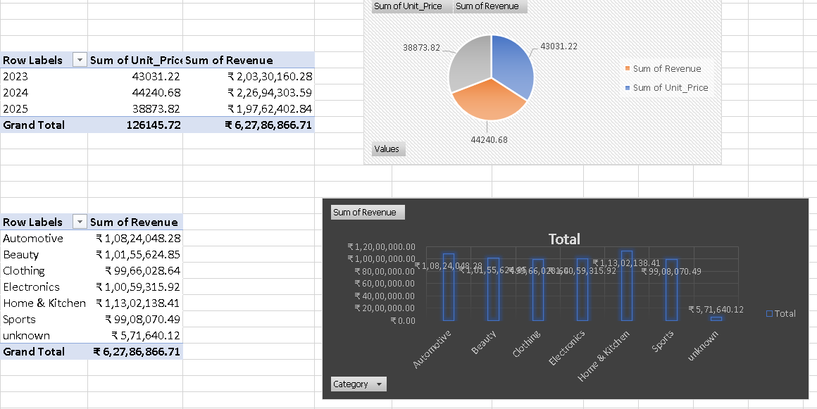
Pic : Pivot table and Pivot charts in Excel

Step 4: Data Visualization (Power BI)
- Imported the cleaned Excel file into Power BI.
- Created interactive visuals such as:
  - Bar charts for category-wise revenue.
  - Line charts for monthly sales trends.
  - Cards to display total revenue, average price, and total units sold.
  - Slicers for month, category, and product filtering.
Here are some examples of the data visualisation,
Here I took the data into Units sold, Revenue and Unit Price wise.

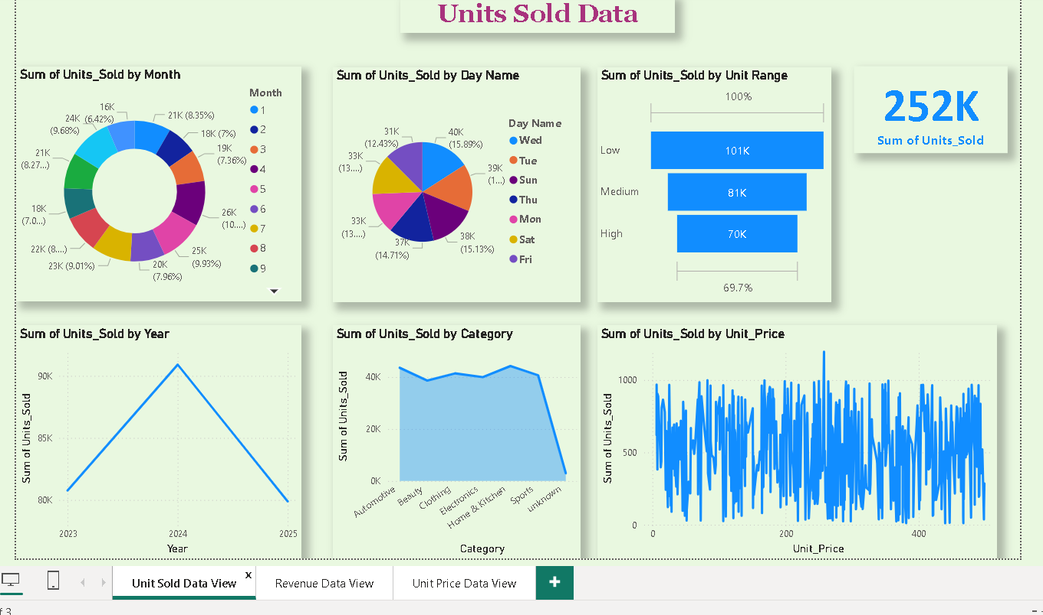
Pic: Example of Data visualisation based on Units sold

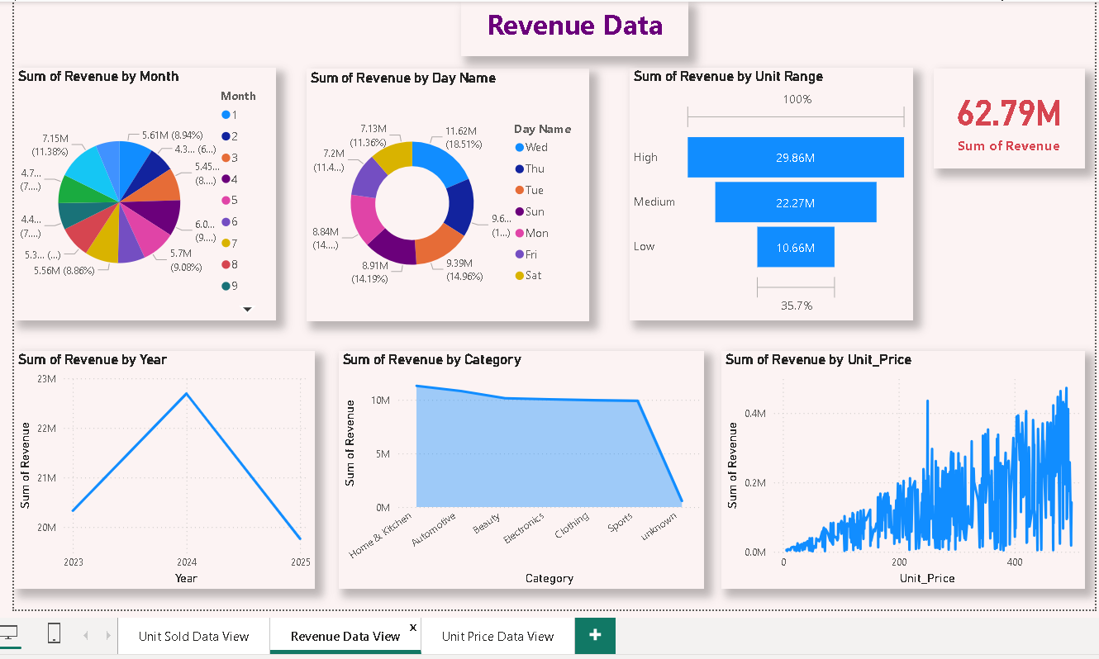
Pic: Example of Data visualisation based on Revenue

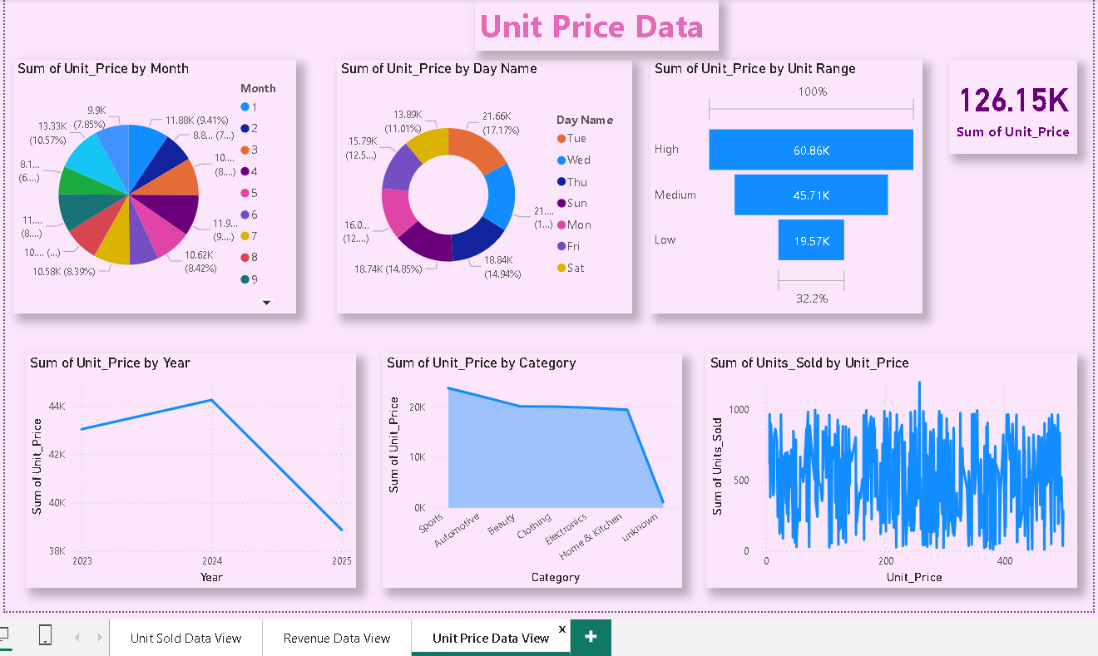
Pic: Example of Data visualisation based on Unit Price

Designed a professional dark-themed dashboard titled “Product Performance Analysis”.

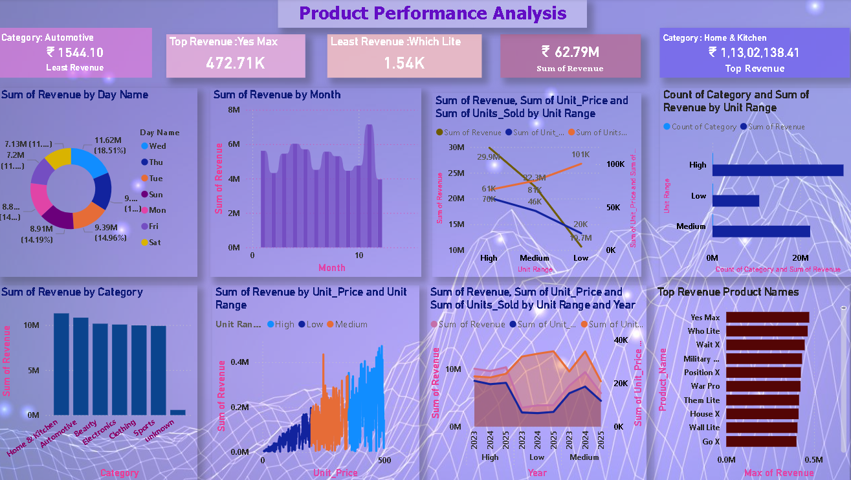
Pic: Dashboard for Product Performance Analysis

Key Insights from Analysis
- High-priced products (₹350–₹500) generate the majority of total revenue.
High: ₹ 2,98,62,883.44
Medium: ₹ 2,22,66,948.51
Low: ₹ 1,06,57,034.76
Total Revenue: ₹ 6,27,86,866.71

- Home & kitchen and Automotive categories consistently perform better in revenue and volume.
Row Labels | Sum of Revenue | Row Labels | Sum of Units_Sold
Automotive | ₹ 1,08,24,048.28 | Automotive | 43589
Beauty | ₹ 1,01,55,624.85 | Beauty | 38631
Clothing | ₹ 99,66,028.64 | Clothing | 41421
Electronics | ₹ 1,00,59,315.92 | Electronics | 39986
Home & Kitchen | ₹ 1,13,02,138.41 | Home & Kitchen | 44252
Sports | ₹ 99,08,070.49 | Sports | 40691
unknown | ₹ 5,71,640.12 | unknown | 2984
Grand Total | ₹ 6,27,86,866.71 | Grand Total | 251554

- April and November show peak sales activity, likely due to festive and summer demand and also Dec and Feb show very less sales.
Row Labels | Sum of Revenue | Row Labels | Sum of Units_Sold
1 | ₹ 56,13,884.90 | Jan | 21006
2 | ₹ 43,22,690.13 | Feb | 17614
3 | ₹ 54,47,203.23 | Mar | 18502
4 | ₹ 60,25,934.41 | Apr | 26056
5 | ₹ 56,98,749.47 | May | 24973
6 | ₹ 45,05,427.35 | Jun | 20017
7 | ₹ 55,64,449.83 | Jul | 22670
8 | ₹ 52,98,534.77 | Aug | 21620
9 | ₹ 44,53,983.34 | Sep | 17772
10 | ₹ 47,58,411.14 | Oct | 20805
11 | ₹ 71,47,134.28 | Nov | 24361
12 | ₹ 39,50,463.86 | Dec | 16158
Grand Total | ₹ 6,27,86,866.71 | Grand Total | 251554

- Low-range products contribute less than 17% of total revenue and also High-range products contributes around 48% of total Revenue.
Range | Revenue | Percentage
High | ₹ 2,98,62,883.44 | 47.56%
Medium | ₹ 2,22,66,948.51 | 35.46%
Low | ₹ 1,06,57,034.76 | 16.97%
Total | ₹ 6,27,86,866.71 | 100.00%

- Weekday analysis shows Wednesday and Thursdays as top-performing days and also Saturday is the least performing day.
Day Name | Sum of Revenue
Mon | ₹ 88,37,493.83
Tue | ₹ 93,93,732.72
Wed | ₹ 1,16,21,826.41
Thu | ₹ 96,90,095.31
Fri | ₹ 72,02,202.27
Sat | ₹ 71,29,840.26
Sun | ₹ 89,11,675.91

- Lowest Performing Product: Which Lite (Automotive) with ₹ 1,544.10 revenue.

- Top Product by Revenue: Yes Max (Clothing) with ₹ 4,72,714.90revenue.

- Year 2024 performing better when compared to remaining years and also year 2025 performing low when compared to remaining years.
Row Labels | Sum of Revenue | Sum of Unit_Price | Sum of Units_Sold
2023 | ₹ 2,03,30,160.28 | 43031.22 | 80763
2024 | ₹ 2,26,94,303.59 | 44240.68 | 90910
2025 | ₹ 1,97,62,402.84 | 38873.82 | 79881
Grand Total | ₹ 6,27,86,866.71 | 126145.72 | 251554

Recommendations:
- Day-wise Performance
- Wednesday and Thursday have the best sales.
- Saturday is the lowest-performing day
- Introduce “Weekend Offers” or “Saturday Discounts” to improve weekend sales.
- Send online promotions on Friday to boost weekend traffic.

- Month-wise Performance
- April and November have the highest sales.
- February and December have the lowest sales.
- Plan big promotions and stock for April and November.
- Give festival or clearance offers during low months to improve sales.

- Year-wise Performance
- Year 2024 performed the best; 2025 is lower in both sales and price.
- Check is there any marketing and campaign changes between 2024 and 2025.
- Focus more on advertising and pricing for 2025 products.

- Top Product by Revenue
- “Yes Max (Clothing)” is the top product with ₹4,72,714.90 revenue.
- Use it as a featured product in ads and promotions.
- Analyze its buyers to target similar audiences.

- Lowest Performing Product
- “Which Lite (Automotive)” has the lowest revenue (₹1,544.10).
- Check if it has low demand, stock issues, or poor visibility.
- Try changing marketing or design; if still low, remove it from the list.

- Home & Kitchen and Automotive Categories
- These two categories perform the best in both revenue and sales.
- Keep more stock and give priority to these products.
- Increase advertisements and offers in these categories.
- Try to follow same strategies to the remaining categories to increase the sales.

- High-Priced Products
- High-priced products (₹350–₹500) give the highest revenue.
- Continue selling these at the same or slightly higher price.
- Offer combo packs or small discounts to increase sales volume.
- Focus marketing and promotions on premium buyers.

- Low-Range Products
- Low-range products give very less revenue (only around 17%).
- Try to improve packaging and visibility for these items.
- Give small combo offers or discounts to attract buyers.
- If some products are not selling, stop or replace them with better ones

Reference Documents:

- https://drive.google.com/file/d/1v2yjsfYHVezf31HM854YjtIGNHDuoPDu/view?usp=drive_link
- https://docs.google.com/spreadsheets/d/1OUcUEYMf1aoM-M4QizYD-b4H6ZD2nGBg/edit?usp=drive_link&ouid=109448462672576180506&rtpof=true&sd=true
- https://drive.google.com/file/d/1_Y7pebrNaJ5HE6FW4qWejvRvFxzomG48/view?usp=drive_link
- https://drive.google.com/file/d/1w8oPlUqqH3wv9XcorMglOFLjLcpKKjmI/view?usp=drive_link
85

