# Module-3

Testing On Live Applications

# 1). What is RDBMS?

Its Relational Database Management System. This is base for all modern database systems like MS SQL, Oracle, MySQL Server, Microsoft Access.

Introduced by E.F. Codd based on DBMS- database management system.

* Database are on relational base that contains more than one table.
* Database contains 1 or more records.
* Database contains 1 or more field, in field data is contained.
* Relation means there is some corelation in between data, they are joined with some data as some common fields.
* Example of RDBMS is as follows.

|  |  |  |
| --- | --- | --- |
| Cust ID | Name | DESIGNATION |
| 1 | ALKA | ADMIN |
| 2 | DIVA | SALES person |

|  |  |  |  |
| --- | --- | --- | --- |
| Employee ID | CUST ID | SALARY | NAME |
| 11 | 1 | 20000 | ALKA |
| 12 | 2 | 25000 | DIVA |
|  |  |  |  |

* Here primary key = CUST ID.
* Here we can retrieve data on basis of CUST ID, there is a relational data of CUST ID, and NAME in both tables.
* ITS easy way to work for long, huge data by this RDBMS.

# In a nutshell

DATA structured, relationships within table, security of data, works scalability, Back up and recovery makes easy.

# 2). What is SQL?

Its Structured Query Language. SQL commands helps to communicate with the database and retrieve immediate results from huge data at a time.

* Its database language for creating data, fetching rows, modify rows and delete the data if not required.
* SQL standard based on ANSI (American national standard Institute) but there are different versions of SQL language.
* Its standard language for RDBMS.
* SQL helps in accessing computer language, storing and manipulate the same as per requirement.

|  |  |
| --- | --- |
| * MY SQL | * Server using T-SQL, ANSI SQL |
| * Oracle | * Server using PL, SQL |
| * MY Access | * Version of SQL JET SQL. |
| * SQL | * Helps access, execute query, retrieve, delete, update, insert data. |

# In a nutshell

SQL is a programming language for storing and processing information in relation database, works for database system in Sybase, Informix, Postgres and SQL server.

# 3). Write SQL Commands?

SQL commands helps to retrieve, manipulate data, insert data, delete data that helps to manage database as per requirement.

* SQL commands execute the command, that determines the best way to carry out our request, SQL engine figure out how to execute the same commands.

|  |  |
| --- | --- |
| Components | Query Dispatcher, optimization Engines, Classic Query Engine, SQL Query engine. |
| Classic Query engine | Handles non-SQL that won’t handle logical files. |
|  |  |

SQL Commands

DDL

DML

DCL

DQL

Data Definition Language.

Commands.

1. CREATE.
2. ALTER.
3. DROP.

DATA Query language.

Commands.

1. SELECT.

Data Control Language.

Commands.

1. GRANT.
2. REVOKE.

DATA Manipulation language.

Commands

1. INSERT.
2. UPADTE.
3. DELETE.

|  |  |  |
| --- | --- | --- |
|  | COMMANDS | SYNTAX |
| DDL | CREATE | CREATE TABLE NAME |
| USE DATABASE |  |
| DROP | DROP DATABASE database_name; |
|  | ALTER | ALTER TABLE table_name |
| TRUNCATE |  |
|  |  |
| DML | DELETE | DELETE FROM table_name WHERE condition; |
| INSERT | INSERT INTO table_name (column 1, column2) Values (value1, value2); |
| UPDATE | UPDATE table_name SET column1 = value1, column2 = value 2 WHERE condition; |
| DQL | SELECT | SELECT Customer_name, city FROM CUSTOMERS; |
| DISTINCT | SELECT DISTINCT Country FROM Customers; |
| WHERE CLAUSE | SELECT * FROM CUSTOMERS WHERE Country= ‘Mexico’; |
| CLAUSE | IN CLAUSE | SELECT * FROM Customers WHERE Country IN (‘Germany’, ‘Uk’); |
| BETWEEN CLAUSE | SELECT * FROM Customers  WHERE EMPLOYEE_ID BETWEEN 100 and 200. |
| AND/OR CLAUSE | SELECT * WHERE Country = ‘India’ AND Customer_Name Like ‘G%’; |
| LIKE CLAUSE | SELECT * FROM Customers WHERE Customer_Name LIKE ‘A%’; |
| ORDER BY CLAUSE | SELECT * FROM Customers ORDER BY Joining_Date; |
| CLAUSE | GROUP BY CLAUSE | SELECT column_name(s) FROM table_name  WHERE condition GROUP BY column_name(s) ORDER BY column_name(s); |
| COUNT CLAUSE | SELECT COUNT (column_name) FROM table_name WHERE condition; |
| HAVING CLAUSE | SELECT column_name(s) FROM table_name WHERE condition GROUP BY column_name(s) HAVING condition ORDER BY column_name(s); |
| CREATE DROP INDEX | CREATE INDEX | CREATE INDEX index_name ON table_name (column1, column2,…); |
| DROP INDEX | DROP INDEX index_name ON table_name; |
| DESC STATEMENT | SELECT * FROM Employee Employee_ID Employee_name DESC |
| SQL COMMIT / ROLLBACK | SQL COMMIT |  |
| SQL ROLLBACK |  |
| JOIN | INNER JOIN | SELECT CUSTOMER_ID, Customer_name, Designation FROM EMPLOYEE INNER JOIN SALARY ON Employee. EMPLOYEE_ID = SALARY. EMPLOYEE_ID; |
| OUTER JOIN/ FULL JOIN | SELECT COLUMN_NAME FROM table1 FULL OUTER JOIN table2 on table1. Column_name = table2.column_name WHERE condition; |
| LEFT JOIN | SELECT Employee_ID FROM table1 LEFT JOIN table2 ON table1.EMPLOYEE_ID = table2. EMPLOYEE_name; |
| RIGHT JOIN | SELECT Employee_ID FROM table1 RIGHT JOIN table2 ON table1. EMPLOYEE_ID = table2. EMPLOYEE_name |
|  |  |  |
|  |  |  |

# 4). What is join & types of Joins?

SQL JOIN. It’s a clause in SQL database used to combine rows and columns by fetching information from two or more tables, based on relational database between them.

* There is different join that is helpful in SQL i.e., inner join, right join, left join, outer(full) join used as a command in SQL.
* JOIN two or more tables.
* Data fetched and create temporary image.
* Types: -

1. Inner Join: Fetch data that have common in both tables and retrieve temporary image for a while.

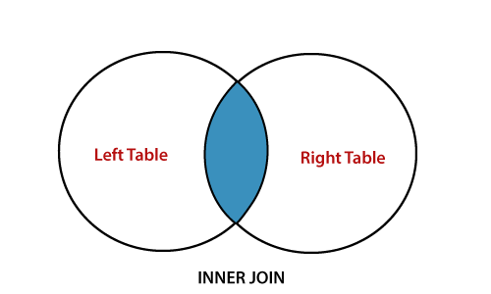

1. Left Join: Fetch data that have common in both tables and all records from left table and retrieve image for a while.

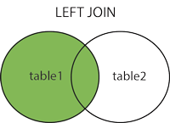

1. Right Join: Fetch data that have common in both tables and all records from right table and retrieve image for a while.

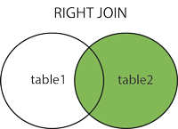

1. Full outer Join: Fetch data from both tables’ full records and common also from both.

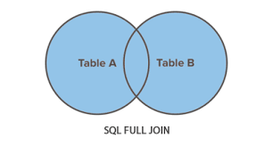

# In a nutshell

Join is helpful in faster execution of query in database, reduces burden of calculations, clear and concise data retrieve as per requirements, reduce number of queries, that helps retrieve in easier way to access related data in database.

# 5). How Many constraints and describes it - self?

SQL constraints means specification of rules in the database table. Due to limiting of data as per requirement it is reliable and helps in accuracy to work with data.

* If any violation in the data it helps to aborted data action.
* There are commonly used constraints: -

1. PRIMARY KEY: It’s a combination of UNIQUE and NOT Null Value. That helps to identify each unique row in a table.

* Syntax: CREATE TABLE EMPLOYEE

(

CUST_ID int NOT NULL PRIMARY KEY,

FirstName varchar(250), LastName varchar(250), Age int

);

1. FOREIGN KEY: It’s a link between tables, preventing wrong action in between the tables.

* Syntax: CREATE TABLE EMPLOYEE

(

CUST_ID int NOT NULL PRIMARY KEY,

CUST_ORDER int NOT NULL,

EMPLOYEE_ID int FOREIGN KEY REFRENCES Name(Employee_ID)

);

1. UNIQUE: Ensures all values are different in a table.

* Syntax: CREATE TABLE EMPLOYEE

(

CUST_ID NOT NULL UNIQUE,

FirstName varchar(250),

LastName varchar(250),

EMPLOYEE_ID int

);

1. NOT NULL: Ensuring column cannot hold null values.

* Syntax: CREATE TABLE EMPLOYEE

(

CUST_ID int NOT NULL,

FirstName varchar(250) NOT NULL,

LastName varchar(250),

EMPLOYEE_ID int

);

1. CHECK: Values in a column specifically satisfies condition.

* Syntax: CREATE TABLE EMPLOYEE

(

CUST_ID int NOT NULL,

FirstName varchar(250) NOT NULL,

LastName varchar(250),

EMPLOYEE_ID int CHECK (EMPLOYEE_ID>=100)

);

1. DEFAULT: Set the default value, if no value is specified.

* Syntax: CREATE TABLE EMPLOYEE

(

CUST_ID int NOT NULL,

FirstName varchar(250) NOT NULL,

LastName varchar(250),

EMPLOYEE_ID int,

City varchar(250) DEFAULT ‘Ahmedabad’

);

1. CREATE INDEX: Used this syntax to create and retrieve data from the database table.

# In a nutshell

Constraints are helpful for business logic, documentation with important rules, enforcing integrity between relational data, ensuring uniqueness to identify from huge data, preventing from wrong update or null values update, helps guaranteed quality data.

# 6). Difference between RDBMS vs DBMS

Relational Database management system vs Database management system.

|  |  |  |
| --- | --- | --- |
| Titles | RDBMS | DBMS |
| Full Form | Relational Database management system. | Database management System. |
| Storage in form | It’s in form of tables. | It’s in form of files. |
| Users support | Supports multiple users at a time. | Supports one user at a time. |
| Database | Its support distributed databases. | It’s doesn’t support distributed databases. |
| Client- Server | Its supports client server architecture. | It’s doesn’t support client server architecture. |
| Examples | SQL SERVER, MYSQL, ORACLE, POSTGRE. | XML, File systems, Window registry. |
| Security | Applies integrity constraints for security as ACID (Atomicity, Consistency, Isolation, Durability). | Does not apply any security with regards to manipulation of data. |
| Relation | Relation between data, as form of storage is in table. | No relation between the data, because it’s in file form. |
| Supports | Supports distributed database. | Doesn’t support distributed database. |
| Data | Deals with large amount of data. | Deals with small data. |
| Users | Supports multiple users at a time. | Supports single user at a time. |
|  |  |  |

# In a nutshell

RDBMS used for large, huge data manipulation in structured table, while DBMS used for small, data in files forms.

# 7). What is API Testing?

Its Application Programming testing, as per name its application internal programming testing between software system, it’s a connector that allow different system to communicate and exchange data.

* Its purpose is to evaluate functionality, reliability, performance testing and security of application programming Interfaces (APIs).
* Defining how developer should request services from an operating system and from other application.
* APIs allows for faster innovation, better products and more flexible.
* Some benefits of APIs are Scalability, innovation, efficiency and abstraction.
* Example of API is as follows:

Server Back-end system.

End User with Browser.

API(Application programming language)

Request

Respond

Chef

Customer

Waiter

Make the order

Delivery of order

Take the order

Bringing from kitchen

***Reference from GeeksforGeeks***

# In a nutshell

API is Application Programming Interface that allows two applications to communicate with each other, it’s a way to share data and extract within and across organization.

# 8). Types of API Testing?

Application programming Interface has mainly three types of testing.

1. Open APIs: This API is publicly available to use, it has given permission without any restriction to use them. From Google it’s OAuth APIs as open to use.
2. Partner APIs: This API is not available to the public as there are specific rights or license require to access this type of APIs. Best example is Amazon, where businesses got the permission to check their business inventory and shipping options it’s called partner APIs.
3. Internal APIs: It means internal and private. That is developed by companies for their internal system usage. That helps to enhance productivity of companies team members. Best example would be call centre team can create an API to access customer information, as this data is confidential for the company which internal usage is required.

Tools for APIs Testing are:

1. PostMan
2. SoapUI
3. Jmeter
4. VRest

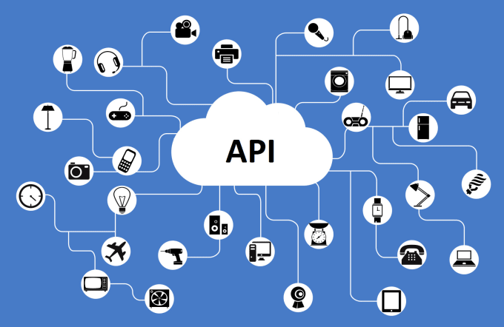

# In a nutshell

As per the requirement we can select API types are work with them. In every system which is getting response is connected to API. Interface can be thought as contract of services between application.

# 9). What is Responsive Testing?

Its Responsive web designing involves a web page that is accessible from any device, starting with mobile phone, laptop, tablet. Ensures that a website or webpage is usable on various devices even in smart phones also.

* It involves how application looks and behaves on different screen resolution, sizes on screen.
* It involves how it behaves on different resolutions of devices.
* It is using CSS media queries to render web pages on multiple devices.
* It’s a survey that says if business on mobile site if poorly designed then 57% users don’t recommend that site.
* In responsive testing we can able to explore every device right from mobile resolution, then tablet, then laptop, then I pad.
* In different screen sizes there resolutions checking is very important, due to digitalisation.

# In a nutshell

Responsive testing involves identifying issues, checking visible differences, manual interaction, that uses CSS media queries ensuring looks of website, uability and appearance as in manual interaction and ensuring functionality is accessable on all devices.

# 10). Which types of tools are available for Responsive Testing

Tools for responsive testing are as follows: -

1. Google chrome Inspect: Right-click on the website, click inspect, then click toggle device toolbar.
2. Screenfly: IN this option to view static screens or enable scrolling option is there, that includes pixel measurements.

* This responsive design tool is totally free and no real technical skills requires.
* Just go to website that we want to test and select devices and screen sizes to see that how website looks.

1. Website Responsiveness

Other tools for testing are: - Testsigma, lambda Test, Am I Responsive? Tool, Browser stack, Cross Browser Testing.

1. Test sigma: - Powerful cloud-based platform, helps in automation testing for web, mobile, desktop apps, and APIs.

* Top AI testing tool that allows QA analyst and automation engineers to create automated tests.
* It has powerful auto healing capabilities for correcting errors.

1. Am I Responsive: - It’s a strong brand identity, helps to check website on different resolutions.
2. Cross browser Testing: - Involves comparing and analysing the behaviour of your website in different browser environments.

# In a nutshell

The purpose of responsive testing is to ensure about the web application how much is effective in different devices and different resolutions of screen that is helpful in categorising website friendly usage.

# 11). How to create step for to open the developer option mode ON?

Developer option mode on steps are as follows: -

1. In android phone open settings.
2. Next step: - Tap about phone.
3. Next step: - Scroll down to find build number.
4. Next step: - Tap build number 7 times.
5. Next step: - Enter your pin or pattern to enable developer options menu.
6. Next step: - Find developer options under system in the setting menu.
7. In computer we can open developer mode: - Click the windows icon and settings icon.
8. Next step: - Select update security.
9. Next step: - Select for developers and turn on switch under developer mode.
10. Next step: - In the displayed dialog box, select yes.

# 12). What is the full form of .ipa, .apk ?

ITS Intelligent Process Automation and its also called as Robotic Process Automation.

* That is performed by software robots has become commonly utilised solution across industries.

FOR APK its Android Application Package.

* Its application file type used in Android operating system and in Android application also like mobile, video games and middleware for distribution and installation.