Chapter 1 Introduction
■ Synchronization refers to relationships among events. ■ Synchronization constraints are requirements pertaining to the ordering of events, examples include serialization (event A before event B) and mutual exclusion (event A and B must not happen at the same time). ■ There are at least two different but equivalent computation models: 1) parallel processor (multiple processors executing on different sequences of instructions) and 2) multi-threaded (multiple threads on a single processor executing different sequences of instructions). The models are equivalent because the issue is the same; the order of instruction execution is unknown. ■ Two events are concurrent if we cannot tell from the program which will happen first. ■ Concurrent programs are non-deterministic. Specific order of instruction execution may change, depending on the scheduler. Challenging to debug (Heisenbugs). ■ The execution path is the realized sequence of executed instructions during an invocation of a program. It is an instance of all permutations of the instruction execution sequence. ■ Atomic operations cannot be interrupted. ■ A high-level language may hide the atomicity of operations. For example x = x + 1; is potentially multiple machine instructions, each of which can be interrupted. ■ Message passing is a mechanism for synchronization. Two parties pass messages to each other to signal changes.
Chapter 2 Semaphores
■ Semaphores definition: A semaphore is a synchronization construct built on the idea of incrementing and decrementing an integer. When a thread decrements the integer and the result is negative, the thread waits. Otherwise, the thread obtains access to the exclusive resource. When a thread increments the integer, if there is a thread waiting, it is allowed access to the exclusive resource, and the signaling thread is released from access to the resource. Can be thought of as like a “turnstile” or a “revolver cylinder”. The threads in the cylinder have access to the resource. Those who wish to acquire access must wait. Those who no longer need access signal their release of the resources. ■ Semaphore operations:
1) “s = Semaphore(x)” // construct a semaphore with the initial value x.
2) “s.signal()” // signal the release of a resource
3) “s.wait()” // enqueue for acquisition of the resource. If the resource is available do not wait, otherwise thread will wait until another thread signals.
Chapter 3 Synchronization Patterns
■ Signaling is when one thread sends a signal to another thread to indicate that something has happened. Signaling solves the serialization problem since it guarantees that some code will run in one thread before code in another thread. For example, consider
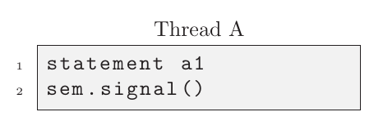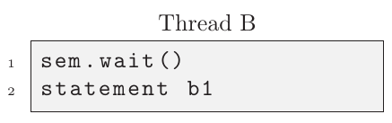
. Statement a1 < a2 < b1 < b2 is guaranteed by a binary semaphore if before a1 thread already waited. ■ Rendezvous is a generalized signal pattern, so thread A has to wait on thread B and thread B has to wait on thread A. Specifically, meeting
b1 < a2 and a1 < b2
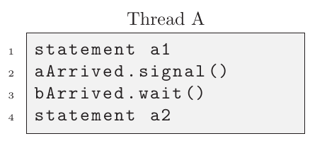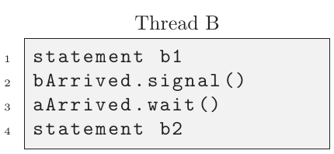
Note that both semaphores aArrived and bArrives must be initialized to zero. ■ Deadlock with semaphores example. 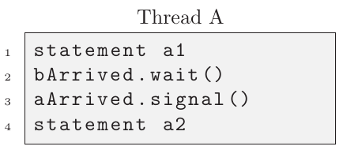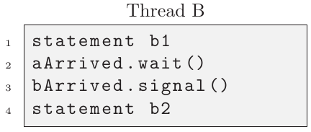
Note how both semaphores wait on each other without proceeding to their respective signaling. In other words, A is waiting on B and B is waiting on A.
■ Mutual Exclusion can be implemented by a semaphore. For example, consider two threads which wish to increment a counter.
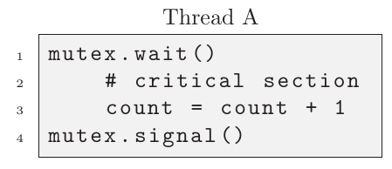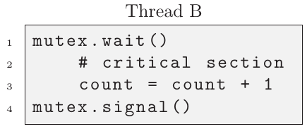
Note that the mutex is initialized as a semaphore with initial value 0. Furthermore, since both threads implement the same critical section (the code requiring protection “critically important to prevent concurrent access”), we consider this a symmetric solution. Solutions which are not symmetric are asymmetric solutions and necessitate thread specific implementations making the implementations less generalizable and potentially more difficult to maintain. We can analogize the mutex as a token passed between threads, granting the holder the ability to enter a critical section. Without the token, a thread must wait until obtained to enter.
■ Multiplex pattern is an n-way mutex. The canonical mutex allows access for 1 user at a time. The two-way mutex allows access to a resource to 2 users at a time. Therefore, the n-way multiplex allows n users access to a resource concurrently.

