Name : Patel Divya Dipakbhai

Stream : MSCIT semester : 3 Subject : Hadoop practical

Enrollnment no : 202300819010029

--------------------------------------------------------------------------------------------------------------------------------------

***Program 1******:***

import java.io.IOException;

import java.util.StringTokenizer;

import org.apache.hadoop.conf.Configuration;

import org.apache.hadoop.fs.Path;

import org.apache.hadoop.io.IntWritable;

import org.apache.hadoop.io.LongWritable;

import org.apache.hadoop.io.Text;

import org.apache.hadoop.mapreduce.Job;

import org.apache.hadoop.mapreduce.Mapper;

import org.apache.hadoop.mapreduce.Reducer;

import org.apache.hadoop.mapreduce.lib.input.FileInputFormat;

import org.apache.hadoop.mapreduce.lib.input.TextInputFormat;

import org.apache.hadoop.mapreduce.lib.output.FileOutputFormat;

import org.apache.hadoop.mapreduce.lib.output.TextOutputFormat;

public class FirstProgram {

public static class Map extends Mapper<LongWritable,Text,Text,IntWritable>{

public void map(LongWritable key,Text value,Context context) throws IOException,InterruptedException{

String line = value.toString();

StringTokenizer token = new StringTokenizer(line);

while(token.hasMoreElements()) {

value.set(token.nextToken());

context.write(value, new IntWritable(1));

}

}

}

public static class Reduce extends Reducer<Text,IntWritable,Text,IntWritable>{

public void reduce(Text key,Iterable<IntWritable> value,Context context) throws IOException,InterruptedException{

int sum = 0;

for(IntWritable i : value) {

sum += i.get();

}

context.write(key, new IntWritable(sum));

}

}

public static void main(String args[]) throws Exception{

Configuration conf = new Configuration();

Job job = Job.getInstance(conf,"FirstProgram");

job.setJarByClass(FirstProgram.class);

job.setMapperClass(Map.class);

job.setReducerClass(Reduce.class);

job.setMapOutputKeyClass(Text.class);

job.setMapOutputValueClass(IntWritable.class);

job.setOutputKeyClass(Text.class);

job.setOutputValueClass(IntWritable.class);

job.setInputFormatClass(TextInputFormat.class);

job.setOutputFormatClass(TextOutputFormat.class);

Path outputPath = new Path(args[1]);

FileInputFormat.addInputPath(job, new Path(args[0]));

FileOutputFormat.setOutputPath(job, new Path(args[1]));

outputPath.getFileSystem(conf).delete(outputPath, true);

System.exit(job.waitForCompletion(true)?0:1);

}

}

***Text File :***

Hadoop

Hadoop

Hadoop

Hadoop

Hadoop

Hadoop

Hadoop

HDFS

HDFS

HDFS

HDFS

HDFS

HDFS

HDFS

HDFS

HDFS

HDFS

***Commands :***

Put file in Hadoop file system :

hdfs dfs -put source destination

hadoop jar jar-path text-file-path-or-csv-file-path output-path

hdfs dfs -cat output-path/part-r-00000

***Output :***

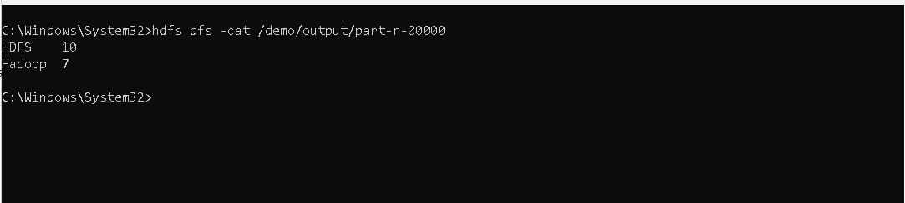

***Program 2 :***

import java.io.IOException;

import org.apache.hadoop.conf.Configuration;

import org.apache.hadoop.fs.Path;

import org.apache.hadoop.io.IntWritable;

import org.apache.hadoop.io.LongWritable;

import org.apache.hadoop.io.Text;

import org.apache.hadoop.mapreduce.Job;

import org.apache.hadoop.mapreduce.Mapper;

import org.apache.hadoop.mapreduce.Reducer;

import org.apache.hadoop.mapreduce.lib.input.FileInputFormat;

import org.apache.hadoop.mapreduce.lib.output.FileOutputFormat;

public class SecondProgram {

public static class Map extends Mapper<LongWritable,Text,Text,IntWritable>{

public void map(LongWritable key,Text value,Context context) throws IOException,InterruptedException{

String[] cols = value.toString().split(",");

String year = cols[0];

int temperature = Integer.parseInt(cols[1]);

context.write(new Text(year),new IntWritable(temperature));

}

}

public static class Reduce extends Reducer<Text,IntWritable,Text,IntWritable>{

public void reduce(Text key,Iterable<IntWritable> values,Context context) throws IOException,InterruptedException{

int minTemp = Integer.MAX_VALUE;

for(IntWritable value : values) {

minTemp = Math.min(minTemp, value.get());

}

context.write(key, new IntWritable(minTemp));

}

}

public static void main(String args[]) throws Exception {

Configuration conf = **new** Configuration();

Job job = Job.*getInstance*(conf,"SecondProgram");

job.setJarByClass(SecondProgram.**class**);

job.setMapperClass(Map.**class**);

job.setReducerClass(Reduce.**class**);

job.setMapOutputKeyClass(Text.**class**);

job.setMapOutputValueClass(IntWritable.**class**);

job.setOutputKeyClass(Text.**class**);

job.setOutputValueClass(IntWritable.**class**);

job.setInputFormatClass(TextInputFormat.**class**);

job.setOutputFormatClass(TextOutputFormat.**class**);

Path outputPath = **new** Path(args[1]);

FileInputFormat.*addInputPath*(job, **new** Path(args[0]));

FileOutputFormat.*setOutputPath*(job, **new** Path(args[1]));

outputPath.getFileSystem(conf).delete(outputPath, **true**);

System.*exit*(job.waitForCompletion(**true**)?1:0);

}

}

***Text File :***

2014 1

2014 3

2014 -1

2014 5

2014 6

2014 8

2014 9

2014 10

2015 1

2015 -2

2015 5

2015 3

2015 4

***Commands :***

Put file in Hadoop file system :

hdfs dfs -put source destination

hadoop jar jar-path text-file-path-or-csv-file-path output-path

hdfs dfs -cat output-path/part-r-00000

***Output :***



***Program 3 :***

import java.io.IOException;

import java.util.StringTokenizer;

import org.apache.hadoop.conf.Configuration;

import org.apache.hadoop.fs.Path;

import org.apache.hadoop.io.IntWritable;

import org.apache.hadoop.io.LongWritable;

import org.apache.hadoop.io.Text;

import org.apache.hadoop.mapreduce.Job;

import org.apache.hadoop.mapreduce.Mapper;

import org.apache.hadoop.mapreduce.Reducer;

import org.apache.hadoop.mapreduce.lib.input.FileInputFormat;

import org.apache.hadoop.mapreduce.lib.output.FileOutputFormat;

public class ThirdProgram {

public static class Map extends Mapper<LongWritable,Text,Text,IntWritable>{

public void map(LongWritable key,Text value,Context context) throws IOException,InterruptedException{

String line = value.toString();

StringTokenizer token = new StringTokenizer(line);

while(token.hasMoreElements()) {

value.set(token.nextToken());

context.write(value, new IntWritable(1));

}

}

}

public static class Reduce extends Reducer<Text,IntWritable,Text,IntWritable>{

private int outerSum = 0;

public void reduce(Text key,Iterable<IntWritable> values,Context context) throws IOException,InterruptedException{

int sum = 0;

for(IntWritable value : values) {

sum += value.get();

outerSum += value.get();

}

context.write(key, new IntWritable(sum));

}

public void cleanup(Context context) throws IOException,InterruptedException{

int avg = outerSum / 2;

context.write(new Text("Average"), new IntWritable(avg));

}

}

public static void main(String args[]) throws Exception {

Configuration conf = **new** Configuration();

Job job = Job.*getInstance*(conf,"ThirdProgram");

job.setJarByClass(ThirdProgram.**class**);

job.setMapperClass(Map.**class**);

job.setReducerClass(Reduce.**class**);

job.setMapOutputKeyClass(Text.**class**);

job.setMapOutputValueClass(IntWritable.**class**);

job.setOutputKeyClass(Text.**class**);

job.setOutputValueClass(IntWritable.**class**);

job.setInputFormatClass(TextInputFormat.**class**);

job.setOutputFormatClass(TextOutputFormat.**class**);

Path outputPath = **new** Path(args[1]);

FileInputFormat.*addInputPath*(job, **new** Path(args[0]));

FileOutputFormat.*setOutputPath*(job, **new** Path(args[1]));

outputPath.getFileSystem(conf).delete(outputPath, **true**);

System.*exit*(job.waitForCompletion(**true**)?1:0);

}

}

***Text File :***

Hadoop

Hadoop

Hadoop

Hadoop

Hadoop

Hotspot

Hotspot

Hotspot

Hotspot

***Commands :***

Put file in Hadoop file system :

hdfs dfs -put source destination

hadoop jar jar-path text-file-path-or-csv-file-path output-path

hdfs dfs -cat output-path/part-r-00000

***Output :***

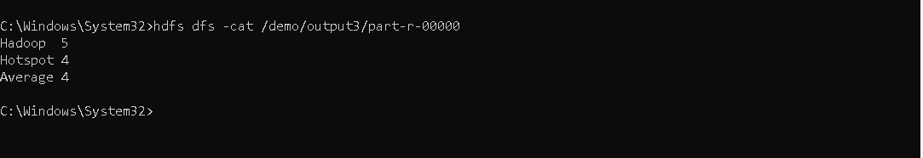

***Program 4 :***

import java.io.IOException;

import java.util.StringTokenizer;

import org.apache.hadoop.conf.Configuration;

import org.apache.hadoop.fs.Path;

import org.apache.hadoop.io.IntWritable;

import org.apache.hadoop.io.LongWritable;

import org.apache.hadoop.io.Text;

import org.apache.hadoop.mapreduce.Job;

import org.apache.hadoop.mapreduce.Mapper;

import org.apache.hadoop.mapreduce.Reducer;

import org.apache.hadoop.mapreduce.lib.input.FileInputFormat;

import org.apache.hadoop.mapreduce.lib.output.FileOutputFormat;

public class FourthProgram {

public static class Map extends Mapper<LongWritable,Text,Text,IntWritable>{

public void map(LongWritable key,Text value,Context context) throws IOException,InterruptedException{

String line = value.toString();

StringTokenizer token = new StringTokenizer(line);

while(token.hasMoreElements()) {

value.set(token.nextToken());

if(value.getLength() >= 4) {

context.write(value, new IntWritable(1));

}

}

}

}

public static class Reduce extends Reducer<Text,IntWritable,Text,IntWritable>{

private int cnt = 0;

public void reduce(Text key,Iterable<IntWritable> values,Context context) throws IOException,InterruptedException{

for(IntWritable value : values) {

cnt += value.get();

}

}

public void cleanup(Context context) throws IOException,InterruptedException{

context.write(new Text("no of Count : "), new IntWritable(cnt));

}

}

public static void main(String args[]) throws Exception {

Configuration conf = **new** Configuration();

Job job = Job.*getInstance*(conf,"FourthProgram");

job.setJarByClass(FourthProgram.**class**);

job.setMapperClass(Map.**class**);

job.setReducerClass(Reduce.**class**);

job.setMapOutputKeyClass(Text.**class**);

job.setMapOutputValueClass(IntWritable.**class**);

job.setOutputKeyClass(Text.**class**);

job.setOutputValueClass(IntWritable.**class**);

job.setInputFormatClass(TextInputFormat.**class**);

job.setOutputFormatClass(TextOutputFormat.**class**);

Path outputPath = **new** Path(args[1]);

FileInputFormat.*addInputPath*(job, **new** Path(args[0]));

FileOutputFormat.*setOutputPath*(job, **new** Path(args[1]));

outputPath.getFileSystem(conf).delete(outputPath, **true**);

System.*exit*(job.waitForCompletion(**true**)?1:0);

}

}

***Text File :***

Java

Python

C

C++

***Commands :***

Put file in Hadoop file system :

hdfs dfs -put source destination

hadoop jar jar-path text-file-path-or-csv-file-path output-path

hdfs dfs -cat output-path/part-r-00000

***Output :***

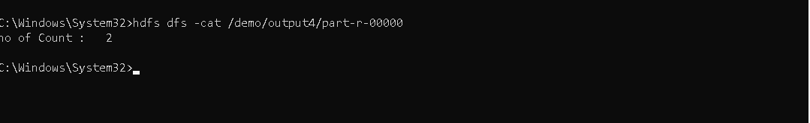

***Program 5 :***

import java.io.IOException;

import org.apache.hadoop.conf.Configuration;

import org.apache.hadoop.fs.Path;

import org.apache.hadoop.io.IntWritable;

import org.apache.hadoop.io.LongWritable;

import org.apache.hadoop.io.Text;

import org.apache.hadoop.mapreduce.Job;

import org.apache.hadoop.mapreduce.Mapper;

import org.apache.hadoop.mapreduce.Reducer;

import org.apache.hadoop.mapreduce.lib.input.FileInputFormat;

import org.apache.hadoop.mapreduce.lib.output.FileOutputFormat;

public class FifthProgram {

public static class Map extends Mapper<LongWritable,Text,Text,IntWritable>{

public void map(LongWritable key,Text value,Context context) throws IOException,InterruptedException{

String[] cols = value.toString().split(",");

String gender = cols[2];

context.write(new Text(gender), new IntWritable(1));

}

}

public static class Reduce extends Reducer<Text,IntWritable,Text,IntWritable>{

private int totalFemale = 0;

public void reduce(Text key,Iterable<IntWritable> values,Context context) throws IOException,InterruptedException{

int sum = 0;

for(IntWritable value : values) {

sum += value.get();

}

if(key.equals(new Text("Female"))) {

totalFemale = sum;

}

}

public void cleanup(Context context) throws IOException,InterruptedException{

context.write(new Text("Total female voters : "), new IntWritable(totalFemale));

}

}

public static void main(String args[]) throws Exception {

Configuration conf = **new** Configuration();

Job job = Job.*getInstance*(conf,"FifthProgram");

job.setJarByClass(FifthProgram.**class**);

job.setMapperClass(Map.**class**);

job.setReducerClass(Reduce.**class**);

job.setMapOutputKeyClass(Text.**class**);

job.setMapOutputValueClass(IntWritable.**class**);

job.setOutputKeyClass(Text.**class**);

job.setOutputValueClass(IntWritable.**class**);

job.setInputFormatClass(TextInputFormat.**class**);

job.setOutputFormatClass(TextOutputFormat.**class**);

Path outputPath = **new** Path(args[1]);

FileInputFormat.*addInputPath*(job, **new** Path(args[0]));

FileOutputFormat.*setOutputPath*(job, **new** Path(args[1]));

outputPath.getFileSystem(conf).delete(outputPath, **true**);

System.*exit*(job.waitForCompletion(**true**)?1:0);

}

}

***Text File :***

1,Divya,Male,20

2,Sumit,Male,20

3,Preksha,Female,20

4,Nikita,Female,20

5,Jishan,Male,20

6,Jhuveriya,Female,20

7,Nisarg,Male,20

8,Meet,Male,20

9,Kirsha,Female,20

10,Karina,Female,20

***Commands :***

Put file in Hadoop file system :

hdfs dfs -put source destination

hadoop jar jar-path text-file-path-or-csv-file-path output-path

hdfs dfs -cat output-path/part-r-00000

***Output :***

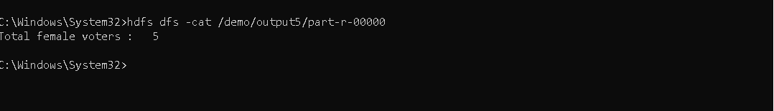

***Program 6 :***

import java.io.IOException;

import org.apache.hadoop.conf.Configuration;

import org.apache.hadoop.fs.Path;

import org.apache.hadoop.io.IntWritable;

import org.apache.hadoop.io.LongWritable;

import org.apache.hadoop.io.Text;

import org.apache.hadoop.mapreduce.Job;

import org.apache.hadoop.mapreduce.Mapper;

import org.apache.hadoop.mapreduce.Reducer;

import org.apache.hadoop.mapreduce.lib.input.FileInputFormat;

import org.apache.hadoop.mapreduce.lib.output.FileOutputFormat;

public class SixthProgram {

public static class Map extends Mapper<LongWritable,Text,Text,IntWritable>{

public void map(LongWritable key,Text value,Context context) throws IOException,InterruptedException {

String cols[] = value.toString().split(",");

String reviewID = cols[0];

context.write(new Text(reviewID), new IntWritable(1));

}

}

public static class Reduce extends Reducer<Text,IntWritable,Text,IntWritable>{

private int total_unique_reviews = 0;

public void reduce(Text key,Iterable<IntWritable> values,Context context) throws IOException,InterruptedException{

int sum = 0;

for(IntWritable value : values) {

sum += value.get();

}

total_unique_reviews++;

context.write(key, new IntWritable(sum));

}

public void cleanup(Context context) throws IOException,InterruptedException{

context.write(new Text("Total unique reviews : "), new IntWritable(total_unique_reviews));

}

}

public static void main(String args[]) throws Exception {

Configuration conf = **new** Configuration();

Job job = Job.*getInstance*(conf,"SixthProgram");

job.setJarByClass(SixthProgram.**class**);

job.setMapperClass(Map.**class**);

job.setReducerClass(Reduce.**class**);

job.setMapOutputKeyClass(Text.**class**);

job.setMapOutputValueClass(IntWritable.**class**);

job.setOutputKeyClass(Text.**class**);

job.setOutputValueClass(IntWritable.**class**);

job.setInputFormatClass(TextInputFormat.**class**);

job.setOutputFormatClass(TextOutputFormat.**class**);

Path outputPath = **new** Path(args[1]);

FileInputFormat.*addInputPath*(job, **new** Path(args[0]));

FileOutputFormat.*setOutputPath*(job, **new** Path(args[1]));

outputPath.getFileSystem(conf).delete(outputPath, **true**);

System.*exit*(job.waitForCompletion(**true**)?1:0);

}

}

***CSV File :***

Note : file is large in size as well as rows wise.

***Commands :***

Put file in Hadoop file system :

hdfs dfs -put source destination

hadoop jar jar-path text-file-path-or-csv-file-path output-path

hdfs dfs -cat output-path/part-r-00000

***Output :*** 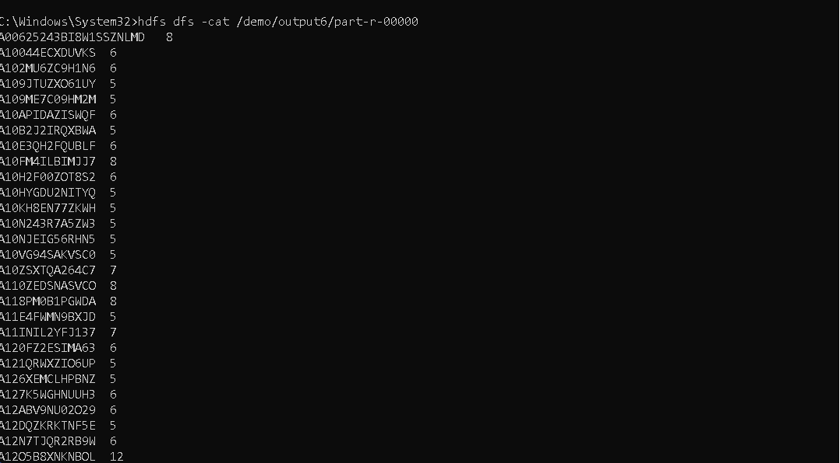

***Program 7 :***

import java.io.IOException;

import org.apache.hadoop.conf.Configuration;

import org.apache.hadoop.fs.Path;

import org.apache.hadoop.io.IntWritable;

import org.apache.hadoop.io.LongWritable;

import org.apache.hadoop.io.Text;

import org.apache.hadoop.mapreduce.Job;

import org.apache.hadoop.mapreduce.Mapper;

import org.apache.hadoop.mapreduce.Reducer;

import org.apache.hadoop.mapreduce.lib.input.FileInputFormat;

import org.apache.hadoop.mapreduce.lib.output.FileOutputFormat;

public class SeventhProgram {

public static class Map extends Mapper<LongWritable,Text,Text,IntWritable>{

public void map(LongWritable key,Text value,Context context) throws IOException,InterruptedException{

String col[] = value.toString().split(",");

String title = col[1].toString();

String genres = col[2].toString();

if(genres.contains("Comedy")) {

context.write(new Text(title+" : "+genres),new IntWritable(1));

}

if(genres.contains("Documentary") && title.contains("1995")) {

context.write(new Text("Documentry"),new IntWritable(1));

}

if(title.contains("Gold")) {

context.write(new Text(title),new IntWritable(1));

}

if(genres.contains("Drama") && genres.contains("Romance")) {

context.write(new Text(title + " : "+genres),new IntWritable(1));

}

if(genres.isEmpty()) {

context.write(new Text("Missing"), new IntWritable(1));

}

}

}

public static class Reduce extends Reducer<Text,IntWritable,Text,IntWritable>{

private int count = 0;

private int missing = 0;

public void reduce(Text key,Iterable<IntWritable> values,Context context) throws IOException,InterruptedException{

int sum = 0;

for(IntWritable value : values) {

sum += value.get();

}

context.write(key, new IntWritable(sum));

if(key.toString().contains("Documentary")) {

count++;

}

if(key.toString().contains("Documentry")) {

missing++;

}

}

public void cleanup(Context context) throws IOException,InterruptedException{

context.write(new Text("Total documentry movie in 1995 : "), new IntWritable(count));

context.write(new Text("Total missing genres : "), new IntWritable(missing));

}

}

public static void main(String args[]) throws Exception {

Configuration conf = **new** Configuration();

Job job = Job.*getInstance*(conf,"SeventhProgram");

job.setJarByClass(SeventhProgram.**class**);

job.setMapperClass(Map.**class**);

job.setReducerClass(Reduce.**class**);

job.setMapOutputKeyClass(Text.**class**);

job.setMapOutputValueClass(IntWritable.**class**);

job.setOutputKeyClass(Text.**class**);

job.setOutputValueClass(IntWritable.**class**);

job.setInputFormatClass(TextInputFormat.**class**);

job.setOutputFormatClass(TextOutputFormat.**class**);

Path outputPath = **new** Path(args[1]);

FileInputFormat.*addInputPath*(job, **new** Path(args[0]));

FileOutputFormat.*setOutputPath*(job, **new** Path(args[1]));

outputPath.getFileSystem(conf).delete(outputPath, **true**);

System.*exit*(job.waitForCompletion(**true**)?1:0);

}

}

***CSV File :***

Note : file is large in size as well as rows wise.

***Commands :***

Put file in Hadoop file system :

hdfs dfs -put source destination

hadoop jar jar-path text-file-path-or-csv-file-path output-path

hdfs dfs -cat output-path/part-r-00000

***Output :***

