CURRICULUM VITAE

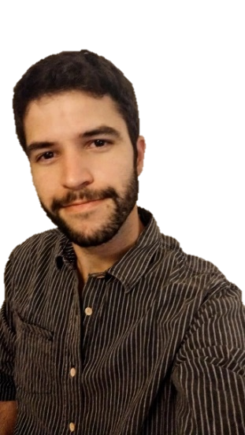

PERSONAL DATA

Full Name: Mauro Damián Ruben

Date of Birth: 04/10/1995

Nationalities: Italian and Argentinian

EU Passport Number: YA5419048

Email Address: [mauroruben@outlook.com](mailto:mauroruben@outlook.com)

EDUCATION

* Currently: Studying a ‘Web Full Stack Junior Developer’ degree at *Argentina Programa* training project. Completion date: September 2022.

Stack:

Front-end: HTML, CSS (Bootstrap framework). Programming language: TypeScrypt (Angular framework based on JavaScript).

Back-end: MySQL database system. Language: Java (Spring Boot framework). Apache Tomcat web server.

* 2021: Certificate in JavaScript and Ruby programming languages from *Argentina Programa* training program. This certificate was issued by Ministerio de Desarrollo Productivo de la Nación and Cámara Empresarial de Software y Servicios Informáticos (CESSI).
* 2015-2021: ‘Professional English-Spanish Translator’ graduated from CAECE University, Mar del Plata, Argentina.
* 2018: Certificate of ‘Pharmacy Assistant’ at Instituto Hilet, Mar del Plata, Argentina.
* 2014: Rotary Youth Exchange Student year in Ressun Lukio school in Helsinki, Finland (Rotary International Sponsorship).
* 2014: Advanced English, Philosophy and Literature courses at Ressun Lukio school in Helsinki, Finland.
* 2001-2013: Primary and secondary school at Unidad Académica Dr. Julio Cesar Lovecchio in Coronel Suarez, Argentina.
* Workshop: “Traducción audiovisual: nuevos desafíos” – CAECE University 2016.
* Seminary: “Modals: un campo minado” – CAECE University 2016.
* Conference: “Un nuevo Traductor para un nuevo paradigma” – CAECE University 2016.
* Seminary: “¿Importa la calidad de las traducciones?” – CAECE University 2016.
* Seminary: “Traducción de cláusulas contractuales vinculadas con cuestiones de responsabilidad y daños” – CAECE University 2016.
* Seminary: “Gestión de riesgos en proyectos de traducción” – CAECE University 2016.
* Conference: “Los corpus virtuales como recurso esencial del traductor técnico-científico” –CAECE University 2016.

JOB EXPERIENCE

* 2020-2022:  FREELANCE PROFESSIONAL TRANSLATOR
* 2016-2022:  ENGLISH TEACHER   
  Mar del Plata – Argentina
* Summer 2018: CALZADO “GAUCHO” – Sales Assistant   
  Mar del Plata – Argentina
* 2014-2015: ROTARY INTERNATIONAL – Conference, Event and Meeting Assistant and Coordinator

Helsinki, Finland and Coronel Suarez, Argentina

LANGUAGES

* Spanish: native language.
* English: proficiency level.
* Finnish: intermediate level. B1 level certificate from the University of Helsinki – Finland (2014).
* Italian: intermediate level. B1 level certificate from CAECE University, Mar del Plata (2015-2017).

IT SKILLS

* SDL Trados Studio 2021
* AntConc
* XBench
* Memsource
* Abbyy Finereader
* Git/GitHub
* Sublime 3
* Visual Studio Code
* Microsoft Word
* LibreOffice
* Microsoft Excel
* Google Drive
* Discord
* Email