
Website Visual Design
For [Business]


Contents
Sitemap 2
Styles 2
Dark Mode 2
Background 2
Font 2
Interactive 3
Light Mode 3
Background 3
Font 3
Interactive 3
Buttons/Cards 3
Website Pages 3
Navigation Bar 4
Footer 4
Register 4
Log in 4
Privacy Policy 4
Home 4
Database 4
Entity Relationship Diagram 4
Data Dictionary 4
AspNetUsers 4
AspNetUserRoles 5
AspNetRoles 5
[Model] 5
[Model] 6
Algorithm Design 7
Register 7
Login 8
[Algorithm] 9
[Algorithm] 9
[Algorithm] 9
Test Strategy 9

Sitemap

Home = The landing page containing…
Privacy = Outlines how the user’s data is being used and protected
Register = Allows to register the user
Login = Allows to log in the user

Styles

Dark Mode

Background
- Body #FFFFFF
- Foreground Elements #FFFFFF
ef

Font
- Font Family = “Font here”
- Normal #FFFFFF
ef
- Lighter #FFFFFF
ef

Interactive
- Normal #FFFFFF
ef
- Hover/Selected #FFFFFF
ef

Light Mode

Background
- Body #FFFFFF
- Foreground Elements #FFFFFF
ef

Font
- Font Family = “Font here”
- Normal #FFFFFF
ef
- Lighter #FFFFFF
ef

Interactive
- Normal #FFFFFF
ef
- Hover/Selected #FFFFFF
ef

Buttons/Cards
- Corners = Rounded (30px +- 10px Radius)
- Background = Drop shadow (10px Blur)
- No outline

Website Pages
Link (If it does not work, see images below or contact my college to resolve any issues):

Navigation Bar

Footer

Register

Log in

Privacy Policy

Home

Database

Entity Relationship Diagram

Data Dictionary

AspNetUsers
Column | Data Type | Required | Default | Validation | Key Type
Id | String | Yes |  |  | Primary
UserName | String | Yes |  |  | None
NormalizedUserName | String | Yes |  |  | None
Email | String | Yes |  | Must include a valid email structure, must have a “@” symbol, must have a domain name | None
NormalizedEmail | String | Yes |  |  | None
EmailConfirmed | Bool | Yes |  | Users must confirm their email | None
PasswordHash | String | Yes |  |  | None
SecurityStamp | String |  |  |  | None
ConcurrencyStamp | String |  |  |  | None
PhoneNumber | String |  |  |  | None
PhoneNumberConfirmed  TwoFactorEnabled | Bool |  |  |  | None
LockoutEnd | Bool |  |  |  | None
LockoutEnabled | Datetime |  |  |  | None
AcessFailedCount | Int |  |  |  | None

AspNetUserRoles
Column | Data Type | Required | Default | Validation | Key Type
Id | Int | Yes |  |  | Primary
UserId | String | Yes | Users Id |  | Foreign
RoleId | String | Yes |  |  | None

AspNetRoles
Column | Data Type | Required | Default | Validation | Key Type
Id | String | Yes |  |  | Primary
Name | String | Yes | Users Id |  | None
NormalizeName | String | Yes |  |  | None
ConcurrencyStamp | String | Yes

[Model]
Column | Data Type | Required | Default | Validation | Key Type
[Model]+Id | Int | Yes |  |  | Primary

[Model]
Column | Data Type | Required | Default | Validation | Key Type
[Model]+Id | Int | Yes |  |  | Primary

Algorithm Design

Register
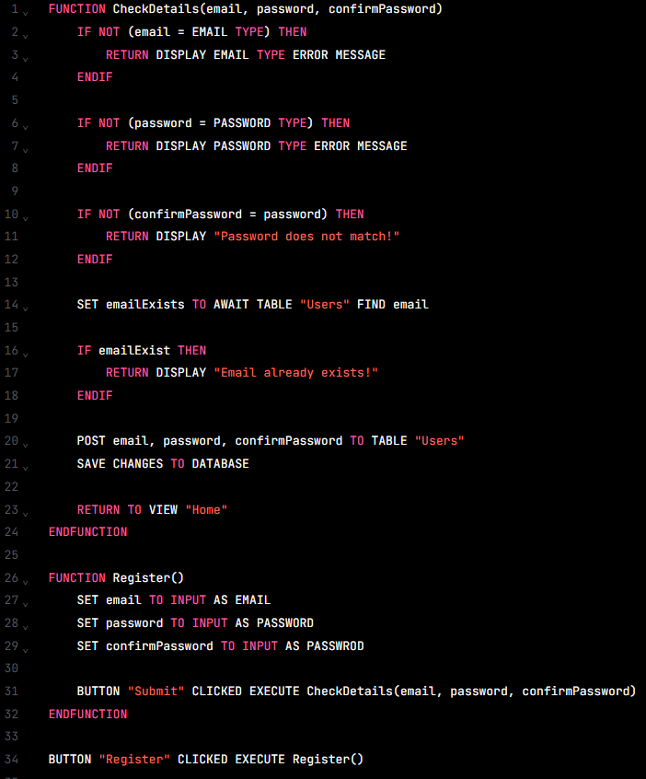
When the user clicks register, get their email, password and confirmation password. Check the information given by the user for email format, password format and confirmation password matches password. If the information is incorrect give them an error message on their screen for the specific information field. If the information is correct send it to the table called “Users” and save the changes made to database.

Login
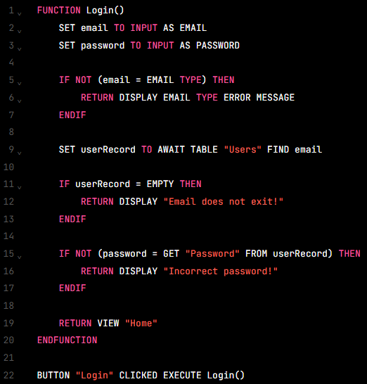
When the user clicks login, get the user’s email address and password. Check the information given by the user for email format, if the email address exists in the “Users” table and if the password matches the password in the record found in the “Users” table using the email address. If the information is incorrect display an error message on the user’s screen for the specific information field. If the information is correct, then send the user to the home page with their account logged in.

[Algorithm]

[Algorithm]

[Algorithm]

Test Strategy
Date of Test | Component to be Tested | Type of Test to be carried out | Prerequisites and dependencies
 | Register | White box  Black box  Functionality  Security  Integration | The register function should be fully functional and implemented.  Migrations and update database must be applied.  The controller logic should be completed to handle user and error handling for incorrect inputs, duplicate accounts and password completely must be set up.  Test Data:  Normal  Email: test@gmail.com  Password: Password123!  Confirm Password:  Password123!  Erroneous  Email: erroremail  Password: 111  Confirm Password:  222  Extreme  Email: test@testemail.com  Password: QwE12?  Confirm Password:  QwE12?
 | Log in | White box  Black box  Functionality  Security  Integration | The log-in page must be created.  Migrations and update database must be applied.  The controller logic must work correctly.  Test Data:  Normal  Email: test@gmail.com  Password: Password123!  Erroneous  Email: erroremail  Password: 111  Extreme  Email: test@testemail.com  Password: QwE12?
 | Log out | Black box  Functionality  Security  Integration | Log in system must be fully functional and allow users to create accounts.  Log out button must work and be visible to the users.  No test data needed.
 | Remember Me check box on the log in page | White box  Black box  Functionality  Integration | Log in system must be fully functional.  Valid account should exist.  Tester must click the remember me check box when logging in, leave the page, open the page on the same device and check if site kept the user logged in.  No test data needed.
 | Forgot password button on the log in page | White box  Black box  Functionality  Integration | Log in system must be fully functional.  Valid account should exist.  Forgotten system must be fully functional.  Tester should click forgot password, and a reset email should be sent to reset password.  No test data needed.
 | Link buttons on the navigation bar | Black box  Functionality  Integration | All the pages for each link should be made and the controller logic for each link must work correctly.  The navigation bar should be made and be fully functional.  Tester must check each link to see if it leads to the correct page.  No test data needed.
 | Logo on the navigation bar and the footer | Black box  Functionality  Integration | Home page should be made and be fully functional.  The navigation bar should be made and be fully functional.  The footer should be made and be fully functional.  Tester should click the logo to check if they are taken to the home page.  No test data needed.
 | Links on the footer | Black box  Functionality  Integration | All the pages for each link should be made and the controller logic for each link must work correctly.  The footer should be made and be fully functional.  Tester must check each link to see if it leads to the correct page.  No test data needed.
 | Accessibility features | Black box  Functionality  Integration | Accessibility system must be fully functional and accessible by users.  Tester should test each accessibility feature to see if it works. For example, colour mode, text resize and text-to-speech.  No test data needed.
 | Cookies functionality | Black box  Functionality  Integration | Cookies UI must be made.  Tester must check if the cookies show/pop up when new users enter the site.  No test data needed.
 | Accept all and decline all buttons on the cookies pop up. | White box  Black box  Functionality  Integration | Cookies must be fully functional and must pop up using JavaScript.  Testers must check if the cookies disappear after either one of the buttons on the cookies is clicked.  No test data needed.

