25 Aug 2022

Background info on how these masks were generated:

In each image below, the underlay is the Social (decision > baseline) > Doors (decision > baseline) contrast. This contrast shows regions with greater activation during the social decision phase (when participants are looking at faces) than during the doors decision phase (when participants are looking at doors). For each target roi, we identified the peak voxel within the cluster and drew a 5mm sphere around it to use as the mask. The only mask that included additional steps beyond that was the bilateral amygdala. For both left and right amygdala, the respective clusters extended well beyond the Harvard Oxford atlas’s anatomically defined borders, so these masks were constrained within those bounds. One additional note: the peak voxel for right amygdala was outside this boundary, so a local maximum within that boundary was used as the center of the sphere instead.

Additional info about targets & coordinates on Slab: <https://smithlab.slab.com/posts/istart-social-doors-jytxt3re#hzcjz-hypothetical-target-regions-for-h-2>

Bilateral amygdala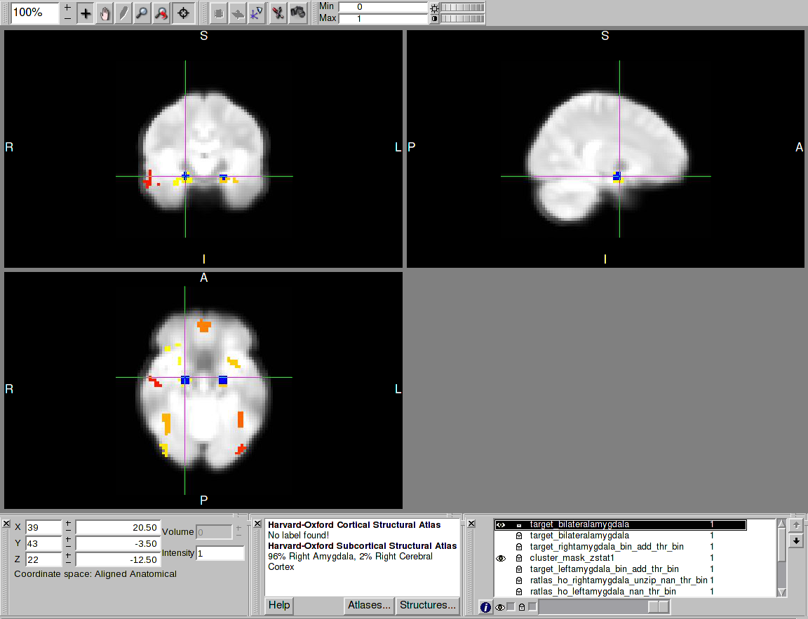

Right FFA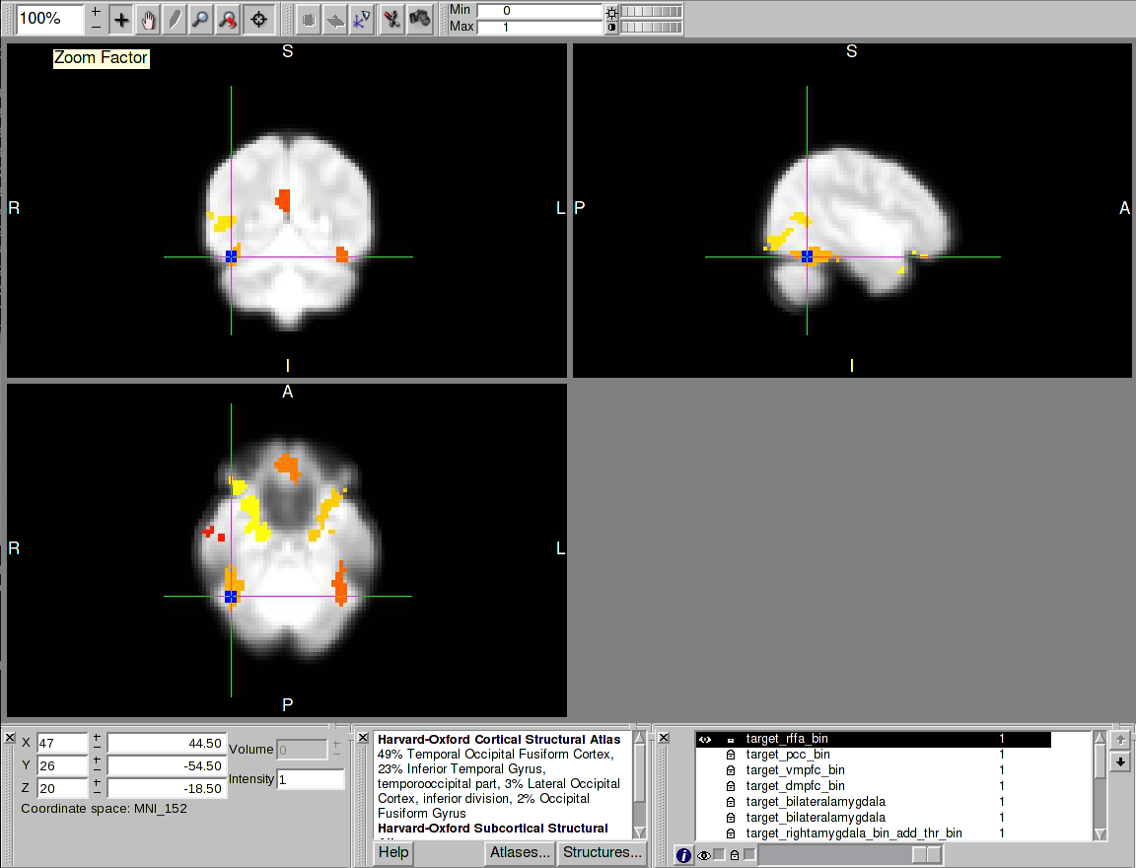

dmPFC 

