Night Owls Scan Manual

**Text or Call Matt with any issues: 941-323-0410**

**IMPORTANT SAFETY INFORMATION:**

**NEVER EVER ENTER THE SCANNER/SCANNER/MAGNET ROOM WITH ANY LOOSE METAL OBJECTS/OTHER MAGNETIC OBJECTS.**

**THIS INCLUDES AND IS NOT LIMITED TO: CELL PHONES, CREDIT CARDS/CARDS WITH MAGNETIC SWIPE, BOBBY PINS**

Best practice is to remove all items from your pockets as soon as you enter the MR suite and leave them on the console table.

# General Overview

Our goal is to scan a small number of participants many times (“precision imaging”), using two reward tasks (MID and Shared Reward). Each reward task is administered twice, before and after a mood induction task. Mood is also checked between each task during the scan. With the number of times participants will be scanned (ideally 2x/wk), it is VERY important they are comfortable and treated respectfully.

Participants are named sub-1xx (e.g., sub-101).

**L2 Protocol:**

**Before Scanning: Testing Room**

If Session 1:

* Read study introduction, answer any questions
* REDCap: Participant completes "Baseline Questionnaire"
  + **Note.** Make sure to open survey (see comment)
* Participant completes practice MID and shared reward tasks

All Sessions*:* Participant completes the following in REDCap:

* (1) PANAS ses-x, (2) Positive Memory ses-x, (3) Prescan Alertness ses-x

**Scanning Sequence:**

**\*\*NOTE\*\*** Odd sessions (order A): MID first (task A), end with resting state scan. Even sessions (order B): Shared Reward first, end with neuromelanin.

To start: Pull night-owls repo. Open PsychoPy 2022.1.4. Load in:

* /mood/ratings_prac
* /mood/MoodRatings_5button
* /mood/MoodInduction_5button
* /mid/MID_5button
* /sharedreward/SharedReward_5button
* /rest_neuromelanin

Task order:

(ratings_prac can be done before starting, as necessary to learn button box)

1. Mood Rating Observation **1**
2. Reward Task **A** Run **1**; see note
3. Mood Rating Observation **2**
4. Reward Task **B** Run **1**; see note
5. Positive Mood Induction (Anatomical during this; REDCap KKS after)
6. Reward Task **A** Run **2**; see note
7. Mood Rating Observation **5**
8. Reward Task **B** Run **2**; see note
9. Mood Rating Observation **6**
10. Resting State / Neuromelanin

## DETAILED L2 PROTOCOL

**Session 1 instruction script:**

*“Thank you for participating in our study. Our goal is for you to complete two fMRI scans a week at a regular interval while completing several monetary reward tasks. You will repeat each task twice at each visit. One task will be focused on your reaction time, where you will be rewarded if you press a button quickly enough. In this task, you can either win money or have no change but cannot lose money. The second task is based on guessing whether a number will be higher or lower than 5. In this task, your rewards will also be split with a real partner, and you can also lose money. We will give you more detailed instructions later on. Also, in the middle of the scan, we will ask you to reflect on a positive memory to try to get in a more positive mood.*

*You will be paid a flat rate of $40 at each visit. Additionally, you will earn bonuses ranging from $0-$50 at each visit, which we will pay you in sum after every 5 sessions or you withdraw from the study. For our study, it is very important that you complete as many sessions as you can, up to 12. For that purpose, if you complete 5 sessions, you will be entered into a lottery to win an additional $500. There will be a maximum of 5 people in this lottery. There will be a second $500 lottery for participants that complete 10 sessions, with again a maximum of 5 participants. Before the fMRI scan, there are just some brief questionnaires to complete on this computer. Do you have any questions?”*

**Subsequent sessions script:**

***“****Thank you for your continued participation! Today will be very similar to what you have done in previous visit(s). As a reminder, you will be reimbursed for this session at a flat rate, and will receive your performance-based bonuses every 5 sessions, after we also complete the $500 lottery. Do you have any questions?”*

## Before participant arrival:

1. In testing room, open up Redcap.
   1. **My Projects → Night Owls → Record Status Dashboard** **→**
   2. Open up tabs for: Baseline questionnaire (if ses-1), PANAS, Prescan Alertness, Positive Memory forms.
   3. Double check subject and session numbers. First participant is 101, second 102, etc. Sessions are 1,2,3, etc.
2. In scanning room:
   1. Pull night-owls repo. (C:)/Users/Public/LAB PROJECTS/Smith-Lab/GitHub/night-owls
   2. Open up PsychoPy 2022.1.4. Load from (C:)/Users/Public/LAB PROJECTS/Smith-Lab/GitHub/night-owls
      1. /mood/ratings_prac
      2. /mood/MoodRatings_5button
      3. /mood/MoodInduction_5button
      4. /mid/MID_5button
      5. /sharedreward/SharedReward_5button

## After participant arrival:

1. Greet them in lobby
   1. Complete consent form
   2. Complete metal safety screener
2. Bring to test room
   1. Read script, answer any questions.
   2. Have them complete redcap forms opened up. **Note. Encourage use of a different memory, but allow same memory if preferred.**
   3. Encourage to use bathroom before scanning.
   4. (If Session 1) – show Shared Reward task and MID task instructions (powerpoint), have them complete practice task ‘xx_prac.py’
      1. **NOTE –** If they seem dubious about shared reward partner, do your best to convince them the face (‘Jack’) is a placeholder for a real person (*‘we can’t show you the person due to confidentiality’)*. Do not bring up if they don’t ask.
   5. Ask the participant one last time if they have any metal on their person, including having them turn out their pockets, change into TUBRIC clothes if necessary, or remove piercings - If they have metal or circular piercings, and require something to put in their place during the scan, bring them MRI safe studs from the EEG room cupboard - Offer them the opportunity to place their belongings in the testing room locker. If they wish to: - Have them put in their belongings - Set the knob straight upwards - WRITE DOWN a 3 digit code first on a post-it (this can be brought with them into the scanner) and then input it on the lock - Lock it by turning the knob 90 degrees counter-clockwise
      1. Have the participant stand facing towards you with their arms and legs apart. Move the wand around the perimeter of the participant’s body, close enough to detect any metal, but without touching them. Have the participant turn facing sideways, and run the wand in front and behind them
   6. If there are any abnormalities in the screening, or notable events, record
   7. Copy memory from Redcap, paste into text and save as: /GitHub/night-owls/mood/memories/sub-xxx/sub-xxx_ses-xx_memory.txt
   8. Push to the GitHub right after for use of the memory txtfile on the scanner computer
3. Bring to scanning room
   1. Introduce L3, ensure safely gets into scanner
   2. Double check comfort and communications before starting.
   3. **Remind them importance of not moving**.
4. Pull Repo again, set volume on computer and box to maximum.
5. For at least first few sessions, run ratings_prac to confirm button box skill.
6. Begin tasks. Enter participant, session, run, and observation in task GUIs.

Odd sessions - Counterbalance A:

1. Localizer
2. Mood Rating Observation **1. Note:** mood induction.py sub#, session n, observation 1
3. MID Run **1**
4. Mood Rating Observation **2**
5. Shared Reward Run **1**
6. Positive Mood Induction (T1w during this) **Note:** manually press “=” sign to trigger memory mood induction material after T1W start and you see “please wait” on the monitor. **Ask if volume is good. If you get an error, you probably didn’t save the .txt file correctly or you entered wrong ses #**
7. Verbal KKS (fmri session notes on redcap; can display image)
8. MID Run **2**
9. Mood Rating Observation **5**
10. Shared Reward Run **2**
11. Mood Rating Observation **6**
12. Resting State Scan

Even sessions - Counterbalance B:

1. Localizer
2. Mood Rating Observation **1 Note:** mood induction.py sub#, session n, observation 1
3. Shared Reward Run **1**
4. Mood Rating Observation **2**
5. MID Run **1**
6. Positive Mood Induction (T1w during this) **Note:** manually press “=” sign to trigger memory mood induction material after T1W start and you see “please wait” on the monitor. **Ask if volume is good. If you get an error, you probably didn’t save the .txt file correctly or you entered wrong ses #**
7. Verbal KKS (fmri session notes on redcap; can display image)
8. Shared Reward Run **2**
9. Mood Rating Observation **5**
10. MID Run **2**
11. Mood Rating Observation **6**
12. Neuromelanin Scan **Note:** Once the NM scan is done (check with L3), you can exit this early manually by pressing ‘z

**Post scan**

1. Ensure participant safely exits scanner and is reimbursed
2. Push saved data to github
3. Complete fmri session notes on redcap

**L3 Protocol:**

## Control Room / Scanner Suite Setup

At the behavioral computer for the scanner:

1. Make sure audio volume turned to 100%
2. Make sure both button box receivers are on.
   1. One for responses from the 5-button box (top silver box), and one to receive and synchronize a kick from the console to the behavioral computer (PsychSoftware white box)

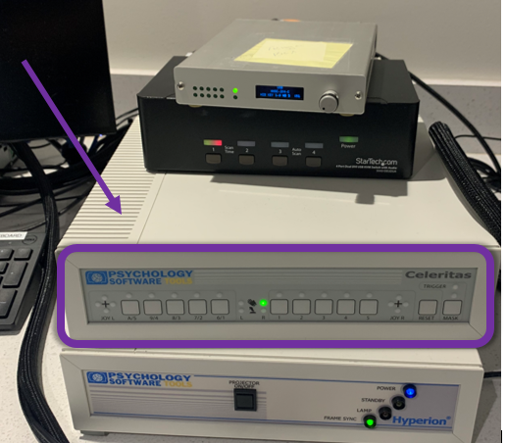

1. Reset button box if necessary (toggle switch in the back)
2. Open **Appointment 2 session notes** on iPad or your personal computer
   1. **My Projects → Night Owls → Record Status Dashboard** **→ Subject ID / ses-x fMRI session notes**
3. Check that projector is on and displaying images into the scanner bore

If control room projector box is fully off / no lights are on:

1. Enter

Press + hold ‘Projector on/off’ for 2-3 seconds.

* IF PROJECTOR IS FULLY OFF/NOT ON STANDBY, FiSt enta scanner room + flip prector switch, then Go into scan room and flip projector switch (top right corner) on follow Step 3 After a couple of minutes, press thold ‘Projector on/Off’ again. Blue power and green tamp Tot of whan 1 Press + hold ‘Projector on/off’ for 2-3 seconds. Yellow Standby light should come on you are IF NO ONE ISSCANNING IMMEDIATELY AFTER YOU OR YOU ARE LAST SCANNER: last scanner Weit 3minutes, then go into scanner room and flip projector switch (top right corner) off This will turn off the fan that was cooling the projector bulb — 3m should be enough time for it to have cooled
  1. If the orange signal light on the actual projector is off, turn it on with the switch in the back
  2. If the light is on but the projector is on standby, go to the interface with the button box receiver next to the behavioral computer push and hold the button 4 seconds until power button comes on

### Scanner Computer Setup

### Registering a Patient

Every patient who is scanned in TUBRIC must be registered on the scanning monitor.

1. Open up [REDCap](https://cphapps.temple.edu/redcap/) to the NOSC databasesession x
   1. **My Projects → Night Owls → Record Status Dashboard** **→ Subject Information** for the **participant’s name, age, handedness, glasses prescription, height, weight**
   2. **Counterbalance order: Odd sessions are A, Even sessions are B.**

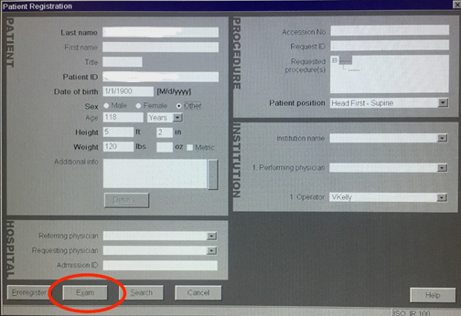

To open the above window, go to top left of the scanner monitor and click Patient → Register

**Now, you must fill out the following sections:**

1. Last Name - “**Smith-NOSC-#####**” (**do not use quotation marks; ##### is the subject ID, which can be found in scanning calendar**)
   1. Do NOT enter the participant’s actual name
2. Patient ID - “**Smith-NOSC-#####**” (you can copy + paste from above)
3. DOB, Height, Weight (in Subject Information on RedCap, NOSC, Info **OR** on the TUBRIC MRI Screening form the subject completed upon arrival)
4. Additional Info: **Project:Smith-NOSC**
5. Accession No.: **Check the TUBRIC’s scan log** - whatever number is after the previous scan’s Tubric ID # is the Accession number.
   1. E.g., the lab before us scanned Tubric ID # 2340, enter 2341 as the Accession number on computer (and write it in the scan log)
6. Patient Position: Head First - Supine
7. Operator - Enter your first initial and last name
   1. E.g., Melanie Kos → MKos, Cooper Sharp, CSharp

**Once that is all entered, click Exam**

The below window will now appear:

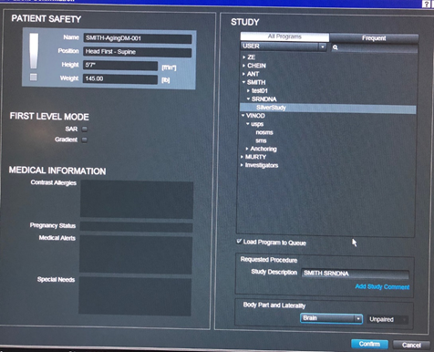

1. In the STUDY pane, under All Programs, select the LABS dropdown, then Smith → SRA … and select the proper Counterbalance (A or B). Odd sessions are A (MID first). Even sessions are B (Shared Reward first).
2. Under **Body Part and Laterality**, select **Brain**

* Once complete, click Confirm

You’ll know that you have set everything up correctly when the scanning protocol appears.

**Troubleshooting:**

If any information is entered incorrectly during registration, it can be corrected by:

* Opening the patient browser
* Right clicking on their top level “Smith-SRA-#####” scan file
* Click Edit in the toolbar and choose Correct
* Choose Yes when the system asks if you really want to continue
* Edit the necessary information and select OK“when you’re done

Please refer to Huiling or a lab manager if you have even the slightest of a doubt

**THE ORDER OF THE BELOW WILL VARY BASED ON COUNTERBALANCE**

To disable Windows Update service:

1. Press “Ctrl + R” to open the Run command.
2. Type in “services.msc”
3. Scroll down until you find “Windows Update”
4. Right click “Windows Update” and select “Properties”
5. Click “Stop” to stop the service from running.
6. Under the Startup Type, select the dropdown box “Disabled” to prevent it from starting again.

## Magnet Room / Scanner Room Setup

1. Make sure the 20-channel coil is plugged in and registering on the MRI’s display (the screen above the scanner)
2. Wrap the head and neck pillow pad in a pillow-sheet and place it in the coil, with the bottom of the sheet tucked in under the bed’s padding
3. Put ***one thin foam head pad in the coil.
4. Pull a sheet of paper from the foot of the bed over to the top, and tuck it in as well before cutting it from the roll
5. Lower the table to its bottom position

## Participant Safety Screening

* ☐ **Magnet Safety Screener**

1. Administer screening form:
   1. Subject MRI Safety Screening
2. Spot check various items to ensure that the form was filled out accurately and attentively (especially the final column)
   1. Ask the participant, ***pregnancy files here
3. Visually check to see if the participant might have had any oversights in filling out the form.

* ☐ **Ferromagnetic detector**
* ☐ *For before entry into MRI room *(including reentry, if the participant has to leave)*
  1. Have the participant take their shoes off
  2. Make sure the door to the magnet room is closed
  3. Turn on the detector and wait 5 seconds for the light to turn green
  4. Have the participant spin in place at a quick pace
  5. Do not let them into the magnet room unless the light remains green

## Scanning Procedure

Now that the participant has completed testing room tasks, they are ready to begin the MR portion of the visit.

### Loading Participant into Scanner

1. STOP: Check to make sure you’ve removed any metal objects from your person
   * ***NEVER ENTER THE SCANNER/MAGNET ROOM WITH YOUR PHONE OR ANY LOOSE METAL OBJECTS/OTHER MAGNETIC OBJECTS.***
2. If participant needs glasses, provide them the magnet-safe pair
   1. Put in lenses of their approximate prescription (less than or equal to what is indicated REDCap)
   2. If they do not know their prescription, you can use your phone and a computer to determine it by taking a photo through their glasses with this app/website <https://www.lensabl.com/prescription-scanner-app>
   3. Have them stand on the mark on the floor to attempt to read the fourth line of the eye chart on the wall across the room from the calendar on the large flat-screen monitor
   4. If they are comfortable, proceed; if not, keep trying lenses based on their preference.
3. Bring the participant to the MRI bed, and place the knee cushion under their legs to their liking. Have them lie down and inch upwards until their shoulders are as close up to the coil as possible.
4. Explain to the participant that we want them to be as comfortable as possible before starting, so that they do not have to leave the scanner
   1. Let them know that although they are entirely free to leave at any point, it will disrupt the experiment and cause a significant delay
   2. We want them to position themselves as comfortably and as relaxed as they can, ensuring that they let us know if they experience any discomfort whatsoever. Anything that’s slightly uncomfortable at this point will become unbearable after 1.5 hrs
   3. Additionally, let them know that we will be checking in on their comfort before we begin and between each task while they are in the scanner, but to be as still as they possibly can in the interim.
5. Provide the participant earplugs from the basket in the control room, and instruct them to twist and squeeze the tips before inserting into their ears and letting the plugs expand.
6. Make sure the participant’s hair is not tied up, so that they can comfortably lay their head down. Once the participant has their head in place on the cushion and between two of the thin foam pads *(these should already be in place)*, put the headphones over their ears, **making sure they are not pressing on the ears or causing discomfort. Ensure that the participant’s neck is straight at this point.**
7. Then place the inflatable cushions and squeeze the inflation ball until the participant’s head cannot easily move side to side. Ask to make sure it’s not uncomfortably tight before proceeding.
8. **Take a roll of medical tape and place a strand across the participant’s forehead to help give them tangible feedback about their motion (they should be familiar with this from the mock scan.**
9. Place the top headcoil over the participant and ***make sure the scanner recognizes that it’s plugged in—it will say something like “Anterior Headcoil” on the screen above the bed***. Also ensure the microphone is close enough to the participant’s mouth. Use only the right hand of the 5-button response box, and ensure the receiver for the 5-button one is on (button box test should verify as well, ask the L2)
10. Communicate with the participant about what you are doing in advance, as you move the bed up and have them close their eyes for the localizer. Make sure the localizer is correctly placed on their forehead, just a hair above their eyebrows, by measuring where the laser is focused using your hand. Once it’s set, send the participant in and let them know they can open their eyes.
11. Back in the control room test out that the microphone and headset are working by speaking to them using the Optoacoustics communication system. The Experimenter will check that the button box is working.
12. Assess comfort on a scale from 0 to 10, with 0 being the most comfortable possible and 10 being the need to get out of the scanner. If they report being above a 1, reposition them before the scan begins.
13. Before the localizer, inform the participant that “For this first scan we’ll just be taking pictures of your brain, so all you have to do is relax, get as comfortable as possible, and stay as still as you can for about 30 seconds.
14. When prompted to set a bounding box, make sure as much of cerebrum and cerebellum is within the bounds, prioritize cerebrum. You may have to “rotate” the box to fit the participant’s head tilt/position in scanner.

At the computer console,

### Localizer acquisition

While the localizer is running.

### Calibrate audio

1. On the OptoAcoustics device, press "FOMRI NOISE CANCELLER" and "MONITOR" on, if they are not already.   
1. Press and hold "

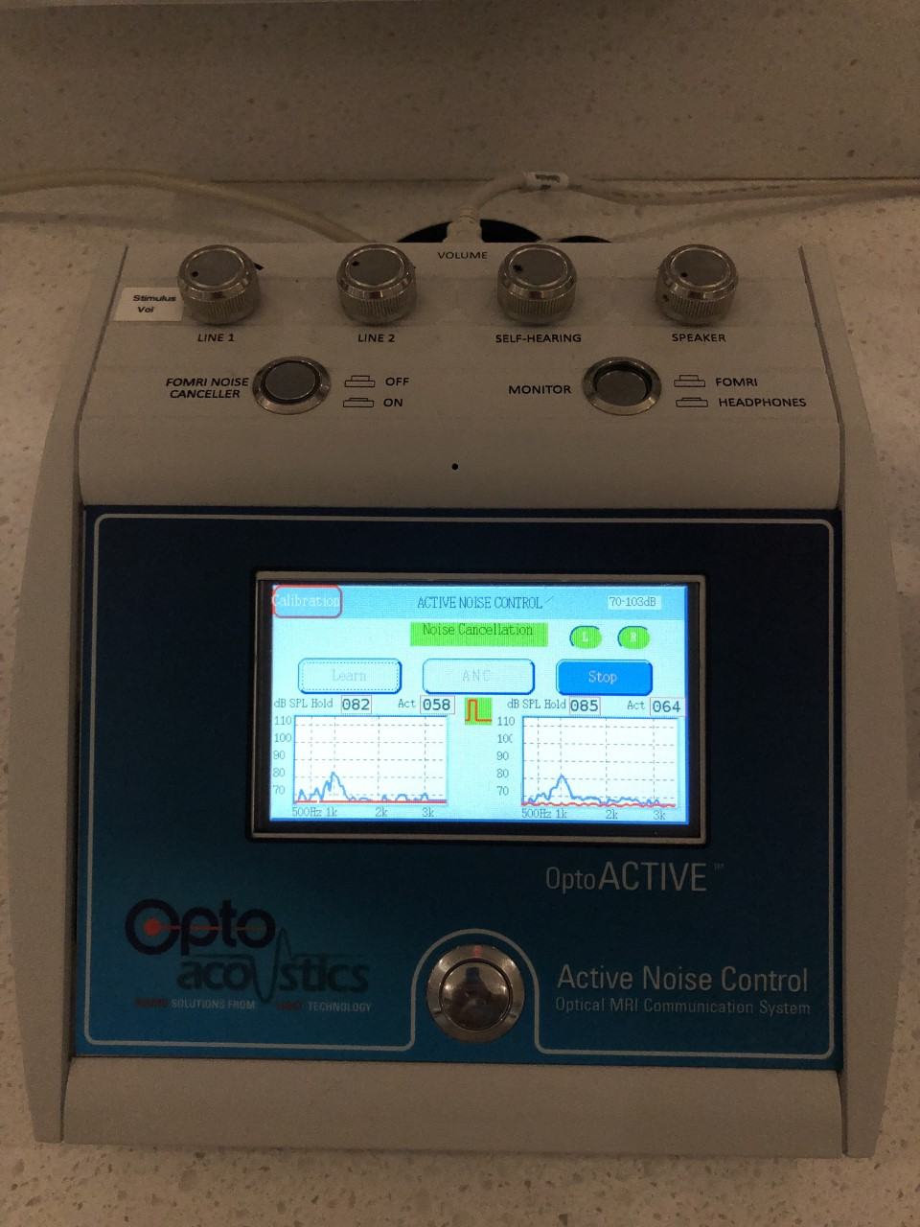

### Important General Notes!

1. Click on the stimulus screen to make sure that the button box input is being logged. Don’t touch anything on the behavioral computer while the participant is doing the task.
2. At the onset of a task, monitor the behavioral computer stimulus screen and the button box to ensure that participant responses are being recorded/that all is functional.
3. Please remind participants to keep their legs uncrossed, they usually will uncross their legs during a scan/crossed legs introduce increased potential for head movement.

If the participant seems to be moving a lot during the scan, check in during the pause and tell them they can move their arms and legs a bit and stretch, but to please keep their head as still as possible.

1. Make sure a live view is open on the console that shows that locations of interest are being captured and motion is minimal.
2. On the scanner computer, make sure that all head coils are turned ON (AKA they are grayed out/not empty); can also right-click on the scan task, select “Edit Properties” and then see that all head coils are green and turned on.

**IF THE PARTICIPANT EXITS THE SCANNER**: make sure to collect *localizer* -AND- *field map* upon re-entry, before proceeding with the next scan in the protocol

**TO REDO LOCALIZER:**

On scanner computer, at the very bottom of the protocol list of scans, there is an extra “localizer” loaded.

1. Shift + Click on “localizer” and then drag it up to where it needs to be inserted into the protocol list.

## Post Scan

Take the participant out of the scanner, and have one operator take the participant back into the testing room for additional tasks ([procedure outlined in Post Scan Tasks](https://smithlab.slab.com/posts/rf-1-sra-scan-manual-detailed-nx9qm8ha#h5401-post-scan-tasks))

### Push Neural and Behavioral Data

1. Close Patient on scanner computer
2. Select Participant→Browse Participants, and ensure that the parent folder with the subject ID is selected (e.g. Smith-SRA-#####). Then select Transfer→Send to XNAT and wait until a message at the bottom of the page changes from Sending to XNAT to Transfer received successfully
   * You can watch “s” turn into “S” to confirm transfer occurred
     + If you get an error message saying that there isn’t enough room to push to XNAT, open Transfer>Network job status and delete all of the completed jobs (***ONLY DELETE COMPLETED JOBS***)
3. Send over response data via GitHub on behavioral computer
   1. If you do this while participant is still in the scanner/during T1, press “Mask” on the white Psychology Software button box to ensure that no keyboard inputs from the behavioral computer are being registered as triggers by the scanner (and thus potentially disrupt the T1/FLAIR scan).
   2. Check that data is populated in left pane on GitHub under the “Changes” tab
      1. there should be 10 changed files (if no scans we re-run/data collection was normal)
   3. Click “Pull Origin” in top right-ish on GitHub
   4. In “Summary (required)” in left pane, input “##### Scan” where ###### is the subject ID number
   5. Click “Commit to main”
   6. Click “Push Origin” in the top right-ish again.

### Clean Up

* Discard disposable items
  + Pop filter (microphone)
  + Headphone covers
  + Paper sheet covering bed
* Put cloth away in hamper
  + Pillow case
  + Any sheets used for warmth
  + Any TUBRIC clothing that participant may have needed
    - Sweatshirt
    - Sweatpants
    - Socks
* Put pillow cushion and head pads in bin for cleaning
* Wipe down all items with a rag and disinfectant, including the bed and cushions
* Replace items to where they were found
  + On wall: Microphone, earphones, inflatable ear cushions
  + On cart: 4-channel button box, top of 20-channel headcoil

If TUBRIC staff has left and you are the last scan of the day:

In the scanner control room, turn off the 1) button boxes and 2) the project box off first. Press and hold the on-off switch to turn off the projector. Wait at least 3 minutes to power off the actual projector in the scanner room by flipping the black switch in the top right corner of the box.

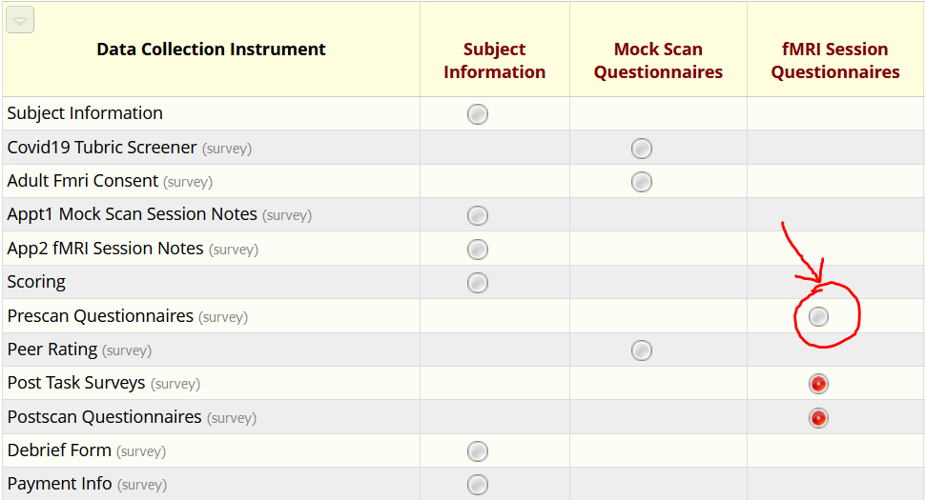

## Scan - See “Task Data Acquistion” for more

Link: [RF1-SRA: Scan Manual (DETAILED)](https://smithlab.slab.com/posts/nx9qm8ha#hiw2v-task-data-acquisition)

1. Open **REDCap, RF1…, App2 fMRI Session Notes** on a separate laptop or the iPad to input information about the session (i.e., participant comfort level, any issues with data collection)
2. Conduct button box test (place it on the projected monitor)
3. In accordance with counterbalance order, hit the green play button on whichever task is indicates to be next
   1. Read the instructions on the screen to the participant through the Optoacoustics monitor
   2. Ensure the subject information is correct and that the task is displaying on the right monitor and on the projector (some subjects will neglect to say if they’re not seeing anything)
   3. Let participants know they can move to the next screen by clicking their index finger
   4. Once each task gets to a screen indicating that the participant must “keep [their] head still,” let the L3 know that they may begin the next task, and **DO NOT TOUCH THE COMPUTER UNTIL THE TASK ENDS**
   5. If you do have to stop a task at any point, click the red ‘x’ button
4. Make sure the participant is comfortable after every other task, and keep track of notes or protocol divergence in REDCap, especially if they result in action items for Asana.

**PAYMENT - $40 PER SESSION. BONUS AWARDED AT BEGINNING OF SESSION 5 (CHECK WITH MATT BEFORE THIS)**