Scanning Procedures

This is our cheat sheet to make sure we follow the same procedures for everyone. The social element is key and must be consistent.

# What happens before the scan?

1. **Instructions and practice.** Let’s walk them through the instructions, the slides, and then give them the quiz before they do the practice.
2. **Social manipulation.** We’ve arranged for one of our confederates to meet us at the scanner. We don’t want to take up more than 5 minutes of their time, so let’s try to save the meeting/greeting for right before the subject gets into the scanner. The subject mainly just meets the confederate and watches the confederate play a few trials of the card task.
3. **Enter control room.** Make sure the subject doesn’t need a bathroom break, and give Gregg screening form. On days were I’m the confederate, I’ll come help with the scan after the subject is inside the magnet.

# What happens during the scan?

1. During structural scan and field map, there will be a short practice consisting of 20 trials (7 minutes).
   1. This is important to get used to the scanning environment and the buttons in the scanner.
   2. Also important to allow the subject to start constructing a values for the star and pentagon.
2. The subject will do the main task for about 55 minutes (4 runs). We’ll use the same random walk of payouts for all subjects (pictured below; you can see there are two switches).
3. They will then do 50 trials of Shaoming’s task (about 10 minutes).

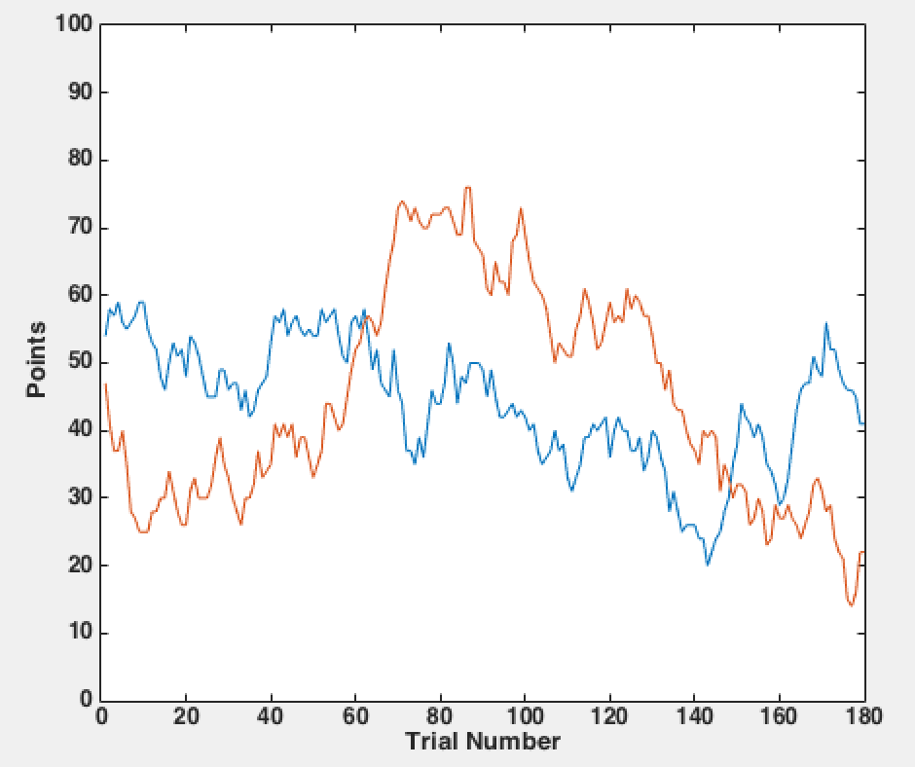

# What happens after the scan?

1. Pay the subject for performance only ($0-25). If they didn’t choose the better option at least 50% of the time, then they don’t get any money.
2. Sign debriefing form and payment receipt.
3. Set up a time in the following week for them to come back to receive the “show-up” money and fill out questionnaires.
   1. Altogether, it will be 1.5 hours of scanning (1.5 x $25) plus 1 hour of behavior (1 x $10).
   2. The behavioral portion will consist of 30 minutes before the scan (instructions, practice, social), and 30 minutes the day they come back for money and questionnaires.
   3. Still open to questionnaires/surveys. “Reading the mind in the eyes” is nice for social, but we could do whatever is approved on my IRB and is short.
4. Walk them out and keep them hidden from me if I’m the confederate (male subjects).