Title: Age-Related Differences in Neural Responses during the Ultimatum Game
Yi Yang*, Rita M. Ludwig*, James B. Wyngaarden, Derrick Dwamena, Jeffrey B. Dennison, Katherine Hackett, Tania Giovannetti, Dominic S. Fareri, David V. Smith

Abstract: (249)
Objectives: This study investigated how age and social context modulate the neural mechanisms of fairness-related economic decisions. We examined age, partner identity (similar age vs. dissimilar age), and fairness influences on participants’ choice, and further tested if individual differences in sensitivity to fairness norm violation correlates with neural activities. Methods: Younger (18–35 years) and older (65–80 years) adults underwent fMRI while playing a modified ultimatum game with ostensible partners of a similar or dissimilar age. Multilevel logistic regression modeled choice behavior and derived a participant-specific measure of sensitivity to fairness norm violation. Whole-brain analyses of activation and functional network connectivity of the Default Mode Network (DMN) and Executive Control Network (ECN) were tested for interactions between age and partner identity. Results: Behaviorally, no interactions or main effects involving age or partner identity were found on choice. In contrast, neuroimaging revealed interactions between age, partner identity, and individual sensitivity to norm violation. Younger adults exhibited enhanced DMN-anterior cingulate (ACC) connectivity when interacting with a similar partner, and older adults showed a reversed pattern. Furthermore, younger adults demonstrated a negative correlation between their sensitivity to norm violation and the partner-identity effect in ECN-mPFC connectivity, and such relationship was reversed in older adults, who exhibited a positive correlation. Discussion: Our findings demonstrate a brain-behavior dissociation, where similar behavioral outcomes are supported by different neural mechanisms across age groups. The opposing patterns of neural responses suggest age-related functional reorganizations, which may represent compensatory strategies that enable older adults to preserve normative social behaviors.

Keywords (five keywords that are NOT in the title of the manuscript)
1. Decision-making
2. Economic game
3. Social context
4. Fairness
5. Functional network connectivity

Introduction (word count: 730-740)
Recent reports show that rates of financial insecurity and fraud are increasing among older Americans (America’s Aging Workforce: Opportunities and Challenges, 2017; Elder Fraud Report, 2021). Empirically-based policy solutions to address these worrying trends are necessary especially as the proportion of Americans entering advanced age continues to grow. Insights from neuroscientific research of aging-related brain changes during information processing, learning, and decision-making may help develop better protections for older people against scams and fraud. The present research adds to a growing body of literature specifically focused on financial decision-making in older adults by using a multi-trial ultimatum game with varying context conditions related to age-group similarity between participants and their game partners. The goal of this work is to illuminate associated neural structures and networks as well as any distinctions across adult age groups.
Among the most common types of scams targeted at seniors are those that attempt to exploit social identity and relationships – a scammer may pretend to be a romantic interest, or to be calling on behalf of a relative in distress (Federal Trade Commission, 2023). Given the apparent real-world influence of social context on financial decisions in older adults, we chose an ultimatum game with multiple social conditions (e.g., game partner identity) to study such decision-making in the lab. Ultimatum games are a take-it-or-leave-it class of economic games wherein a proposer divides an endowment with a responder, who then either chooses to accept or reject the offered split; if the responder rejects the offer, both parties walk away with nothing (Güth, Schmittberger, & Schwarze, 1982). These games are thought to elicit processes of social cognition, reward valuation, and learning by provoking a motivational conflict between economic self-interest and higher-order social goals of maintaining norms of fairness and reciprocity (Anderoni & Blanchard, 2006; Rabin, 1993). Indeed, despite the economically rational choice being to always accept non-zero offers to increase personal net gain, responders frequently make the pyrrhic choice to reject unfair offers (Güth & Kocher, 2014).
An ultimatum game allows us to study if manipulating the social context of game partner similarity produces a difference in decision-making processes as indexed by the chocie pattern of accepting unfair outcomes, and if this difference is also related to age. To-date, behavioral research on age differences in ultimatum games has provided conflicting results; players aged 60 years and older have been reported both to choose to accept (Fernandes et al. 2019; Girardi, Sala, & MacPherson, 2018) and reject (Harlé & Sanfey, 2012) more unfair offers than younger adults. At the brain level, neuroscientific research using the ultimatum games also focused primarily on distinctive regional brain activations (e.g., Harlé & Sanfey, 2012) or connectivity between regions (e.g., Gao et al., 2018). Aging neural circuitry has been shown to be associated with variability in both task-based (Schlesinger et al., 2017) and resting state (Nomi et al., 2017) BOLD signal. Results from studies utilizing other economic games also illuminate differences in the affective and motivation systems underlying decision-making in younger versus older adults (Fareri et al., 2022; Samanez-Larkin & Knutson, 2015). However, little is known about how social context may moderate age-related differences in brain network connectivity, and how age and social context-related activities may be associated with overt behavior above and beyond offer fairness in the ultimatum games.
In the present research, we attempt to clarify and extend previous mixed behavioral results and contribute to the literature of age and social context-related differences in brain activation and network connectivity during ultimatum games. First, our social context conditions go beyond a human versus computer partner paradigm (Harle & Sanfey, 2012; Batten et al., 2023) by including two human partner conditions to manipulate partner identity, which has been shown to relate to judgments of interpersonal trust and to offer rejection rates (Alarcon, Lyons, & Christensen, 2016; Bailey, Ruffman, & Rendell, 2013). Second, the present research also contributes to the literature of age and social context-related differences in brain activation and connectivity during ultimatum games. Besides examining the role of the anterior cingulate cortex (ACC), ventromedial prefrontal cortex (VMPFC), ventral striatum (VS), and anterior insula (AI) following previous results from empirical studies and those from coordinate-based meta-analyses of the ultimatum game (Fehr & Camerer, 2007; Gabay et al., 2014), we also extend our investigation to the default-mode network (DMN) and executive control network (ECN) that have demonstrated partner identity-related differences in connectivity (Fareri, Smith, & Delgado, 2020).

Methods (to update, a lot of trimming is needed)

Participants and Procedure
Participants were recruited according to their age to represent our two groups of interest, younger adults aged 18-35 and older adults aged 65-80. Our sample size was planned a priori to collect at least 20 usable participants in each group for a total of at least 40 participants; this planned sample size was limited by available funding for data collection. Young adult participants were recruited primarily through the Temple University Psychology Department participant pool, while older adult participants were recruited locally in Philadelphia, PA via flyering and newspaper advertisements, and reaching out to community and senior centers. All participants were screened before data collection to rule out major psychiatric or neurologic illness as well as MRI contraindications. Older adults were screened to rule out dementia using the Telephone Interview for Cognitive Status, with a score under 30 meeting exclusion criteria (Brandt et al., 1988). This sampling procedure resulted in a final N of 50; 26 young adults (16 female, 10 male) and 24 older adults (11 female, 13 male). Participants recruited through the participant pool were compensated with course credit, while those from the community were were compensated $25 per hour of participation with Amazon and/or Visa gift cards; to increase the ecological validity of the task, we additionally provided bonus payments based on one randomly chosen trial from the experimental session. This study was approved by the Temple University Institutional Review Board and all participants gave informed consent.
After assessing eligibility based on initial screening procedures, participants were invited to participate in our study. We collected various measures as part of a larger neuroimaging experiment (see Smith et al. 2023 for more details), but here we will report only the pertinent details for the ultimatum game. Participants completed two appointments. During the first appointment, which lasted approximately 90 minutes, they underwent a mock MRI scan to acclimate them to the scanner and help control for motion. They then completed a brief neuropsychological test battery, with older adults additionally completing a self-report measure of everyday functioning. At the beginning of the second appointment, participants played a practice version of the ultimatum game to reduce the number of trials missed during the scan. The remaining duration of this appointment was spent playing economic games in the scanner and completing post-scan tasks, after which participants were thanked, compensated, and dismissed.

Experimental Design
Participants played as responders in a multi-trial version of an ultimatum game wherein we manipulated both the fairness of proposed offers and the social context in which they were presented. Participants received 144 total offers (18 blocks with 8 trials each) from three partners whom they were told they would be splitting a $20 endowment with: a computer (which served as our non-social control), a gender- and race-matched younger adult, and a gender- and race-matched older adult. Whether the human partner was considered a ‘similar’ or ‘dissimilar’ condition was therefore dependent upon the age of the participant. Trials were presented in blocks where 6 out of 8 offers were either mostly fair (i.e., between 35% – 50% of the endowment value) or unfair (between 5% – 20%), with the remaining two trials consisting of one neutral offer (25% or 30%) and one offer from the other condition; the specific value of all offers was randomly generated from within those parameters. Our within-subjects design therefore yielded responses to three mostly unfair blocks and three mostly fair blocks of trials per partner type.
On each trial, participants saw a screen with the offer value and the partner proposing that split as cued by a cartoon image of a younger adult, older adult, or computer. Following an interval one second, participants had two seconds to either reject or accept the offer. See Figure 1 for a depiction of the task.
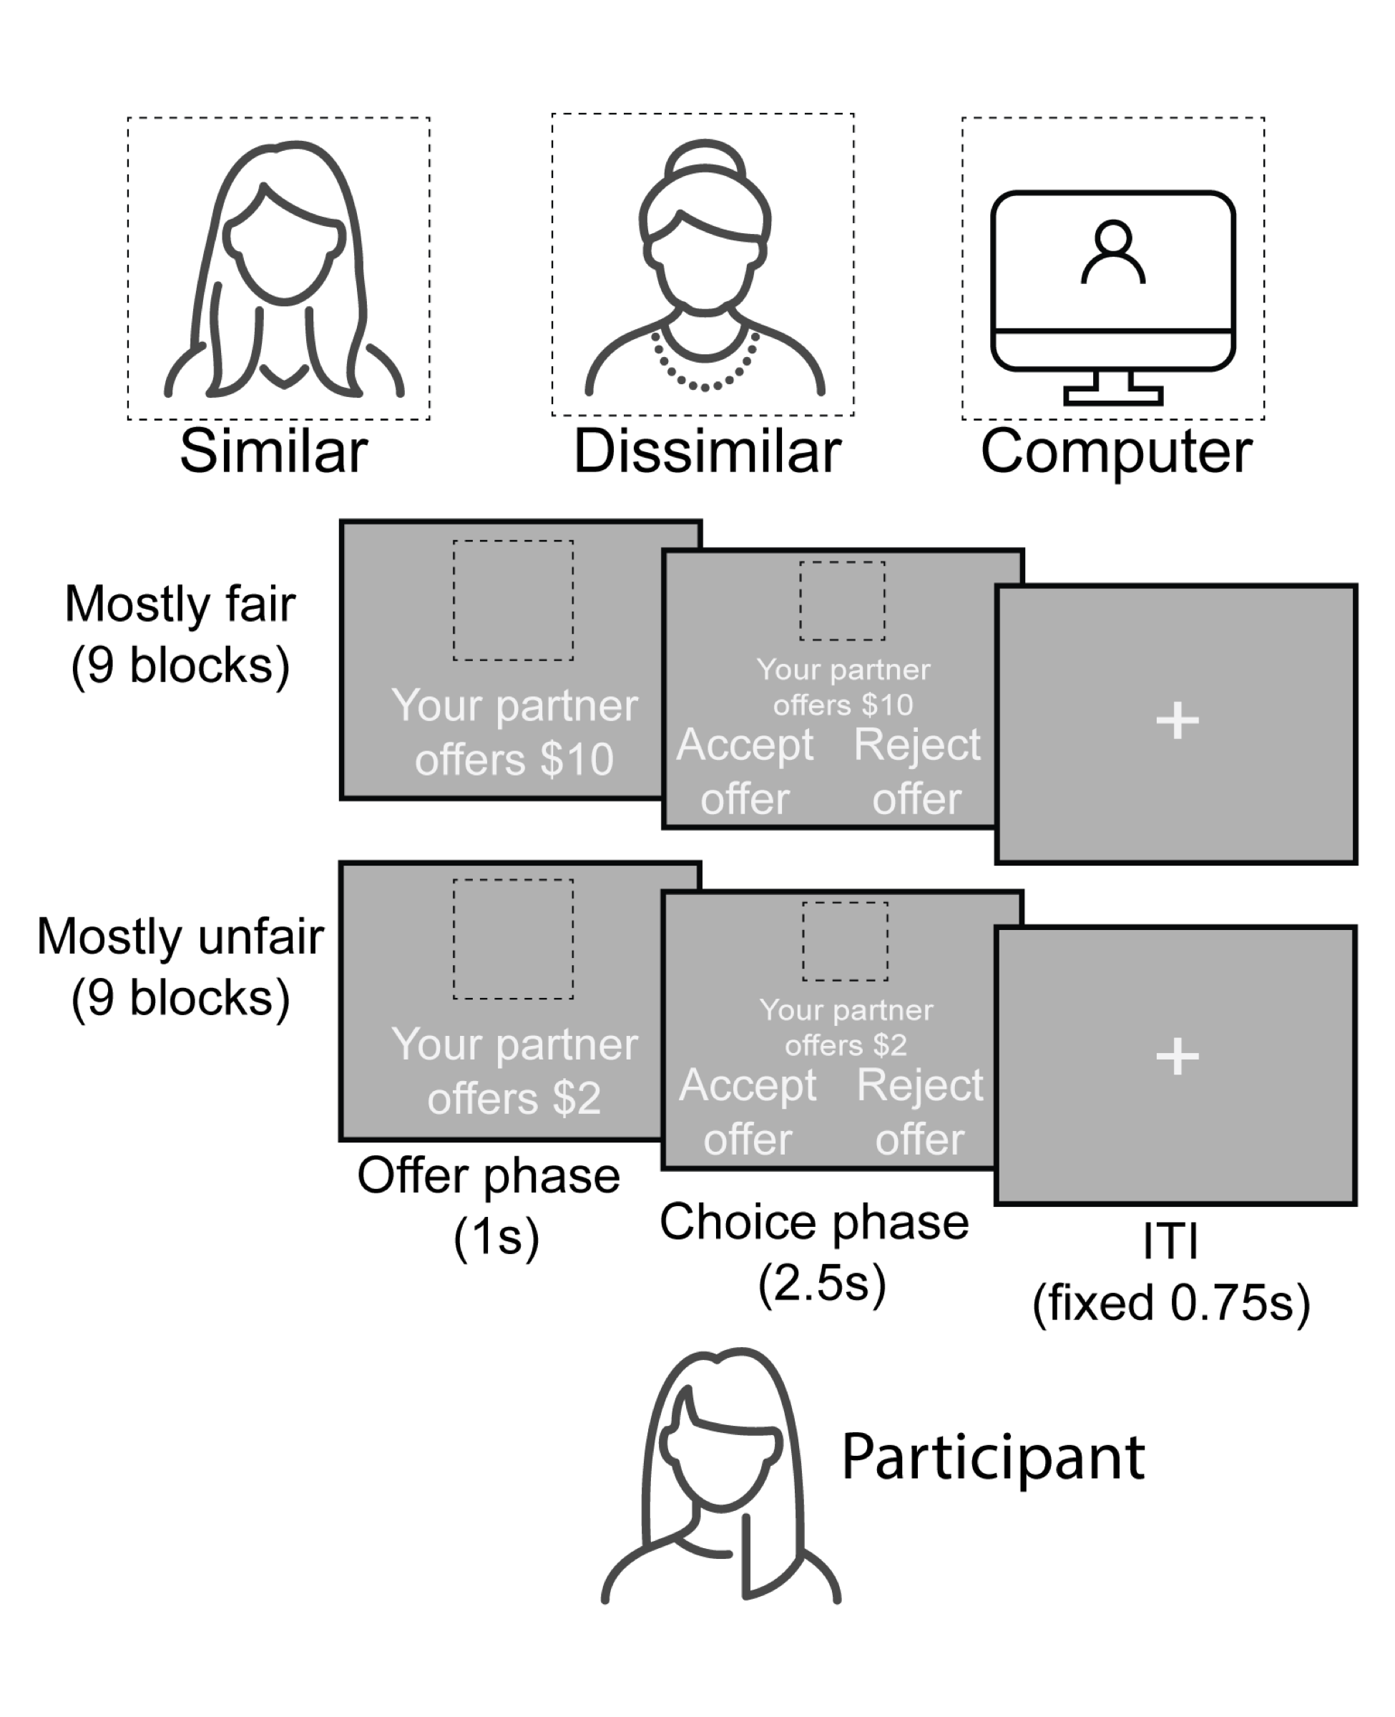
Figure 1. Depiction of ultimatum game task that participants completed while undergoing neuroimaging. Participants received 144 total offers (18 blocks with 8 trials each) from three partners whom they were told they would be splitting a $20 endowment with: a computer (which served as our non-social control), a gender- and race-matched younger adult, and a gender- and race-matched older adult. Whether the human partner was considered a ‘similar’ or ‘dissimilar’ condition was therefore dependent upon the age of the participant. Condition types of offer amount and partner identity were fully crossed, such that participants saw all offer sizes from all three partner types, though the order of the pairing of these conditions was randomized.

Neuroimaging Data Collection and Preprocessing
These data were collected as a part of a larger pilot study involving age-related differences in social and economic decision-making. The full dataset is openly available on OpenNeuro and described in our data paper (Smith et al., 2023). Preprocessing of neuroimaging data was performed using fMRIPrep 20.2.3 (RRID:SCR_016216; Esteban, Markiewicz, et al., 2018; Esteban, Blair, et al., 2018), which is based on Nipype 1.6.1 (RRID:SCR_002502, Gorgolewski et al, 2011; Gorgolewski et al., 2018). For clarity, we have removed extraneous details of the fMRIprep descriptions that were not used in this study.

Data Acquisition
Neuroimaging data were collected at the Temple University Brain Research and Imaging Center (TUBRIC) using a 3.0 Tesla Siemens Prisma scanner and a 20-channel phased-array head coil. Functional images sensitive to blood-oxygenation-level-dependent (BOLD) contrast were collected using a single-shot T2*-weighted echo-planar imaging sequence with slices roughly parallel to the axial plane collected in descending order [repetition time (TR): 2.02 s; echo time (TE): 23 ms; matrix 74×74; voxel size: 2.97×2.97×2.80 mm; 36 slices (15% gap); flip angle: 76°]. We also collected other images to facilitate co-registration and normalization of functional data and allow for other analyses focused on age-related structural differences. These additional images included the following types of scans: a high-resolution T1-weighted structural scan (TR: 2.4 s; TE: 2.2 ms; matrix 192×192; voxel size: 1.0 mm³; 192 slices; flip angle: 8°); a B0 field map (TR: 645 ms; TE1: 4.92 ms; TE2: 7.38 ms; matrix 74×74; voxel size: 2.97×2.97×2.80 mm; 36 slices, with 15% gap; flip angle: 60°).

Anatomical Preprocessing
A total of 1 T1-weighted (T1w) images were found within the input BIDS dataset.The T1-weighted (T1w) image was corrected for intensity non-uniformity (INU) with N4BiasFieldCorrection (Tustison et al. 2010), distributed with ANTs 2.3.3 (Avants et al. 2008, RRID:SCR_004757), and used as T1w-reference throughout the workflow. The T1w-reference was then skull-stripped with a Nipype implementation of the antsBrainExtraction.sh workflow (from ANTs), using OASIS30ANTs as target template. Brain tissue segmentation of cerebrospinal fluid (CSF), white-matter (WM) and gray-matter (GM) was performed on the brain-extracted T1w using fast (FSL 5.0.9, RRID:SCR_002823, Zhang, Brady, and Smith 2001). Volume-based spatial normalization to one standard space (MNI152NLin2009cAsym) was performed through nonlinear registration with antsRegistration (ANTs 2.3.3), using brain-extracted versions of both T1w reference and the T1w template. The following template was selected for spatial normalization: ICBM 152 Nonlinear Asymmetrical template version 2009c (Fonov et al., 2009, RRID:SCR_008796; TemplateFlow ID: MNI152NLin2009cAsym).

Functional Preprocessing
For each of the 2 BOLD runs per subject, the following preprocessing steps were performed. First, a reference volume and its skull-stripped version were generated using a custom methodology of fMRIPrep. A B0-nonuniformity map (or fieldmap) was estimated based on a phase-difference map calculated with a dual-echo GRE (gradient-recall echo) sequence, processed with a custom workflow of SDCFlows inspired by the epidewarp.fsl script and further improvements in HCP Pipelines (Glasser et al. 2013). The fieldmap was then co-registered to the target EPI (echo-planar imaging) reference run and converted to a displacements field map (amenable to registration tools such as ANTs) with FSL’s fugue and other SDCflows tools. Based on the estimated susceptibility distortion, a corrected EPI (echo-planar imaging) reference was calculated for a more accurate co-registration with the anatomical reference. The BOLD reference was then co-registered to the T1w reference using flirt (FSL 5.0.9, Jenkinson and Smith 2001) with the boundary-based registration (Greve and Fischl 2009) cost-function. Co-registration was configured with nine degrees of freedom to account for distortions remaining in the BOLD reference. Head-motion parameters with respect to the BOLD reference (transformation matrices, and six corresponding rotation and translation parameters) are estimated before any spatiotemporal filtering using mcflirt (FSL 5.0.9, Jenkinson et al. 2002). BOLD runs were slice-time corrected using 3dTshift from AFNI 20160207 (Cox and Hyde 1997, RRID:SCR_005927). The BOLD time-series (including slice-timing correction when applied) were resampled onto their original, native space by applying a single, composite transform to correct for head-motion and susceptibility distortions. These resampled BOLD time-series will be referred to as preprocessed BOLD in original space, or just preprocessed BOLD. The BOLD time-series were resampled into standard space, generating a preprocessed BOLD run in MNI152NLin2009cAsym space. First, a reference volume and its skull-stripped version were generated using a custom methodology of fMRIPrep.
Several confounding time-series were calculated based on the preprocessed BOLD: framewise displacement (FD), DVARS and three region-wise global signals. FD was computed using two formulations following Power (absolute sum of relative motions, Power et al. (2014)) and Jenkinson (relative root mean square displacement between affines, Jenkinson et al. (2002)). FD and DVARS are calculated for each functional run, both using their implementations in Nipype (following the definitions by Power et al. 2014). The three global signals are extracted within the CSF, the WM, and the whole-brain masks. Additionally, a set of physiological regressors were extracted to allow for component-based noise correction (CompCor, Behzadi et al. 2007). Principal components are estimated after high-pass filtering the preprocessed BOLD time-series (using a discrete cosine filter with 128s cut-off) for the two CompCor variants: temporal (tCompCor) and anatomical (aCompCor). tCompCor components are then calculated from the top 2% variable voxels within the brain mask. For aCompCor, three probabilistic masks (CSF, WM and combined CSF+WM) are generated in anatomical space. The implementation differs from that of Behzadi et al. in that instead of eroding the masks by 2 pixels on BOLD space, the aCompCor masks are subtracted a mask of pixels that likely contain a volume fraction of GM. This mask is obtained by thresholding the corresponding partial volume map at 0.05, and it ensures components are not extracted from voxels containing a minimal fraction of GM. Finally, these masks are resampled into BOLD space and binarized by thresholding at 0.99 (as in the original implementation). Components are also calculated separately within the WM and CSF masks. For each CompCor decomposition, the k components with the largest singular values are retained, such that the retained components’ time series are sufficient to explain 50 percent of variance across the nuisance mask (CSF, WM, combined, or temporal). The remaining components are dropped from consideration. The head-motion estimates calculated in the correction step were also placed within the corresponding confounds file. All resamplings can be performed with a single interpolation step by composing all the pertinent transformations (i.e. head-motion transform matrices, susceptibility distortion correction when available, and co-registrations to anatomical and output spaces). Gridded (volumetric) resamplings were performed using antsApplyTransforms (ANTs), configured with Lanczos interpolation to minimize the smoothing effects of other kernels (Lanczos 1964). Non-gridded (surface) resamplings were performed using mri_vol2surf (FreeSurfer).
Many internal operations of fMRIPrep use Nilearn 0.6.2 (Abraham et al. 2014, RRID:SCR_001362), mostly within the functional processing workflow. For more details of the pipeline, see the section corresponding to workflows in fMRIPrep’s documentation.

Whole-brain Neuroimaging Analyses
We used FSL (version 6.00) to conduct our neuroimaging analyses. These analyses utilized a general linear model (GLM) with local autocorrelation correction (Woolrich, Ripley, Brady, & Smith, 2001). We first focused on task-related activation using a GLM consisting of nine regressors. We used three regressors to model trials (duration = 3.5 s) within each of the partner blocks. We also included parametric modulators for each of these three regressors, where each trial within a block was weighted by the amount of the offer (i.e., the fairness) on that trial. Given that response time may vary across conditions and participants, we included additional regressors modeling the response as a constant term and with a parametric modulator for the response time on each trial. Finally, we included a regressor to account for missed trials. Each of these regressors were convolved with the canonical hemodynamic response function.
We additionally generated trial-by-trial estimates of BOLD activity in our ROIs using the Least Squares – Separate model (LSS; Mumford et al., 2012). Under this approach, separate design matrices of GLMs with two regressors are run for each of the t trials, with t_{i} modeled as the regressor of interest and all other trials combined into a single nuisance regressor. For participants with complete data, we would therefore run a total of 144 GLMs to estimate trial activation in each ROI.
Task-dependent changes in connectivity were examined using psychophysiological interaction (PPI) analysis (Friston, et al., 1997; Smith, Gseir, Speer, & Delgado, 2016). Regions exhibiting significant PPI effect can be interpreted as showing a context-specific modulation of effective connectivity, though we note that the directionality of such an effect is ambiguous without additional analyses (Friston, 2011). Given that our primary hypotheses focus on the executive control network (ECN) and default mode network (DMN), we elected to use a network PPI approach that is not limited to single seed regions (Dobryakova & Smith, 2022; Utevsky, Smith, Young, & Huettel, 2017). We conducted two separate models using the 10 networks characterized in prior work (Smith et al., 2009): one with the ECN as the primary network of interest (with the remaining 9 networks, including DMN, as covariates) and one with DMN as the primary network of interest (with the remaining 9 networks, including ECN, as covariates). Each network time course was extracted using the spatial regression component of the dual regression approach (Nickerson, Smith, Ongur, & Beckmann, 2017; Smith, et al., 2014) and then added to the task-related activation model described above. We formed the PPI regressors by multiplying each of the 9 task regressors by the primary network regressor, which produced a total of 28 regressors for each model.
In both activation and connectivity models, we included a common set of confound regressors derived from the output of fMRIprep. Specifically, we included six regressors for head motion parameters (rotations and translations), the first six aCompCor components explaining the most variance, non-steady state volumes, and the framewise displacement across time. We also included a set of discrete cosine basis functions to apply a high-pass filter (128 s cut-off).
Group-level analyses were carried out using FLAME (FMRIB's Local Analysis of Mixed Effects) Stage 1 and Stage 2 (Beckmann, Jenkinson, & Smith, 2003; Woolrich, Behrens, Beckmann, Jenkinson, & Smith, 2004). We implemented two types of group-level models focused on comparisons older and younger adults. The first model examined main effects of and included regressors for age group (younger and older adults), and similar to our prior work (Fareri et al., 2022), we also included covariates to account for gender, temporal signal to noise ratio (tSNR), mean framewise displacement, and mean response time to control for potential confounding effects of participant demographics and data quality measures. The second model examined age group interactions and included the same covariates as the first model plus two additional interaction regressors: ingroup minus outgroup for younger adults and ingroup minus outgroup for older adults, where ingroup refers to trials with same-age partners and outgroup refers to trials with different-age partners. All z-statistic images were thresholded and corrected for multiple comparisons using an initial cluster-forming threshold of Z > 3.1 followed by a whole-brain corrected cluster-extent threshold of p < 0.05, as determined by Gaussian Random Field Theory (Flandin & Friston, 2019; Nichols & Hayasaka, 2003).

Statistical Analyses
Our statistical analysis plan was pre-registered on aspredicted (https://aspredicted.org/blind.php?x=43V_3R7) and the Open Science Framework (OSF, https://doi.org/10.17605/OSF.IO/NMP87) prior to any inspection or manipulation of the data. Analyses were performed in R version 4.3.2, Python 3.7, and FSL 6.0. De-identified data is available on OpenNeuro (https://doi.org/10.18112/openneuro.ds003745.v2.0.2) and described in a recent data paper (Smith et al., 2023).

Behavioral Data
We tested one group of behavioral hypotheses on offer acceptance rates, and another on the epsilon and alpha parameters generated by the Rescorla-Wagner reinforcement learning model (Rescorla & Wagner, 1972). The first group of hypotheses are as follows:
- All participants will reject more unfair offers from human partners as compared to computer partners; this effect will be stronger in younger adults.
- Within human partner conditions, younger adults will show increased rates of acceptance when interacting with similar vs. dissimilar partners; older adults’ rates of acceptance will not differ between partners.
- Acceptance rates for an individual offer will vary according to its consistency with other offers in a given block rather than the objective dollar amount of the offer. That is, as opposed to participants always rejecting unfair offers and always accepting fair offers, acceptance of higher, unfair offers will be greater in unfair blocks, and acceptance of lower, fair offers will be lower in fair blocks.
Hypotheses from this group were tested using mixed effects models wherein either the proportion of offers accepted overall (H1 and H2) or the trial-level decisions (H3) were set as outcome variables with factors such as age group, partner, and block fairness included as fixed effects (depending on the specific hypothesis being tested) and participants modeled as random effects; H1 and H2 were tested with linear models, H3 with logistic. We first determined that these models were appropriate to run with our data by running a null (i.e. random intercept only) model and inspecting the intraclass correlation coefficient to confirm evidence of clustering (Raudenbush & Bryk, 2002). All models were constructed and fit with the lme4 package in R (Bates, Mächler, Bolker, & Walker, 2015).
The second group of hypotheses, specific to the learning model outputs, are:
- There will be a main effect of age on sensitivity to violations of internal norms of fairness, such that older adults will be more willing to accept offers below internal norms.
- There will be a main effect of partner type on sensitivity to violations of internal norms of fairness (alpha), such that participants will be less willing to accept offers below internal norms when those offers are made by human (relative to computer) partners.
- There will additionally be an interaction between these variables, such that younger participants will be less willing to accept offers below internal norms from human partners than older participants.
- There will be no main effect of age on overall norm adaptation rate (epsilon).
- There will be a main effect of partner type on norm adaptation, such that adaptation rates will be higher for participants when receiving offers from human (relative to computer) partners.

Neuroimaging Data
We additionally sought to test hypotheses about neural activation, connectivity, and exploratory relationships with task design and choice outcome. Our activation hypotheses are:
- Recruitment of neural circuits associated with processing social norm violations (DLPFC, insula) will be diminished in older adults during receipt of unfair offers from human versus computer partners.
- The anterior insula, dorsal anterior cingulate cortex (dACC), ventromedial prefrontal cortex (vmPFC), and ventral striatum (VS) will be associated with choice. These associations will be blunted in older adults.
- The insula and dACC will be activated during the rejection of offers. This effect will be enhanced for offers from humans versus computer partners.
- The vmPFC and VS will be activated during the acceptance of offers.
Whole brain contrasts were used to examine BOLD response as a function of offer fairness and partner type, while double subtraction analyses provided tests of age-related and partner-related differences in resultant neural effects.
Our hypothesis regarding connectivity among our brain regions of interest is:
- Age-dependent changes in neural responses to unfair offers will be tied to differential changes in connectivity of both the executive control network and default mode network with the temporoparietal junction.
We tested this with task-based network analyses (nPPI) and seed-based analyses to examine connectivity of the ECN, DMN and insula/DLPFC during fair/unfair offers with older and younger partners. Both connectivity and activation hypotheses were tested using FSL as previously described.
Finally, we generated exploratory hypotheses about the relationship between brain and choice behaviors.
- Connectivity among our ROIs may be related to choice outcome.
- A behavioral model of choice may be improved with the addition of brain data.
These exploratory hypotheses were tested by building a series of nested mixed effects models predicting trial-by-trial choices from age, partner type, block type, offer value, and ROI BOLD signal, and then performing a chi square goodness-of-fit test on the nested models (Cosme, Ludwig, & Berkman, 2019). A specification curve analysis for all possible models provided further assessment of fit for models of interest and was conducted using XX package in R.

Results (current count: 400ish)

Offer Amount and Choice behavior
We first examined if choice decisions are correlated with fairness, participant age group, and game partner’s similarity to the participant. We found a significant main effect of fairness. Participants are more likely to accept an offer as the fairness increases (beta = 1.65, p < 0.001). We did not find any age group or partner similarity-related effects on participants’ choice.

Age and Partner-Related Neural Response to Fairness
The focus of our study is how fairness-related brain activities may change across age groups and game partner identity. To answer this question, we conducted whole-brain activation and DMN and ECN network connectivity analyses. For whole-brain activation, we did not find any interaction between age group and partner similarity. We also did not find any age group or partner similarity main effects. For brain network analyses, we found significant interaction between age group and partner similarity interaction (contrast: [young_similar-young_dissimilar] > [old_similar-old dissimilar]) in fairness-related DMN-anterior cingulate gyrus (ACC) connectivity (Figure XX). Specifically, younger adults exhibited a stronger fairness-modulated DMN-ACC connectivity when interacting with a similar partner, whereas older adults demonstrated the opposite pattern (contrast = [young_similar-young_dissimilar] > [old_similar-old dissimilar], MNIxyz = -13.3, 34, 27.8; cluster = 26 voxels, p = .023, correction XXX). We did not find any significant interaction or main effect of age or partner similarity in ECN network connectivity.
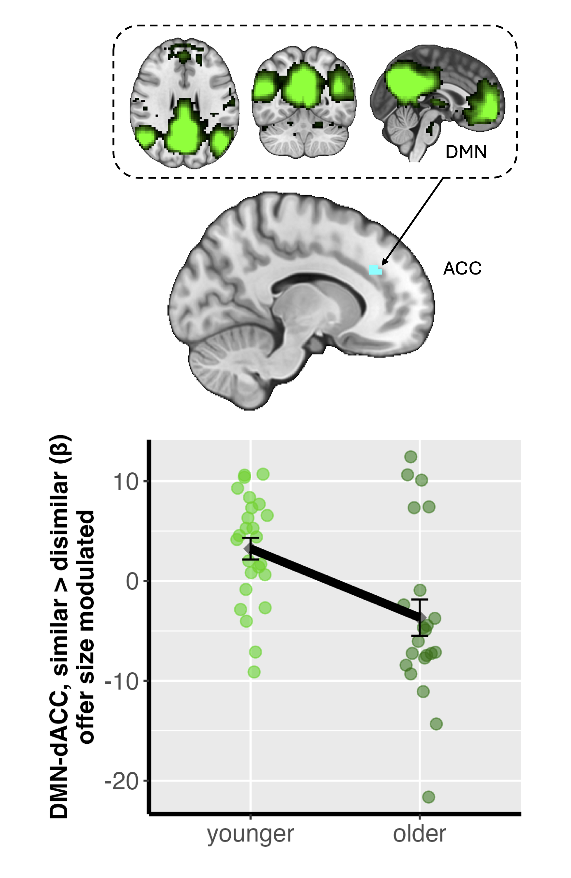
Figure 2. Age group and partner identity Effects on offer amount modulated Default Mode Network (DMN)-anterior cingulate cortex (ACC) connectivity. The x-axis represents the two Age Groups (Younger Adults: 18-35 years; Older Adults: 65-80 years). The y-axis displays the individual-level parameter estimates (beta) reflecting offer amount-modulated DMN-ACC connectivity difference between the 'similar partner' and 'dissimilar partner' conditions (similar > dissimilar, ACC MNIxyz = -13.3, 34, 27.8; cluster = 26 voxels, p = .023). Each dot represents a single participant's mean connectivity value for this contrast. Error bars indicate the standard error of the mean for each age group. A positive value on the y-axis signifies stronger offer amount-modulated DMN-ACC connectivity when interacting with a similar partner compared to a dissimilar partner. This figure visually demonstrates the reversed pattern of social context-dependent DMN-ACC connectivity between younger and older adults. Brain image is thresholded and corrected for multiple comparisons using an initial cluster-forming threshold of Z > 3.1 followed by a whole-brain corrected cluster-extent threshold of p < 0.05.

Neural Response and Sensitivity to Fairness Norm Violation
In addition to interaction between age group and partner identity, we are also interested in whether behavior-level individual differences in sensitivity to fairness norm violation is associated with brain activities beyond fairness, age group, and partner similarity. To test this, we first estimated each participant’s sensitivity to fairness norm violation using participant-specific slopes from a multilevel logistic regression model (i.e., the sum of group-level fixed offer amount effect and a participant’s unique corresponding random slope. See model XX.). A steeper positive slope indicates a greater sensitivity to the violation of a participant’s fairness norm. We then introduced these participant-specific fairness sensitivity slopes as a covariate into the L3 models for DMN and ECN connectivity analyses (model XX and XX). We find a significant violation sensitivity effect in offer amount-modulated ECN-mPFC connectivity related to age group and partner identity ([older_similar-older_dissimilar] > [young_similar-young_dissimilar]). Younger adults’ behavioral sensitivity to fairness was negatively associated with ECN-mPFC connectivity difference between similar and dissimilar partners, whereas older adults show a positive correlation (contrast = [young_similar-young_dissimilar] > [old_similar-old dissimilar], MNIxyz =4.58, 60.7, 11.7; cluster = 23 voxels, p = .029).
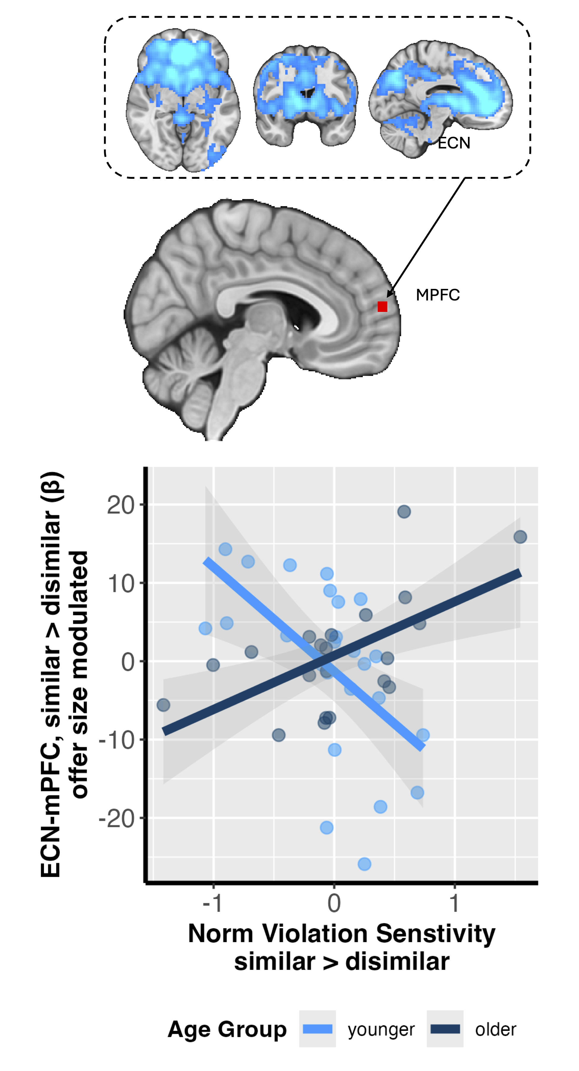
Figure 3. Brain-behavior relationship between ECN-mPFC connectivity and fairness norm violation sensitivity. The x-axis represents individual participant's norm violation sensitivity difference between similar and dissimilar partners. The y-axis displays the individual-level parameter estimates (beta) reflecting offer amount-modulated ECN-mPFC connectivity difference between the 'similar partner' and 'dissimilar partner' conditions (similar > dissimilar, mPFC MNIxyz =4.58, 60.7, 11.7; cluster = 23 voxels, p = .029). Light blue dots represent individual younger adult participants, while dark blue dots represent individual older adult participants. The solid lines indicate the linear fitted regression lines for each age group. The shaded regions around each fitted line denote the estimated standard error of the fitted line. This figure visualizes the opposing correlations between behavioral fairness sensitivity and neural differentiation in ECN-mPFC connectivity between similar and dissimilar partners across younger and older adults. MPFC image is thresholded and corrected for multiple comparisons using an initial cluster-forming threshold of Z > 3.1 followed by a whole-brain corrected cluster-extent threshold of p < 0.05.

Discussion (current count: 1000ish)
The present study investigated how age and social context of partner identity modulate the neurobehavioral correlates of fairness-related economic decision-making. Although younger and older adults did not differ in their overt choices by consistently preferring fairer offers regardless of partner identity, their underlying neural mechanisms diverged significantly. Specifically, younger adults showed enhanced DMN-anterior cingulate connectivity when considering offers from a similar partner, a pattern that was significantly reversed in older adults. We also found age-dependent modulation interacted with individual differences in sensitivity to fairness norm violation, where greater sensitivity was linked to opposing patterns of ECN-medial prefrontal cortex connectivity in younger versus older adults. Collectively, these dissociations between behavior and brain activities suggest that younger and older adults employ fundamentally different neurocognitive strategies to navigate economic decisions across social context; older adults may engage distinct compensatory or reprioritized neural systems to achieve outcomes equitable to those of younger adults.

Functional Reorganization of Networks in the Aging Brain
Our neuroimaging results provide insights into the functional reorganization of brain networks among older adults. A primary finding was the age-related reversal in DMN-ACC connectivity associated with partner identity, where younger adults exhibited heightened connectivity when considering offers from a similar partner, while older adults showed the inverse pattern. This result both aligns with and extends prior work. While intrinsic DMN connectivity has been indicated to often decline with age (e.g., Sambataro et al., 2010; Ng et al., 2016; Grady et al., 2010), our findings reveal a task-based functional reconfiguration that is critically sensitive to social context. This pattern is consistent with theories like the Default-Executive Coupling Hypothesis of Aging (DECHA), which posits that older adults may leverage reduced network segregation as an adaptive strategy to support goal-directed cognition (Turner & Spreng, 2015). This neural recalibration was further illuminated by our second key finding: an interaction involving ECN-mPFC connectivity, individual sensitivity to fairness norm violation, age, and social context. The mPFC is a critical hub for socio-affective processing (Tovar & Chavez, 2021; Lieberman et al., 2019), and its functional community structure is known to become less specialized and more interconnected with other networks during decision-making in older adults ((Moussa et al., 2014; Ranjbar-Slamloo et al., 2025). Our results provide evidence for functional consequences for this known age-related reorganization: altered ECN-mPFC connectivity among older adults is meaningfully tied to sensitivity of individual fairness norms, but in a direction opposite to that of younger adults. Taken together, these findings cohesively implicate age-related neural adaptation, suggesting that the mechanisms supporting fairness-related decision making are not merely degraded by age, but are fundamentally re-calibrated in relation to both external social context and stable internal dispositions.

Preserved Behavioral Outcomes Despite Altered Neural Dynamics
Notably, the complex, age and social context-dependent patterns of neural activity we found stood in stark contrast to our behavioral findings, which showed no significant differences in choice behavior between age groups or partner identities. This dissociation between behavioral outcomes and their underlying neural substrates is a well-documented characteristic of cognitive aging and is broadly consistent with theories of neural compensation and functional reorganization (Morcom & Johnson, 2015). Previous research has demonstrated that older adults can achieve task performance comparable to or even better than their younger counterparts by recruiting different or additional neural resources (e.g., Knights et al., 2024; Bagarinao et al., 2019). The age-dependent reversals in DMN-ACC and ECN-mPFC connectivity that we observed may represent such a compensatory shift. While younger adults appear to engage these networks in a manner sensitive to partner similarity, older adults may successfully regulate their behavior to align with social context and fairness norms by engaging these same networks in a different, and perhaps more deliberate, manner. This suggests that older adults can preserve normative social behavior by adapting their neurocognitive strategies to overcome age-related changes in the baseline function and connectivity of key brain networks like the DMN and ECN.

Reconciling Behavioral Discrepancies through Methodological Refinement
The absence of a main effect of age on choice behavior, while interpretable in light of our neural findings, also requires reconciliation with a body of literature characterized by conflicting results. Previous results in age-related differences in choice behaviors during the ultimatum games are inconsistent. Older adults have been found to accept unfair offers either more frequently (e.g., Fernandes et al., 2019) or less frequently (e.g., Harle & Sanfey, 2012) than younger adults in different studies. In the present study, we did not find any age difference in accepting unfair offers between younger and older adults. This discrepancy between studies may be partially attributable to critical differences in analytical methodology. Whereas prior studies dichotomize offers into "fair" and "unfair" categories using a fixed and relatively arbitrary cutoff, our approach employed a multilevel logistic regression that treated offer fairness as a continuous variable. This method avoids the potential biases inherent in categorization and imposing an arbitrary fairness threshold, instead modeling the full fairness-response relationship between offer value and acceptance probability. It is plausible that the age effects reported previously are introduced by imposing certain subjective (un)fairness categorization. Future studies could address these discrepancies by adopting standardized analytical approaches that model offer fairness as a continuous variable across a broad range of offer values, thereby avoiding arbitrary cutoffs and enabling more precise characterization of age-related differences in choice changes across fairness levels.

Conclusion
In summary, the present study advances our understanding of how aging shapes the neural mechanisms underlying fairness-related social decision-making. While behavioral choices remained stable across age groups, our findings reveal a profound reorganization of functional brain networks, particularly involving the DMN, ACC, ECN, and mPFC, which adaptively support fairness processing in distinct social contexts. This neural flexibility may reflect compensatory or strategic shifts that enable older adults to maintain normative social behavior despite age-related changes in brain function. Future research should further elucidate the causal dynamics of these network adaptations and explore their generalizability across diverse social and cultural settings. By integrating behavioral, neural, and individual difference measures, this work lays important groundwork for a more nuanced model of socio-cognitive aging that bridges brain function with real-world social behavior.

Acknowledgements (to add, require data and code availability info and preregistration info)
(- in a paragraph in the acknowledgments, indicate if they will or will not make their data, analytic methods, and study materials available to other researchers. If an author agrees to make materials available, the author must specify where that material will be available.
- in a paragraph in the acknowledgments, indicate if the conducted research was preregistered with an analysis plan in an independent, institutional registry)

Reference (to add when text is finalized, max = 30)

Aggregated Figure Captions (to add after caption finalized)

