Vyacheslav Kashis / Donat Vucetaj

At this point in our project, we have set up the groundwork for the initial level. This is the level where the character will meet the alien who acts as a NPC for 'information on-demand'. He will be there in every level if the player needs a hint or instructions for the level. The boundaries have been set up for this level where the player cannot walk through the cars and the player cannot walk through the houses, which will all be portals to different levels.
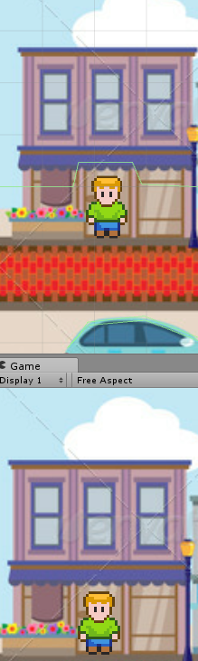
As seen here, the green borders indicate the collision points where the players character cannot pass. They are designed so that the player does not see any border, but because they can see the background it gives the illusion of interaction with the background because of the door. These areas with raised borders will act as contact zones for switching levels/scenes. Each house will contain information about a different drug, essentially making that drug the theme of that level. The Alien will be available for interaction if the player is confused with what to do in the level and for information about drugs. This is the strategy because the player will need to talk to the Alien to understand the level and what to do, so putting information about drugs in there will force the player to learn about drugs while learning to play the level. This will work almost as a subliminal message in that regard.
We are not sure if we are going to allow the player to enter any level at will, or if they will need to complete them in chronological order. The story is still being worked on and the method of action the player will take (most likely a quiz game or puzzle game).

