Practical 3

Objective : Establish Network Connection and add/configure IP
Theory : IP stands for Internet Protocol is a rule that governs the way the data is broken down into packets, addressed and routed from source to destination.
Solution : Following are steps to est. a connection b/w two end devices :
    - Open Packet Tracer from Application Launcher. Select the End Devices in the bottom left then select PC icon.
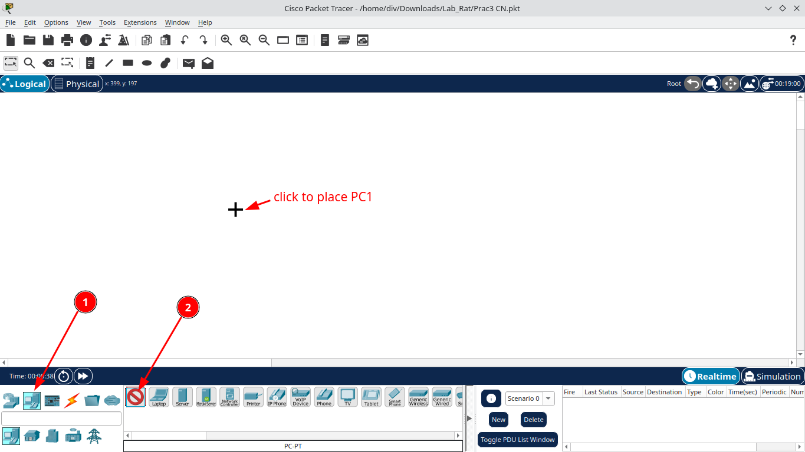
    - The cursor will change to ‘+’ sign. Click on empty white screen to place a PC. Redo the process again to place another PC.
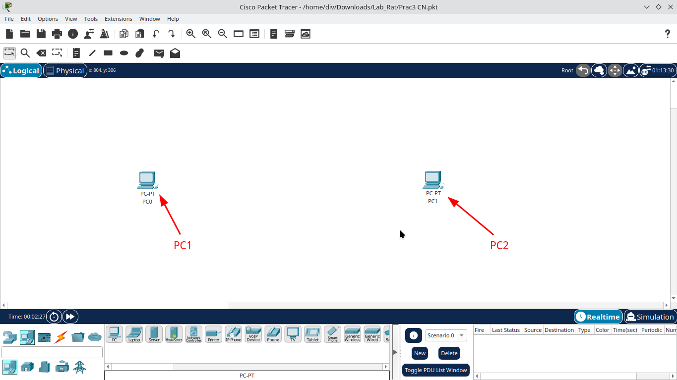
    - Now under Connections, select croosover wire. Then two PCs with cable through their fast-ethernet ports
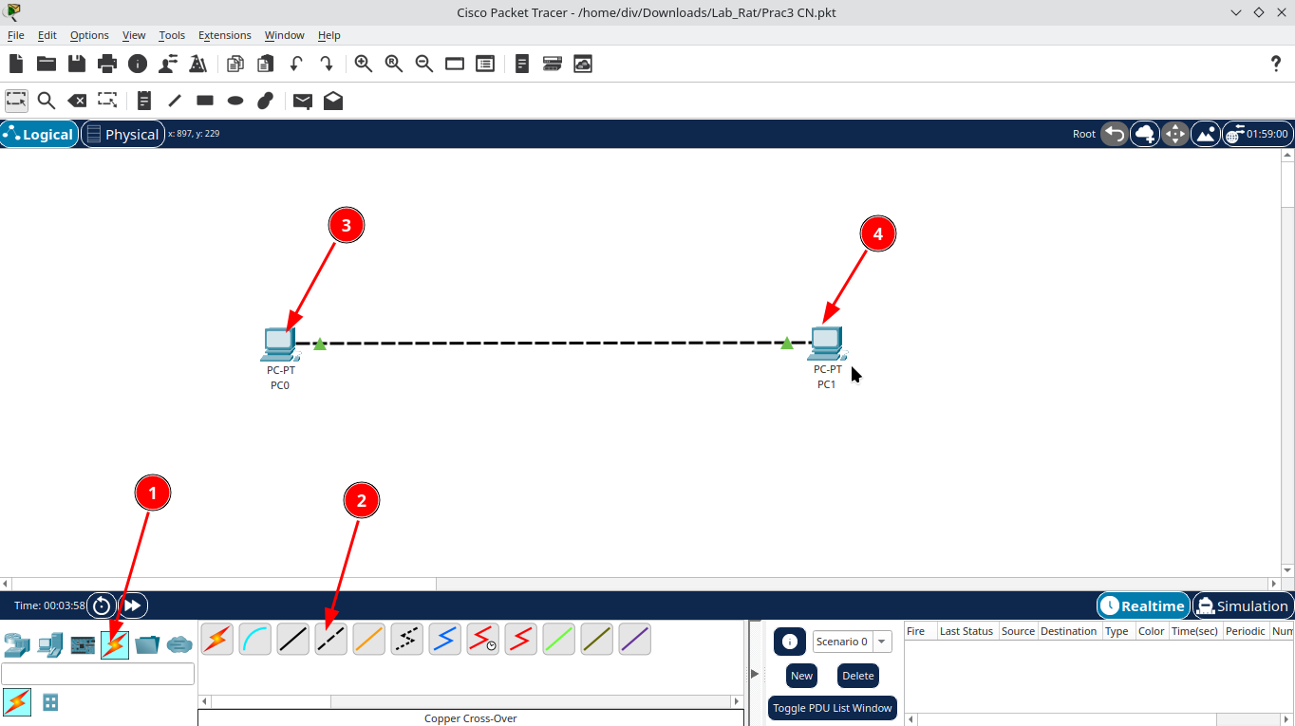
    - The now click PC1 and under Desktop tab , select IP configuration.
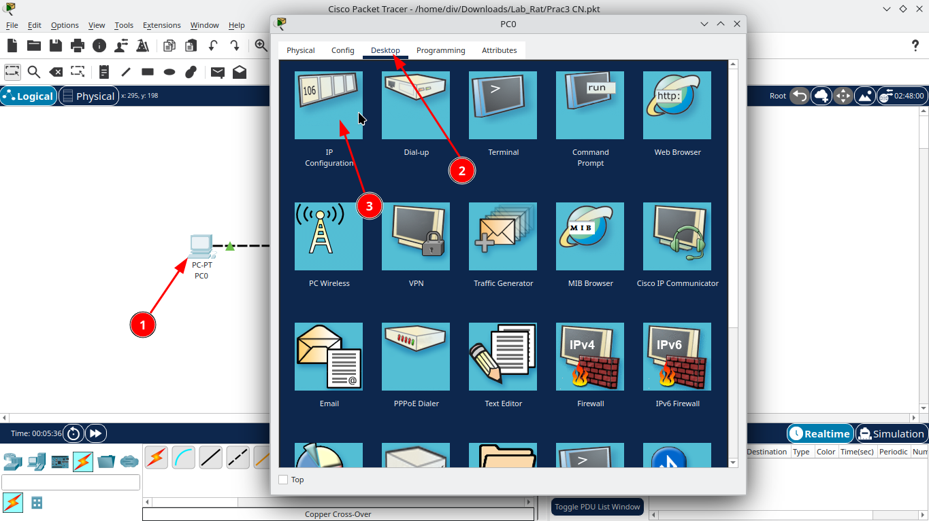
    - Inside IP configure option, type IP 1.1.1.1 in IPv4 field. Click Subnet Mask to let it auto fill. Redo the process for PC2 with IPv4 as 1.1.1.2
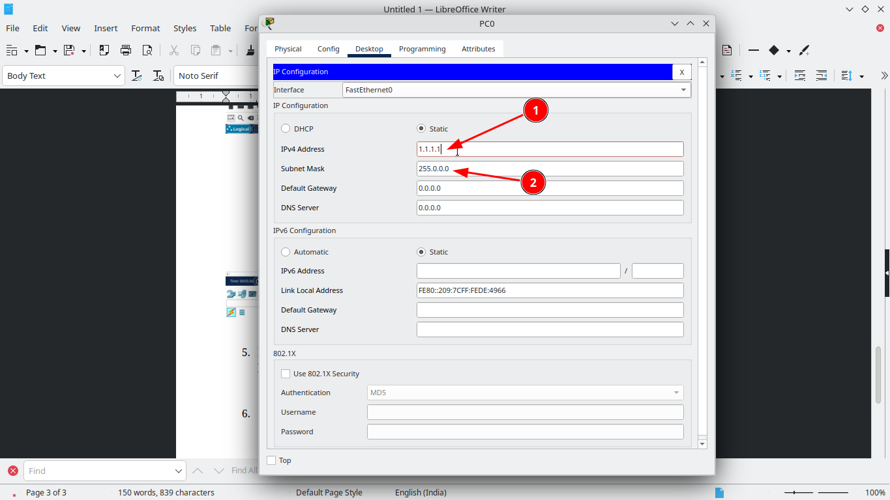
    - To test the network click PC1 and under desktop tab click Command Prompt. Follwing terminal will open. Type Ping 1.1.1.2, following output shows successfull connection
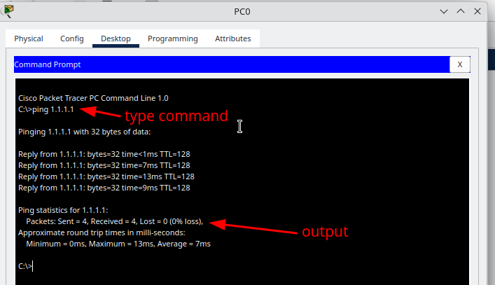
    - Now to send a packet from PC1 to PC2, select Add Simple PDU icon on toolbar. Click on PC1 and then on PC2. Now hit the simulation button in right bottom of screen and select play.
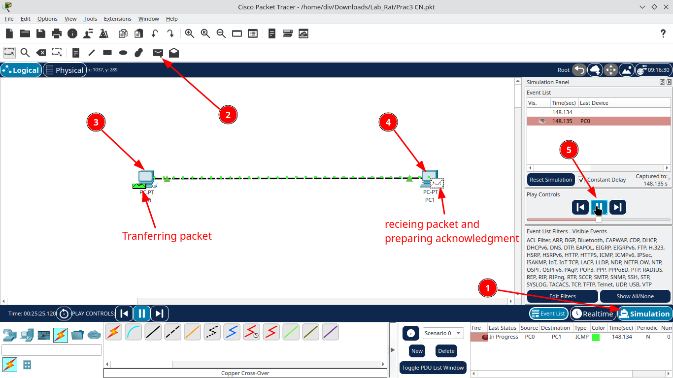
This check icon show the succesfull implemetation of network, packet sending and acknowledge recieval.
