Practical 1

Objective : Installation of Cisco Packet Tracer
Theory : Cisco Packet Tracer is a network simulation tool that is used to design and test networks first on software, then implement them in physical form. Cisco Packet Tracer is the best simulation software to learn networking tools and their implementation by imitating real-life scenarios.
Solution: Following are the steps to install Cisco Packet Tracer :
      - Open a browser and head to link: https://www.netacad.com/resources/lab-downloads?courseLang=en-US
      - Click login in top left of webpage. Create the credentials and then login in to the webpage.

      - After login, scroll the page and find the installer links. Click the download links according to the OS of your system. The downloading starts.
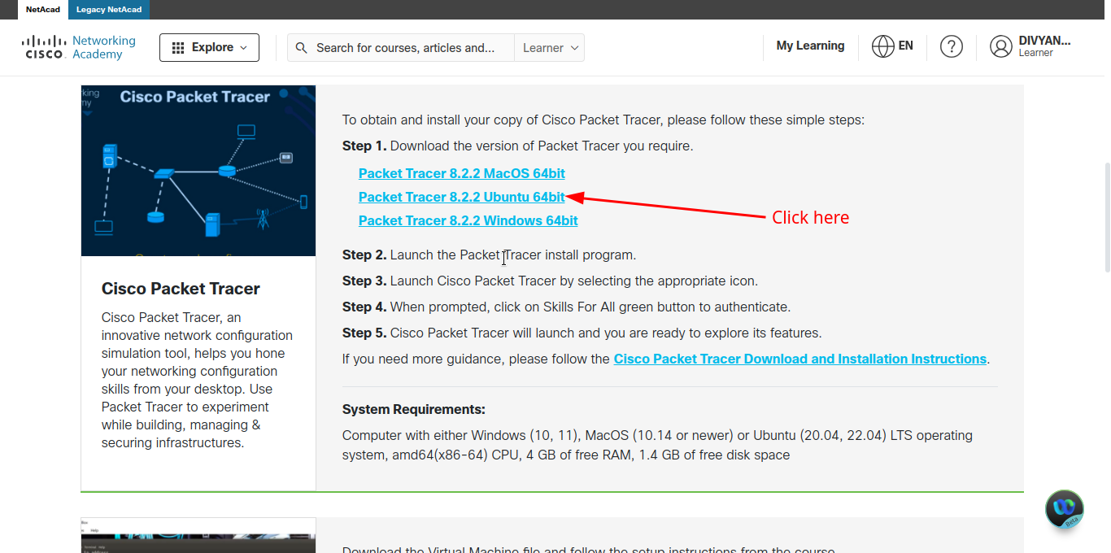
      - After downloading, run the installer by allowing required permissions, download path, etc. After a successfull installation, run Packet Tracer from application launcher.
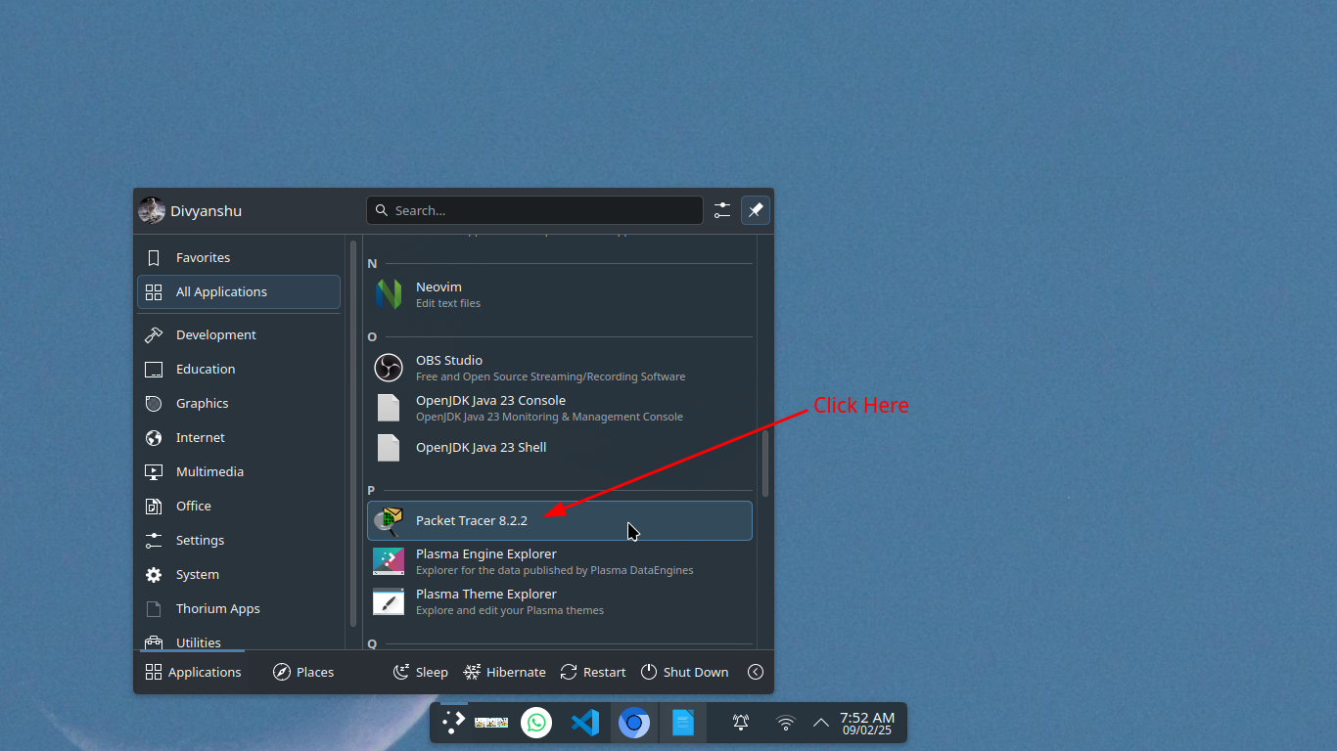
      - If login screen appears , then login using network academy using same credentials. The application should launch successfully.
