Supplementary materials

Supplementary materials S1 – Data Specification

S1.1 - Surgical Procedure Classification
Surgical technique was assessed using the procedure codes recorded for each case using the OPSC-4.9 version as described in Table S4 For each case, the procedure was included into a group if one of the eligible OPSC codes was identified (Inclusive of all 3-digit codes within each 2-digit code) and then subsequently removed if an exclusion code was also present. To exclude concurrent procedures within the mouth where the tonsils may additionally be removed (such as a glossectomy or mandibular resection), the remainder of the F chapter was excluded across the simple procedure groups. The use of coblation and electrocautery were determined with the same method and then added as a feature to each procedure. The three surgical groups were checked to ensure mutual exclusivity.

Table S4 - Criteria for surgical cohort eligability
Surgical Group | Eligible OPSC codes | Exclusion OPSC codes
Tonsillectomy | F34, F35 | E20, F0:F33, F36:F99
Adenoidectomy | E20 | F34, F35, F0:F33, F36:F99
Adenotonsillectomy | F34, F35, E20 | F0:F33, F36:F99, Patients already identified in tonsillectomy and adenoidectomy cohorts.
Coblation | Y10.1, F34.7, F35.2
Electrocautery | Y10.2, Y11.1 | Y10.1
Only where a technique is explicitly coded is it auditable. For example, all ENT procedures are set up with electrocautery (diathermy) as standard, but only in cases where explicit mention is made in the surgical operation note are the coded then captures and auditable. Thus, surgical technical may be significantly underestimating the true prevalence.

S1.2 – Past Medical History
For a patient to be considered as ‘positive’ for a previous medical condition their problem list was searched for eligible ICD-10-5th edition codes, where a 3-digit code was provided, this included all of the 4-digit codes inclusive, unless the 4-digit code was provided in the exclusion ICD codes.

Table S5 - Eligability for past medical history filtering on ICD10 codes
Past medical history item | Eligible ICD codes | Exclusion ICD codes
Chronic Pain | R52 | R52.0
Opioid Dependence | F11
Chronic Tonsillitis | J35 | J35.8
Sleep apnoea | G47.3

S1.3 – Intra-operative Medications
Broadly the majority of preparations provided on the intra-operative MAR were intravenous preparations but there are a few examples of oral medications being given. All medication doses in theatre were converted to mg and if given in discrete doses within a theatre episode where pooled to produce the total intra-operative dose.

Table S6 - Formulations for interoperative medications
Medication group (if applicable) | Medication | Medication preparation
 | Paracetamol | paracetamol 1g/100ml solution for infusion, paracetamol 500mg/50ml solution for infusion vial, paracetamol 500mg tablets, paracetamol 500mg suppository, paracetamol 250mg/5ml suspension sugar-free, paracetamol 250mg/5ml oral suspension
NSAIDs | Diclofenac* | diclofenac sodium 75mg/3ml injection, diclofenac sodium 100mg suppository, diclofenac sodium 50mg suppository
 | Dexamethasone | dexamethasone 6.6mg/2ml injection, dexamethasone 2mg tablet
 | Tramadol | tramadol 100mg/2ml injection
 | Clonidine | clonidine 150microgram/1ml injection, clonidine 25microgram tablets
 | Ketamine | ketamine 50mg/5ml injection preservative-free, ketamine 200mg/20ml injection, ketamine 100mg/2mL, ketamine 500mg/10ml injection
 | Magnesium | magnesium sulfate in 100 ml in normal saline, magnesium sulfate in 250 ml in normal saline
Strong opioid | Morphine | morphine sulfate 10mg/1ml solution for injection ampoule, morphine sulfate 1mg/ml injection, morphine sulfate 10mg/5ml oral solution
 | Oxycodone | oxycodone hydrochloride 10mg/1ml injection, oxycodone hydrochloride 20mg/2ml injection, oxycodone hydrochloride 50mg/1ml injection, oxycodone 100mg/50ml pca solution for infusion, oxycodone hydrochloride 5mg/5ml oral solution sugar-free
 | Fentanyl | fentanyl 100microgram/2ml injection, fentanyl 2000mcg/100ml pca infusion
 | Diamorphine | diamorphine hydrochloride 5mg powder for solution for injection, diamorphine hydrochloride 10mg powder for solution for injection
* Note: Diclofenac is the only NSAID used within UCLH theatres. A review of Aspirin, Naproxen, Celecoxib and ibuprofen revealed no intra-operative administrations across the cohort.

S1.4 – Discharge medications
Discharge medications were counted if there were prescribed on the discharge paperwork, regardless if they were dispensed from hospital pharmacy, sent to the community pharmacy or patients were instructed to purchase over the counter. Specific formulations of discharge medications have not been provided as clinicians will prescribe a generic medication and dose regime and formulation details are not provided on the discharge paperwork.

Table S7 - Formulations for discharge medications
Medication group | Medications generic name
Paracetamol | paracetamol
NSAID’s* | Ibuprofen, Diclofenac sodium, Naproxen, Etoricoxib, Celecoxib
Strong opioid | morphine sulfate, oxycodone hydrochloride, buprenorphine, fentanyl, diamorphine hydrochloride
Weak opioid | codeine phosphate, dihydrocodeine, co-dydramol (dihydrocodeine and paracetamol), co-codamol (codeine and paracetamol), tramadol
- Aspirin was not included as the primary intention is usually not for post-operative analgesia

Supplementary materials S2 - Missing data
The level of missing data for each of the key variables were assessed as reported in Table S8. All other variables had no missing values. Extracted variables for past medical history and medications administered required a past medical history and medication administration record to be able to assess, there was no missing records so these fields have no missing variables. It is noted by the authors the limitations of accuracy of the medical record. Where missing data exists for computed variables there was a missing variable during the computation, hence the resulting value being NA (for example if a patient did not have any pain scores recorded within 3 hours post-op the median value is not computable and thus missing).

Table S8

Supplementary materials S2 - Oral Morphine Equivalence
For each medication the routes were grouped and a conversion value attributed using the standard equivalence table provided by Neilsen et al. Oral morphine equivalence (OME) was then calculated as a weighted sum using the standard OME equation.
for i∈{1,...,n}OME=dref+i∈N​cididref=dose of reference medicationdi=dose of medicationci=conversion value of medicationN=non-referance medications
Distributions and mean dose sum of each opioid within each treatment group are described within the results.

Supplementary materials S3 - Analysis code
Data was extracted from the EPR and stored in a proprietary data model in the parquet format. Extraction code is not provided as it contains intellectual property of the EPR provider Epic, Wisconsin.
The dataset was cleaned to remove known issues by the script import_proccess.qmd.
The tonsillectomy dataset was produced by the script peri_op_med_dataset.qmd.
The analysis was performed by the script peri_op_med_analysis.qmd and supplementary analysis and materials in peri_op_med_supp_mat.qmd.
The code is held at the following github repository https://github.com/DW10/tonsillectomy_analgesia

Supplementary materials S4 – Sensitivity analysis

S4.1 – Rescue opioid administration
The time to first post-operative opioid was extracted for all patients, and a sensitivity analysis was performed to establish the best cut off time as show in the Table S9 and Figure S6. A threshold time of 3 hours was selected given the clinical rational of any inter-operative analgesia plan would include adequate analgesic for this period and any opioids administered within 3 hours would represent inadequate analgesic effect.

Table S9
Table 1: Sensitivity analysis for Rescue opioid administration
Time (hours) | Patients receiving 1 or more doses (N) | Proportion of patients who received an opioid (%) | Proportion of all patients (%)
0.5 | 2 | 0.23 | 0.06
1.0 | 22 | 2.53 | 0.66
1.5 | 298 | 34.21 | 8.98
2.0 | 610 | 70.03 | 18.37
2.5 | 738 | 84.73 | 22.23
3.0 | 797 | 91.50 | 24.01
3.5 | 817 | 93.80 | 24.61
4.0 | 825 | 94.72 | 24.85
4.5 | 834 | 95.75 | 25.12
5.0 | 838 | 96.21 | 25.24
5.5 | 842 | 96.67 | 25.36
6.0 | 848 | 97.36 | 25.54

Figure S6 - Cumulative density of opioid administration times in recovery
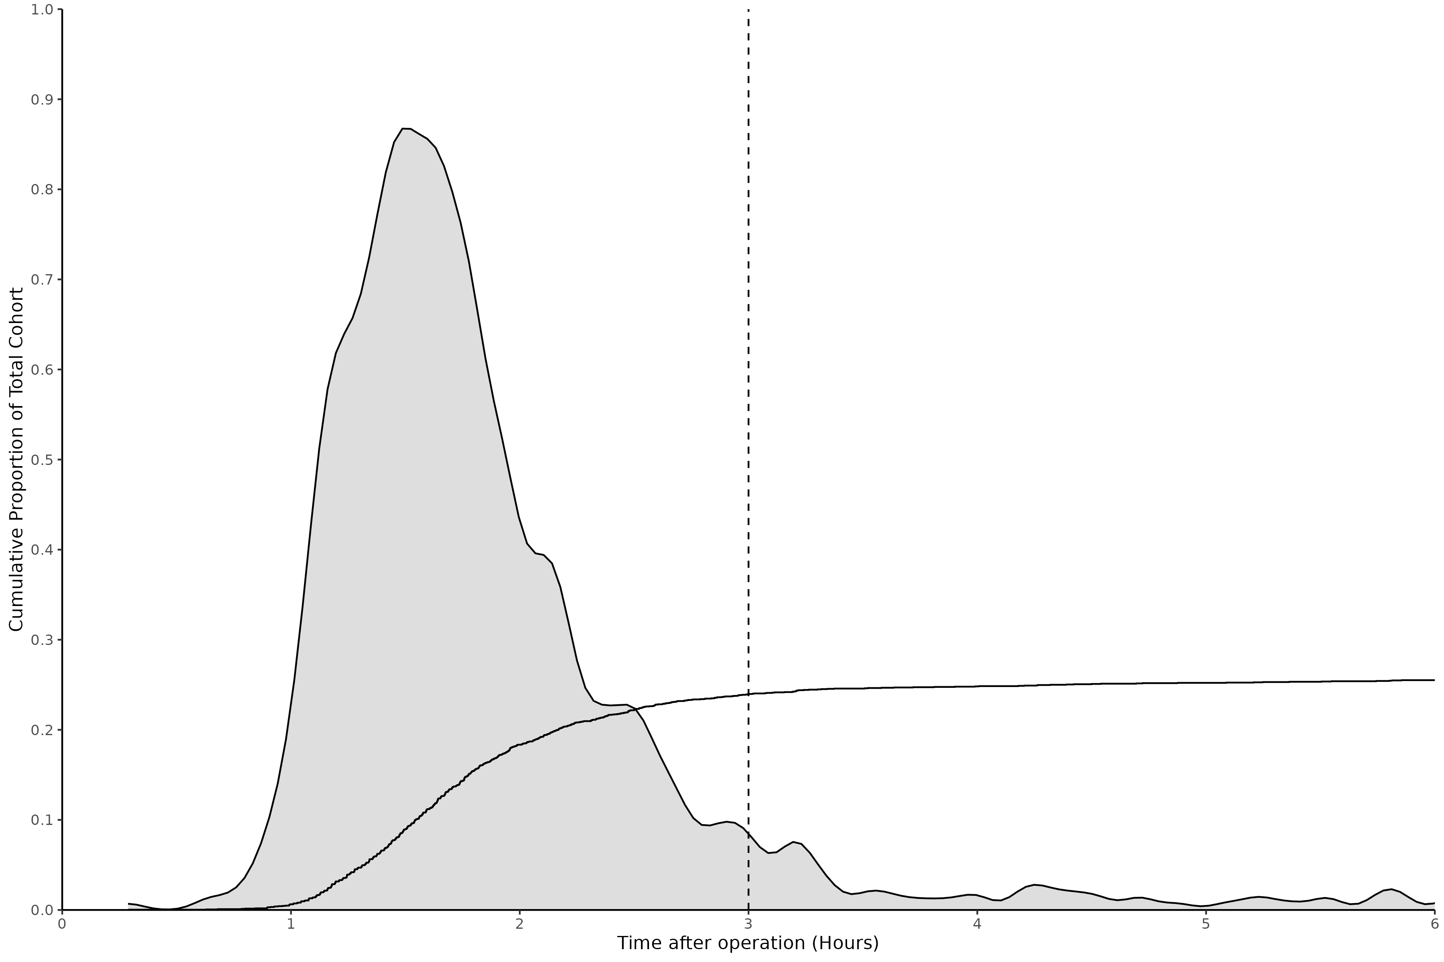
Cumulative density plot of the administration times of opioid medications from the end of surgery to the first dose given for patient that received an opioid within 6 hours of surgery. Gray filled area depicts the density distribution and dotted line denotes the time cut off point of 3 hours.

S4.2 – Presentation to the emergency department
All of the subsequent presentations to the UCLH emergency department within 35 days was extracted for the patients. Primary reason for attendance was not extracted and where patients attended more than once within the 40 day period the first presentation was used. A sensitivity analysis was performed to understand the distribution of the data against the clinically benchmarked timepoints of 7, 14 and 30 days. The table below and figure S2 depicts the proportion of presentations across important timepoints.

Table S10
Time (Days) | Patients attending the emergency department (N) | Proportion of patients who presented within 35 days (%) | Proportion of all patients (%)
1 | 31 | 8.64 | 0.93
2 | 59 | 16.43 | 1.78
3 | 87 | 24.23 | 2.62
4 | 121 | 33.70 | 3.64
5 | 160 | 44.57 | 4.82
6 | 205 | 57.10 | 6.17
7 | 244 | 67.97 | 7.35
14 | 328 | 91.36 | 9.88
30 | 350 | 97.49 | 10.54
35 | 354 | 98.61 | 10.66

Figure S7 - Cumulative density of time to presentation to the emergency department
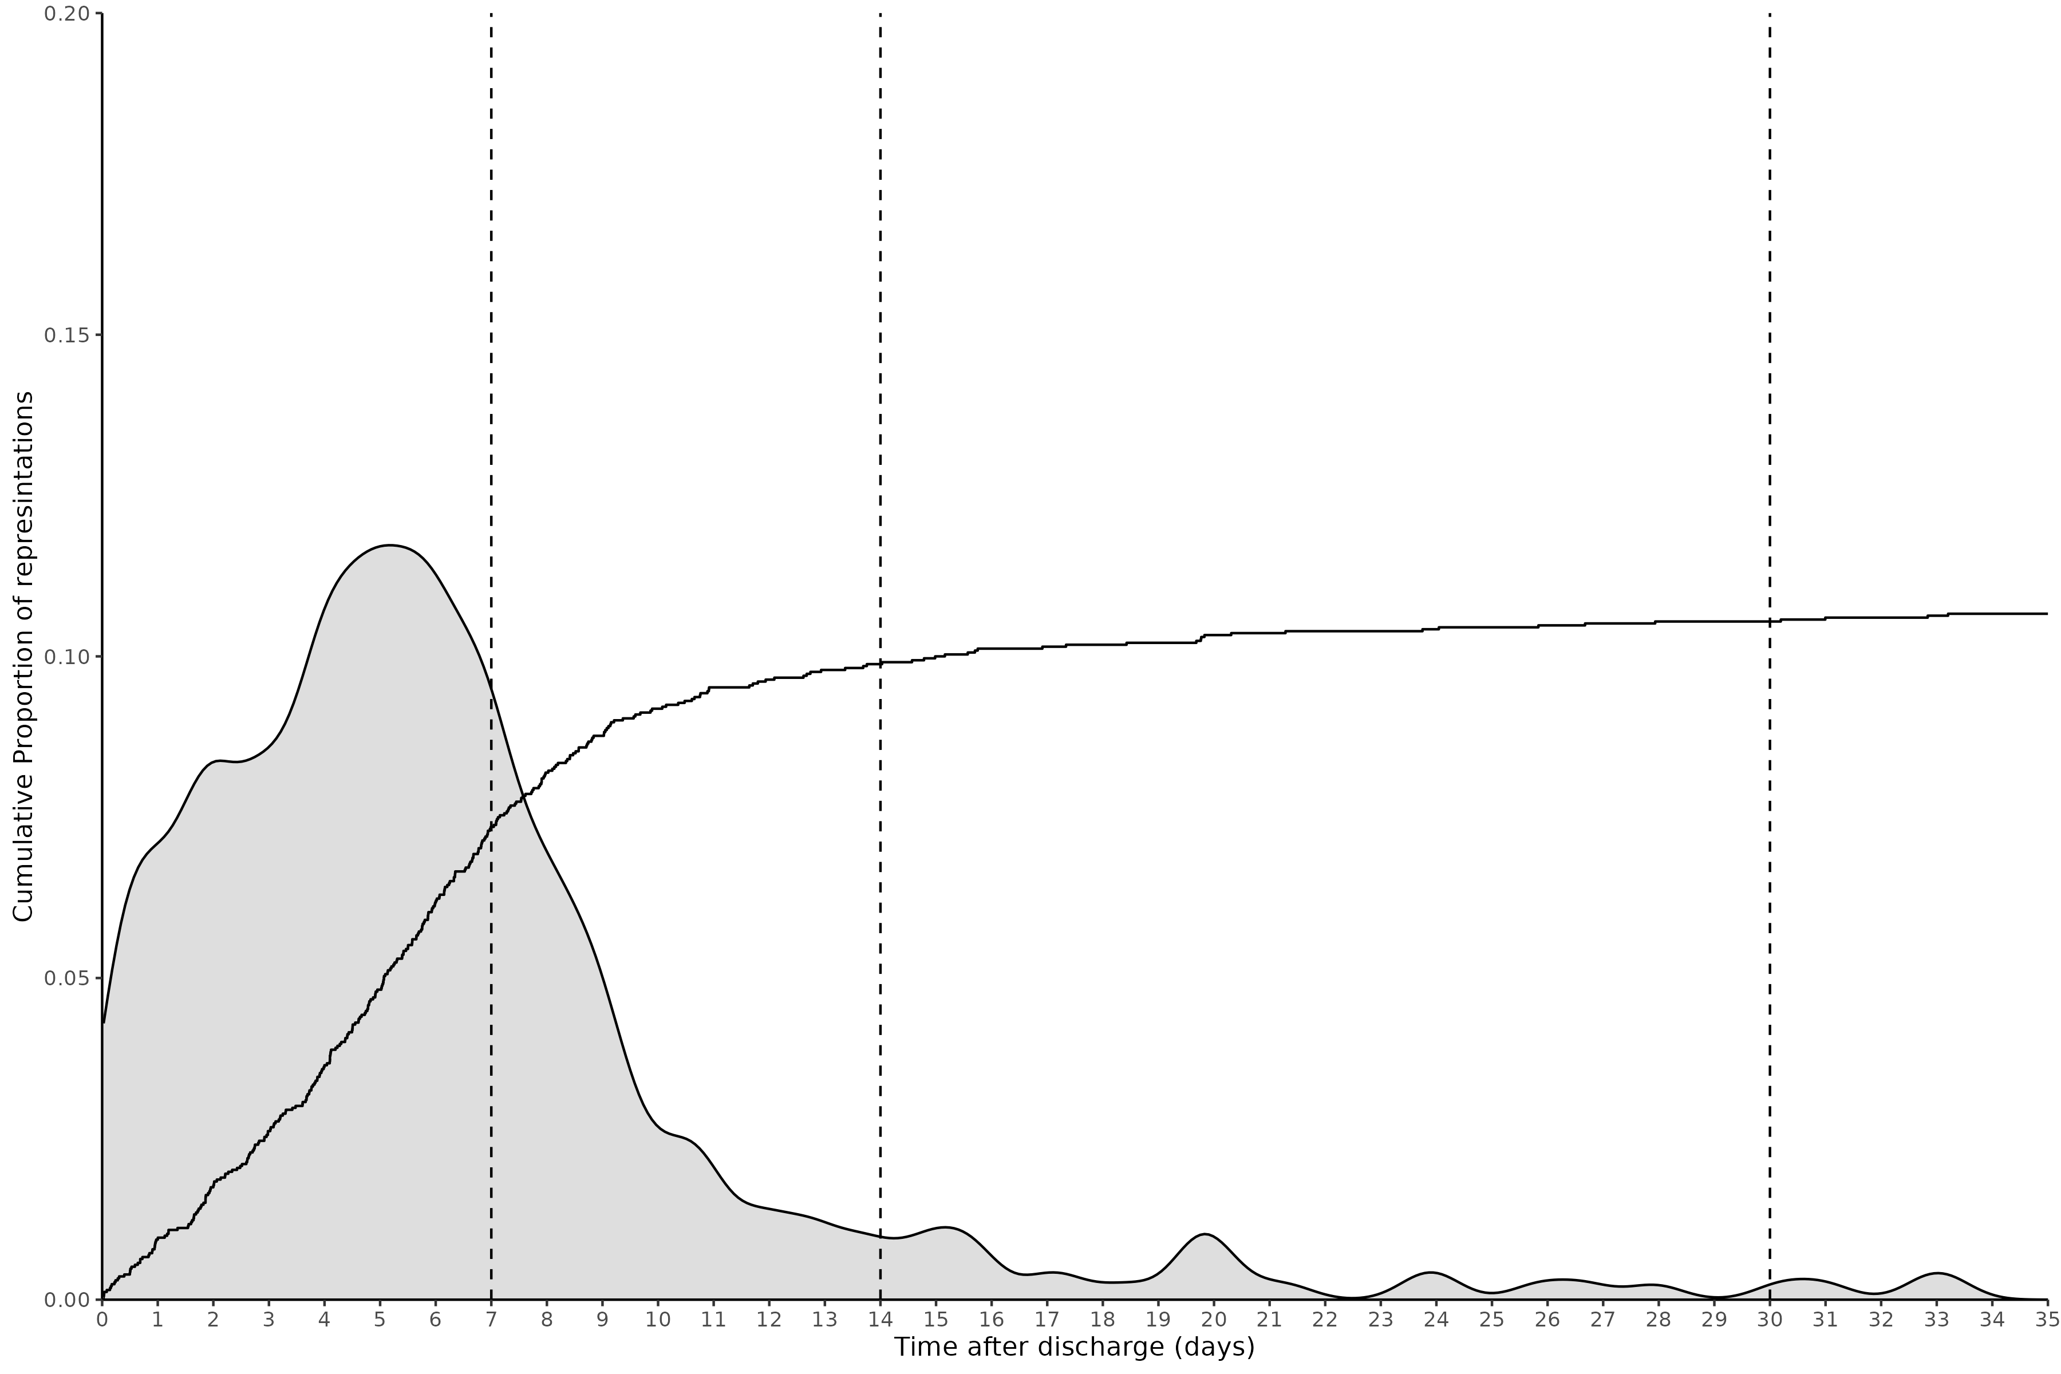 Cumulative density plot of the of the time to presentation at the emergency department (ED) from the discharge date to the ED visit time. Gray filled area depicts the density distribution and dotted line denotes the time point of 7,14 and 30 days.

S4.3 – Multi-level modelling group size threshold
To account for inter-clinician difference in practices, multi-level modelling has been used. To balance the power of the model against the generalisability a threshold of case size has been used.
Clinicians who have performed fewer than 5 cases for adult patients across the whole study period were deemed not experienced enough to impart personalised differences in practice to the care and thus were removed from the modelling.
A threshold of 5 was chosen from the sensitivity Table S11 and Figure S8.
The maximum threshold values test was 70 due to failure of model convergence beyond this value.

Table S11
 |  |  | Beta of Treatment group (Log Odds) |  |  | Standard Error of Treatment group
Theshold value | Patients included (N) | Clinicans included (N) | 2 | 3 | 4 | 2 | 3 | 4 | Variance from Clinician | AIC | Model convergence
0.00 | 1,295.00 | 85.00 | 0.01 | -0.09 | -1.16 | 0.26 | 0.24 | 0.27 | 0.07 | 1,302.47 | TRUE
2.00 | 1,268.00 | 58.00 | 0.02 | -0.09 | -1.15 | 0.26 | 0.25 | 0.28 | 0.07 | 1,284.33 | TRUE
4.00 | 1,227.00 | 40.00 | -0.03 | -0.08 | -1.21 | 0.27 | 0.25 | 0.28 | 0.07 | 1,244.51 | TRUE
6.00 | 1,158.00 | 24.00 | -0.06 | -0.09 | -1.21 | 0.27 | 0.25 | 0.28 | 0.05 | 1,185.45 | TRUE
8.00 | 1,144.00 | 22.00 | -0.06 | -0.10 | -1.20 | 0.27 | 0.25 | 0.29 | 0.05 | 1,171.02 | TRUE
10.00 | 1,127.00 | 20.00 | -0.09 | -0.15 | -1.15 | 0.27 | 0.26 | 0.29 | 0.04 | 1,155.37 | TRUE
20.00 | 1,022.00 | 13.00 | -0.06 | -0.10 | -1.09 | 0.28 | 0.26 | 0.30 | 0.03 | 1,077.76 | TRUE
30.00 | 974.00 | 11.00 | -0.09 | -0.12 | -1.13 | 0.29 | 0.27 | 0.31 | 0.03 | 1,024.39 | TRUE
40.00 | 974.00 | 11.00 | -0.09 | -0.12 | -1.13 | 0.29 | 0.27 | 0.31 | 0.03 | 1,024.39 | TRUE
50.00 | 974.00 | 11.00 | -0.09 | -0.12 | -1.13 | 0.29 | 0.27 | 0.31 | 0.03 | 1,024.39 | TRUE
60.00 | 806.00 | 8.00 | -0.31 | -0.24 | -1.50 | 0.31 | 0.29 | 0.36 | 0.00 | 851.25 | TRUE
70.00 | 614.00 | 5.00 | -0.44 | -0.49 | -1.71 | 0.33 | 0.31 | 0.38 | 0.00 | 640.56 | FALSE
Table of model performance of the unadjusted multilevel model of primary outcome (rescue opioids) with varying threshold levels

Figure S8 - Plot of sensativity analysis of mutli-level threshold
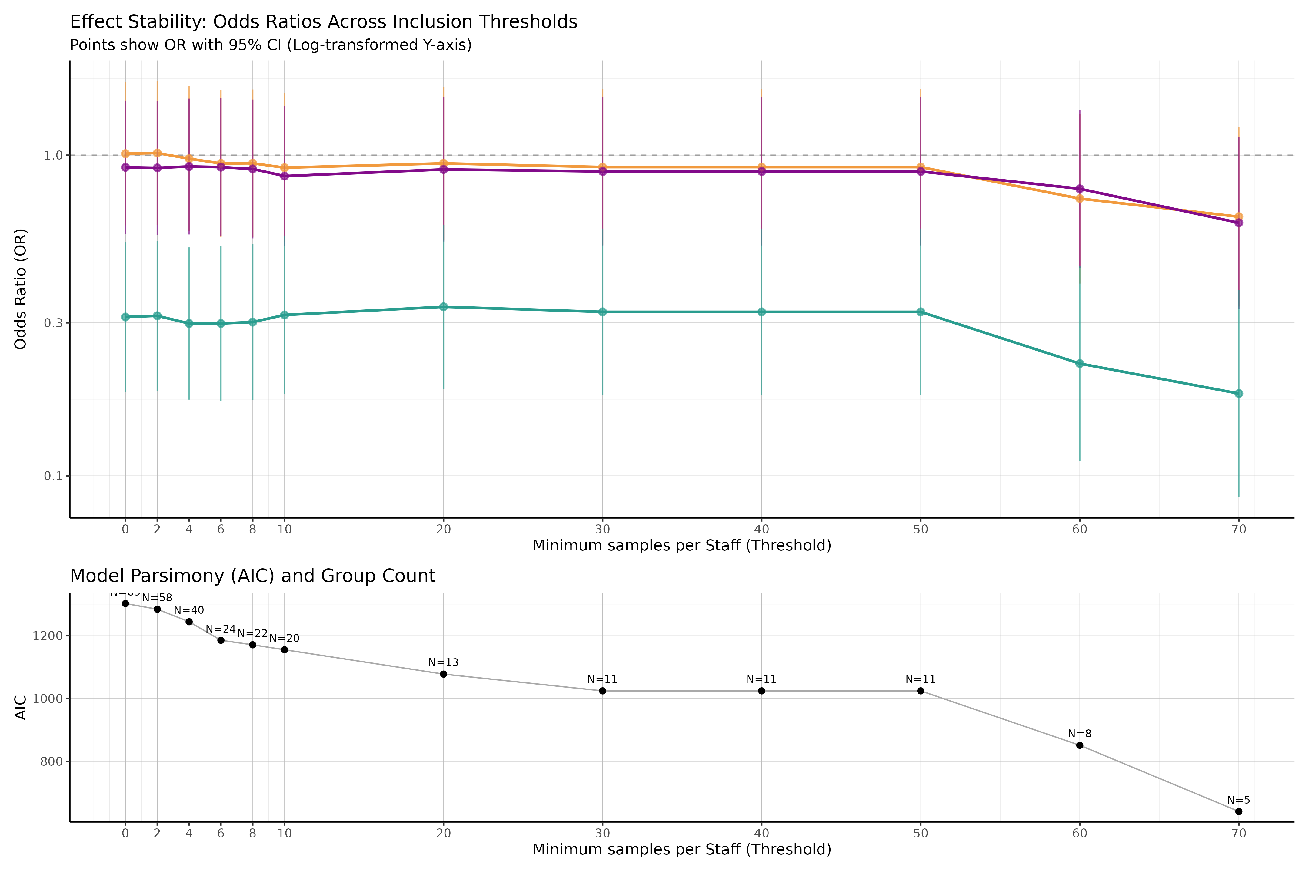
Upper plot, line chart of odds ratio with 95% confidence interval bands for differing clinical group size threshold values.Lower plot, line chart of AIC over threshold values with number of clinicians included shower per point.

Supplementary materials S5 – Modelling

S5.1 – Models parameters

Table S12
Model Number | Cohort | Outcome | Multi-level by primary anaesthetist | Co-variants | Notes
0 | Adult | Recovery opioids | No | Nil
1 | Adults | Recovery opioids | Yes | Nil
2 | Adults | Recovery opioids | Yes | age, sex, surgical cohort, ASA, history of chronic pain, procedure length and use of coblation
3 | Adults | Time in recovery | Yes
4 | Adults | Same discharge | Yes
5 | Adults | Opioid on discharge | Yes |  | Model fails to converge
6 | Adults | Return to ED at 7 days | Yes |  | Model fails to converge
The following secondary outcomes were not modelled with the associated justification:
- Length of admission (Days) – Same day discharge has been modelled as a logistic regression instead due to the multi-modal disruption of length of admission.
- Median pain score – Significant number of missing data as pain scores not being collected in recovery, only on the ward.
- Discharge medications – Medication prescriptions at the point of discharge likely represent the variation in discharging clinician rather than anaesthetic clinician
- Return to theatre– Lack of distribution of outcome
- Re-presentation – Lack of distribution of outcome
- Deaths – Lack of distribution of outcome

S5.2 Multilevel modelling
An ANOVA was performed between model 0 (without multi-level modelling) and model 1 (with multi-level modelling) to establish the difference in model performance

Table S13 - ANOVA of Model 0 and Model 1
npar | AIC | BIC | logLik | deviance | Chisq | Df | Pr(>Chisq)
4 | 1208.382 | 1227.618 | -600.1911 | 1200.382 | NA | NA | NA
5 | 1208.728 | 1232.773 | -599.3639 | 1198.728 | 1.654465 | 1 | 0.1983523

S5.3 - Results of Model 1
In Model 1 the variance explained by the anaesthetist ID was 5.6%

Table S14 - Fixed effects of model 1
Table 1:
Cohort: Adult (unadjusted) Outcome: Recovery opioids
Term | Coefficient | Standard error | z value | p value | Odds Ratio | OR 95% CI Lower | OR 95% CI Upper
(Intercept) | 0.544 | 0.235 | 2.313 | 0.0207 | 1.723 | 1.087 | 2.732
Treatment group 2 | -0.089 | 0.269 | -0.332 | 0.7402 | 0.915 | 0.540 | 1.550
Treatment group 3 | -0.112 | 0.252 | -0.443 | 0.6579 | 0.894 | 0.545 | 1.467
Treatment group 4 | -1.274 | 0.283 | -4.503 | 0.0000 | 0.280 | 0.161 | 0.487

Figure S9 - Random effects of model 1
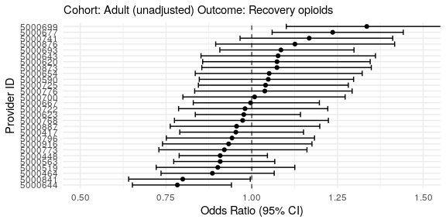

S5.4 - Results of Model 2
In Model 1 the variance explained by the anaesthetist ID was 3.2%

Table S16 - Fixed effects of model 2
Table 1:
Cohort: Adult (adjusted) Outcome: Recovery opioids
Term | Coefficient | Standard error | z value | p value | Odds Ratio | OR 95% CI Lower | OR 95% CI Upper
(Intercept) | 1.317 | 0.361 | 3.647 | 0.0003 | 3.733 | 1.839 | 7.577
Treatment group 2 | 0.006 | 0.385 | 0.017 | 0.9865 | 1.007 | 0.473 | 2.141
Treatment group 3 | -0.014 | 0.335 | -0.042 | 0.9669 | 0.986 | 0.512 | 1.900
Treatment group 4 | -0.812 | 0.525 | -1.545 | 0.1223 | 0.444 | 0.159 | 1.243
Age (years) | -0.010 | 0.007 | -1.308 | 0.1910 | 0.991 | 0.977 | 1.005
Sex: Male | -0.345 | 0.153 | -2.261 | 0.0238 | 0.708 | 0.525 | 0.955
Cohort: Adenoidectomy | -1.213 | 0.307 | -3.953 | 0.0001 | 0.297 | 0.163 | 0.542
Cohort: Adenotonsillectomy | 0.050 | 0.434 | 0.114 | 0.9090 | 1.051 | 0.449 | 2.461
ASA: 2 | 0.201 | 0.154 | 1.304 | 0.1924 | 1.222 | 0.904 | 1.653
ASA: 3 | 0.812 | 0.426 | 1.907 | 0.0566 | 2.252 | 0.978 | 5.190
Chronic pain EPR diagnosis | 16.211 | 2,223.486 | 0.007 | 0.9942 | 10,972,539.782 | 0.000 | Inf
Procedure length (Minutes) | -0.002 | 0.003 | -0.543 | 0.5872 | 0.998 | 0.991 | 1.005
Coblation | -1.369 | 0.470 | -2.914 | 0.0036 | 0.254 | 0.101 | 0.639
Intra-operative opioid dose (OME mg) | -0.030 | 0.016 | -1.842 | 0.0655 | 0.970 | 0.940 | 1.002

Figure S10 - Random effects of model 2
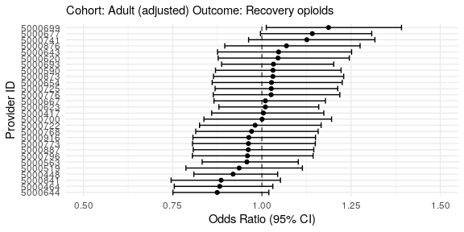

S5.4 - Results of Model 3
In Model 3 the standard deviation of the variance explained by the anaesthetist ID was 3.1 minutes.

Table S17 - Fixed effects of model 3
Table 1:
Cohort: Adult (adjusted) Outcome: Time in recovery (minutes)
Term | Coefficient | Standard error | z value | Degrees of freedom | p value | 95% CI Lower | 95% CI Upper
(Intercept) | 95.534 | 9.079 | 10.523 | 369.526 | 0.000 | 77.681 | 113.386
Treatment group 2 | -18.769 | 9.833 | -1.909 | 620.799 | 0.057 | -38.078 | 0.541
Treatment group 3 | -24.560 | 8.479 | -2.897 | 511.283 | 0.004 | -41.218 | -7.903
Treatment group 4 | -50.253 | 13.598 | -3.696 | 680.167 | 0.000 | -76.951 | -23.554
Age (years) | 0.078 | 0.189 | 0.414 | 861.844 | 0.679 | -0.293 | 0.450
Sex: Male | -1.124 | 3.971 | -0.283 | 835.356 | 0.777 | -8.919 | 6.671
Cohort: Adenoidectomy | -20.132 | 8.044 | -2.503 | 844.248 | 0.013 | -35.920 | -4.345
Cohort: Adenotonsillectomy | -5.745 | 11.486 | -0.500 | 861.441 | 0.617 | -28.290 | 16.799
ASA: 2 | 4.972 | 4.011 | 1.239 | 849.277 | 0.216 | -2.901 | 12.845
ASA: 3 | 19.429 | 10.290 | 1.888 | 857.133 | 0.059 | -0.767 | 39.625
Chronic pain EPR diagnosis | 6.548 | 27.524 | 0.238 | 862.331 | 0.812 | -47.474 | 60.570
Procedure length (Minutes) | 0.000 | 0.092 | 0.004 | 855.493 | 0.996 | -0.179 | 0.180
Coblation | -3.243 | 11.204 | -0.289 | 862.436 | 0.772 | -25.232 | 18.747
Intra-operative opioid dose (OME mg) | 0.567 | 0.424 | 1.337 | 430.026 | 0.182 | -0.266 | 1.400
p value's calculated using Satterthwaite's approximation

Figure S11 - Random effects of model 3
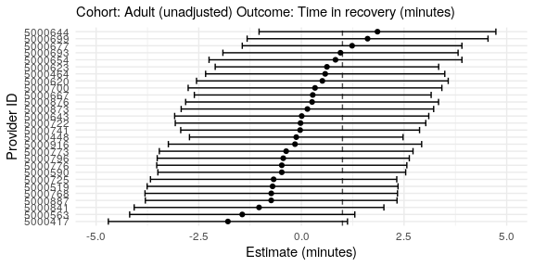

S5.5 - Results of Model 4
In Model 4 the variance explained by the anaesthetist ID was 29.7%

Table S18 - Fixed effects of model 4
Table 1:
Cohort: Adult (adjusted) Outcome: Same day discharge
Term | Coefficient | Standard error | z value | p value | Odds Ratio | OR 95% CI Lower | OR 95% CI Upper
(Intercept) | 1.772 | 0.428 | 4.144 | 0.0000 | 5.882 | 2.545 | 13.598
Treatment group 2 | 0.900 | 0.458 | 1.965 | 0.0495 | 2.460 | 1.002 | 6.037
Treatment group 3 | 0.729 | 0.395 | 1.845 | 0.0650 | 2.072 | 0.956 | 4.493
Treatment group 4 | 1.466 | 0.666 | 2.200 | 0.0278 | 4.330 | 1.173 | 15.982
Age (years) | -0.003 | 0.009 | -0.376 | 0.7071 | 0.997 | 0.980 | 1.014
Sex: Male | -0.311 | 0.184 | -1.686 | 0.0918 | 0.733 | 0.510 | 1.052
Cohort: Adenoidectomy | 1.180 | 0.433 | 2.723 | 0.0065 | 3.253 | 1.392 | 7.605
Cohort: Adenotonsillectomy | 0.202 | 0.533 | 0.378 | 0.7051 | 1.223 | 0.431 | 3.476
ASA: 2 | -0.255 | 0.191 | -1.338 | 0.1809 | 0.775 | 0.534 | 1.126
ASA: 3 | -1.515 | 0.426 | -3.555 | 0.0004 | 0.220 | 0.095 | 0.507
Chronic pain EPR diagnosis | -0.023 | 1.193 | -0.020 | 0.9843 | 0.977 | 0.094 | 10.123
Procedure length (Minutes) | -0.020 | 0.004 | -4.733 | 0.0000 | 0.980 | 0.972 | 0.988
Coblation | -0.093 | 0.580 | -0.160 | 0.8729 | 0.911 | 0.292 | 2.843
Intra-operative opioid dose (OME mg) | -0.005 | 0.021 | -0.243 | 0.8079 | 0.995 | 0.955 | 1.037

Figure S12 - Random effects of model 4
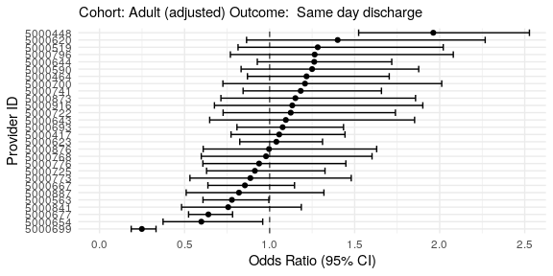

S5.3 - Results of Model 5
In Model 5 the variance explained by the anaesthetist ID was 0.0%

Table S19 - Fixed effects of model 5
Table 1:
Cohort: Adult (adjusted) Outcome: Opioids on discharge
Term | Coefficient | Standard error | z value | p value | Odds Ratio | OR 95% CI Lower | OR 95% CI Upper
(Intercept) | -24.145 | 12,118.085 | -0.002 | 0.9984 | 0.000 | 0.000 | Inf
Treatment group 2 | 18.638 | 12,118.085 | 0.002 | 0.9988 | 124,291,690.601 | 0.000 | Inf
Treatment group 3 | 18.541 | 12,118.085 | 0.002 | 0.9988 | 112,746,400.185 | 0.000 | Inf
Treatment group 4 | 17.909 | 12,118.086 | 0.001 | 0.9988 | 59,978,628.824 | 0.000 | Inf
Age (years) | 0.056 | 0.032 | 1.738 | 0.0822 | 1.058 | 0.993 | 1.126
Sex: Male | -1.257 | 1.084 | -1.159 | 0.2463 | 0.285 | 0.034 | 2.382
Cohort: Adenoidectomy | -39.911 | 8,677,660.732 | 0.000 | 1.0000 | 0.000 | 0.000 | Inf
Cohort: Adenotonsillectomy | -66.189 | 13,538,098.155 | 0.000 | 1.0000 | 0.000 | 0.000 | Inf
ASA: 2 | -1.243 | 0.909 | -1.367 | 0.1717 | 0.289 | 0.049 | 1.715
ASA: 3 | -32.459 | 8,705,881.253 | 0.000 | 1.0000 | 0.000 | 0.000 | Inf
Chronic pain EPR diagnosis | -39.635 | 33,624,945.054 | 0.000 | 1.0000 | 0.000 | 0.000 | Inf
Procedure length (Minutes) | 0.005 | 0.021 | 0.249 | 0.8032 | 1.005 | 0.965 | 1.047
Coblation | -56.626 | 13,524,429.253 | 0.000 | 1.0000 | 0.000 | 0.000 | Inf
Intra-operative opioid dose (OME mg) | -0.004 | 0.077 | -0.058 | 0.9541 | 0.996 | 0.856 | 1.158

Figure S13 - Random effects of model 5
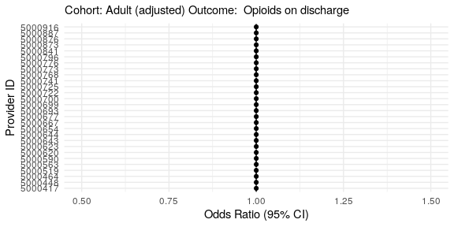

S5.3 - Results of Model 6
In Model 6 the variance explained by the anaesthetist ID was 7.1%

Table S20 - Fixed effects of model 6
Table 1:
Cohort: Adult (adjusted) Outcome: Presentation to emergency department within 7 days
Term | Coefficient | Standard error | z value | p value | Odds Ratio | OR 95% CI Lower | OR 95% CI Upper
(Intercept) | -1.419 | 0.515 | -2.757 | 0.0058 | 0.242 | 0.088 | 0.664
Treatment group 2 | -0.070 | 0.554 | -0.126 | 0.8994 | 0.932 | 0.315 | 2.760
Treatment group 3 | -0.029 | 0.480 | -0.061 | 0.9516 | 0.971 | 0.379 | 2.486
Treatment group 4 | -0.636 | 0.782 | -0.813 | 0.4161 | 0.529 | 0.114 | 2.453
Age (years) | -0.010 | 0.011 | -0.885 | 0.3762 | 0.990 | 0.969 | 1.012
Sex: Male | 0.075 | 0.223 | 0.338 | 0.7352 | 1.078 | 0.697 | 1.668
Cohort: Adenoidectomy | -1.736 | 0.752 | -2.307 | 0.0211 | 0.176 | 0.040 | 0.770
Cohort: Adenotonsillectomy | -1.280 | 1.043 | -1.226 | 0.2200 | 0.278 | 0.036 | 2.150
ASA: 2 | 0.061 | 0.216 | 0.282 | 0.7776 | 1.063 | 0.696 | 1.624
ASA: 3 | -1.453 | 1.050 | -1.384 | 0.1664 | 0.234 | 0.030 | 1.831
Chronic pain EPR diagnosis | 0.949 | 1.210 | 0.784 | 0.4329 | 2.583 | 0.241 | 27.667
Procedure length (Minutes) | 0.000 | 0.006 | 0.085 | 0.9325 | 1.000 | 0.990 | 1.011
Coblation | -14.584 | 759.492 | -0.019 | 0.9847 | 0.000 | 0.000 | Inf
Intra-operative opioid dose (OME mg) | -0.002 | 0.024 | -0.078 | 0.9378 | 0.998 | 0.952 | 1.046

Figure S14 - Random effects of model 6


