**10_Plot_CombinedCurves**

Graphical Representation:

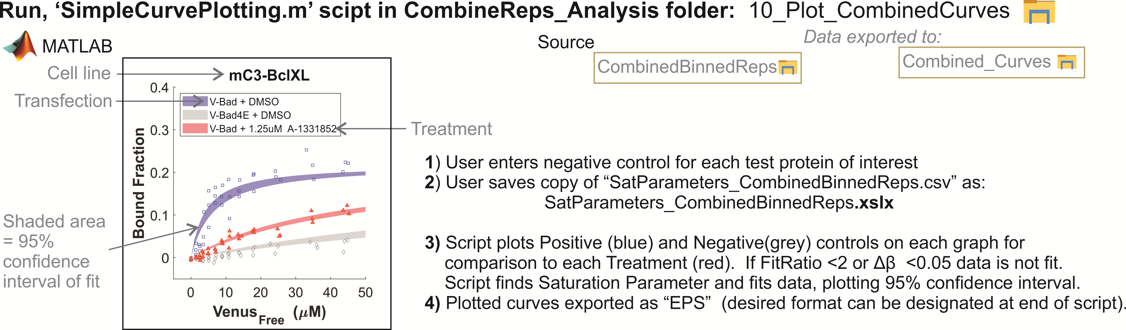

The simple plotting script can be used to examine the binding data closely from individual wells rapidly, rather than plotting all by hand. The user designates each positive and negative control. Then the script runs through the data, finding each treated well and plotted on the same graph the positive and negative control for comparison. The script passes the data through the same thresholds and fitting as was done for calculating Kd. It references the “Saturation Parameter” file exported from the fitting analysis in order to select the same fitting parameters, including any user-inputted changes. The confidence interval of the fit is shown for all three curves. If fitting could not be done (ie. If data points = insufficient, if Δβ <0.05, or sRatio <2) then data is plotted without fitting. Each file is exported as a .BMP for quick viewing and in .EPS vector format for publication quality graphs.