**12_GenerateHeatmaps**

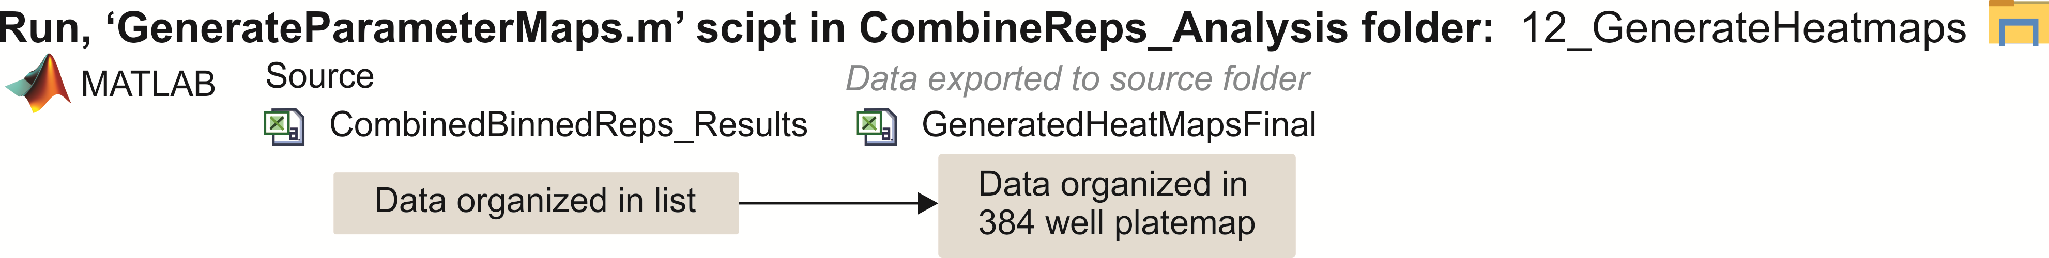

To examine binding information for the entire screen, color coded plate maps are generated. These represent heat map plotted as a grid of squares for the different extracted binding parameters. The plate map for the first repetition is used to create the heatmap. Heatmaps of Kd (displayed in **Figures 3-6**), bound fraction, number of points in curve, % drug resistance, sRatio, range of data sampled, and cumulative sum of the area under the curve may be plotted from our analysis pipeline.

Heatmap Data may be plotted in Matlab using our “PLOTHeatmap.m” also included in folder 12.