**8_CombineReps**

Graphical representation:

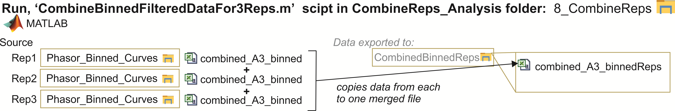

In this step the generated binned binding curves are combined for all reps prior to extracting final binding information. Rather than simply finding all data labelled with the same WellID, the script references the MasterPlatemap, examines each row in “Rep1”, then finds the matching Cells/Transfection/Treatment/Concentration in platemaps for Reps 2,3,4. This approach makes sure that the data combined is identical and allows users to account for any changes/mistakes in their platemap for every replicate. The data is pasted together in one sheet “Combined_WellID_binnedReps”, exported to CombinedBinnedReps subfolder. This script also calculates the average of 3+ replicates, for each VenusFree bin. *Note that the bins designated here must match any changes to bins made in Replicate Analysis:Step7.