**9_FitCombinedData**

Graphical Representation:

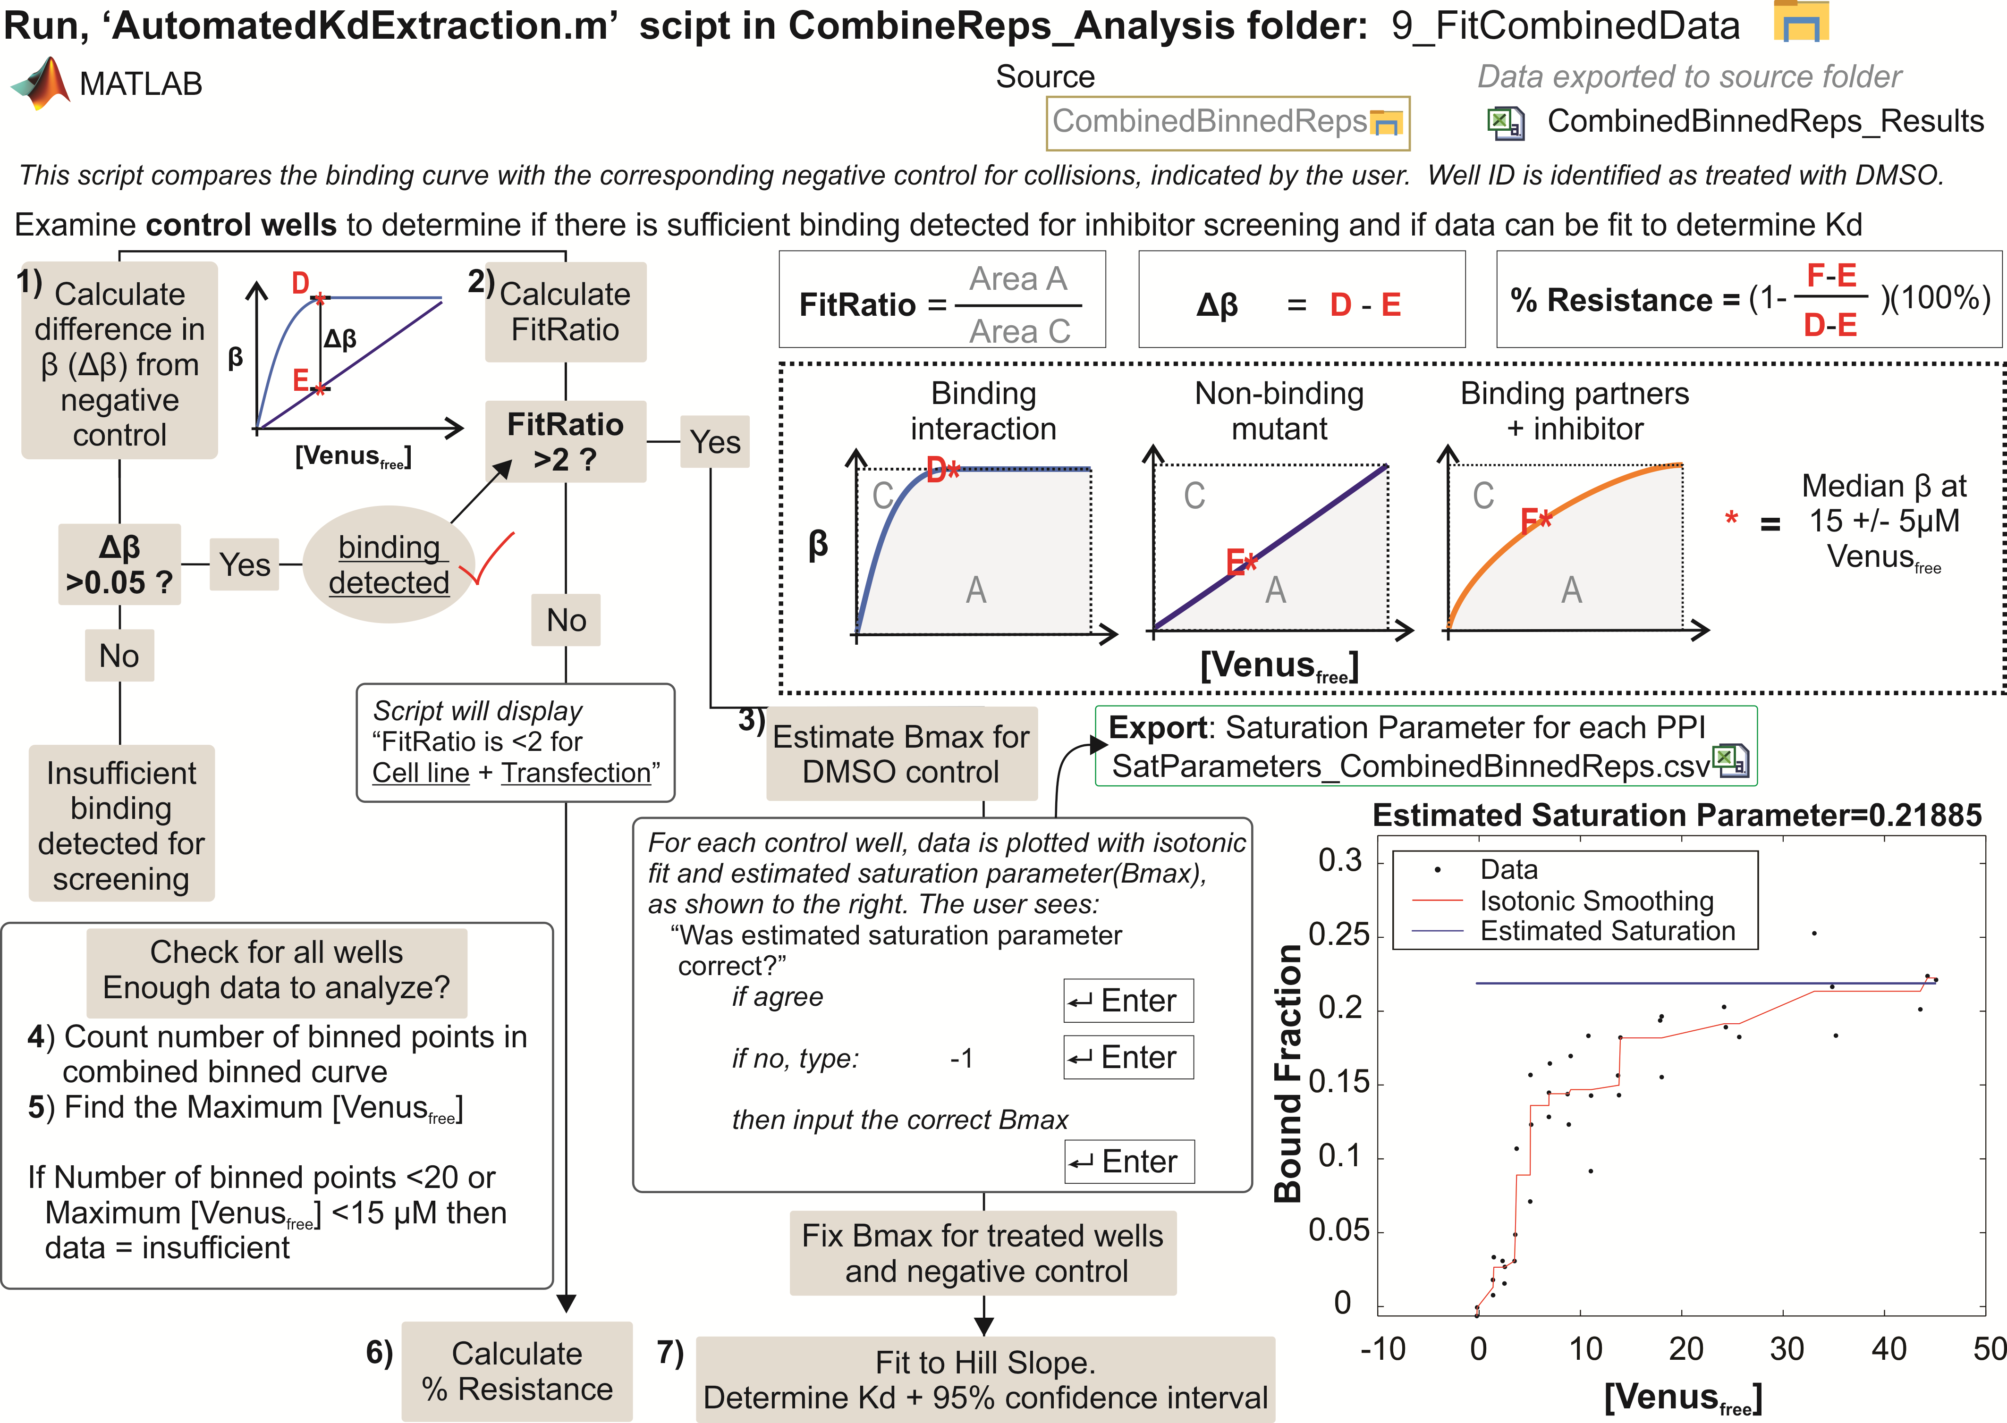

Proper FLIM FRET binding analysis can only be conducted with appropriate negative and positive controls. The absence of the controls renders the extracted information completely useless. In this part of the analysis we examine extract several key binding parameters. These include the dissociation constant, the shape ratio, and the percent resistance (**Supplementary Fig. 5**).

The script first constructs a table of positive and negative controls for each transfection (**Supplementary Fig. 5h**). Binding curves for the controls are used to extract the maximum observed bound donor fraction. If the difference in bound fraction Δβ, between the positive and negative control, is not larger than 0.05 then binding is deemed as “not detected”. Dissociation constant is not determined for wells these transfection conditions. Wells with Δβ > 0.05 are passed to the next phase of the analysis.

The second part of the analysis ensures that the binding behaviour is real and not caused by the decrease of the donor lifetime due to collisional effects. We utilized non-parameterized approach to examine the shape of the binding curve. We refer to this as the shape ratio (sRatio). sRatio larger than 2 indicates a non-collisional binding profile and the profile is fit to a single-site binding Hill slope equation. **Supplementary Figure 5f** shows how simulated curves were used to determine the sRatio threshold of 2 for binding. The maximum bound fraction that can be reached within the examined protein-protein interactions is determined from the positive control. This is used as a fixed parameter when fitting the binding curve to the one site Hill slope equation.

The third parameter used in our binding analysis, is the percent resistance. This is determined as the percent change in the observed bound fraction, at a specific free acceptor concentration, compared to the bound fraction difference between the positive and negative controls. This part of the script is run in a semi-supervised way. The user is presented with the positive controls profile and asked if the bound fraction and the sRatio are correctly estimated by the algorithm. Ensuring the quality of the binding curves observed for positive controls should be taken in consideration when interpreting the binding data.