**5_Filter_data_ExtractRawCurves**

Graphical representation:

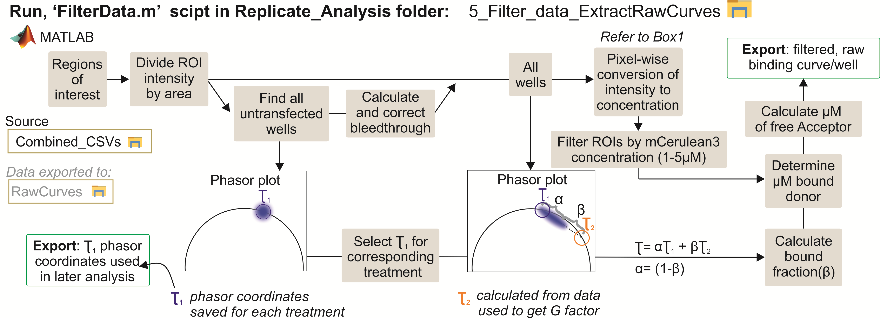

They key task of this step of the analysis is to convert photon and intensity information for each ROI into concentration information. During each screening repetition, gradients of purified mCerulean3 (donor) and Venus (acceptor) are imaged (**Supplementary Fig. 1f**). These gradients are then used to reconstruct standard curves that convert photon counts and intensities to concentrations. The fluorescence lifetime decays from the FLIM channel are used to determine the total donor concentration and the bound donor fraction. While the spectral profile is used to determine the total acceptor concentration.

To extract the concentration parameters correctly, bleedthrough and noise artifacts are first corrected. Starting with the donor bleedthrough into the acceptor hyperspectral profile (**Supplementary Fig. 1g**). This bleedthrough is introduced due to the spectral overlap of the donor emission and the acceptor excitation (FRET conditions) and signal collected by PMT detectors in the hyperspectral channel is performed non-synchronously with respect to the excitation pulses. The amount of bleed through is directly proportionGral to the fluorescence intensity of the donor labelled fluorescent proteins. Proteins that aggregate in the subcellular components have higher overall intensity per pixel and result in greater degree of bleedthrough. To account for such variation in bleedthrough, we construct bleedthrough profile, during each experiment, for every cell line. This is accomplished by examining the intensity profile of cells expressing donor labelled proteins (untransfected cells). A linear function is fit to the total photon counts (TCSPC donor channel) versus spectral intensity at 530 nm (hyperspectral acceptor channel.

Fluorescence lifetime decay represents a probability distribution of the number of molecules that had gone through a resonance energy transfer. Molecules that remain longer in the excited state will more likely donate their energy to a nearby acceptor fluorophore. Since FRET is an event that occurs on a scale of nanoseconds, photon counts in the first few 100 picoseconds after excitation (we refer to this as time T0) are most likely generated from molecules that have not gone through the energy transfer process. On average, these counts are directly proportional to the total donor molecules imaged within each RIO, irrelevant of the FRET activity. The photon counts at T0 for the mCerulean3 protein gradient is used to determine the total donor concentration.

The phasor approach is used to determine the fraction of bound donors within each decay. In the phasor space it represents the distance along the vector connecting the donor lifetime decays in Its bound and non-bound states. The phasor coordinates for the non-bound state is easily determined from an untransfected well. Coordinates for the bound state are extrapolated by fitting the distribution of all ROI points, in the phasor space, to a line passing through the non-bound state coordinates and finding where it intersects the semi-universal circle. The concentration of bound donor molecules is obtained by multiplying the bound fraction by the total donor concentration. Here it is worth noting that it is very important to measure the changes of the fluorescence lifetime of the donor when a compound is added. For example, ABT-199 has been shown to serve as an acceptor and will act as and will reduce the mCerulean3 lifetime. In this part of the analysis, a table of unbound coordinates for each cell line, at different compounds concentrations, is constructed.

Once the bleedthrough profile and the phasor coordinates for non-binding lifetime is determined, the total donor concentration, the total acceptor concentration, and the donor bound fraction is determined for each ROI. ROIs with total donor concentration smaller than 1 µM and larger than 3 µM are filtered out. For each accepted ROI, the total acceptor concentration, total donor concentration, free acceptor concentration, bound fraction, FRET efficiency, and acceptor to donor ratio is exported. These parameters are saved as CSV file with file name ending with “filtered_raw” to indicate this is the filtered data. The filtered data are much smaller in size than the raw CSV files and are used to construct binding curves (**Supplementary Fig. 5d**)**.**