Daniel Abrego

SWEN 6837

Spring 2021

**Examples of Wiki platforms and common functionality**

Almost all wikis share a set of common functions. Where they differ is how user permissions or group permissions are handled. Some platforms offer fine granularity at the user level, but some grant permissions at more of a group level. Abstractions of these groups vary in terminology and in composition. So a user may or may not be the point at which permissions are applied.

Basic universal features are:

* View page
* Create page
* Delete page
* Edit page
* Link pages
* Search page
* Search tags
* Add tags

**Example 1: Atlassian Confluence**

<https://support.atlassian.com/confluence-cloud/docs/what-are-confluence-cloud-permissions-and-restrictions/>

<https://learning.oreilly.com/library/view/atlassian-confluence-5/9781849689526/#toc>

<https://confluence.atlassian.com/crowd040/group-998652832.html>

Confluence is a social media wiki platform meant for corporate environments. It uses 3 levels of permissions, and users hold permissions as individuals and as part of a group. The three levels of permissions are:

* Global – sitewide permissions assigned by confluence administrators
* Space – each space has it’s own permissions managed by a space admin, a space is a way of organizing content similar to folders
* Page – pages are open to editing by default but can be restricted to users or groups

Users do not have permission to edit the wiki. That permission is provided by being part of a space. Space permissions are:

* view
* delete own
* add page
* delete page
* add blog
* delete blog
* add attachment
* delete attachment
* add comment
* delete comment

Default groups are:

* users – typical users that can add spaces and collaborate, permissions you assign to this group are assigned to all new users
* admistrators
  + add and administer users
  + can create and assign users to groups
  + types
    - space administrators
    - confluence administrator
    - system administrator

simple use-case of wiki interaction:

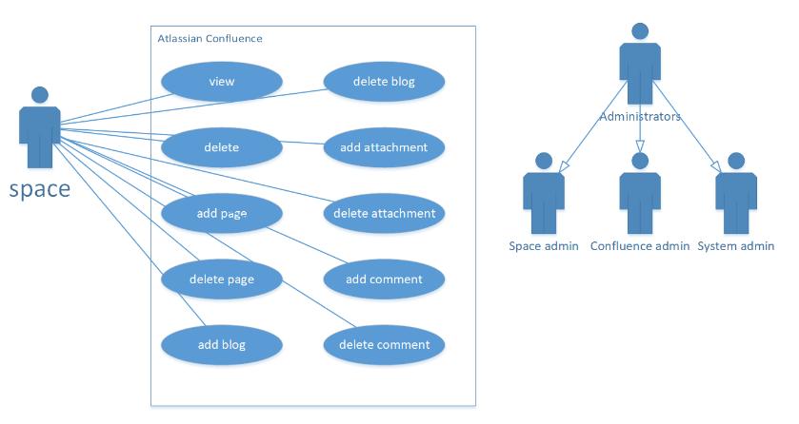

**Example 2: Mediawiki**

<https://workingwithmediawiki.com/book/chapter8.html#toc-Section-49>

<https://learning.oreilly.com/library/view/mediawiki-11/9781847196040/ch08.html>

Wikimedia is a free, open source platform that powers wikis such as Wikipedia and Wictionary.

User rights is done through groups. You must assign a user to a group in order to enforce permissions.

User rights are permissions that give you the right to edit or delete pages. User rights are part of the user group.

The list of possible permissions is extensive and found here:

<https://www.mediawiki.org/wiki/Manual:User_rights#List_of_permissions>

Commonly found permissions:

* read page
* create page
* edit page
* move page

Default groups are

* Sysop – performs administrative tasks on wiki pages
* Bureaucrat – assign users to different groups
* Bot – used by accounts that are automated scripts
* Users

simple use-case of wiki interaction:

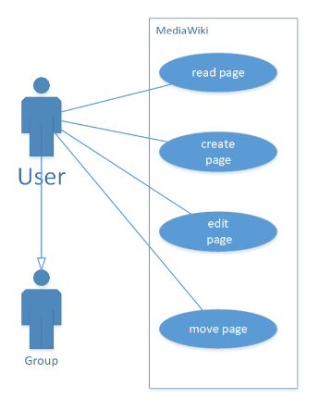

**Example 3: Sakai Learning Management**

<https://sakai.screenstepslive.com/s/sakai_help/m/68426/l/728722-what-are-permissions-and-roles>

Sakai learning management is a free educational platform that functions as a learning management system often used by schools. It included a wiki. Wiki permissions are simple.

2 levels – site and page level.

Permissions (from URL referenced above):

* Read (read pages)
* Create (create new pages; update must be enabled to allow this)
* Update (edit pages)
* Admin (alter site permissions)
* Super-admin (typically reserved for system administrators)

simple use-case of wiki interaction:

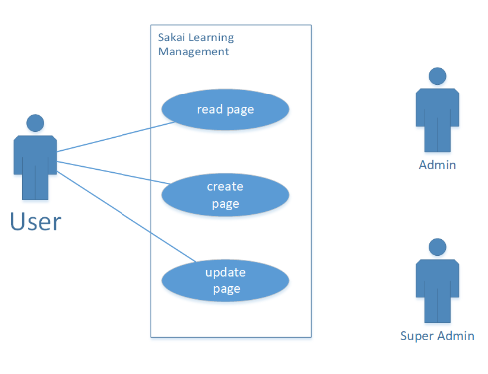

**Example 4: Dokuwiki**

<https://www.dokuwiki.org/acl>

https://www.inmotionhosting.com/support/edu/dokuwiki/create-namespace-doku/

Dokuwiki is an open source wiki platform that operates on text files rather than a database. Dokuwiki makes use of an Access Control List to restrict access. Access restrictions can be bound to:

* Pages
* Namespaces – a namespace is a folder that allows for organization of pages in sub categories

From <https://en.wikipedia.org/wiki/DokuWiki>:

*Access control can be handled by a user manager which allows users and groups of users to be defined, and an*[*access control list*](https://en.wikipedia.org/wiki/Access_control_list)*where an admin user can define permissions on page and namespace level, giving it much better access control than Mediawiki.*

Permissions are:

* None
* Read
* Edit
* Create
* Upload
* Delete
* Admin

simple use-case of wiki interaction:

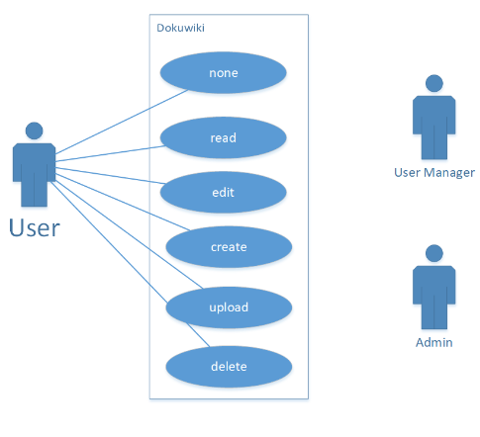

**Example 5: Sharepoint**

<https://learning.oreilly.com/library/view/microsoft-sharepoint-2016/9780735699274/app01.html>

Sharepoint is a collaborative platform primarily used for document management. But it also includes a wiki feature. Access to wiki permissions is done through permissions or permission levels. An admin position will assign permissions to a user or assign a group of users to a permission level.

Default permission levels from <https://www.cloudfronts.com/understanding-the-permission-level-in-sharepoint-online/>

* **Full Control** – Has full control.
* **Edit** – Can add, edit and delete lists; can view, add, update and delete list items and documents.
* **View Only** – Can view pages, list items, and documents. Document types with server-side file handlers can be viewed in the browser but not downloaded.
* **Contribute** – Can view, add, update, and delete list items and documents.

simple use-case of wiki interaction:

