Development Log

The development of the game started using the assessment starter code, as well as the refactored code from the class sessions. The main challenge of adapting this code was the fact that objects containing references to other objects used a string representing the name of the object rather than the object itself. Removing this kind of reference required refactoring almost all of the code and it became apparent that completely starting over would have been a better process.

Another challenge was initialising all the required location objects when the directions dictionary for each one referenced ones that hadn’t been made yet. To fix this I initialised them all as strings when creating the locations and then made a dictionary that linked the strings to the actual objects. A method in game then replaces the strings in the directions dictionaries with the actual locations using the before mentioned dictionary.

Another challenge was using an ‘equipped’ attribute for each item. This led to very complicated logic for equipping items in different slots and unequipping the old item in that slot. To solve it I created a loadout class that had an attribute for each slot that starts empty. This loadout was then used in the player class alongside the inventory slot which made it easier to keep track of and also display to the player via the GUI.

I originally built the “run” method in the gui class to parse all of the players commands. Upon reaching the testing stage I realised that this logic needed to exist separately from the GUI of the game and created a command_parser class between the game and GUI. This could have been avoided by considering the testing aspect of the process during the design of the game and with more careful planning.

The overall development process was hard as I was learning new techniques as I went and frequently had to go back and refactor things to include new syntax or techniques. This combined with the starter code being very inefficient required constant changes and it became hard to keep track of each module and what was finished and working. If I did this again I would create some simple headless testing to use throughout the process as well as ignoring the starter code and building the program from the ground up.

Data Types

Tuples
The commands help variable in the GUI class contains a list of tuples that is used to build the commands list popup:

(gui.py line 7)
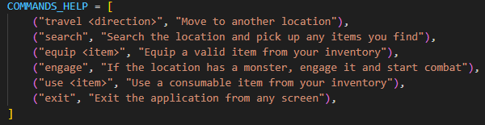

A tuple is used because each command needs the actual name of the command and what it does and these need to be in a consistent order to display in the window correctly. A tuple can be used here because these commands will never change.

Lists
A list is used in the inventory class to store the players currently owned items:

(inventory.py line 3)
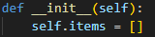

A list is used because of its mutability, meaning the inventory can be added to or removed from as the game runs and because the items in the list are specifically referred to they can just be stored as a value without an identifying key.

Dictionaries

A dictionary is used to map actual location objects to the initial string references in the locations:

(game.py line 119)
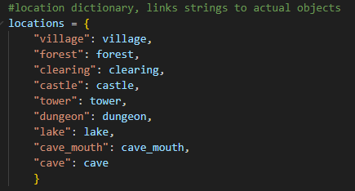

Using a dictionary here allows the locations to be looked up by name, as this is how they are initialised earlier, and find the correct value that corresponds to that name.

Sets
A set is used in the GUI class to display to the player their equipped items:

(gui.py line 99)

A set is used because this is an unordered collection of unique items. The refresh display method that updates the inventory window does not need to have these items in order and a set enforces that there is no duplicates which would not make sense as an item can only be equipped to a single slot.

Comprehensions

The game class uses dictionary comprehension to replace each locations directions strings with the actual location object:

(game.py line 133)
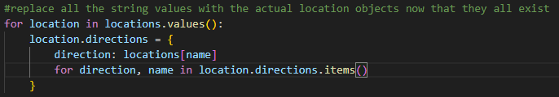

The comprehension is used to find the correction location object using the string found in the directions location as the key. The correct value is then returned (the location object).

Final Reflection

I found this project to be ideal for learning and using python. The language itself is very intuitive and the main difficulty I had was constantly looking up the syntax for things I knew to exist. As mentioned before, if i had to do this project again I would disregard the starter code entirely but I’m sure adapting and fixing that code was a good learning tool in how not to do some things and the ways code can be hard to read and maintain.

A lot of the time was spent trying to make FreeSimpleGUI behave correctly, the documentation for the package is quite hard to read and apply especially after developing browser apps in other courses. The actual game code outside of the GUI was quite simple and easy to make.

Keeping to a very simple design was a good choice and made the development easy as the requirements and game design changed very little throughout the process.

