Adam Whitaker-Wilson and Doug Walch

Dollar Grocers Website

Comp 2680 - Web Design & Development I

December 2nd 2016

Here at dollar grocers we pride ourselves on providing exceptional service and unique selections of natural and organic food products to Vancouver’s very own commercial drive. At this one stop shop we aim to satisfy all your needs for fresh produce, dairy, deli, bulk foods, groceries, and rare imported specialty products that you can’t find anywhere else. We listened to our costumers and now have a brand-new Juice Bar with delicious fresh pressed juices prepared daily for you to grab and go! Come on in to Dollar Grocers now and experience this family owned, community-driven store packed with local, imported, natural and organic varieties at affordable prices.

Project Objectives:

1. Develop a web presence with multimedia, general store information and a suppliers list.

2. Include a simple quick order form.

3. Include an extended pick-up or delivery order form.

4. Include a questions or comments form.

5. Include a photo gallery page.

6. Current product specials presented in a table.

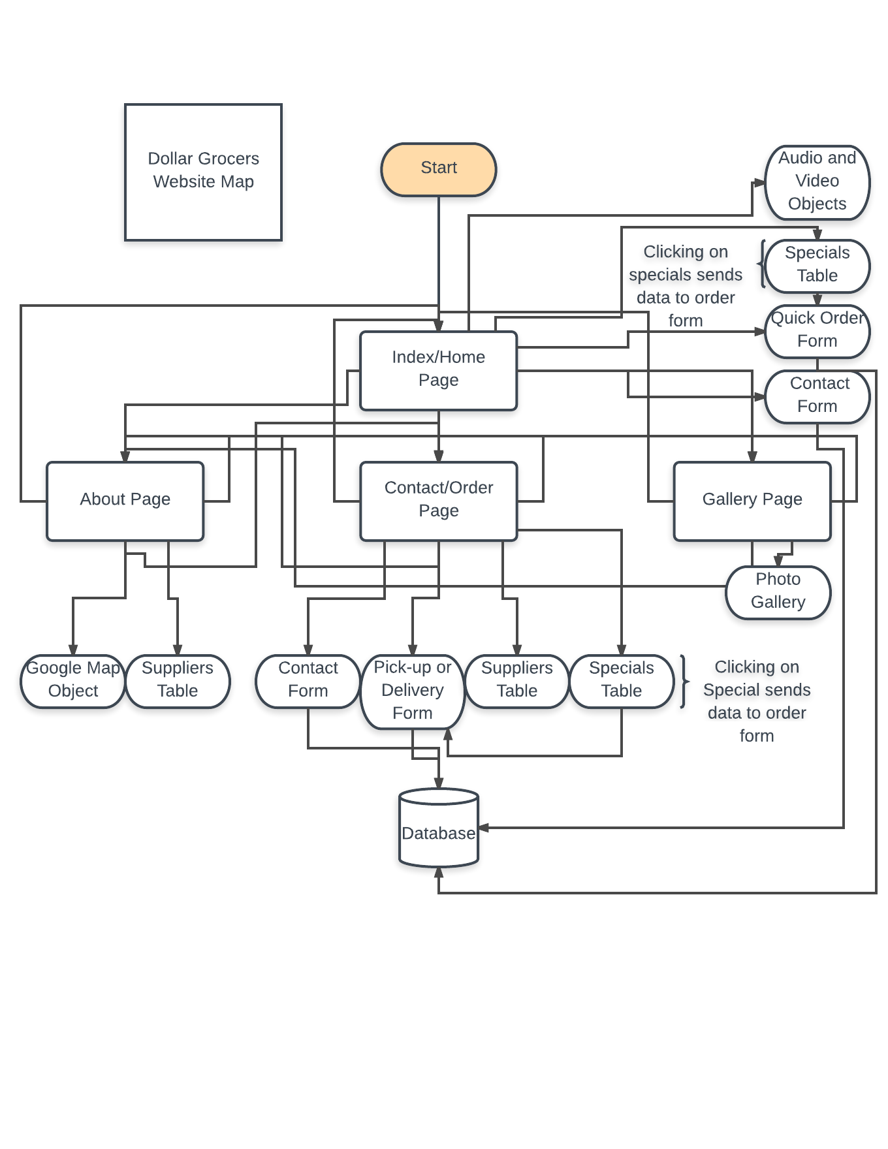

Bibliography

1. www.bensound.com, Website Title: Royalty Free Music by Bensound | Creative Commons Music,

Article Title: ROYALTY FREE MUSIC by BENSOUND, Date Accessed: December 01, 2016

2.http://www.w3schools.com/, Website Title: W3Schools Online Web Tutorials,

Article Title: HTML, Date Accessed: December 01, 2016

3.https://www.w3.org/standards/webdesign/script.html, Website Title: JavaScript Web APIs - W3C,

Article Title: W3C, Date Accessed: December 01, 2016

4.Patrick Carey, New perspectives on HTML, CSS, and Dynamic HTML, 5th Edition.

Course Technology Cengage Learning, Australia, 2013. ISBN-13: 9781111526436

5.http://www.youtube.com

6.https://www.google.ca/maps

7.https://www.lucidchart.com

8.https://validator.w3.org/

9.http://www.dollargrocers.com/