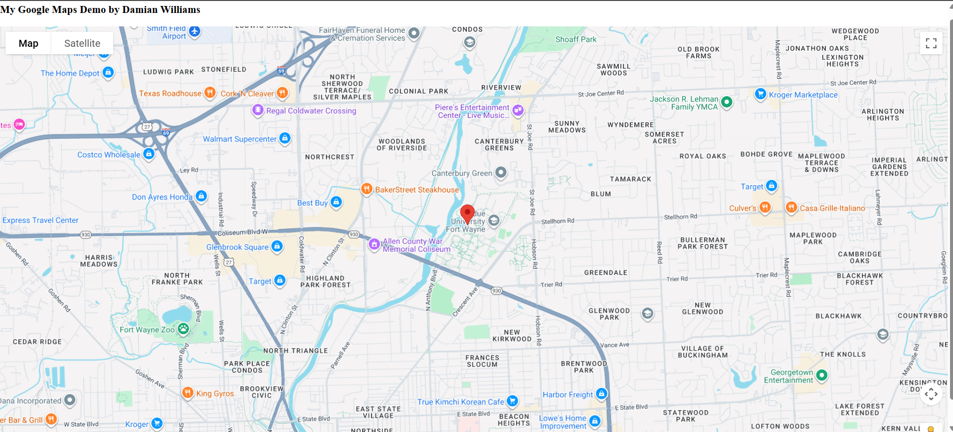
Google Map that displays a map centered at our university
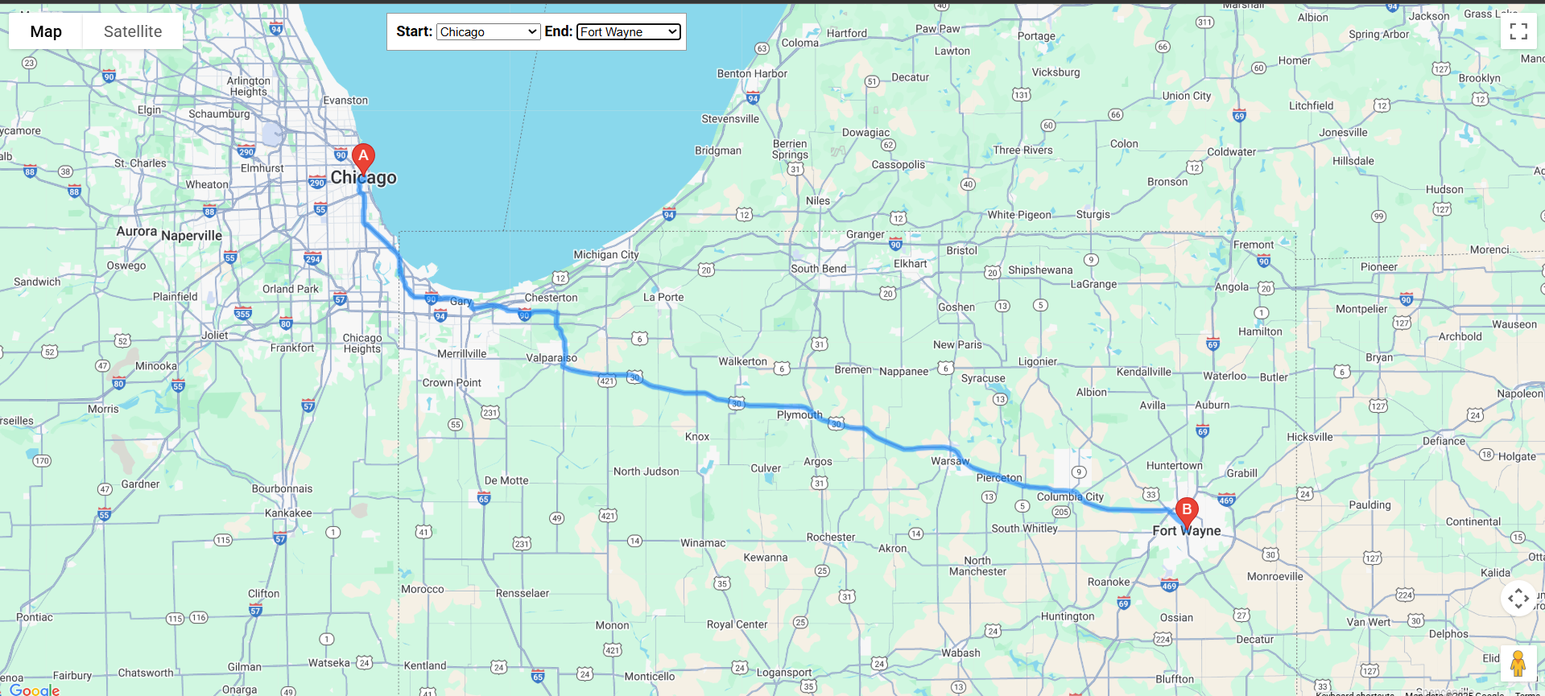
Google Map that displays the direction route from Chicago, IL to Fort Wayne, IN
