Relaxed

Excited

Scared

Angry

Sad

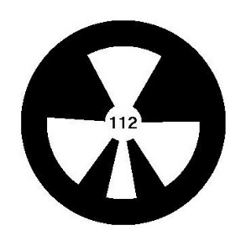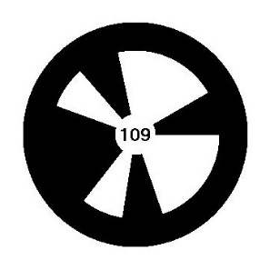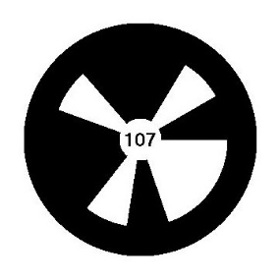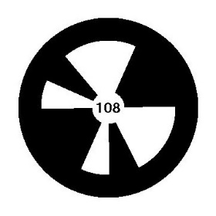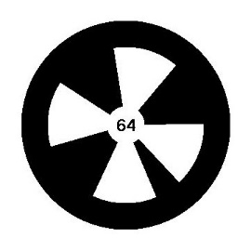

Relaxed

Excited

Scared

Angry

Sad

Show this

to

the robot

Show this

to

the robot

Show this

to

the robot

Show this

to

the robot

Show this

to

the robot