Cortana extension - the use of voice commands
Overview:
Cortana is a personal intelligent assistant, it can understand the user's preferences and habits to help users make a schedule, answer the questions, etc…
Cortana was officially released together with Windows Phone 8.1. And now Win10 SDK has been greatly improved in voice command function. Among them, the biggest progress is the new definition of the command configuration file to support for more natural language form, and support the new features of SDK Win10---App Service. By calling the App Service, you can provide data for Cortana to interact with the APP without the foreground progressing. Then Cortana voice commands can not only support the interaction with the front APP, but also with the background services. Through this upgrade, Win10 SDK provided a more intelligent voice command API to make developers integrate voice commands more easily.
Through the samples you will learn:
- File element and attribute definition of Voice Command Definition（VCD）;
- Using voice commands to start the foreground application in Cortana;
- Create App Service;
- Using voice commands to start the background application in Cortana;
- How to interact with the background application in Cortana;
- How to dynamically modify the voice command definition (VCD) phrase list.

Foreground voice command architecture
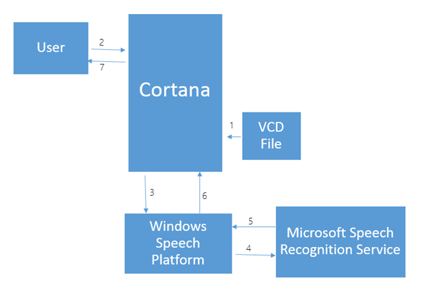
Workflow of Cortana is as follows:
- When APP is running, you need to install the VCD file in Cortana. (VCD: voice command definition, a XML file, which contains all the commands used to activate the application).
- The users can use the command which defined in the VCD file to start the application.
- (3, 4, 5, 6) users can convert voice into command text through Microsoft cloud voice platform and Microsoft voice recognition services.
- Cortana will receive the identified alphabetic string to start the application, and carry out the corresponding event in the application
Challenge
We will use Visual Studio 2015 to create a new project to learn about API related to Windows Cortana.
Scenario description
We have implemented a management of travel plans in this project. Users can record the relevant information about the trip through this APP, such as: the time period, which city, and what have done. The users can start the foreground application through the Cortana voice commands, and can also interact with the background services of the application through voice commands. In this application, you can display the details of the travel notes based on voice commands. In order to improve the intelligence level of the program, the application can update the phrase list of commands by using the language which the current device sets up.
Using voice commands to start the foreground application in Cortana
Running Visual Studio 2015 from the desktop or start menu.
- Create a new project
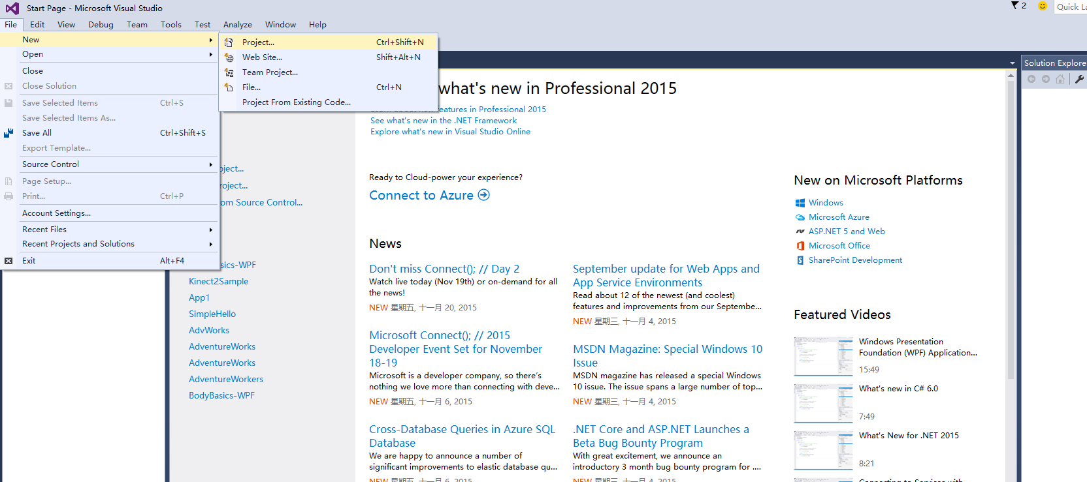
Select the blank application (general Windows) type project from the project template. This template is located in Installed > Template > Visual C# > Windows > Blank application (general Windows). Blank application (general Windows) is one of the most simple window applications, it can run on a number of Windows 10 platforms. The purpose of this experiment for the project, we proposed to call the project as AdventureWorks.
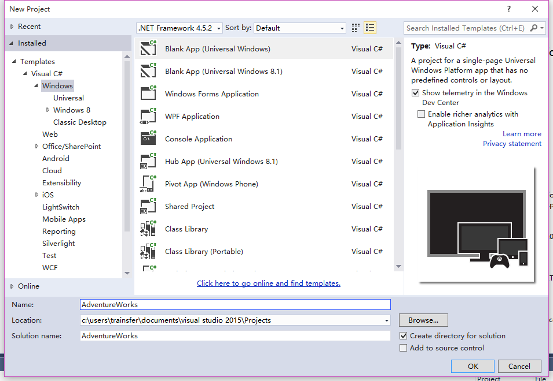
Create Voice Command Definition (VCD) document
Right-click the Adventureworks item (unless you have other names) in “solution “explorer. Select “new project” from “add” menu.
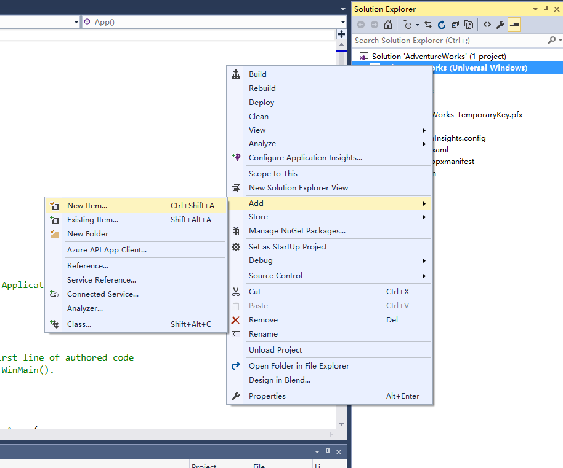
In the left panel, click Installed– data and select "XML file". For the purpose of the experiment for this project, we recommend that you create the XML file name as AdventureWorksCommands.xml. Click the “add” button.
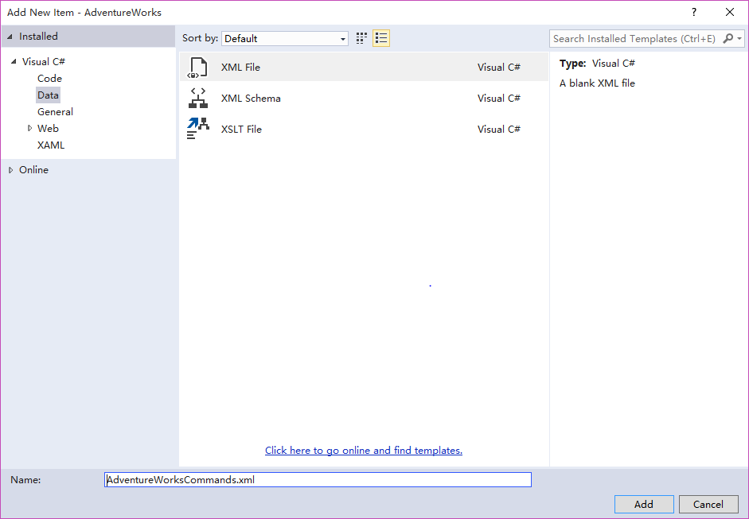
In “solution explorer”, click “AdventureWorksCommands.xml”. In “properties “window, set the “copy to the output directory” option to always copy, which will ensure that the XML file is part of the application package.
Edit the AdventureWorksCommands.xml file for the application to add voice commands, based on the purpose of our experiments, our voice commands are defined as follows:
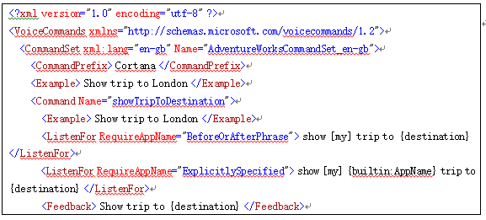
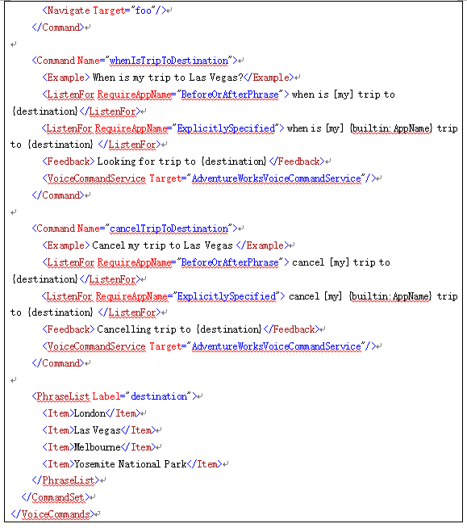
Notes: in XML file, we have defined a Chinese speech command set, in voice command definition file, there is a CommandPrefix node, and its content is Cortana. This node is the prefix used by the user to invoke the voice command.
When calling the voice command, the user needs to tell Cortana "Cortana, show the trip to London", then you can open the application.
Press” Ctrl + S” to save the above file to “AdventureWorksCommands.xml”.
Command Definition Voice (VCD) file must contain the following elements:
- Voice Commands element: root node of VCD file, the attribute of xmlns must be “http://schemas.microsoft.com/voicecommands/1.2”, it can contain 1-15 CommandSet nodes, each CommandSet node represents a language of voice commands.
- CommandSet element: A set of commands for different languages definitions. Such as: xml:lang="zh-cn", has Defined a set of Chinese voice commands. (Attention: Lang attribute must be unique)
- CommandPrefix element: the child node of CommandSet, which have defined the prefix of the command, the command is usually composed of CommandPrefix +Command.
- Command element: the child node of CommandSet, which defines a separate command. It contains several elements and must be listed in the order, such as : Example (1), Listen For (1 to 10), Feedback (1), and Navigate (1).
- Example element: tell users the description of the voice commands supported by this App.
- Listen For element: Monitor and recognize the user's instructions, each command can have (1-10) elements. (The contents in element {} can be defined in PhraseList node, the phrase [] can be ignored).
- Feedback element: A feedback to the user after Cortana identifies the command. It is for Cortana to display.
- Navigate element: Declare that Voice command will be used in foreground of the application. It is mutually exclusive with Navigate element, so only one of them can be used.
- Phrase List element: Used to define a set of phonetic characters, specify the corresponding provisions of the character, and eliminate ambiguity. PhraseList limition recognition is applicable to a relatively small set of words. When the word set is too large (for example, hundreds of words) or should not be limited , use PhraseTopic element and Subject element to optimize the relevance of the results of the voice recognition, thus enhancing the scalability.
- PhraseTopic element: it can improve the recognition rate, the internal attribute Subject can specify the type of keyword, such as name, city name, address, etc…
Install VCD command file
In “solution” explorer, click App.xaml to open App.xaml.cs file.
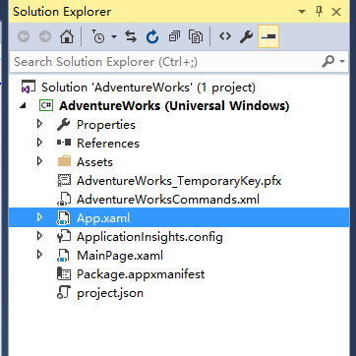
Add the following namespace at the top of the file:
using Windows.ApplicationModel.VoiceCommands
Find “OnLaunched” method, in the end of the method, add the code to install the VCD file, at the same time, to modify OnLaunched method as async. Code is as follows:
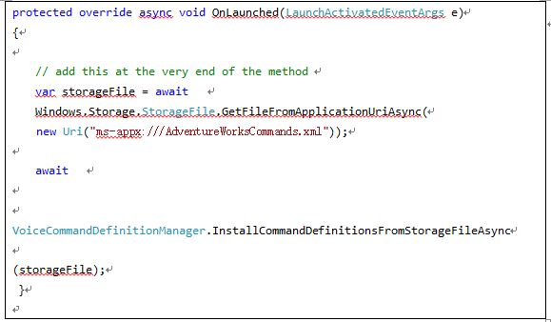
After running the program, the VCD file can be installed and registered in Cortana. After the installation of the VCD file, input "Cortana, show the trip to London " in Cortana, then you can open our application.
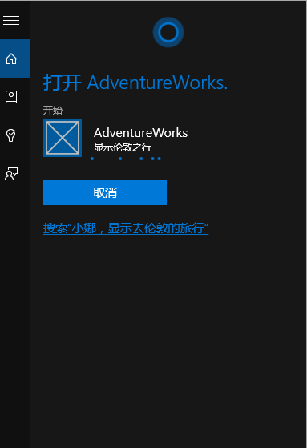
Create XAML view file
We need to add two pages to show our list of travel plans and travel details.
Right-click the Adventureworks item (unless you have other names) in “solution “explorer. Select “new project” from “add” menu. Find Installed Template > Visual C# > Blank page, based on the purpose of our project, we suggest the name of the page as TripListView. xaml.
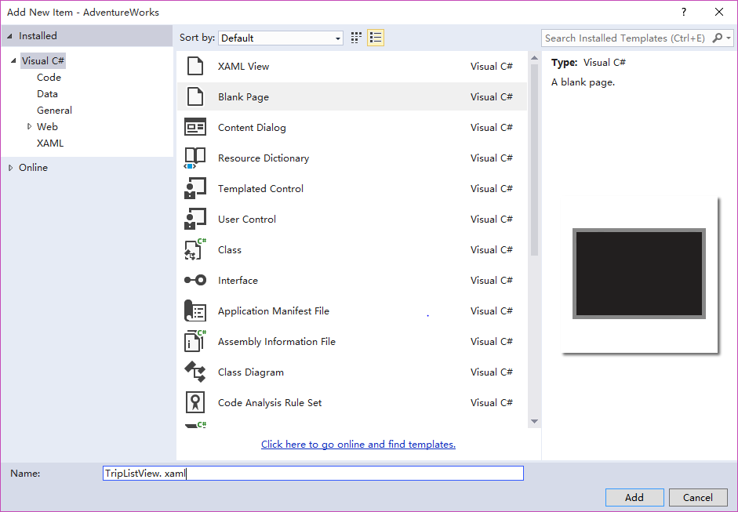
Repeat the Previous step operation, then we add a new page to show the details of the trip. We propose to name it as TripDetails. xaml.
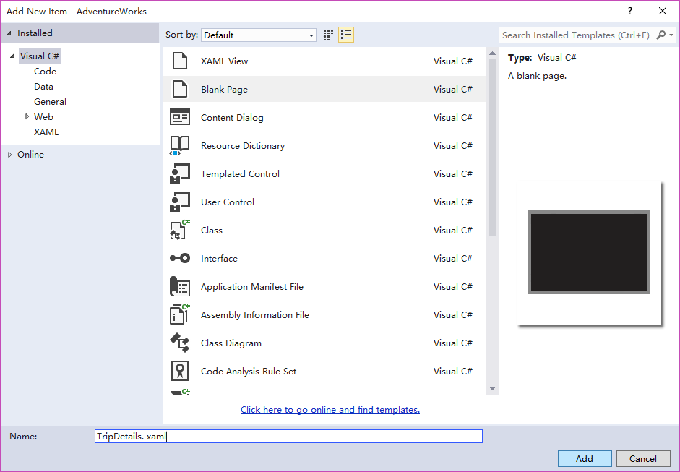
Processing voice commands
Cortana will start our APP through the corresponding voice commands. So in App.xaml.cs file, we need to override the OnActivated method. The method is invoked by the system when the APP is started, we need to determine which voice command is used by the user in this method, and realize the corresponding logic to finish page jump. OnActivated method code is as follows:
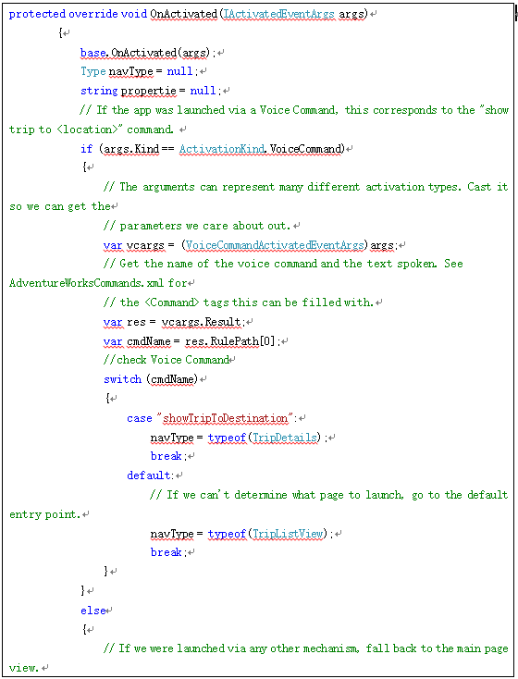
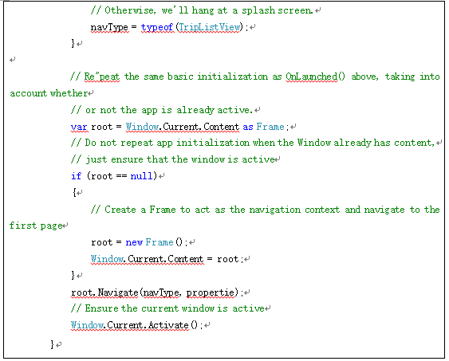
Press “Ctrl + S” to save the above code to the App.xaml.cs file.
Test it
Finally, we need to run the project. Use the debug menu below to change your target platform.
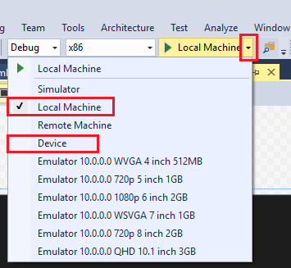
You can open our application by saying “Cortana, show the trip to London “in Cortana, and then jump to the "London trip" details page.
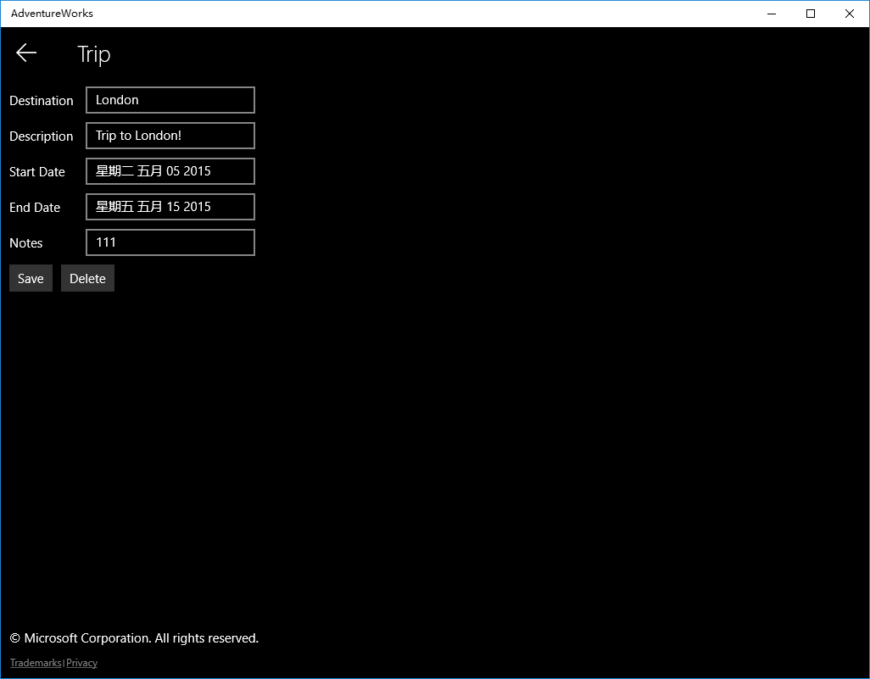
Using voice commands to start background application in Cortana
Win 10 SDK adds a new technology called APP Service to the application, which can be called by APP Service to invoke other applications. App service is handled by the background task, so we don’t need to start the application, the caller only need to know program package name which provides service to the application, and the service name will be called to invoke.
Scenario description
Saying “Cortana, when is the trip to Las Vegas” In Cortana, Cortana will check out the time to Las Vegas through the background APP Service and display it in Cortana panel.
Create application service (APP Service)
Open “solution explorer”, and right-click" solution AdventureWorks" (unless you have other names), and click Add - > New project in the pop-up menu.
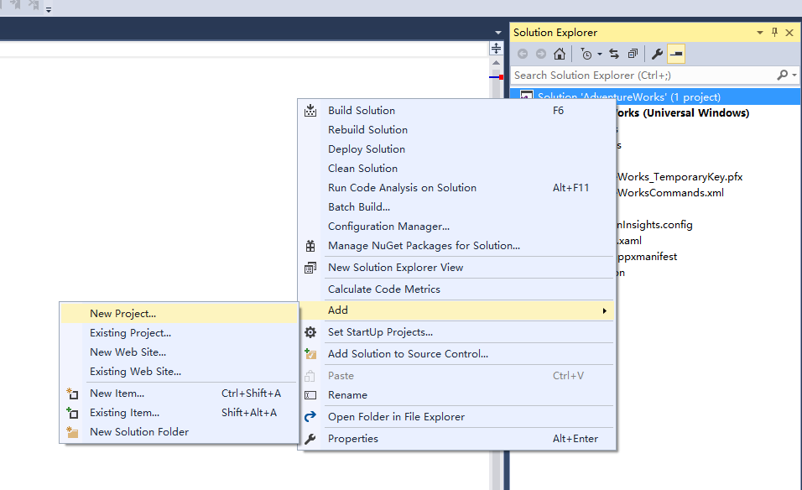
In the new project panel we choose Installed->Visual C#->Windows-> Windows runtime components (general Windows), Based on the experiment purpose of our project, we propose the name as VoiceCommandService.
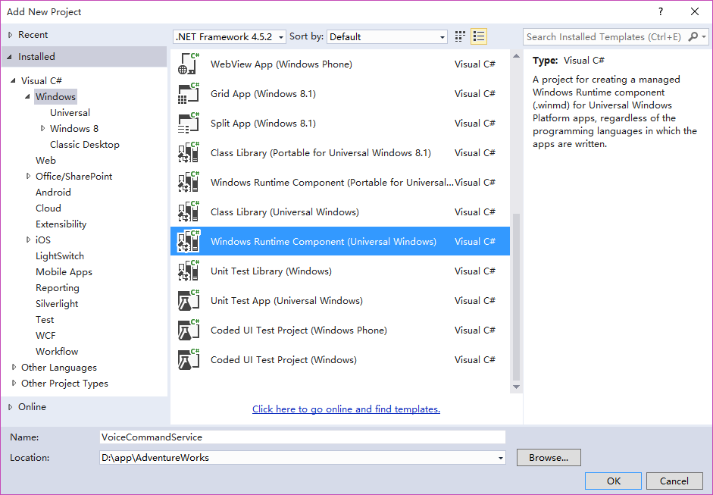
When the project has been created, it will automatically add a class named "Class1" to us. In this example, we will rename the file as
"AdventureWorksVoiceCommandService.cs"
In "AdventureWorksVoiceCommandService.cs" file, we need to create a new class to carry out IBackgroundTask. Run method is required for the entry point and is invoked after the recognition of voice commands in Cortana. (Note: background task class itself and all other classes in the background task project need to be used as a public class).
The following is a background task class for the Adventure Works application.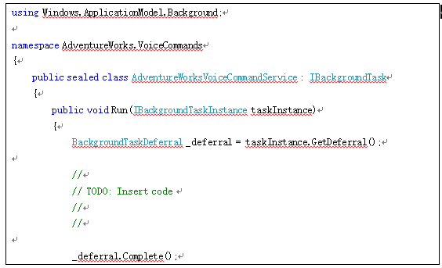
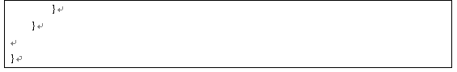
Configure App Service
In “solution explorer”, right-click “Package.appxmanifest”file and select”View Code", then find the Application element, add “Extension” element to the element, configuration item is as follows:
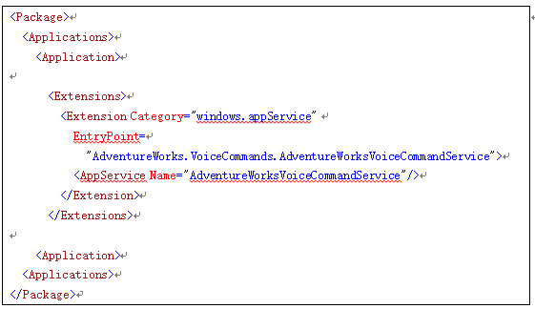
In Extension element, there are two important properties: Category and EntryPoint.
Category property: the type of definition extension, where it is APP Service.
EntryPoint property: A portal namespace for application services, we specify the class we have defined as "AdventureWorksVoiceCommandService". When Cortana invokes the background service, it will run the Run method of this class.
AppService element: Defined the name of App Service.
Modify the VCD file, add the background start command
In”Solution explorer”, open AdventureWorksCommands.xml file and add the following command:
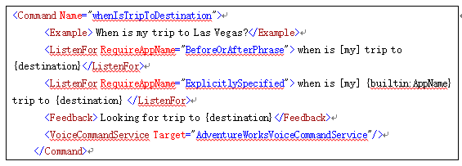
Press “Ctrl + S “to save above code to the AdventureWorksCommands.xml file.
Processing voice commands in application service
Open "AdventureWorksVoiceCommandService. cs" file in "VoiceCommandService" project, and add the following namespace:
using Windows.ApplicationModel.VoiceCommands;
using Windows.ApplicationModel.AppService;
Command processing code is as follows:
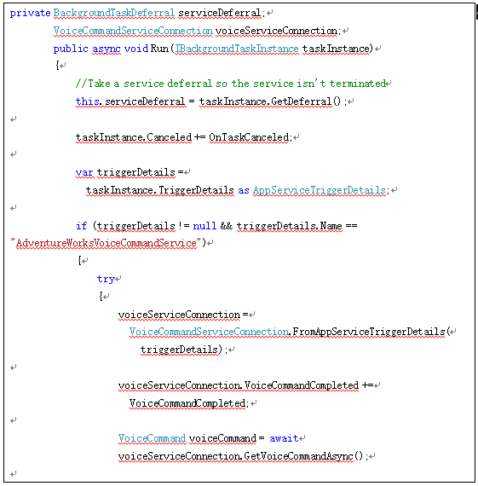
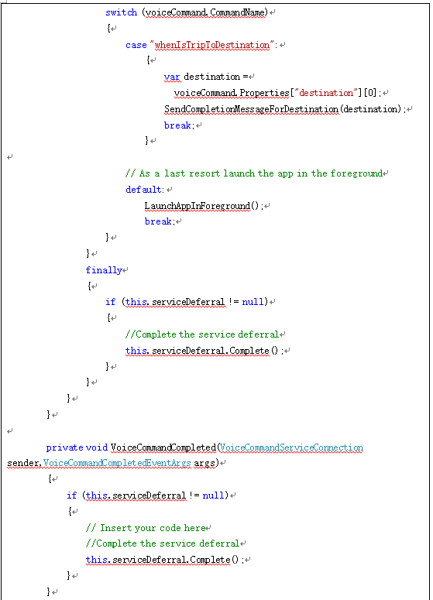
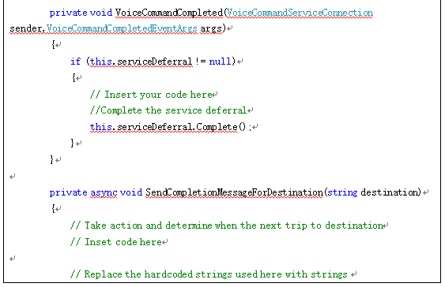
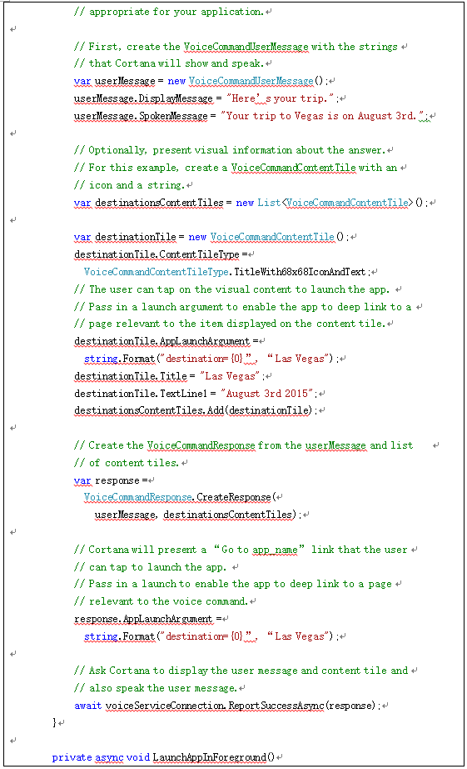
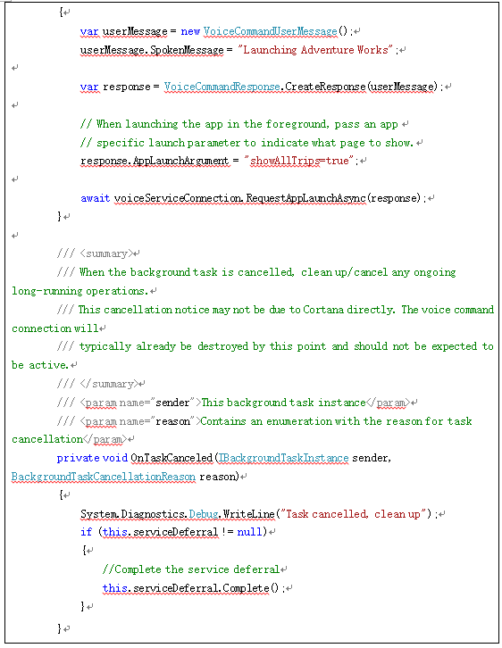
The main function of the background task is to respond to the voice commands which Cortana received, the application triggers through the background App Service, then we can interact in the background task.
VoiceCommandServiceConnection class: Its instance can be obtained from the trigger data in background task instances. It obtains instance by using “FromAppServiceTriggerDetails”method. Several important methods for this class are as follows:
- ReportSuccessAsync (VoiceCommandResponse response): Inform Cortana that processing has been completed, and returns a message to the panel of Cortana to display. (Note: Once Cortana starts the background service, the application service has 0.5 seconds to invoke ReportSuccessAsync method. Cortana uses the data provided by the application to display and speak out the feedback specified in the VCD file. If the application runs it more than 0.5 seconds, Cortana will display switch screen until the application invokes the ReportSuccessAsync method, which will show up to 5 seconds. If the service does not invoke ReportSuccessAsync or any VoiceCommandServiceConnection method which provides information for Cortana, then the user will receive an error message and the application service will be canceled.)
- ReportFailureAsync(VoiceCommandResponse response)：The method is used to feed back the error message to Cortana.
- ReportProgressAsync(VoiceCommandResponse response)：The method is used to report the progress to Cortana, but does not specify a specific progress value, just show the progress bar for 5 seconds on Cortana panel.
- RequestAppLaunchAsync(VoiceCommandResponse response)：The method is used to request Cortana to start the current application.
- RequestConfirmationAsync(VoiceCommandResponse response)：The method is used to send a message which needs the user to confirm to Cortana panel, and the background service will wait for the user's confirmation to decide what to do next.
- RequestDisambiguationAsync(VoiceCommandResponse response)：The method is used to send a message which needs the user to confirm to Cortana panel. Differently from the above method, this method will list several options on Cortana panel, so that users can choose or click to select the option, Cortana will return the user’s choice to the application service to decide what to do next.(Note: VoiceCommandResponse instance as the method parameter must use the CreateResponseForPrompt static method to create)
- VoiceCommandUserMessage class：This calss is mainly used in the interaction process which Cortana interacts with the background service to send a message to Cortana panel package. It has two important properties.
- DisplayMessage: Display text message on Cortana panel.
- SpokenMessage: Text which we hope Cortana to speak out.
Press“Ctrl + S”to save the above code to“AdventureWorksVoiceCommandService.cs”file. Run the application once. Speak or type "Cortana, when start to travel to Las Vegas " in Cortana
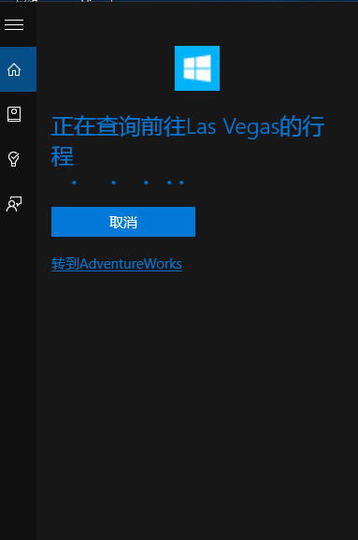
After the interaction between Cortana and the background service, you can check “the time to Las Vegas" in Cortana panel.
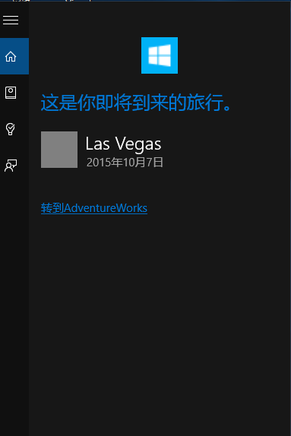
Dynamically modify voice command definition (VCD) phrase list
Modify the voice command definition (VCD) phrase list, in fact is to modify the Item of PhraseList element in VCD file.
Sometimes, in order to support multi language voice commands, we need to dynamically modify the PhraseList content to suit the multi language. Such as: when the device current language is English, the content of PraseList will be {London is Las, Vegas Yosemite, Melbourne, National Park}. In Command, if the phrase hits a project in ParseList, Cortana will call the foreground or background service based on the command. But when we switch the device language into Chinese, we need to update the content in PraseList as {London and Las Vegas, Melbourne, Yosemite National Park} to support the Chinese voice commands.
Open “AdventureWorksCommands.xml”file in “Solution explorer”, Modify the PhraseList element as following code:
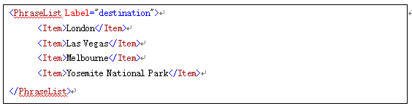
Click and open App.xaml.cs file in “solution explorer”to add the following code:
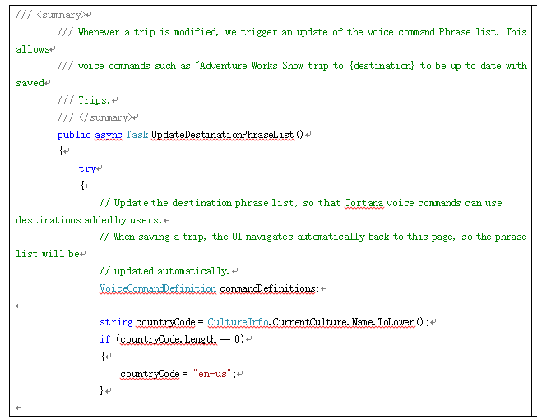
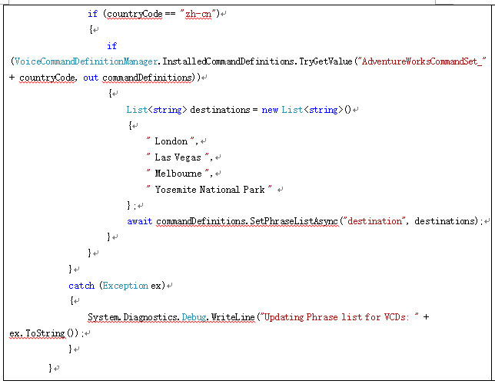
In OnLaunched method, add a call to above code. As shown in the following code:
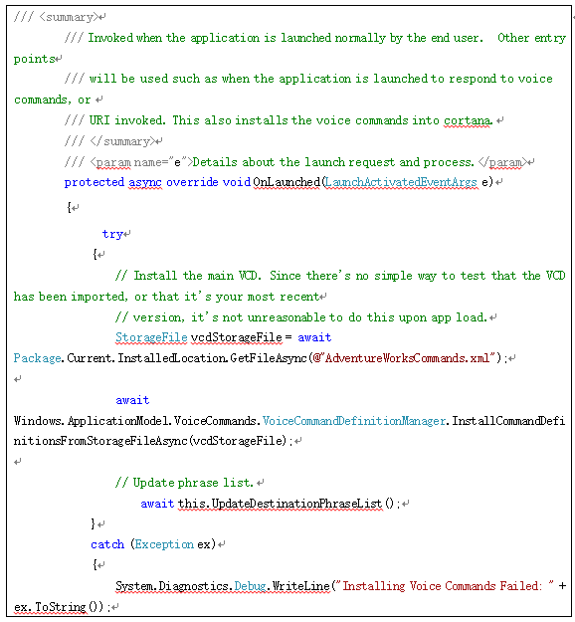VoiceCommandDefinitionManager class：The class is used for the management of VCD file.
InstallCommandDefinitionsFromStorageFileAsync(StorageFile file) method: This method is used to install and register VCD file.
InstalledCommandDefinitions property: The property returns to the description of VCD file.

The VoiceCommandDefinition class contains an important method SetPhraseListAsync, which is used to update the PhraseList element in VCD file. (Notice: if you use this method to modify the phrase list , it will replace the entire phrase list).

