Application of Windows Hello
Overview
Windows Hello is a smart identity authentication system based on biometrics. With it, the user can unlock the device through biometric features such as facial features, iris and fingerprint without using password. Windows 10 SDK provides the API of Windows Hello for developers. Developers can construct their own security strategy through the API and combine their own authentication system with windows Hello to develop more cool applications.
Through the samples you will learn:
- Local password credential management. Credential creation, credential acquisition;
- Enable Windows Hello. Apply PIN Code;
- Others. Application supports multi language;
Ready to work
Windows 10 requires that the PIN code must be enabled on the device containing the biometric sensor to use the Windows Hello to manage the login credentials.
Next, we will demonstrate how to enable PIN code. (If you have enabled PIN code, please ignore the content of this paragraph.)
Enable PIN Code
Open “Start” menu, click Settings - login options
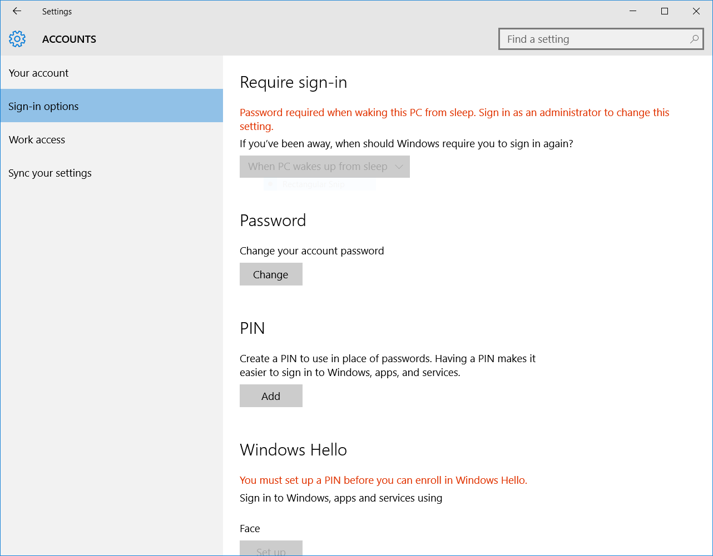
Under “login options” panel, add a PIN code, you can open Windows Hello.
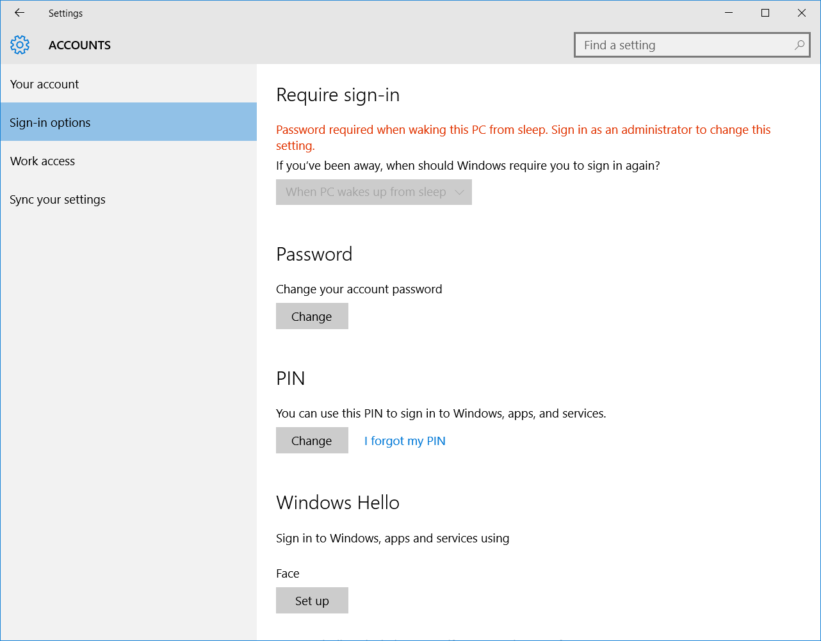
Under “Windows Hello” option, we can set the fingerprint, face, to capture our biological characteristics through the device of the sensor.
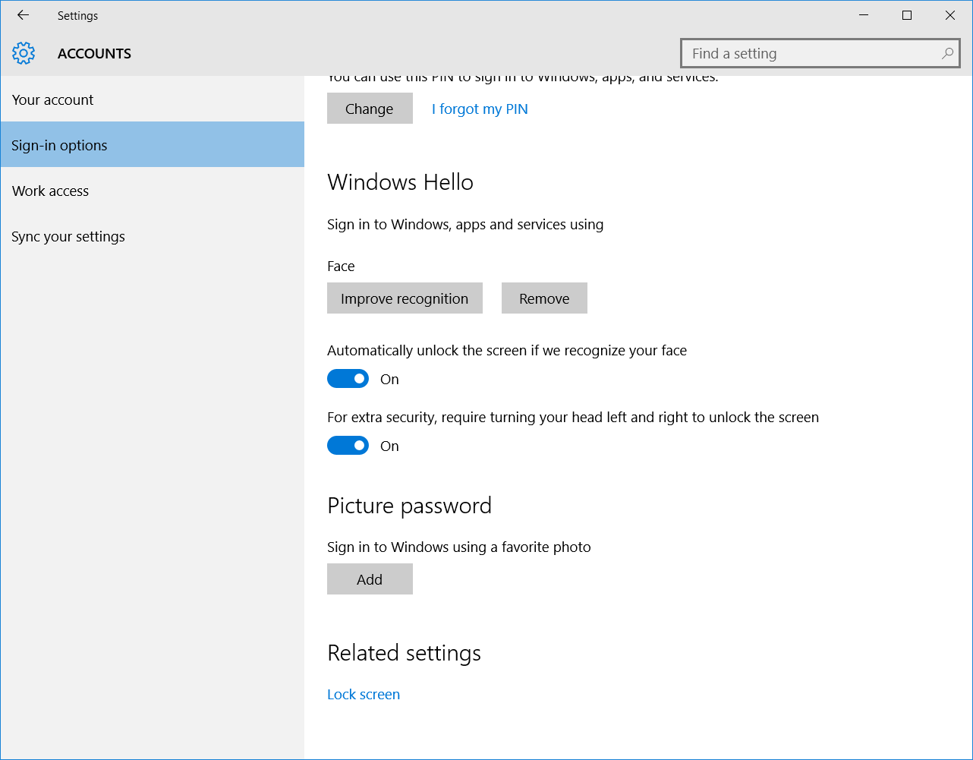
Challenge
We will use Visual Studio 2015 to create a new project to learn about API related to Windows Hello.
Run Visual Studio 2015 from the desktop or start menu.
Create a new project

Select blank application (general Windows) type project from the project template provided.
This template is located in Installed > Template > Visual C# > Windows > Blank application (general Windows).
Blank application (general Windows) is one of the most simple window applications, it can run on a number of Windows 10 platforms. For the purpose of this experiment, we proposed the project name as SimpleHello.
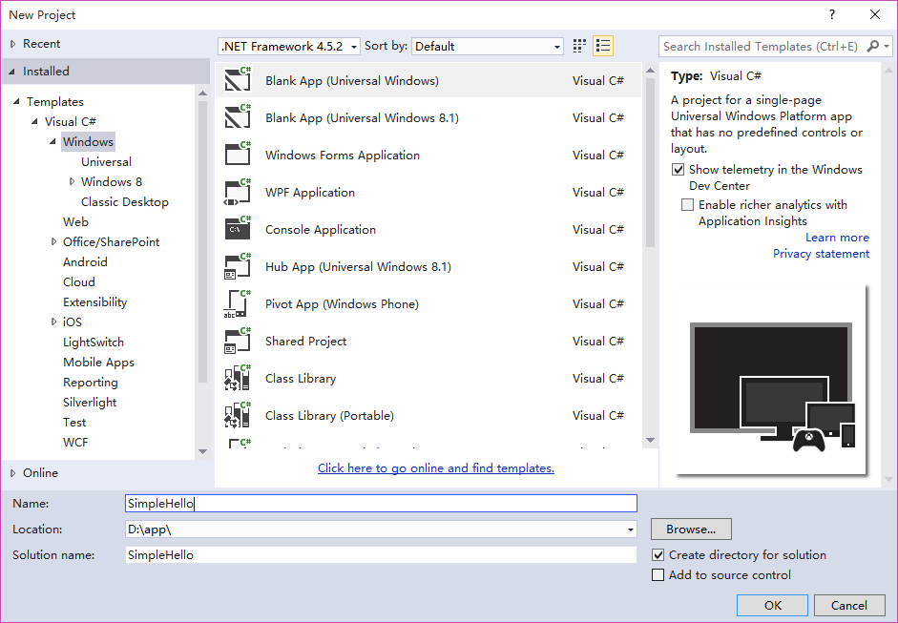
Create scenario
Scenario Description
In this scenario, the main demonstration is how to use Windows Hello API to manage account credentials. This scenario has shown a bank account login process. When the user logged in for the first time, the application will detect whether the current device supports Windows Hello. If the device supports, the application will use the current account credential to create local password credentials. When the user logs in next time, you can use the sensor device to verify biometric features, read and verify the local credentials at the same time, when the credentials are verified successfully, users can check the details of bank accounts.

Knowledge points
Windows Hello key credential management is used KeyCredentialManager class under Windows.Security.Credentials namespace.
KeyCredentialManager class: The class is used for the management of local secret key credentials. The main methods are as follows:
RequestCreateAsync(System.String name, KeyCredentialCreationOption option)：It is used to create local credentials, the method returns a search result class of the password credentials KeyCredentialRetrievalResult. (The method will invoke Windows Hello to return biometric verification results by using local biometric identification.)
KeyCredentialCreationOption parameter: it is a creation operation enumeration, and mainly contains two options: ReplaceExisting (replace if the password credentials exist) and FailIfExists (Password credentials exist, return error).
OpenAsync(System.String name)：Open the local password credentials according to the password credentials user name, this method returns a result calss of the password credentials KeyCredentialRetrievalResult. (The method will invoke Windows Hello to return biometric verification results by using local biometric identification.)
IsSupportedAsync: The method returns to a boolean type used to determine whether the current device supports Windows Hello or not.
KeyCredentialRetrievalResult：This class used to save the search results of password credentials. It contains two properties: KeyCredential and KeyCredentialStatus.
KeyCredentialStatus：It is an enumeration class which defines the retrieval results of the key credentials.
KeyCredential: This class is used to preserve the secret key credentials information, the main method is as follows.
GetAttestationAsync: The method returns to an authentication result.
RequestSignAsync(IBuffer data): The method returns to a password certificate verification results.

Create log in helper class
Right-click SimpleHello(unless you have other names) in solution explorer. Select “new project” from “add” menu.
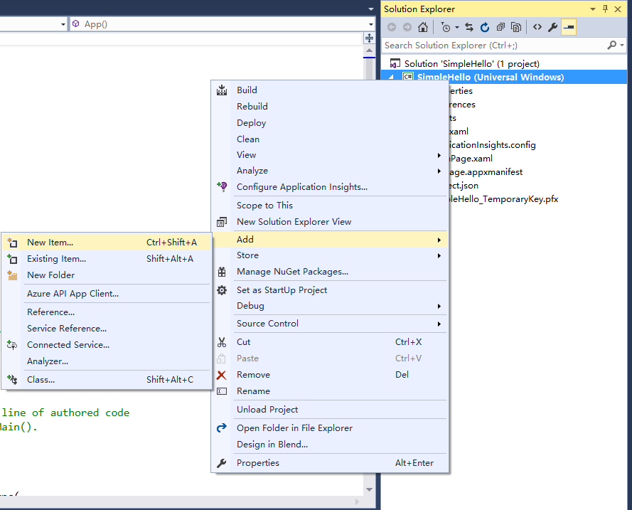
In the left Visual C# template, you can select file type. We add a "class" to implement key management.
We proposed the name as LoginHelp. It is mainly used for the example of the log assisted functions.
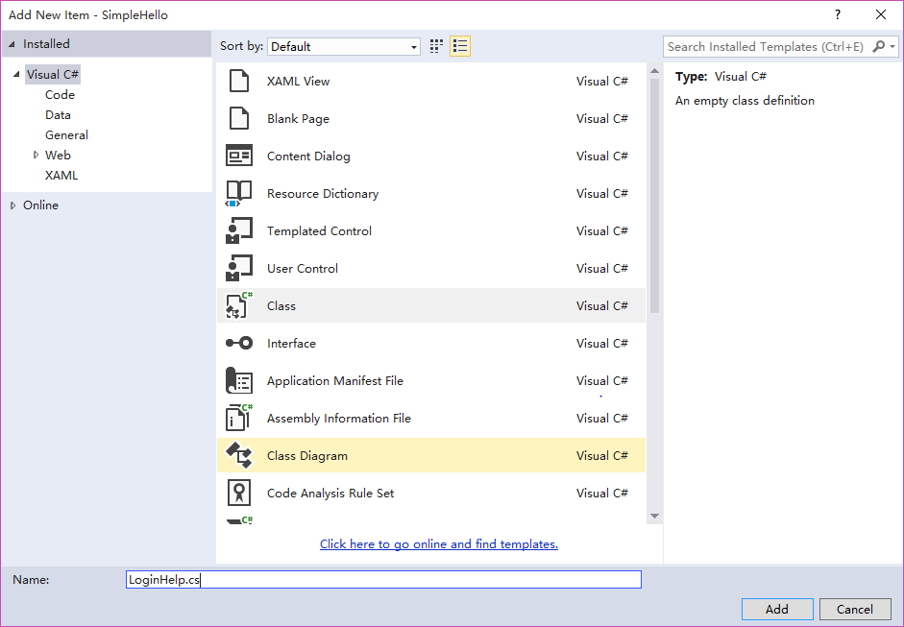
Open LoginHelp.cs file, add key management and log related methods. Code sample is as follows:
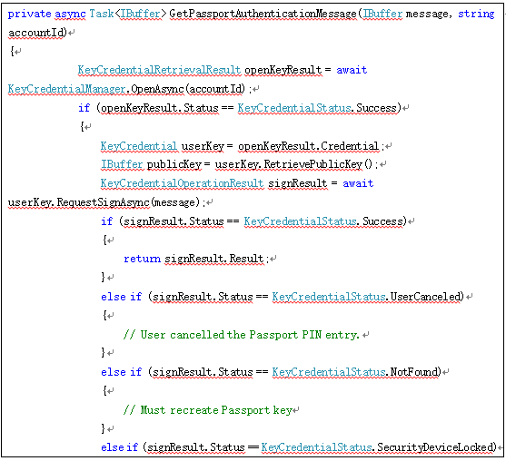
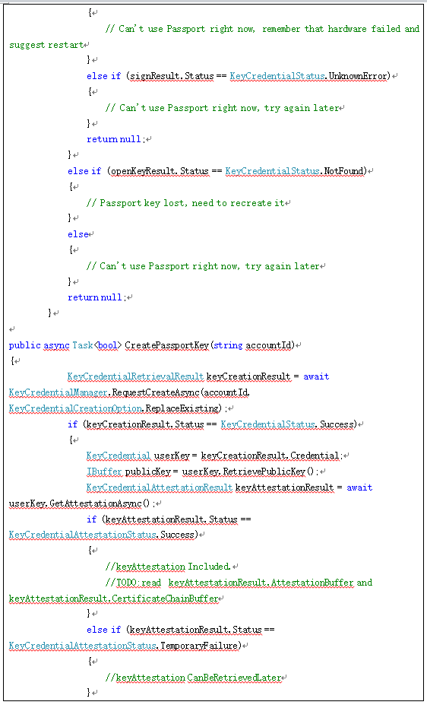
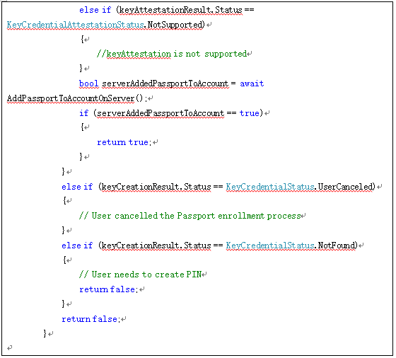
The two methods in the code fragment accomplished the creation and identification of the local key credentials through the current device's biometric identification (Windows Hello).
CreatePassportKey(string accountId)：This method realized the creation of local password credentials.
GetPassportAuthenticationMessage(IBuffer message, string accountId)：This method realized the reading of the local password credentials.
Create log view file
Right-click SimpleHello(unless you have other names) in solution explorer. Select “new project” from “add” menu.
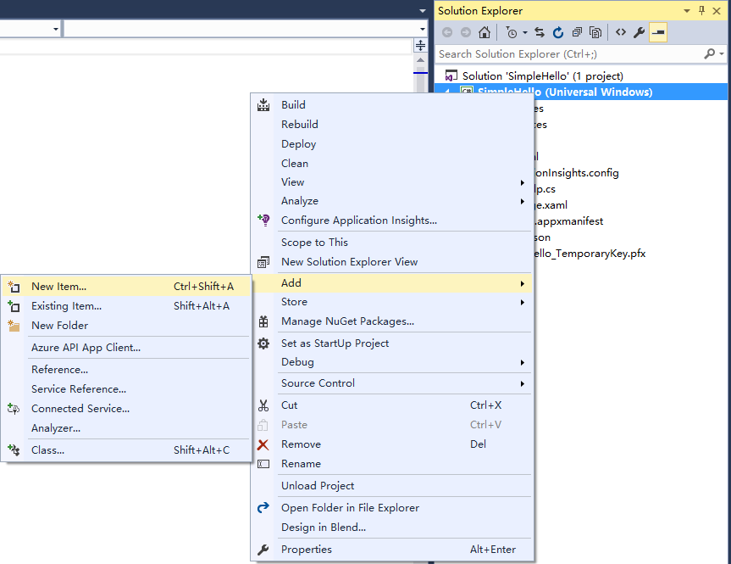
In the left Visual C# template, you can select file type. We added a "blank page" to show our login page. We proposed the name as SignIn.
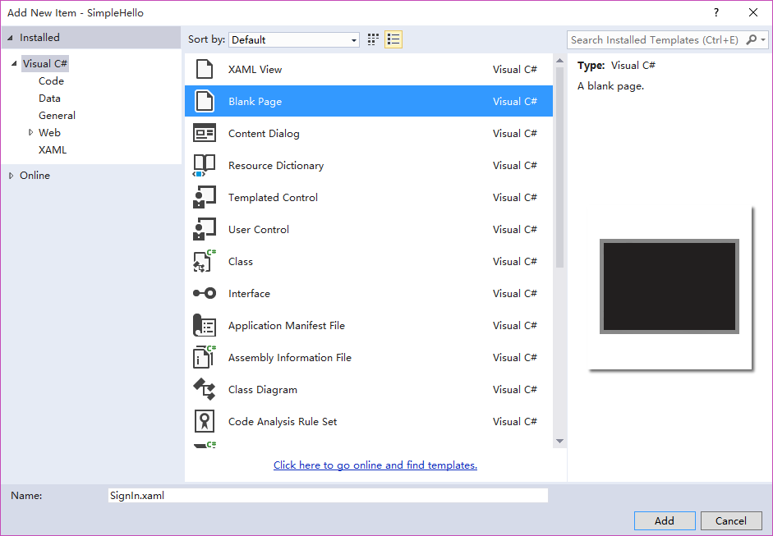
The login page code sample is as follows:
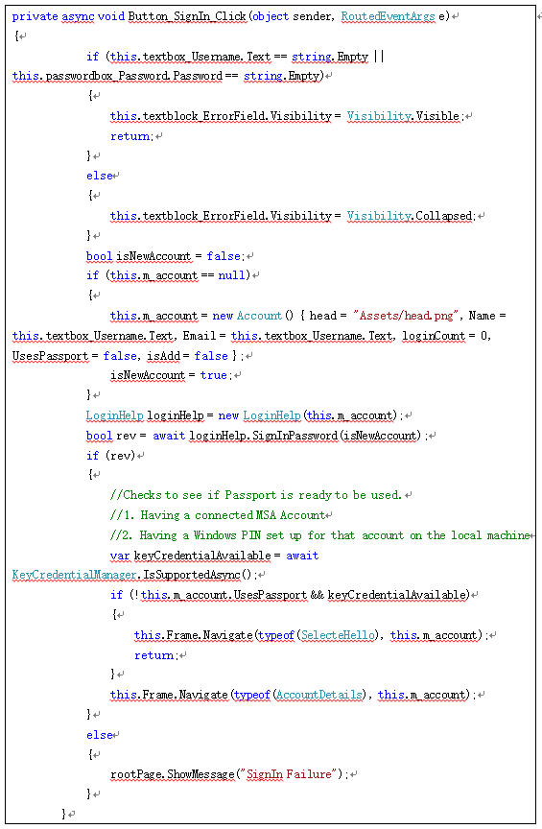
In the code segment, we use the following code to determine whether the current device supports Windows Hello.
var keyCredentialAvailable = await KeyCredentialManager.IsSupportedAsync
If the device supports, we will jump to a page after login, let users choose whether to use the local biometric identification to create a local password credentials for the next login.
Create and use Windows Hello view file
Right-click SimpleHello(unless you have other names) in solution explorer. Select “new project” from “add” menu.
In the left Visual C# template, you can select file type. We added a "blank page" to display Windows Hello setting login page. We proposed the name as SelecteHello.
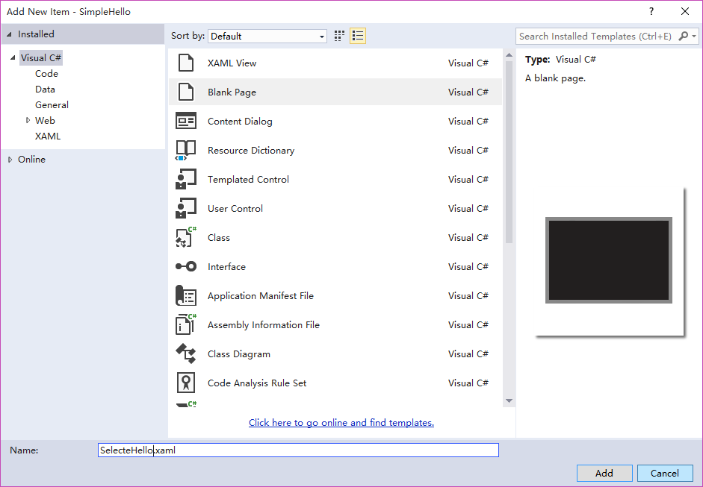
This page code sample is as follows:
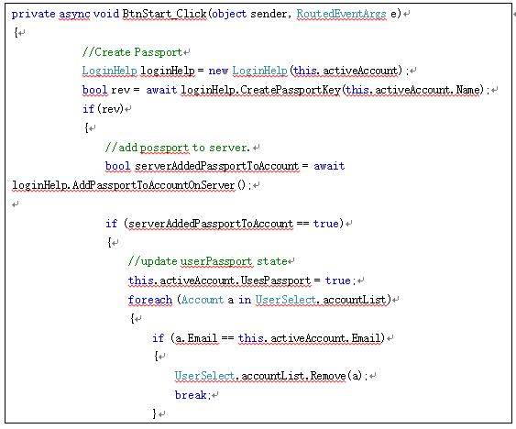
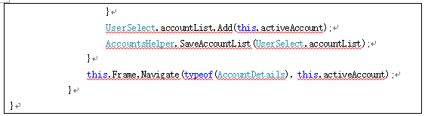
After the user sets and starts Windows Hello login in this page, we use the method in LoginHelp class to create the local password certificate for the user's next login verification.
Multi language support
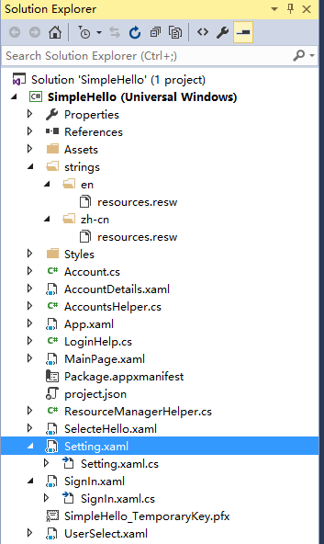
Add the strings folder, which were created in both English and Chinese resource file in solution.
en/resources.resw、zh-cn/resources.resw. English display and Chinese display for storing UI elements.
The current language setting can use the following code in Windows 10:
Windows.Globalization.ApplicationLanguages.PrimaryLanguageOverride = "zh-cn"; or
Windows.Globalization.ApplicationLanguages.PrimaryLanguageOverride = "en-US"
PrimaryLanguageOverride: The preferred language for the current application.

