

Software Requirements Specification (SRS)

Course: Software Engineering 1000
Case Study 1: A Patient Information System for Mental Health Care

Group Student Name: 22301500-Võ Duy Bình
22300236-Trần Bá Lợi
22300363-Huỳnh Ngọc Quang
22204783-Đậu Minh Tân
Professor: Nguyen Van Son

Date: May 16, 2025

1. Introduction
This Software Requirements Specification (SRS) document provides a detailed description of the proposed Mental Health Care – Patient Management System (MHC-PMS), a system designed to support the ongoing care of patients with mental health conditions. The goal of this system is to enhance the quality and efficiency of mental health services by allowing authorized medical staff and administrative users to securely access, manage, and monitor patient data across various locations, including hospitals, community health centers, and local clinics.
Mental health care poses unique challenges. Patients may often forget appointments, lose prescriptions, or struggle to follow treatment instructions. In more severe cases, some individuals may be legally detained for their safety or the safety of others. The MHC-PMS is developed with these realities in mind, aiming to provide clinicians with tools that allow for better tracking, documentation, and legal compliance during the course of treatment.
One of the system’s most notable features is its support for both online and offline operation. In clinics or mobile settings where internet access is limited or unavailable, the system enables local data access and later synchronization with a centralized, encrypted database. This flexibility ensures that medical care is not disrupted due to technical limitations and that critical patient information is always within reach of those who need it.
This document specifies the necessary functional and non-functional requirements for building a robust, safe, and efficient mental health information system. It is intended for use by software developers, quality assurance testers, project managers, clinical stakeholders, and other contributors involved in the design, implementation, and evaluation of the system. By outlining the expected behavior, constraints, and user interactions, this SRS aims to serve as a foundation for a system that improves both clinical outcomes and administrative oversight in mental health care environments.

2. User and System Requirements

2.1 User Requirements
- UR1: Authorized clinicians, including psychiatrists and general practitioners, must be able to securely access and update patient medical records. This includes reviewing consultation history, entering new treatment notes, modifying prescriptions, and updating patient diagnoses. Access must be restricted by role and activity logged to ensure data integrity and patient confidentiality.
- UR2: Registered nurses must be able to input, view, and update records related to medication administration. This includes logging administered dosages, times of administration, missed doses, and any patient reactions to medication. These entries must be timestamped and linked to the corresponding clinician's treatment plan.
- UR3: Front-desk staff, such as receptionists, must have the ability to create, modify, and cancel patient appointments through an integrated scheduling interface. The system must prevent double bookings, allow entry of appointment reasons, and provide alerts for missed or overlapping appointments. Receptionists must not have access to confidential medical notes.
- UR4: Administrative users must be able to generate periodic reports summarizing patient activity, treatment outcomes, resource utilization, and associated costs. These reports must include both detailed patient-specific data (where authorized) and anonymized, aggregated data for management and compliance reporting. Report generation should be customizable by date range, clinic location, and user role.

2.2 System Requirements
- SR1: The system shall store all patient-related data, including personal information, medical history, treatment records, and legal status, within a centralized and encrypted database. The encryption must comply with current healthcare data protection standards (e.g., AES-256 encryption), ensuring data confidentiality both at rest and in transit.
- SR2: The system shall implement role-based access control (RBAC) to restrict system functionalities and data visibility based on user roles. For example, clinicians shall have full access to patient records, nurses shall be permitted to update medication logs, receptionists shall be limited to scheduling functions, and administrative staff shall access reporting tools only. User permissions must be strictly enforced to prevent unauthorized data exposure.
- SR3: The system shall support both online and offline operation. When a stable internet connection is available, the system will operate in real-time, synchronizing all updates with the central database. In offline scenarios, the system shall maintain a local copy of necessary records, allowing clinicians to continue working. Once connectivity is restored, all changes must be automatically and securely synchronized with the central server.
- SR4: The system shall maintain a comprehensive audit log of all user interactions involving access to sensitive patient information. The log shall include the user ID, timestamp, nature of the access (view, edit, delete), and the affected record. This log must be immutable and available for legal audits or internal reviews, ensuring accountability and transparency in system usage.

3. Functional and Nonfunctional Requirements

3.1 Functional Requirements
- FR1: The system shall enable authorized doctors to perform full CRUD (Create, Read, Update, Delete) operations on patient profiles. This includes the ability to register new patients, review existing records, edit clinical notes, update treatment plans or prescriptions, and archive or remove records when patients are discharged or transferred. All modifications must be logged and time-stamped for accountability and legal compliance.
- FR2: The system shall automatically send appointment reminders to patients via email and/or SMS based on the contact information stored in their profile. Notifications should be triggered at configurable intervals (e.g., 24 hours and 2 hours prior to appointment time) and include essential details such as clinic location, attending doctor, and appointment time. Failed delivery attempts must also be logged for follow-up.
- FR3: The system shall allow administrative users to generate monthly reports that summarize key operational metrics. These reports may include patient visit counts, treatment durations, medication usage, appointment adherence rates, and overall clinic performance. The reports should be exportable in standard formats (e.g., PDF, Excel) and customizable by date range, clinic unit, or patient category.
- FR4: The system shall monitor patients who are legally detained (sectioned) under mental health legislation and automatically issue alerts if mandatory appointments, check-ins, or legal assessments are missed. These alerts must be visible to clinicians and relevant administrative personnel and should include details of the missed requirement, patient identity, and recommended follow-up actions.

3.2 Nonfunctional Requirements
- NFR1: The system shall maintain a minimum uptime of 99.9% to ensure continuous availability for healthcare professionals. Given the critical nature of mental health treatment, the system must be accessible 24/7, including nights, weekends, and public holidays, across all supported clinical sites. Scheduled maintenance windows must be minimal and announced in advance.
- NFR2: The system shall strictly comply with all relevant health information privacy regulations, such as the Health Insurance Portability and Accountability Act (HIPAA) and the General Data Protection Regulation (GDPR). This includes proper consent management, access logging, secure data handling, and patient rights regarding data access, correction, and deletion.
- NFR3: The system shall respond to typical user actions—such as retrieving patient records, loading the appointment calendar, or generating reports—within an average of two (2) seconds. Performance should be monitored continuously, and any consistent deviation from this benchmark must trigger system alerts and corrective action.
- NFR4: The system shall support at least 100 concurrent users performing a mix of read and write operations without any significant degradation in performance or user experience. System architecture must be scalable to accommodate future growth in user base and data volume.

4. Structured Requirement Specification
ID | Type | Description
UR1 | User Requirement | Clinicians must be able to view and update patient records securely.
UR2 | User Requirement | Nurses must be able to enter medication administration records.
SR1 | System Requirement | The system must store patient data in an encrypted centralized database.
FR1 | Functional Requirement | Allow CRUD operations on patient profiles by authorized users.
FR4 | Functional Requirement | Trigger alerts if a detained patient misses required check-ups.
NFR1 | Nonfunctional Requirement | System uptime must be 99.9%.
NFR2 | Nonfunctional Requirement | Comply with data protection regulations like GDPR/HIPAA.

5. Use Case Diagram
The use case diagram illustrating system functionality is included below). It summarizes user interactions with the system based on the defined functional requirements.
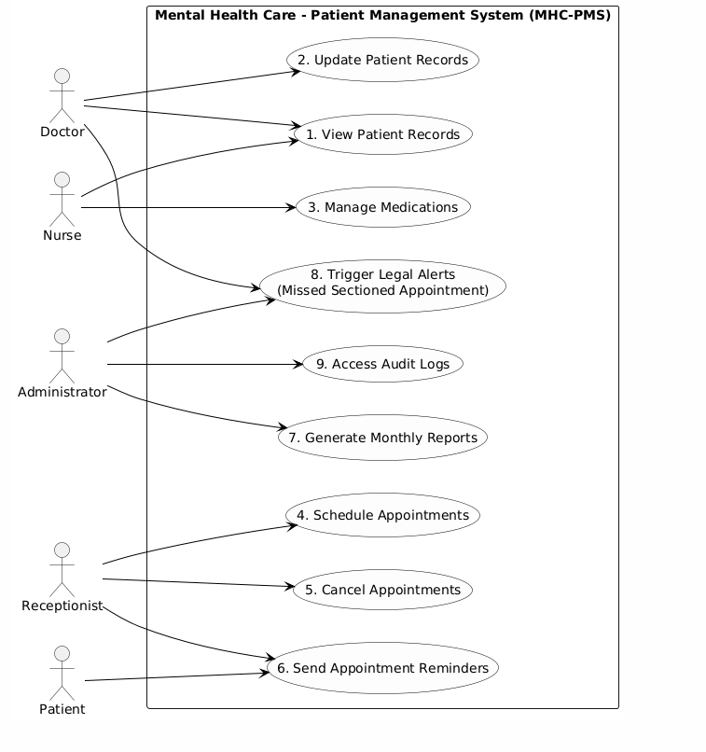

6. Conclusion
This Software Requirements Specification (SRS) document provides a comprehensive and structured overview of the requirements for the Mental Health Care – Patient Management System (MHC-PMS). It outlines the expectations of the system from both technical and operational perspectives, clearly distinguishing between user-level needs and system-level functionality. By specifying functional and nonfunctional requirements, defining key user roles, and identifying system constraints, this document establishes a solid foundation upon which the system can be designed, implemented, tested, and validated.
The unique nature of mental health care requires a system that is not only technically robust but also sensitive to the specific needs of clinicians, administrators, and patients. The MHC-PMS system is expected to facilitate secure, real-time access to patient records, support offline functionality, generate timely alerts for legal and clinical compliance, and offer automated administrative reporting tools. These capabilities are essential to improving service quality, enhancing patient safety, and ensuring that medical staff operate within legal frameworks.
Furthermore, the inclusion of structured requirement specifications and a visual representation through the use case diagram provides clarity and shared understanding among all stakeholders involved in the system development lifecycle. As the project moves forward into design and development phases, this document will serve as a primary reference point for ensuring alignment between business goals, user expectations, and technical feasibility.
Ultimately, this SRS aims to contribute to the delivery of a reliable, scalable, and user-centered information system that will strengthen mental health care practices and support the ongoing efforts of medical professionals to deliver compassionate and accountable care.
References
Sommerville, I. (2011). Software Engineering (9th ed.). Pearson Education.
Case Study: A Patient Information System for Mental Health Care, Mlearning System.[Hoa Sen University]
IEEE. (1998). IEEE recommended practice for software requirements specifications (IEEE Std 830-1998). Institute of Electrical and Electronics Engineers. https://doi.org/10.1109/IEEESTD.1998.88286
Sommerville, I. (2011). Software engineering (9th ed.). Pearson Education.
Pressman, R. S., & Maxim, B. R. (2014). Software engineering: A practitioner’s approach (8th ed.). McGraw-Hill Education.
Bourque, P., & Fairley, R. E. (Eds.). (2014). Guide to the software engineering body of knowledge (SWEBOK) (Version 3.0). IEEE Computer Society. https://www.computer.org/education/bodies-of-knowledge/software-engineering
World Health Organization. (2013). Mental health action plan 2013–2020. https://www.who.int/publications/i/item/9789241506021
Office of the National Coordinator for Health Information Technology (ONC). (2019). Introduction to privacy and security in electronic health records. U.S. Department of Health and Human Services. https://www.healthit.gov

