DYCI2 (very) quick start guide
J. Nika, November 2021

Installation

This section concerns the installation instructions to use the DYCI2 Max library for creative projects using the LaunchDyci2Agents.app built from the DYCI2 Python library (not compatible with Mac OS X Big Sur yet). Developers or expert users can also refer to the last section of this document "Using DYCI2 from Python source code".

Drag the DYCI2lib directory wherever you want (but not in Max packages / libraries !).
Open Max (not a DYCI2 patch yet) and add the path to DYCI2lib/Max_library into Max's search path (in Max: Options/File preferences... then add the path with the subfolders.)

/!\ The path of this folder must not contain any whitespace. /!\

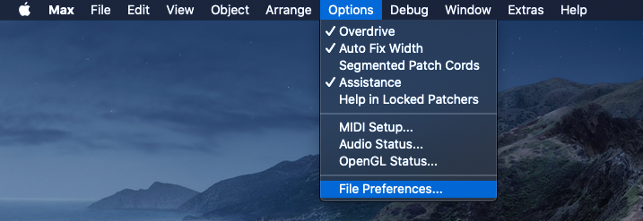

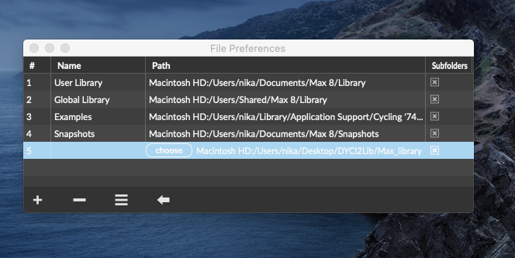

Install Mubu for Max: In Max, open File/Show Package Manager, then search "Mubu for Max", then click “Install”.

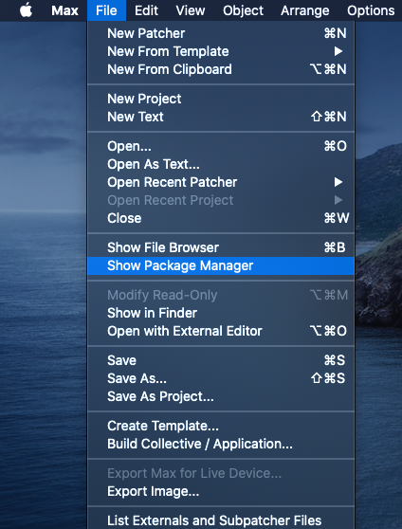
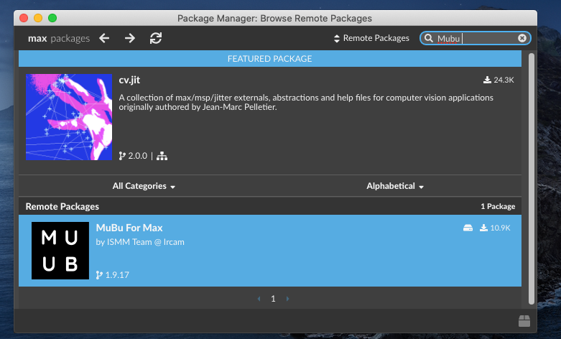

Download the sound files for the tutorials

Insert the media files downloaded at http://repmus.ircam.fr/nika/dyci2_library in DYCI2Lib/Max_library/_Tutorials_/_ExamplesCorpus_.

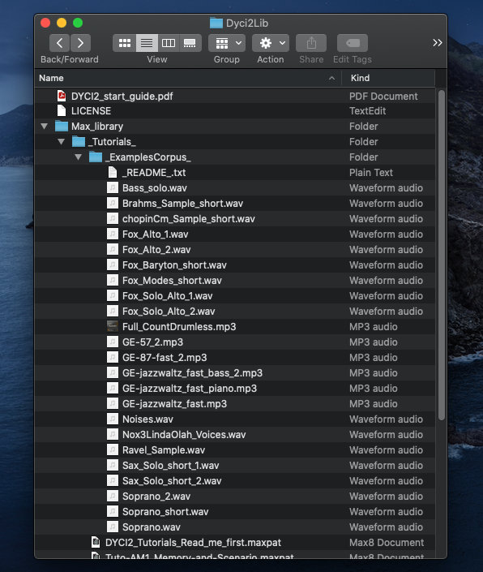
/!\ The sampling rate of Max must be the same as that of the audio file(s) used in the memory(/ies) (44100 Hz for the tutorials). /!\

Authorization and security issues (depending on the version of Mac OSX)

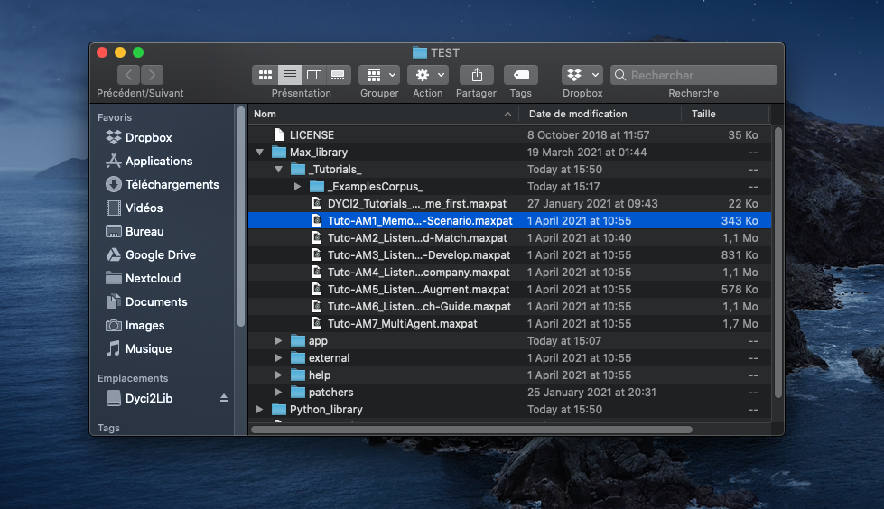
When opening your very first DYCI2 patch, this message box may appear: “shell.mxo” cannot be opened because the developer cannot be verified.
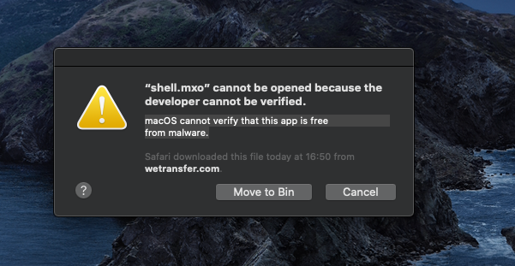

Click on "Cancel" and open the Apple menu at the top left of your screen, then System preferences... .
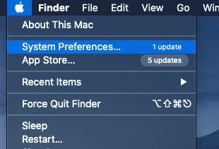
Open the Security & Privacy menu.
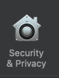
Click on "Open Anyway" next to the sentence “shell.mxo” was blocked from use because it is not from an identified developer.
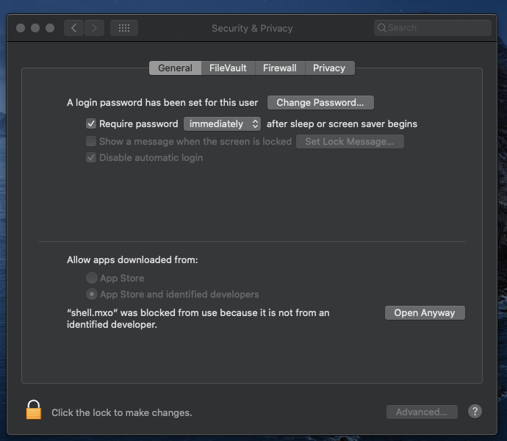
The message box “macOS cannot verify the developer of “shell.mxo”. Are you sure you want to open it?”

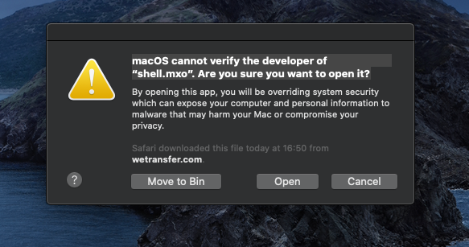
Click on "Open", exit Max. And everything should be OK from now on, you can explore the tutorials in Max_Library/Tutorials !
Using DYCI2 (from) Python source code

Download and install the last version of Python 3 (https://www.python.org/downloads).
Open Terminal to install the dependencies, then:
type cd [DRAG_AND_DROP_THE_DIRECTORY_Dyci2lib]
type enter
type pip3 install -r requirements.txt –user
type enter

In the Max Patches, you can then open the “p LaunchDyci2Agents” patcher and select “python 3 code” on the right, swith Off then On the “Start / Stop server”, to run DYCI2 agents from the DYCI2 Python library instead of the LaunchDyci2Agents.app application built from it.
