OM-DYCI2 quick start guide to the Release version
December 2021

Introduction

OM-DYCI2 is a framework for interactive generation of musical sequences combining generative agents and computer-assisted composition tools. It enables guiding corpus-based generative processes through explicit specifications of temporal structures, or us- ing another layer of generative models trained on a corpus of structures. OM-DYCI2 is the compositional declination of the Max DYCI2 library dedicated to interaction (https://github.com/DYCI2/Dyci2Lib) developed in the OM# (https://github.com/cac-t-u-s/om-sharp) and OpenMusic (http://repmus.ircam.fr/openmusic/) visual programming and computer-aided composition environments.

If using the library, please quote:
Nika, Jérôme, and Jean Bresson. "Composing Structured Music Generation Processes with Creative Agents." 2nd Joint Conference on AI Music Creativity (AIMC 2021). 2021.(https://aimc2021.iem.at/wp-content/uploads/2021/06/AIMC_2021_Nika_Bresson.pdf).
The appendix of this article refers to multimedia resources extracted from recent creations using OM-DYCI2 (Pascal Dusapin, Steve Lehman, Rémi Fox, Le Fresnoy - Studio National des Arts Contemporains, etc.). Moreover, it is a good introduction to the use of the library since it details all the playing modes implemented in the tutorials.

This guide addresses the release version of om-dyci2 ready to be included in your OM# or OM 6.13/6.14 libraries folder (the corresponding development repository is available here: https://github.com/DYCI2/om-dyci2). To be able to use all the features, we recommend for the moment to use OM# (other features will be ported to OM in a future release).
The om-dyci2/om-dyci2/patches directory includes basic example patches for OM# and OM6, and new advanced examples for OM# only (Tutorials 1 to 3) requiring the OM-SuperVP library (https://forum.ircam.fr/projects/detail/om-supervp/) as detailed below.

OM-DYCI2 takes audio files with annotations (time markers and labels) as input. The library does not yet provide definitive tools for the segmentation and analysis of corpora, which must therefore be carried out by the user in the environment of his/her choice and have the format corresponding to the example annotation files that can be found in Tutorials 1 and 2. On the other hand, OM-DYCI2 proposes manual segmentation interfaces (Tutorial 0), and a first draft (work in progress) of segmentation patches and automatic pitch and energy analysis (Tutorial 3).

Python 3 settings

The release version of om-dyci2 provides all the required binaries, so there is no need to compile anything,but the dependencies of the Python DYCI2 Library must be installed. OM-DYCI2 will instantiate a virtual Python interpreter and run the generative processes in it, so the last version of Python 3 and the Python dependencies of DYCI2 library must be installed on your computer :
1. Download and install the last version of Python 3 (https://www.python.org/downloads )
2. Use your terminal to install the dependencies :
$ cd [path to the om-dyci2 directory containing “python-requirements.txt”]
$ pip install -r python-requirements.txt
(If _pip_ is not installed: 'curl https://bootstrap.pypa.io/get-pip.py -o get-pip.py' then 'python3 get-pip.py' or 'sudo easy-install pip')
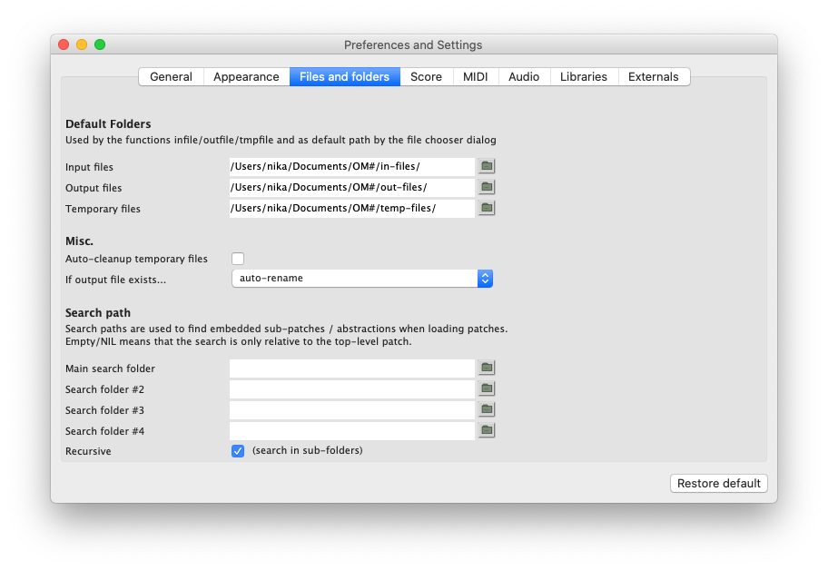
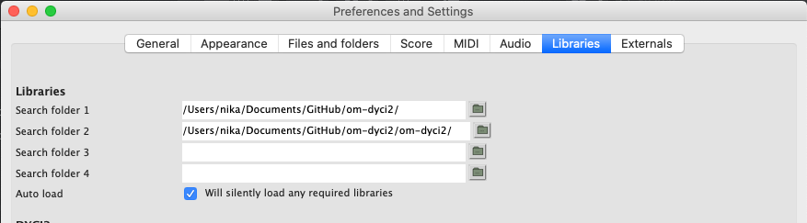
OM# settings
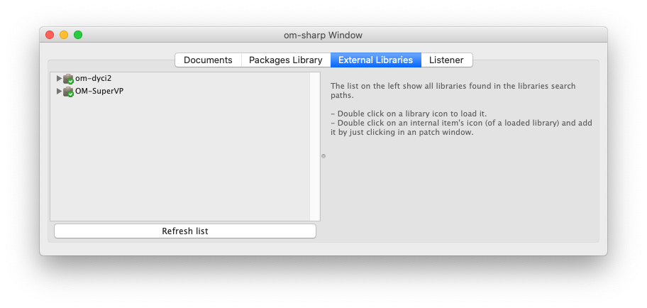
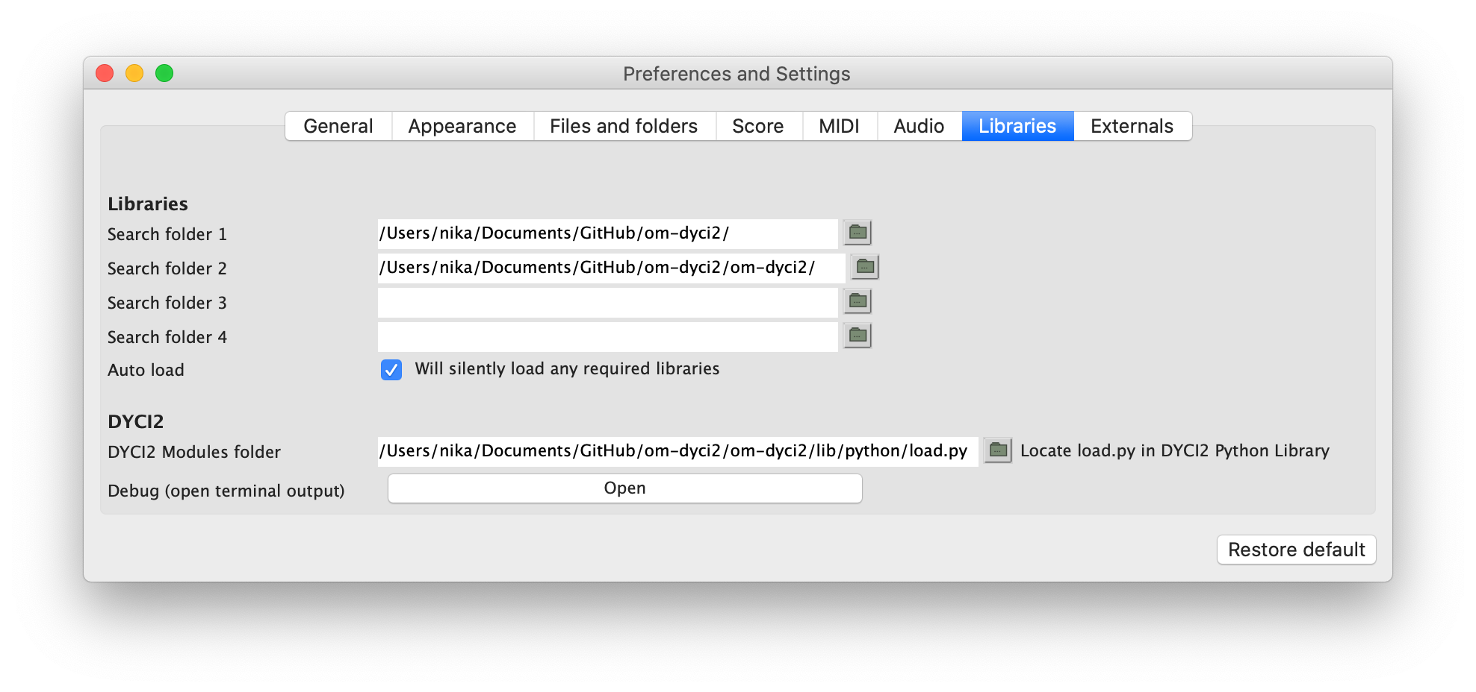
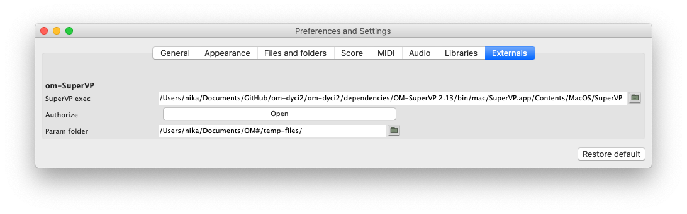
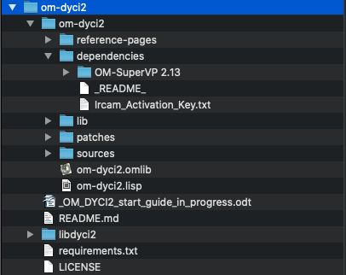
Using the SuperVP external for Tutorials 1 to 3
(<-- Path to your “Ircam_Activation_Key.txt” file)

The tutorials in the directories 2-advanced-tutorials-synchronyzing and 3-tutorials-audio-analysis require the OM-SuperVP library.

1) Get it from https://forum.ircam.fr/projects/detail/om-supervp/.

2) Move the superVP lib for instance in om-dyci2/dependencies/ and make sure that the path to this directory is in the search path.

3) This release includes SuperVP executables for macOS, Windows, Linux. These programs are protected and require an authorization through Ircam forum subscription.
See: https://www.ircam.fr/product/abonnement-premium-individuel-annuel/

4) Then in OM#:
- windows/session window/external libraries then double click on om-supervp to load it
- preferences/libraries, in om-SuperVP :
- SuperVP exec --> path to supervp exec (for instance dependencies/om-supervp/resources/bin/mac/SuperVP/SuperVP.app/Contents/MacOS/supervp-2.103.2)
- Authorize --> path of the activation key if needed (for instance dependencies/om-supervp/resources/bin/mac/Ircam_Activation_key.txt)

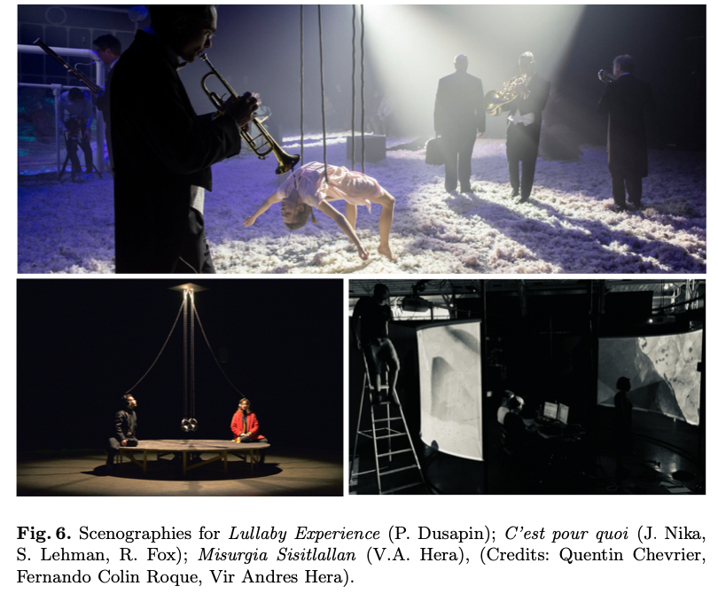

. Free-releases of the library (not including the binaries) are available at: https://github.com/openmusic-project/OM-SuperVP/releases. You will still need the binaries (and then an Ircam forum subscription): get et them from IRCAM ForumNet (https://forum.ircam.fr/projects/detail/analysissynthesis-command-line-tools/) and either put them in OM-SuperVP/resources/bin/{mac,win,linux}/, OR set the path to SuperVP (for instance in .../AudioSculpt/Kernels/) in the OM Preferences/Externals path (visible when the library is loaded).

