All circuits in this section are annotated with reference numbers on circuit schematic in the anticlockwise manner

Excitation circuit:

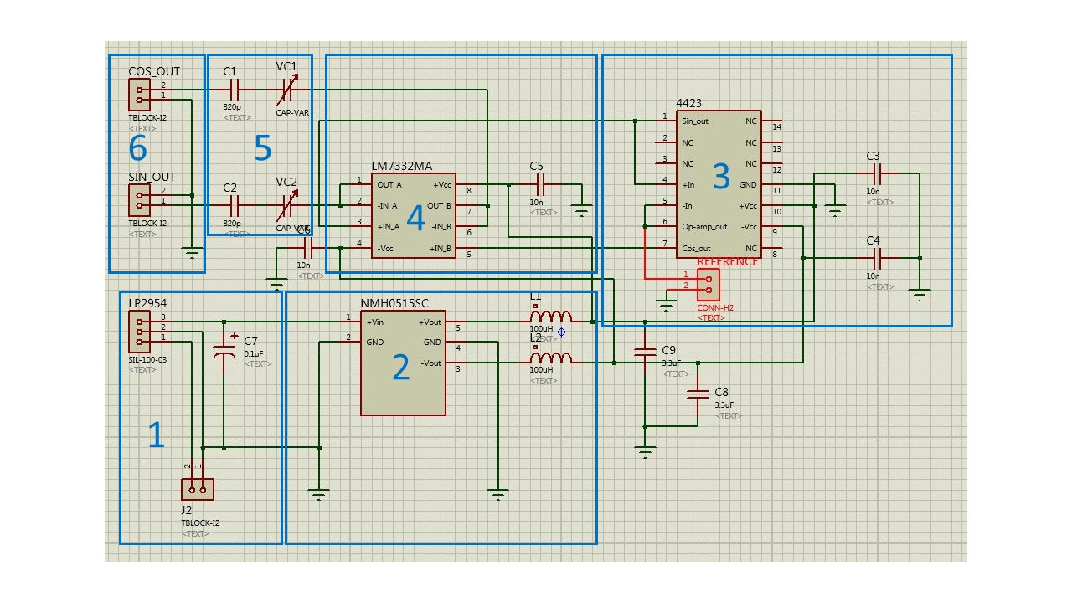

1. Battery is connected to the screw-in terminal, which in turn connected to the LP2954 voltage regulator that outputs 5v. To suppress the ripple on the output of the voltage regulator, 0.1uF decoupling capacitor is placed on the power line.
2. Murata NMH0515SC acts as a dual rail booster, increasing the voltage from the LP2954 to +15 and -15 volts. On the output of the chip, inductor of value 100uH and decoupling capacitor are placed, following the recommendations given in the datasheet for the component. This setup will filter out the ripples from the NMH0515SC and help obtain stable DC voltage. The maximum power that this component is able to supply is 2W, so this limits the maximum power that can be transmitted as well as affecting the choice of the operational amplifier.
3. Quadrature oscillator 4423 is used to create two phase shifted waveforms with the maximum amplitude of 10v. To achieve this, the supply voltage is +15 and -15 volts given by Murata chip, also, to increase the stability of the output, two decoupling capacitors of 10nF are placed close to the power supply inputs of the chip. The outputs of the chip has to be boosted in terms of current, which is achieved in the section 4, using the operational amplifier.

Additionally, to simplify the testing further on, one of the inputs of the chip is fed through built in operational amplifier so that the waveform can be sampled using oscilloscope and checked for stability and integrity.

1. Operational amplifier LM7332MA is configured as a current boosted, providing a maximum of 70mA per channel, while also electrically insulating the quadrature oscillator from the coils. The supply used for this component is also +15 and -15 volts and to provide stable power supply to the components, 10nF capacitor is used for decoupling.
2. Tuning stage consists of fixed value and variable capacitor. The outputs from operational amplifier are fed into capacitor connected to the coil in series, effectively making the LC series circuit that allows to tune the coils to achieve maximum power transmission. Variable capacitor allowed to make fine tuning to the value of the fixed capacitor, however, this type of capacitor is susceptible to the changes in temperature. To minimise the effect of the temperature on a capacitors, high quality ceramic capacitors has been used, with a precision in the range of +-10%.
3. Output stage, capacitor outputs are connected to the coils through screw-in terminals that allowed to quick changes during the testing. Second pin of the screw-in terminal is grounded.