## INTRODUCTION

The project utilises 3 main technologies: Node-RED, Python and Arduino. Diagram below illustrates how microwave setup is set up to work:

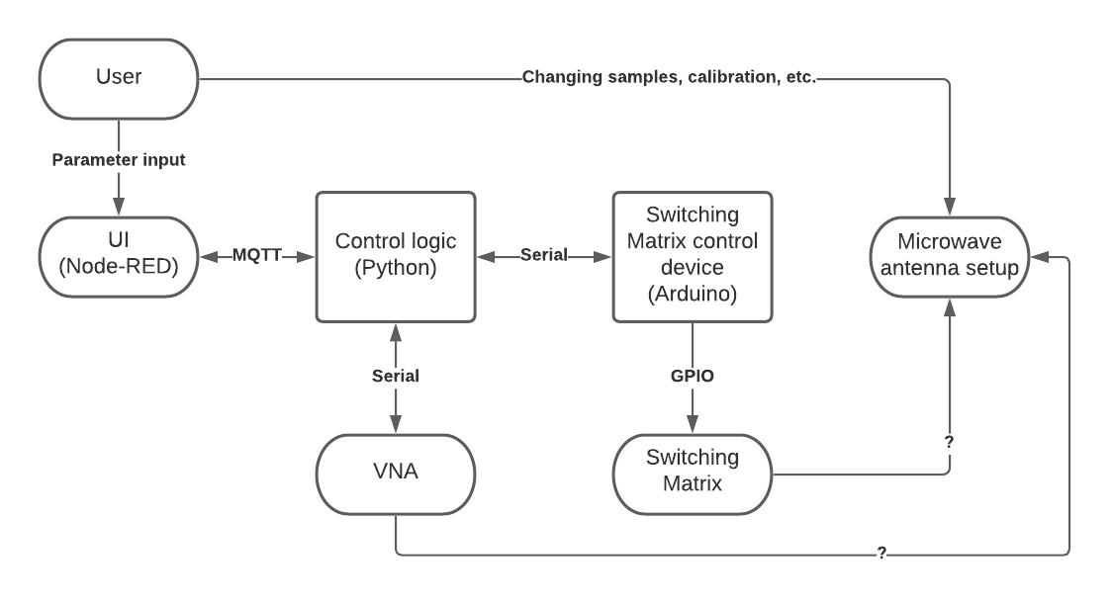

Node-RED: is an open-source programming tool for wiring together hardware devices, APIs and online services for variety of applications. One of its features is the browser-based editor that allows to develop software remotely and cross-platform from the start without additional configuration. Node-RED community is active and growing, which makes it a good choice both for quick prototyping as well as making production-ready platforms due to a large number of libraries and support available.  
In our project it has been used as a way to provide user with a simple interface for running the experiments and allow for two-way communication – user can input parameters into the control program, while UI can provide feedback that the user can act upon.  
[https://nodered.org/]

Python: a well-known open-source programming language in scientific communities.   
In this project its role is in controlling the experiment steps order flow, communication with the devices and providing feedback to the user via user interface, linked via MQTT communication protocol.  
[https://www.python.org/]

Arduino: initially a teaching tool for students to show how to program embedded devices, but used more widely due to its ease of use, open-source and wide community support.  
Both hardware and software Arduino platforms are used for controlling the Switching Matrix via relays connected to its outputs. When it receives a command from Python via Serial communication protocol, it enables the required combination of relays connected to a microwave switches and informs the control program when operation is complete.  
[https://www.arduino.cc/]

MQTT: is a communication protocol based on a client-broker system. Any device/program in a system can either publish or receive data for a number of pre-programmed topics. When broker publishes the message, all clients subscribed to it will receive it.   
Since its lightweight and supported by both Node-RED and Python, it has been chosen as medium of exchange between the user interface and control program respectively.