Assessment 1 – Data set

A1844790 - Dylan Rohan

04/11/2021

library(tidyverse)

## -- Attaching packages --------------------------------------- tidyverse 1.3.1 --

## v ggplot2 3.3.5 v purrr 0.3.4  
## v tibble 3.1.5 v dplyr 1.0.7  
## v tidyr 1.1.4 v stringr 1.4.0  
## v readr 2.0.2 v forcats 0.5.1

## -- Conflicts ------------------------------------------ tidyverse_conflicts() --  
## x dplyr::filter() masks stats::filter()  
## x dplyr::lag() masks stats::lag()

library(dplyr)  
library(stringr)  
ashes <- read_csv("C:\\Users\\rohad\\OneDrive\\Documents\\Data science\\Data Taming, modelling and Vizalization_RStudio\\a1\\a1\\ashes.csv")

## Rows: 27 Columns: 13

## -- Column specification --------------------------------------------------------  
## Delimiter: ","  
## chr (13): batter, team, role, Test 1, Innings 1, Test 1, Innings 2, Test 2, ...

##   
## i Use `spec()` to retrieve the full column specification for this data.  
## i Specify the column types or set `show_col_types = FALSE` to quiet this message.

#double slashes for windows directory  
ashes <- read_csv("ashes.csv")

## Rows: 27 Columns: 13

## -- Column specification --------------------------------------------------------  
## Delimiter: ","  
## chr (13): batter, team, role, Test 1, Innings 1, Test 1, Innings 2, Test 2, ...

##   
## i Use `spec()` to retrieve the full column specification for this data.  
## i Specify the column types or set `show_col_types = FALSE` to quiet this message.

#testing something mentioned in the discussion board, neat!  
#ashes#  
#Checked the table, currently a tibble of 27 x 13  
unique(ashes$team)

## [1] "England" "English" "Australia"

#need to correct variable English to be England  
unique(ashes$role)

## [1] "allrounder" "bowl" "wicketkeeper" "bat" "bowler"   
## [6] "batting" "batsman" "all rounder" "all-rounder"

#many duplicates under alternate variable names, eg. bat, batsman, batting

## Question One: Reading and Cleaning

##### 1.1

(Note: I finished the assignment very early, so I went back and put the code in for the way the course probably expected to see it as well.)

1.1) For our analysis, the subjects are not the cricketers themselves, but each batting innings they participated in. In order to make the data tidy each subject needs its own row. Rearrange the data into a long format so that there is a row for each batter in each innings. Your new tibble should have 270 rows. [2 points]

Each cell should represent only one measurement. Use str_match() to create new columns for each of the following for each player innings: * the player’s batting number * their score * the number of balls they faced. [2 points]

colnames(ashes)

## [1] "batter" "team" "role"   
## [4] "Test 1, Innings 1" "Test 1, Innings 2" "Test 2, Innings 1"  
## [7] "Test 2, Innings 2" "Test 3, Innings 1" "Test 3, Innings 2"  
## [10] "Test 4, Innings 1" "Test 4, Innings 2" "Test 5, Innings 1"  
## [13] "Test 5, Innings 2"

ashes_longform <- gather(ashes, key = "innings", value = "description", "Test 1, Innings 1" : "Test 5, Innings 2")  
#tibble now in long form, 270 x 5  
ashes_innings_first <- ashes_longform[c(4, 1, 2, 3, 5)]  
#tibble now in long form with subject first  
  
order <- str_match(ashes_innings_first$description, "Batting at number ..")  
with_order <- cbind(ashes_innings_first, order)  
#Order now has its own column  
runs <- str_match(with_order$description, "scored ....")  
with_runs <- cbind(with_order, runs)  
#runs now has its own column  
no._of_balls <- str_match(with_runs$description, "from ....")  
all_columns<- cbind(with_runs, no._of_balls)  
#no. of balls now has its own column  
batting_order <- str_replace_all(all_columns$order, "[^0-9.-]", "")  
runs_ <- str_replace_all(all_columns$runs, "[^0-9.-]", "")  
balls_ <- str_replace_all(all_columns$no._of_balls, "[^0-9.-]", "")   
#Taking numerical values from strings  
order1 <- tibble(batting_order)  
runs1 <- tibble(runs_)  
balls1 <- tibble(balls_)  
#making data frames from those values  
a1_o <- cbind(ashes_innings_first, order1)  
a1_o_r <- cbind(a1_o, runs1)  
a1_o_r_b<- cbind(a1_o_r, balls1)  
#Order same, so binding columns  
a1o_r_b <- a1_o_r_b$description <- NULL  
a1_o_r_b <- a1_o_r_b %>%  
 mutate_all(na_if, "")  
#removing description column  
#now a tibble of 270 x 7 (removed description, but unused data is still accessible in "ashes_innings_first')  
   
  
 #_______________________________________________________#  
#WAS A KEEN BEEN, SO ALTERNATIVELY:  
  
trial <- ashes_innings_first %>%  
 mutate("runs_"=str_match(description,"from ....") , "batting_order" = str_match(description, "Batting at number .."), "balls_" = str_match(description, "scored ...."))  
#description string broken into appropriate columns  
trial <- trial %>%  
 mutate("runs_" = str_replace_all(trial$runs_, "[^0-9.-]",""), "balls_"=str_replace_all(trial$balls_, "[^0-9.-]",""), "batting_order"=str_replace_all(trial$batting_order, "[^0-9.-]",""))  
trial <- mutate_all(trial, na_if, "")  
#Left the description column in here, but all is right with the world  
   
 # _______________________________________________________#

##### 1.2

1.2) Recode the data to make it ‘tame’, that is: * ensure all categorical variables with a small number of levels are coded as factors, * ensure all categorical variables with a large number of levels are coded as characters, * ensure all quantitative variables are coded as integers or numeric, as appropriate. [3 points]

ashes_tibble <- as_tibble(a1_o_r_b)  
#making a data frame from a1_o_r_b to set value type  
ashes_tibble$batting_order <- as.factor(ashes_tibble$batting_order)  
#low level ordinal, label = factor  
ashes_tibble$runs_ <- as.integer(ashes_tibble$runs_)  
ashes_tibble$balls_ <- as.integer(ashes_tibble$balls_)  
#countable, discrete = integer  
ashes_tibble$innings <- as.factor(ashes_tibble$innings)  
#innings total=10, a label/name, low ordered count = factors  
ashes_tibble <- rename(ashes_tibble,"player"="batter")  
ashes_tibble$player <- as.character(ashes_tibble$player)  
#player makes more sense as a variable name. The teams have several people that could take the position, and many people they could put in as players, categorical variable = character. There is a valid argument for it to be listed as a factor two. My understanding is factors take up less space and give each value a number while characters keep the information of the entire string which we really don't need here.  
ashes_tibble$team <- as.factor(ashes_tibble$team)  
ashes_tibble$role <- as.factor(ashes_tibble$role)  
#both low value labels, so factors

##### 1.3

Clean the data; recode the factors using fct_recode() such that there are no typographical errors in the team names and player roles. [2 points] ✓

unique(ashes_tibble$player)

## [1] "Ali" "Anderson" "Bairstow" "Ball" "Bancroft" "Bird"   
## [7] "Broad" "Cook" "Crane" "Cummins" "Curran" "Handscomb"  
## [13] "Hazlewood" "Khawaja" "Lyon" "Malan" "MMarsh" "Overton"   
## [19] "Paine" "Root" "SMarsh" "Smith" "Starc" "Stoneman"   
## [25] "Vince" "Warner" "Woakes"

summary(unique(ashes_tibble$innings))

## Test 1, Innings 1 Test 1, Innings 2 Test 2, Innings 1 Test 2, Innings 2   
## 1 1 1 1   
## Test 3, Innings 1 Test 3, Innings 2 Test 4, Innings 1 Test 4, Innings 2   
## 1 1 1 1   
## Test 5, Innings 1 Test 5, Innings 2   
## 1 1

summary(unique(ashes_tibble$team))

## Australia England English   
## 1 1 1

unique(ashes_tibble$team)

## [1] England English Australia  
## Levels: Australia England English

unique(ashes_tibble$role)

## [1] allrounder bowl wicketkeeper bat bowler   
## [6] batting batsman all rounder all-rounder   
## 9 Levels: all-rounder all rounder allrounder bat batsman batting ... wicketkeeper

#English to England, unify roles  
ashes_corrected_ <- ashes_tibble %>%  
 mutate(team = fct_recode(team, "England" = "English"))%>%  
 mutate(role = fct_recode(role, "all-rounder" = "allrounder", "all-rounder"="all rounder", "batsman"="batting", "batsman"="bat", "bowler"="bowl"))  
ac <- ashes_corrected_

## Question Two: Univariate Analysis

##### 2.1

Produce a histogram of all scores during the series. ✓ [1 point]

#Histogram default below, bin of 30  
ggplot(ac)+geom_histogram(aes(x=runs_, ), fill= "black", na.rm=TRUE) +   
 ggtitle("The Runs Achieved Over An Innings in the 2017/18 Ashes Series")+labs(x= "Scores reached", y ="Frequency")

## `stat_bin()` using `bins = 30`. Pick better value with `binwidth`.

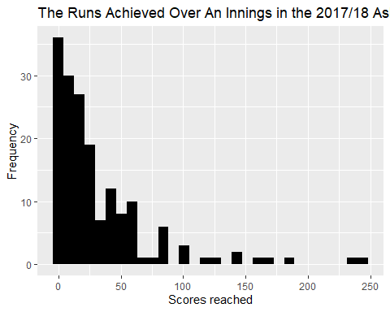

#ac$runs_ %>%  
# unique()  
#cool find: 70 unique values excluding NA, bin of 70 width = 1 for a bar chart as below  
#ggplot(ac)+geom_histogram(mapping = aes(x=runs_), na.rm=TRUE, bins=70, binwidth = 1)+  
# ggtitle("Total runs acheieved")+labs(x= "Total runs")

##### 2.2

Describe the distribution of scores, considering shape, location spread and outliers. [4 points]

summary(ac$runs_, na.rm = TRUE)

## Min. 1st Qu. Median Mean 3rd Qu. Max. NA's   
## 0.00 6.00 18.00 32.09 41.00 244.00 101

range(ac$runs_, na.rm = TRUE, finite= TRUE)

## [1] 0 244

sd(ac$runs_, na.rm = TRUE)

## [1] 41.30805

table(ac$runs_)

##   
## 0 1 2 3 4 5 6 7 8 9 10 11 12 13 14 15 16 17 18 19   
## 12 4 8 3 9 5 4 3 2 4 3 6 3 2 8 3 1 3 2 2   
## 20 21 22 23 24 25 26 27 28 29 30 31 36 37 38 39 40 41 42 44   
## 5 1 3 1 3 4 3 2 1 2 1 1 4 1 3 2 2 2 2 1   
## 47 49 50 51 53 54 55 56 57 58 61 62 67 76 82 83 86 87 101 102   
## 1 1 1 2 2 1 1 4 1 1 2 1 1 1 1 3 1 1 1 1   
## 103 119 126 140 141 156 171 181 239 244   
## 1 1 1 1 1 1 1 1 1 1

This is a right-skewed shaped graph. The mean score was 32 with a standard deviation of 32. Two players achieved scores over 200 which pulled the mean away from the mode, 12, and median, 18. The interquartile range was 35, the domain was [0,244], and the range [0,25]. An outlier is anything 1.5 x IQR from the mean in either direction. Functionally, this indicates that any score higher than (1.5x35+32=) 85 is an outlier. With that definition, there are 13 outliers over the series.

##### 2.3

Produce a bar chart of the teams participating in the series, with different colours for each team. Noting that each player is represented by 10 rows in the data frame, how many players were used by each team in the series? [3 points] Australia = 13 England = 14

#ggplot(ac, aes(x= runs_, col=team))+geom_bar()  
#^this maps every players innings, we need to combine player scores across the innings  
indiv_runs <- ac%>%  
 group_by(player) %>%  
 summarise(team,role,runs_in_series = sum(runs_, na.rm=TRUE))%>%  
 unique()

## `summarise()` has grouped output by 'player'. You can override using the `.groups` argument.

unique(ac$player)

## [1] "Ali" "Anderson" "Bairstow" "Ball" "Bancroft" "Bird"   
## [7] "Broad" "Cook" "Crane" "Cummins" "Curran" "Handscomb"  
## [13] "Hazlewood" "Khawaja" "Lyon" "Malan" "MMarsh" "Overton"   
## [19] "Paine" "Root" "SMarsh" "Smith" "Starc" "Stoneman"   
## [25] "Vince" "Warner" "Woakes"

#all players accounted for  
ggplot(indiv_runs, aes(x=team, fill=team))+  
 geom_bar()+ggtitle("Number of Players On Each Team in the 2017/18 Ashes Series")+  
 scale_y_continuous(breaks = seq(0, 20, by = 1))+  
 labs(x = "Team", y= "Number of players")

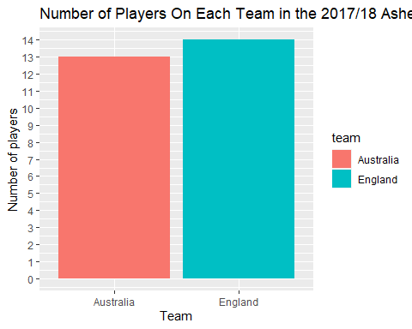

#players per team^   
  
   
#What I thought question 2.3 wanted  
indiv_runs %>%  
 ggplot(aes(x=player, y=runs_in_series, fill=role))+  
 geom_bar(stat="identity")+  
 ggtitle("Individual performance over the 2017/18 Ashes series")+  
 labs(x = "", y= "")+  
 theme(axis.text.x= element_text(angle =-90, hjust = 0))

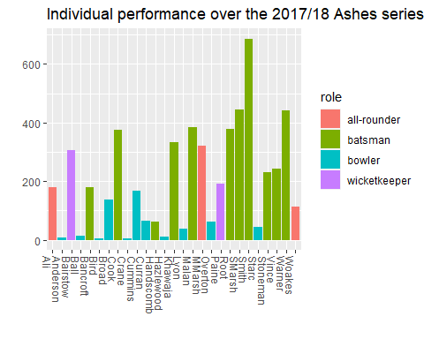

#score per player

## Question Three: Scores for each team

#####3.1  
Using ggplot, produce histograms of scores during the series, faceted by team. [1 point]

ac %>%  
 ggplot(aes(x=runs_, fill=team))+  
 geom_histogram(show.legend = FALSE)+  
 scale_y_continuous(breaks = seq(0, 30, by = 1))+  
 facet_wrap(~team)+  
 ggtitle("Team Batting Performance in the 2017/18 Ashes Series")+  
 labs(x = "Score", y= "Frequency")

## `stat_bin()` using `bins = 30`. Pick better value with `binwidth`.

## Warning: Removed 101 rows containing non-finite values (stat_bin).

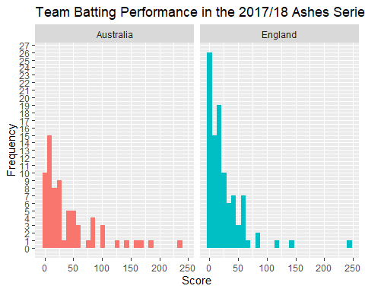

#####3.2  
Produce side-by-side boxplots of scores by each team during the series. [1 point]

ac %>%  
 ggplot(aes(y=runs_, fill=team))+  
 geom_boxplot(show.legend = FALSE)+  
 facet_grid(~team)+  
 ggtitle("Boxplot of Team Batting Performance over the 2017/18 Ashes Series")+  
 labs(x = "Team", y="Runs over the series")

## Warning: Removed 101 rows containing non-finite values (stat_boxplot).

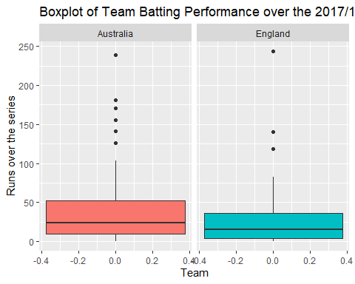 #####3.3  
Compare the distributions of scores by each team during the series, considering shape, location, spread and outliers, and referencing the relevant plots. Which team looks to have had a higher average score? ✓ [5 points]

england_only <- indiv_runs %>%  
 filter(team =="England")  
summary(england_only$runs_in_series)

## Min. 1st Qu. Median Mean 3rd Qu. Max.   
## 6.0 63.0 157.5 178.8 290.0 383.0

sd(england_only$runs_in_series)

## [1] 141.8369

england_only %>%  
 arrange(runs_in_series) #no mode#

## # A tibble: 14 x 4  
## # Groups: player [14]  
## player team role runs_in_series  
## <chr> <fct> <fct> <int>  
## 1 Crane England bowler 6  
## 2 Anderson England bowler 8  
## 3 Ball England bowler 15  
## 4 Overton England bowler 62  
## 5 Curran England bowler 66  
## 6 Woakes England all-rounder 114  
## 7 Broad England bowler 136  
## 8 Ali England all-rounder 179  
## 9 Stoneman England batsman 232  
## 10 Vince England batsman 242  
## 11 Bairstow England wicketkeeper 306  
## 12 Cook England batsman 376  
## 13 Root England batsman 378  
## 14 Malan England batsman 383

#England's statistics  
  
aus_only <- indiv_runs %>%  
 filter(team =="Australia")  
summary(aus_only$runs_in_series)

## Min. 1st Qu. Median Mean 3rd Qu. Max.   
## 4.0 44.0 179.0 224.6 333.0 687.0

sd(aus_only$runs_in_series)

## [1] 209.2871

aus_only %>%  
 arrange(runs_in_series) #no mode#

## # A tibble: 13 x 4  
## # Groups: player [13]  
## player team role runs_in_series  
## <chr> <fct> <fct> <int>  
## 1 Bird Australia bowler 4  
## 2 Hazlewood Australia bowler 10  
## 3 Lyon Australia bowler 37  
## 4 Starc Australia bowler 44  
## 5 Handscomb Australia batsman 62  
## 6 Cummins Australia bowler 166  
## 7 Bancroft Australia batsman 179  
## 8 Paine Australia wicketkeeper 192  
## 9 MMarsh Australia all-rounder 320  
## 10 Khawaja Australia batsman 333  
## 11 Warner Australia batsman 441  
## 12 SMarsh Australia batsman 445  
## 13 Smith Australia batsman 687

#Australia's statistics  
  
#for outliers  
ac %>%  
 filter(team =="Australia") %>%  
 summary(ac$runs_, na.rm=TRUE)

## Warning in if (length(ll) > maxsum) {: the condition has length > 1 and only the  
## first element will be used  
  
## Warning in if (length(ll) > maxsum) {: the condition has length > 1 and only the  
## first element will be used  
  
## Warning in if (length(ll) > maxsum) {: the condition has length > 1 and only the  
## first element will be used  
  
## Warning in if (length(ll) > maxsum) {: the condition has length > 1 and only the  
## first element will be used

## innings player team role   
## Test 1, Innings 1:13 Length:130 Australia:130 all-rounder :10   
## Test 1, Innings 2:13 Class :character England : 0 batsman :60   
## Test 2, Innings 1:13 Mode :character bowler :50   
## Test 2, Innings 2:13 wicketkeeper:10   
## Test 3, Innings 1:13   
## Test 3, Innings 2:13   
## Test 4, Innings 1:13   
## Test 4, Innings 2:13   
## Test 5, Innings 1:13   
## Test 5, Innings 2:13   
##   
##   
## batting_order runs_ balls_   
## 1 : 8 Min. : 0.00 Min. : 3.00   
## 10 : 5 1st Qu.: 10.00 1st Qu.: 19.75   
## 11 : 3 Median : 24.00 Median : 50.50   
## 2 : 8 Mean : 41.71 Mean : 86.09   
## 3 : 7 3rd Qu.: 52.50 3rd Qu.:119.75   
## 4 : 7 Max. :239.00 Max. :399.00   
## 5 : 7 NA's :60 NA's :60   
## 6 : 7   
## 7 : 6   
## 8 : 6   
## 9 : 6   
## NA's:60

Both teams have right-skewed histograms, indicating higher scores are less common than lower scores. England was more right-skewed than Australia due to it having more players reaching lower scores. Using the default bin numbers, the domains are similar for both teams, [0,~250). But ranges differed, England had more players end the innings with scores lower than 50 so their range is much larger, [0, 26]; Australia’s is sitting [0, 15]. Australia appears to have had the highest average score. The mean score total was located at 225 for Australia with standard deviation of 209 (median of 179), but only 179 for England with a standard deviation of 142 (median 158). The IQR was 227 for England, but only 181 for Australia. Together this indicates that the Australians performed more consistently; players did not have to compensate as much for weaker performances of teammates (lower variation) and allowed their best players to really boost the teams average. According to the boxplots, there were six outliers for Australia, and three for England. Once again highlighting how impressive the Australians performed in the series. That’s six players with total scores sitting above 406 for Australia. Coincidentally, R has found that England has the same threshold for an outlier of 406.

## Question Four: Scoring rates

##### 4.1

Produce a scatterplot of scores against number of balls. [1 point]

ggplot(ac, aes( x = runs_, y= balls_, col=team))+  
 geom_point()+  
 geom_smooth()+  
 ggtitle("Relationship between Balls Faced and Score Reached in the 2017/18 Ashes Series")+  
 labs(x = "Score reached", y="Balls")

## `geom_smooth()` using method = 'loess' and formula 'y ~ x'

## Warning: Removed 101 rows containing non-finite values (stat_smooth).

## Warning: Removed 101 rows containing missing values (geom_point).

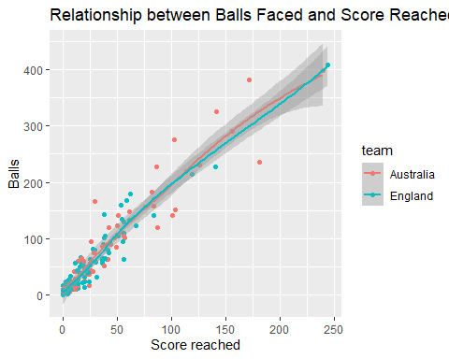

##### 4.2

Describe the relationship between score and number of balls. Are players who face more balls likely to score more runs? [4 points] There is a positive linear trend for both teams that indicates the more balls faced, the higher the score is likely to be. There are a few things to consider: 1) The first is that you can refuse the first five balls and stay neutral provided you hit a six on the sixth. In that way the ratio of one ball to one run can be maintained. The same goes for hitting fours. This leaves a lot of room for batters to increase their scores and create a strong positive trendline. 2) A ball can only ever generate a neutral change in score of 0, it cannot reduce the offensive team’s score. Statistically, the offensive team always has the advantage as every ball has the ability to increase the offensive teams score by 0, 1, 4, or 6. 3) This relationship pertains to this specific series. Where skill levels are approximately equivalent and there doesn’t appear to be any contextual factors at first glance that drastically influenced players on game day. But consider this, a great bowler could hit the stumps leaving the opposition with a score of zero, or a defensive batter could stay in without making a single run, four, or six. This would leave us with a very different trend. Probability and the output of data from this specific series indicates that more balls will result in more runs. But its important to be mindful of the assumptions that are made to get to that conclusion.

##### 4.3

Compute a new variable, scoring_rate, defined as the number of runs divided by the number of balls. Produce a scatterplot of scoring_rate against number of balls. [2 points]

scoring_rate_tibble <- ac %>%  
 mutate(scoring_rates = runs_/balls_)  
#introduced a scoring rate column  
ggplot(scoring_rate_tibble, aes( x = scoring_rates, y= balls_, col=team))+  
 geom_point()+  
 geom_smooth()+  
 ggtitle("Relationship between Balls Faced and Scoring Rate in the 2017/18 Ashes Series")+  
 labs(x = "Scoring rates (Score/balls faced)", y="Balls faced")

## `geom_smooth()` using method = 'loess' and formula 'y ~ x'

## Warning: Removed 102 rows containing non-finite values (stat_smooth).

## Warning: Removed 102 rows containing missing values (geom_point).

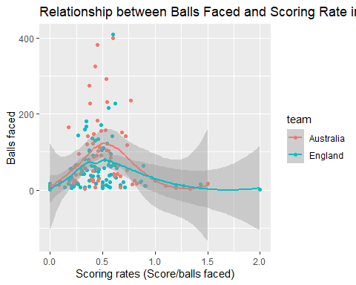 ##### 4.4 Is there a relationship between scoring rate and number of balls? Are players who face more balls likely to score runs more quickly? [2 points]

Scoring rate and balls faced doesn’t appear to have a meaningful relationship. This question isn’t logical. Assuming a large number of balls and all players skill-levels are equivalent, perhaps it would make sense for the first few balls to show an improvement in scoring rank as the player warmed up and gets their emotions in check. A trend would indicate that majority of players somehow improve or get worse as they play. I wouldn’t expect the best players Australia and England have to offer to do either of those things. Interestingly the geom_smooth function indicates that there is a negative quadratic relationship with a maximum around a scoring rate of 0.5 at ~100 balls. This shape indicates that scores generally increase up until around the 100th ball. This indicates the sooner the batter is out the better (who’d have thought?). The cause is more likely to do with batting style. Defensive players let more balls pass by, offensive players take more risks. Perhaps this just indicates the optimal batting style for timely ball to score conversion.

## Question Five: Teams’ roles

##### 5.1

Produce a bar chart of the number of players on each team participating in the series, with segments coloured by the players’ roles. [1 point]

ggplot(indiv_runs, aes(x=team, fill=role))+  
 geom_bar()+  
 ggtitle("Players per Team in the 2017/218 Ashes Series")+  
 labs(x = "Team", y= "Number of players")

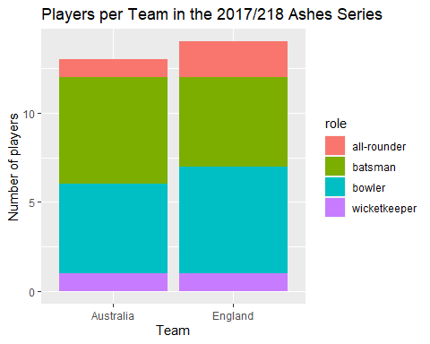 ##### 5.2  
Produce a contingency table of the proportion of players from each team who play in each particular role. [2 points]

con_table <- indiv_runs%>%  
 group_by(role) %>%  
 summarise(team, role,player) %>%  
 unique()

## `summarise()` has grouped output by 'role'. You can override using the `.groups` argument.

#keeps 27 subjects and all variables required  
con_table <- con_table %>%  
 count(team, role)%>%  
 spread(key = "team", value = n)  
#a table showing the total players in each roler per team  
ct <- mutate(con_table, total = sum(Australia+England))  
#adds a column for row totals  
contingency_table <- ct%>%  
 mutate(Aus=Australia/total, Eng= England/total)  
#adds a column indicating the proportion of each  
contingency_table <- contingency_table %>%  
 mutate(Australia = NULL, England =NULL, total=NULL)  
#removes unnecessary columns to reveal the...  
contingency_table

## # A tibble: 4 x 3  
## # Groups: role [4]  
## role Aus Eng  
## <fct> <dbl> <dbl>  
## 1 all-rounder 0.333 0.667  
## 2 batsman 0.545 0.455  
## 3 bowler 0.455 0.545  
## 4 wicketkeeper 0.5 0.5

##### 5.3

Using these two figures, state which team is made up of a larger proportion of batters, and which team contains a larger proportion of all-rounders. [2 points] [Total: 5 points]

The bar chart shows that Australia opted for an extra batsman, while England opted for an extra bowler. In doing so Australia had more batters. The English also had an additional all-rounder, thus having the highest proportion of them. The contingency table puts numbers to that effect, indicating the proportion of player roles for each team. You can see rows two and three indicate the different choice of player, row 1 indicate the English doubled the amount of all rounders held by the Australians, and the number of keepers was equivalent.

## Question Six: Summary of Insights

Cricket Australia are interested in any insights you can bring with respect to the differences between the two teams, as well as any insights related to scoring. In plain English, write a summary of your key findings from Questions 2-5. Your response should be between 200-250 words. [3 points] • The score to ball ratios will never be less than zero • Scoring rates probably don’t provide a whole lot of meaning without knowing how the score was accumulated. Knowing that will give you an indication of batting style. And then perhaps some incite into the optimal batting style. • The optimal team design can’t really be determined from just two teams alone, but there may be merit in having an additional batsman on the team in place of a bowler. Perhaps worth further investigation.



Note that the echo = FALSE parameter was added to the code chunk to prevent printing of the R code that generated the plot.