Assessment 2 - Scaffolded Case Study and Data

## Data Clean

**Step 1:**

# Reading in data  
affairs_df <- read.csv("affairs.csv")  
affairs_df <- as_tibble(affairs_df)  
  
# Child, Religious, Sex, and Rate are ordinal/nomial so it makes sense to store them as factors (will address education and occupation later).   
affairs_df$religious <- as_factor(affairs_df$religious)  
affairs_df$rate <- as_factor(affairs_df$rate)  
affairs_df$child <- as_factor(affairs_df$child)  
affairs_df$sex <- as_factor(affairs_df$sex)

# Printing first 6 rows  
knitr::kable(head(affairs_df, 6))

| affair | sex | age | ym | child | religious | education | occupation | rate |
| --- | --- | --- | --- | --- | --- | --- | --- | --- |
| 0 | male | 37 | 10.00 | no | 3 | 18 | 7 | 4 |
| 0 | female | 27 | 4.00 | no | 4 | 14 | 6 | 4 |
| 0 | female | 32 | 15.00 | yes | 1 | 12 | 1 | 4 |
| 0 | male | 57 | 15.00 | yes | 5 | 18 | 6 | 5 |
| 0 | male | 22 | 0.75 | no | 2 | 17 | 6 | 3 |
| 0 | female | 32 | 1.50 | no | 2 | 17 | 5 | 5 |

**Step 2:**

The outcome variable is ‘*affair*’ – with ‘0’ indicating they’d never had an affair and a ‘1’ indicating they have had at least one affair.,

The predictor variables are the gender (*sex*), age (*age*), number of years of marriage (*ym*), whether they have children (*child*), how devout they consider themselves to be to their religion (*religious*), their level of education (*education*), their occupation according to the Hollinghead classification (*occupation*), and how happy they are in their marriage (*rate*).

**Step 3:**

# Skim() is great for an overview but very cumbersome to view   
skim(affairs_df)

Data summary

|  |  |
| --- | --- |
| Name | affairs_df |
| Number of rows | 601 |
| Number of columns | 9 |
| _______________________ |  |
| Column type frequency: |  |
| factor | 4 |
| numeric | 5 |
| ________________________ |  |
| Group variables | None |

**Variable type: factor**

| skim_variable | n_missing | complete_rate | ordered | n_unique | top_counts |
| --- | --- | --- | --- | --- | --- |
| sex | 0 | 1 | FALSE | 2 | fem: 315, mal: 286 |
| child | 0 | 1 | FALSE | 2 | yes: 430, no: 171 |
| religious | 0 | 1 | FALSE | 5 | 4: 190, 2: 164, 3: 129, 5: 70 |
| rate | 0 | 1 | FALSE | 5 | 5: 232, 4: 194, 3: 93, 2: 66 |

**Variable type: numeric**

| skim_variable | n_missing | complete_rate | mean | sd | p0 | p25 | p50 | p75 | p100 | hist |
| --- | --- | --- | --- | --- | --- | --- | --- | --- | --- | --- |
| affair | 0 | 1 | 0.25 | 0.43 | 0.00 | 0 | 0 | 0 | 1 | ▇▁▁▁▂ |
| age | 0 | 1 | 32.49 | 9.29 | 17.50 | 27 | 32 | 37 | 57 | ▃▇▂▂▁ |
| ym | 0 | 1 | 8.18 | 5.57 | 0.12 | 4 | 7 | 15 | 15 | ▆▅▃▃▇ |
| education | 0 | 1 | 16.17 | 2.40 | 9.00 | 14 | 16 | 18 | 20 | ▁▂▆▇▇ |
| occupation | 0 | 1 | 4.19 | 1.82 | 1.00 | 3 | 5 | 6 | 7 | ▅▂▂▇▆ |

There are currently:

* No missing values
* 601 rows (but three will be removed below)
* The variables have been read in correctly, but data types will be altered in a few steps time to better reflect the information they provide. There is also some cleaning to be done.

Double check and data cleaning:

# There are no NA values  
sum(is.na(affairs_df))

# Clear  
  
# Skim doesn't show you what values are present (spelling mistakes, invalid values, etc.)

unique(affairs_df$affair)

unique(affairs_df$sex)

unique(affairs_df$age)

unique(affairs_df$ym)

unique(affairs_df$child)

unique(affairs_df$religious)

unique(affairs_df$education)

unique(affairs_df$occupation)

unique(affairs_df$rate)

# No errors identified   
# Clear  
  
# Skim doesn't show you conditional errors  
# Does their age and years married make sense?  
filter(affairs_df, age <= 17.5)

a <- filter(affairs_df, age <= 17.5 & ym==10)  
knitr::kable(head(a))

| affair | sex | age | ym | child | religious | education | occupation | rate |
| --- | --- | --- | --- | --- | --- | --- | --- | --- |
| 0 | female | 17.5 | 10 | no | 4 | 14 | 4 | 5 |

A 17.5-year-old woman had been married for 10 years? Married since the age of 7.5?

This American magazine printed from 1967. The subject was highly religious so perhaps not unheard of, but the American census suggests the law requires you be at least 14 to marry (Hetzel and Cappetta 1971). Which would make this an unlawful marriage; or an outlier at a minimum. If the American census did not recognize the union, I see no reason why I should.

# remove unlawful child marriages  
filter(affairs_df, (age-ym) < 14 )

clean <- affairs_df %>% slice(-c(which(affairs_df$age <= 17.5 & affairs_df$ym==10, arr.ind=TRUE)))  
# Removed  
  
# Is their level of education feasibly possible?  
filter(clean, age < 23, education == 20)

b <- filter(clean, age < education)  
knitr::kable(head(b))

| affair | sex | age | ym | child | religious | education | occupation | rate |
| --- | --- | --- | --- | --- | --- | --- | --- | --- |
| 0 | male | 17.5 | 1.50 | yes | 3 | 18 | 6 | 5 |
| 0 | female | 17.5 | 0.75 | no | 2 | 18 | 5 | 4 |

You couldn’t attend school from the womb in the 1960s to my knowledge. In the American system, children begin formal education aged 3 or 4, meaning you can’t be younger than 23 and have a PhD without being some kind of savant. A savant is, by definition, extremely different from the population anyway. These occurrences will be excluded.

clean <- subset(clean, age>education)  
# Removed  
  
# checking for oddities between participant's education and occupation  
filter(clean, occupation == 7, education < 15 )

## # A tibble: 5 x 9  
## affair sex age ym child religious education occupation rate   
## <int> <fct> <dbl> <dbl> <fct> <fct> <int> <int> <fct>  
## 1 0 female 47 15 yes 5 14 7 2   
## 2 0 male 57 15 yes 2 14 7 2   
## 3 0 male 52 15 yes 2 14 7 4   
## 4 1 female 27 10 yes 4 12 7 3   
## 5 1 male 32 7 yes 3 14 7 4

# ^highly skilled jobs, but did not have any tertiary education. But unions and regulations might have been less stringent in the 1960s?  
# Questionable, but clear

Three rows removed due to impossible or unlawful outliers considering the 1960s context. This took the initial 601 rows down to **598 rows**, the **9 columns** containing the observations for each subject are still present.

**Step 4:**

# Setting the binary values to yes/no factor values  
clean$affair <- ifelse(clean$affair == 1, "yes", "no")  
clean$affair <- as.factor(clean$affair)  
  
# Counting values  
sum(clean$affair == "yes")

## [1] 150

sum(clean$affair == "no")

## [1] 448

# No longer care about numeric information for education and occupation, converting to factors  
clean$education <- as.factor(clean$education)  
clean$occupation <- as.factor(clean$occupation)  
knitr::kable(head(clean))

# affair sex age ym child religious education occupation rate  
# <fct> <fct> <dbl> <dbl> <fct> <fct> <fct> <fct> <fct>

| affair | sex | age | ym | child | religious | education | occupation | rate |
| --- | --- | --- | --- | --- | --- | --- | --- | --- |
| no | male | 37 | 10.00 | no | 3 | 18 | 7 | 4 |
| no | female | 27 | 4.00 | no | 4 | 14 | 6 | 4 |
| no | female | 32 | 15.00 | yes | 1 | 12 | 1 | 4 |
| no | male | 57 | 15.00 | yes | 5 | 18 | 6 | 5 |
| no | male | 22 | 0.75 | no | 2 | 17 | 6 | 3 |
| no | female | 32 | 1.50 | no | 2 | 17 | 5 | 5 |

The tibble now has 150 ‘yes’ values and 448 ‘no’ values in place of their binary counterparts. All Character values have been converted to factors. Occupation and education variables concerned me because the context between each value doesn’t increase linearly, it’s exponential. The same can be said for the lifestyle that comes with each level of the Hollinghead classification system. To reflect the differences better, I am treating them as factors with levels (ordinal).

**Step 5:**

skim(clean)

Data summary

|  |  |
| --- | --- |
| Name | clean |
| Number of rows | 598 |
| Number of columns | 9 |
| _______________________ |  |
| Column type frequency: |  |
| factor | 7 |
| numeric | 2 |
| ________________________ |  |
| Group variables | None |

**Variable type: factor**

| skim_variable | n_missing | complete_rate | ordered | n_unique | top_counts |
| --- | --- | --- | --- | --- | --- |
| affair | 0 | 1 | FALSE | 2 | no: 448, yes: 150 |
| sex | 0 | 1 | FALSE | 2 | fem: 313, mal: 285 |
| child | 0 | 1 | FALSE | 2 | yes: 429, no: 169 |
| religious | 0 | 1 | FALSE | 5 | 4: 189, 2: 163, 3: 128, 5: 70 |
| education | 0 | 1 | FALSE | 7 | 14: 153, 16: 115, 18: 110, 17: 89 |
| occupation | 0 | 1 | FALSE | 7 | 5: 203, 6: 142, 1: 113, 4: 67 |
| rate | 0 | 1 | FALSE | 5 | 5: 230, 4: 193, 3: 93, 2: 66 |

**Variable type: numeric**

| skim_variable | n_missing | complete_rate | mean | sd | p0 | p25 | p50 | p75 | p100 | hist |
| --- | --- | --- | --- | --- | --- | --- | --- | --- | --- | --- |
| age | 0 | 1 | 32.56 | 9.25 | 17.50 | 27 | 32 | 37 | 57 | ▃▇▂▂▁ |
| ym | 0 | 1 | 8.20 | 5.57 | 0.12 | 4 | 7 | 15 | 15 | ▆▅▃▃▇ |

sum(clean$affair == "yes")

## [1] 150

sum(clean$child == "yes")

## [1] 429

mean(clean$age)

## [1] 32.56271

mean(as.integer(clean$religious))

## [1] 3.117057

1. How many people responded to having an affair? 150
2. How many responded to having children? 429
3. What is the mean age of respondents? 32.56
4. What is the mean response on the religious scale? 3.12 (Approximately 3)
5. Do you think you should normalize the numeric variables? Yes
6. Why/Why not? Because we have different ranges for each variable. Larger values will have more weighting but may not be better predictors. By normalizing we create uniform scales which will allow R to better interpret variable importance.

## Exploratory Data Analysis

**Step 1: female proportionality of response to affair**

# For women responding No  
count(filter(clean, affair == "no", sex == "female"))/count(filter(clean, affair == "no"))

## n  
## 1 0.5379464

# For women responding yes  
count(filter(clean, affair == "yes", sex == "female"))/count(filter(clean, affair == "yes"))

## n  
## 1 0.48

# Added after tute:  
CrossTable(clean$affair, clean$sex)   
## | clean$sex   
## clean$affair | male | female | Row Total |   
## -------------|-----------|-----------|-----------|  
## no | 207 | 241 | 448 |   
## | 0.199 | 0.181 | |   
## | 0.462 | 0.538 | 0.749 |   
## | 0.726 | 0.770 | |   
## | 0.346 | 0.403 | |   
## -------------|-----------|-----------|-----------|  
## yes | 78 | 72 | 150 |   
## | 0.593 | 0.540 | |   
## | 0.520 | 0.480 | 0.251 |   
## | 0.274 | 0.230 | |   
## | 0.130 | 0.120 | |   
## -------------|-----------|-----------|-----------|  
## Column Total | 285 | 313 | 598 |   
## | 0.477 | 0.523 | |   
## -------------|-----------|-----------|-----------|

* 74.9% of participants had **never** had an affair.
* 53.79% of participants that indicated they’d **never had** an affair were female
* 48% of participants that indicated they **have had** an affair were female.

Gender does not appear to be a great indicator of whether or not someone will have an affair, it’s almost as likely as a coin flip.

**Step 2: parenthood status proportionality of response to affair**

# For parents responding yes  
count(filter(clean, affair == "yes", child == "yes"))/count(filter(clean, affair == "yes"))

## n  
## 1 0.82

# For women responding no  
count(filter(clean, affair == "no", child == "no"))/count(filter(clean, affair == "no"))

## n  
## 1 0.3169643

# Added after tute:  
CrossTable(clean$affair, clean$child)   
## | clean$child   
## clean$affair | no | yes | Row Total |   
## -------------|-----------|-----------|-----------|  
## no | 142 | 306 | 448 |   
## | 1.871 | 0.737 | |   
## | 0.317 | 0.683 | 0.749 |   
## | 0.840 | 0.713 | |   
## | 0.237 | 0.512 | |   
## -------------|-----------|-----------|-----------|  
## yes | 27 | 123 | 150 |   
## | 5.588 | 2.201 | |   
## | 0.180 | 0.820 | 0.251 |   
## | 0.160 | 0.287 | |   
## | 0.045 | 0.206 | |   
## -------------|-----------|-----------|-----------|  
## Column Total | 169 | 429 | 598 |   
## | 0.283 | 0.717 | |   
## -------------|-----------|-----------|-----------|

* 429 subjects had children, 169 subjects did not.
* 82% of people that **did have** an affair indicated they were parents.
* 31.70% of people that **did not have** an affair indicated they were childless.

In the 1960s, it appears having children increased the likely hood of having an affair. Perhaps due to the added economic, physical and mental stresses that family life would have entailed. Parental status appears to be a good predictor of whether or not someone will have an affair.

**Step 3:**

ggplot(clean, aes(x = affair, y=as.integer(rate), fill=affair)) +  
 geom_boxplot(outlier.shape = 22, outlier.fill="#1b98e0") +  
 scale_fill_manual(values = c("#1b98e0", "violet"), breaks=waiver()) +  
 ggtitle("Figure 1: How loyal and disloyal participants rated \ntheir marriages") +  
 xlab("Respons to question 'Have you had an affair?'") +  
 ylab("rate\n\n(1=unhappy, 5=Very happy)\n")

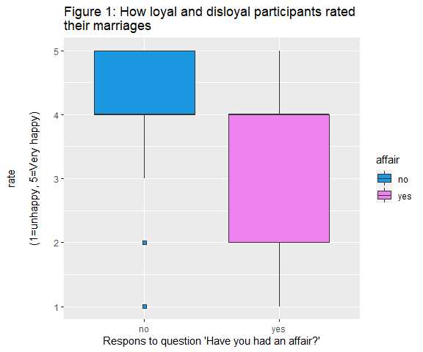

In both cases the median sits on a rate value of 4. However, the spread for the bulk of the data was much smaller for the loyal cohort (between 3 and 5 with a few outliers). Whereas the disloyal cohort had a spread from the minimum to the maximum rate values (1 to 5). It is difficult to comment on the reliability of ‘rate’ as a predictor because there is a good deal of whisker overlap between populations. However, the disloyal cohort skews to lower/unhappy values while the loyal cohort skews to higher/very happy values.

*consideration: We should also consider that there may be a sampling bias in the data. Magazine cost, accessibility, regularity of purchase, etc. could be used to scrutinize these effects but that is outside the scope of this assignment.

**Step 4:**

#..prop.. is also stat(prop) now  
levels <- c('no'="Loyal cohort", 'yes'= "Disloyal cohort" )  
ggplot(clean, aes(x = rate, group = sex, fill = sex)) +  
 geom_bar( aes(y = stat(prop)),   
 stat = "count",  
 position = position_dodge()) +  
 scale_fill_manual(values = c("navy", "dark red"), breaks=waiver()) +  
 geom_text( aes(label = scales::percent( accuracy = 1, (stat(prop))),   
 y = stat(prop)),   
 stat = "count",   
 vjust = -.5,   
 position = position_dodge(0.9),  
 size = 2,  
 color = "white") +  
 facet_grid(~affair, labeller = as_labeller(levels)) +  
 ggtitle("Figure 2.1: The proportion of rate responses split\n by sex for both the loyal and disloyal cohorts" ) +  
 xlab("Gender") +  
 ylab("Proportion of rate response") +  
 scale_y_continuous(limits = c(0,0.5),  
 labels = scales::percent) +  
 theme_dark()

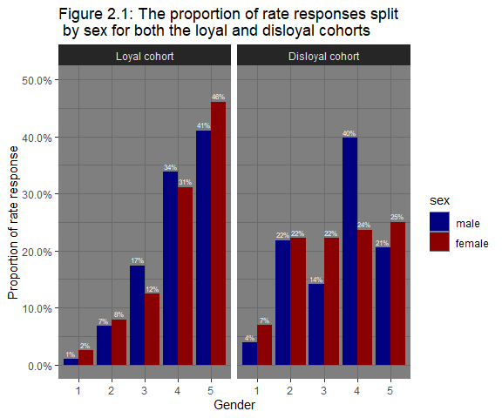

From Figure 2.1, we see that the disloyal males have a multi-modal distribution with most of the data present at level 4 - one less than the maximum happiness value. The disloyal women have a more uniform distribution, except for ratings of 1; indicating few disloyal women ranked themselves as the unhappiest they could be with their marriage. This is very different to what we see in the loyal cohort which is unimodal and left skewed.

There is another way to interpret the question, so I’ve provided that below:

ggplot(clean,   
 aes(x = sex, group = rate, fill = rate)) +  
 geom_bar( aes(y = stat(prop)),   
 stat = "count",   
 position = position_dodge()) +  
 scale_fill_brewer()+  
 geom_text( aes(label = scales::percent( accuracy = 1, (stat(prop))),   
 y = stat(prop)),   
 stat = "count",   
 vjust = -.5,   
 position = position_dodge(.9),  
 size = 1.8,  
 color = "white") +  
 scale_y_continuous(limits = c(0,1),  
 labels = scales::percent) +  
 facet_grid(~affair,  
 labeller = as_labeller(levels)) +  
 ggtitle("Figure 2.2: The proportion of gender for each marriage \nrating for each sex-affair response pair" ) +  
 xlab("Gender") +  
 ylab("Proportion of rate response ") +  
 theme_dark()

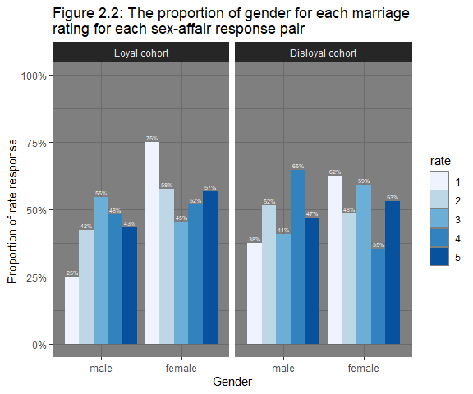

The population of men and population of women that indicated they’d been disloyal both have a multi-modal distribution. The males appear to have more of a left skew and the women more of a right skew; indicating that disloyal men were happier in their marriages than the disloyal women. Sadly, there were also larger proportions of dissatisfaction in loyal women as well.

*Consideration: The rate variable has a lot of unknown variation as participants have different tolerance and threshold levels. It’s also worth mentioning that there is no record of why they had an affair or with what gender their affair was with. Perhaps a better variable would have been the cause, then we could have established a ranking of cause severity instead of a list of arbitrary tolerance/thresholds for each individual. It would still be arbitrary, but the ranking would be consistent thus minimizing variation between values.

**Step 5:**

ggplot(clean, aes(x=as.numeric(education), y=..prop..)) +  
 geom_bar() +  
 facet_wrap(~affair) +  
 scale_y_continuous(limits = c(0,0.3),  
 labels = scales::percent) +  
 geom_text( aes(label = scales::percent( accuracy = 1, (stat(prop))),   
 y = stat(prop)),   
 stat = "count",   
 vjust = -.5,   
 position = position_dodge(width =0.9),  
 size = 3)+  
 ggtitle("Figure 3: The proportion of participant education for the loyal\n and disloyal cohorts" ) +  
 xlab("Years of education") +  
 ylab("Proportion of participants ") +  
 theme_bw()

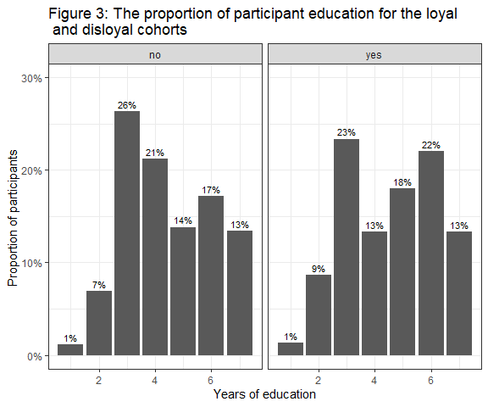

There was a great deal of similarity between the cohorts, both were multimodal and many of the categories have identical proportions between cohorts. The loyal cohort appears to have a right skew when it comes to education, but the disloyal cohort appears to be spread more randomly. Years of education does not appear to hold much information regarding whether or not someone will have an affair.

*Consideration: Perhaps it would have been better to also indicate the discrepancy of education levels between the married couple and also investigate the education level of the person they had the affair with.

Something else to consider is that we cannot assume that someone is more intelligent because they’ve studied longer. The quality and type of studies, their genetic predispositions, etc. will determine intelligence. That being the case, we don’t really have a true measure of education or intelligence, but a loose commentary on their socioeconomic status.

## Split and Preprocess

**step 1 and 2:**

# Setting seed for reproducibility  
set.seed(1234)  
# Indexing each row  
index <- sample(1:nrow(clean))  
repro_clean <-clean[index, ]

set.seed(1234)  
# Creating training and test sets  
clean_split <- initial_split(repro_clean)  
  
clean_training <- training(clean_split)  
knitr::kable(head(clean_training, 6))

| affair | sex | age | ym | child | religious | education | occupation | rate |
| --- | --- | --- | --- | --- | --- | --- | --- | --- |
| no | female | 37 | 7.0 | no | 4 | 18 | 5 | 5 |
| yes | male | 22 | 1.5 | no | 2 | 12 | 3 | 3 |
| yes | male | 27 | 1.5 | yes | 3 | 17 | 5 | 4 |
| no | female | 52 | 15.0 | yes | 5 | 12 | 1 | 3 |
| no | female | 27 | 7.0 | yes | 2 | 12 | 1 | 2 |
| no | female | 22 | 1.5 | no | 2 | 14 | 1 | 5 |

# Setting seed for reproducibility  
set.seed(1234)  
clean_testing <- testing(clean_split)  
knitr::kable(head(clean_testing, 6))

| affair | sex | age | ym | child | religious | education | occupation | rate |
| --- | --- | --- | --- | --- | --- | --- | --- | --- |
| no | female | 27 | 4.0 | yes | 4 | 12 | 1 | 5 |
| no | male | 57 | 15.0 | yes | 5 | 20 | 6 | 5 |
| no | female | 22 | 1.5 | no | 3 | 16 | 5 | 5 |
| no | male | 37 | 15.0 | yes | 4 | 20 | 6 | 5 |
| no | male | 47 | 15.0 | yes | 4 | 16 | 6 | 4 |
| no | male | 22 | 4.0 | yes | 4 | 14 | 2 | 4 |

nrow(clean_training)

## [1] 448

nrow(clean_testing)

## [1] 150

There are 448 rows in the training set and 150 in the testing set.

**Step 3:**

The step_downsample() function is used to remove rows in a data set to ensure levels are interpreted equally. If you have strings as nominal values in your data set, this function will prevent them from being interpreted as ordinal. R interprets levels based on the ASCII, so there are inadvertent levels present in all our qualitative predictors as a result of setting them as factors:

levels(clean$religious) #"1" "2" "3" "4" "5"

levels(clean$rate) #"1" "2" "3" "4" "5"

levels(clean$child) #"no" "yes"

levels(clean$sex) #"male" "female"

levels(clean$education) # "9" "12" "14" "16" "17" "18" "20"

levels(clean$occupation)# "1" "2" "3" "4" "5" "6" "7"

**Step 4:**

# Preparing recipe  
affair_recipe <- recipe(affair ~ ., data = clean_training) %>%  
 themis::step_downsample(affair) %>%  
 step_dummy(sex, child, religious, rate, education, occupation) %>% #for nominal data, I nhindsight should have used all_nominal()   
 step_normalize(all_predictors())%>%  
 prep()  
  
affair_recipe

## Recipe  
##   
## Inputs:  
##   
## role #variables  
## outcome 1  
## predictor 8  
##   
## Training data contained 448 data points and no missing data.  
##   
## Operations:  
##   
## $terms  
## <list_of<quosure>>  
##   
## [[1]]  
## <quosure>  
## expr: ^affair  
## env: 0x0000000020735c10  
##   
##   
## $under_ratio  
## [1] 1  
##   
## $ratio  
## [1] NA  
##   
## $role  
## [1] NA  
##   
## $trained  
## [1] TRUE  
##   
## $column  
## [1] "affair"  
##   
## $target  
## [1] 117  
##   
## $skip  
## [1] TRUE  
##   
## $id  
## [1] "downsample_pdHMv"  
##   
## $seed  
## [1] 84294  
##   
## $id  
## [1] "downsample_pdHMv"  
##   
## attr(,"class")  
## [1] "step_downsample" "step"   
## Dummy variables from sex, child, religious, rate, education, occupation [trained]  
## Centering and scaling for age, ym, sex_female, child_yes, religious_X2, r... [trained]

**Step 5:**

# Preprocessing the training set  
affair_training_prepro <- affair_recipe %>%  
 juice() # Using clean_training data from recipe  
affair_training_prepro

## # A tibble: 234 x 25  
## age ym affair sex_female child_yes religious_X2 religious_X3  
## <dbl> <dbl> <fct> <dbl> <dbl> <dbl> <dbl>  
## 1 -0.0703 -0.811 no -1.03 -1.74 -0.619 -0.586  
## 2 0.491 0.270 no 0.964 0.573 -0.619 -0.586  
## 3 -0.632 -1.51 no -1.03 -1.74 -0.619 1.70   
## 4 2.74 1.17 no -1.03 0.573 -0.619 -0.586  
## 5 -1.19 -1.26 no 0.964 -1.74 -0.619 1.70   
## 6 -0.0703 0.270 no 0.964 0.573 -0.619 -0.586  
## 7 -0.632 -1.40 no 0.964 -1.74 -0.619 -0.586  
## 8 1.05 1.17 no -1.03 0.573 1.61 -0.586  
## 9 -0.632 -0.271 no 0.964 0.573 -0.619 -0.586  
## 10 -1.19 -1.46 no 0.964 -1.74 -0.619 -0.586  
## # ... with 224 more rows, and 18 more variables

#Preprocessing the testing set  
affair_test_prepro <- affair_recipe %>%  
 bake(clean_testing)  
affair_test_prepro

## # A tibble: 150 x 25  
## age ym affair sex_female child_yes religious_X2 religious_X3  
## <dbl> <dbl> <fct> <dbl> <dbl> <dbl> <dbl>  
## 1 -0.632 -0.811 no 0.964 0.573 -0.619 -0.586  
## 2 2.74 1.17 no -1.03 0.573 -0.619 -0.586  
## 3 -1.19 -1.26 no 0.964 -1.74 -0.619 1.70   
## 4 0.491 1.17 no -1.03 0.573 -0.619 -0.586  
## 5 1.61 1.17 no -1.03 0.573 -0.619 -0.586  
## 6 -1.19 -0.811 no -1.03 0.573 -0.619 -0.586  
## 7 2.74 1.17 no -1.03 0.573 -0.619 -0.586  
## 8 0.491 1.17 no -1.03 0.573 -0.619 -0.586  
## 9 -1.19 -1.40 no 0.964 -1.74 1.61 -0.586  
## 10 0.491 -0.811 no -1.03 0.573 -0.619 -0.586  
## # ... with 140 more rows, and 18 more variables

**Step 6:**

skim(affair_training_prepro)

Data summary

|  |  |
| --- | --- |
| Name | affair_training_prepro |
| Number of rows | 234 |
| Number of columns | 25 |
| _______________________ |  |
| Column type frequency: |  |
| factor | 1 |
| numeric | 24 |
| ________________________ |  |
| Group variables | None |

**Variable type: factor**

| skim_variable | n_missing | complete_rate | ordered | n_unique | top_counts |
| --- | --- | --- | --- | --- | --- |
| affair | 0 | 1 | FALSE | 2 | no: 117, yes: 117 |

**Variable type: numeric**

| skim_variable | n_missing | complete_rate | mean | sd | p0 | p25 | p50 | p75 | p100 | hist |
| --- | --- | --- | --- | --- | --- | --- | --- | --- | --- | --- |
| age | 0 | 1 | 0 | 1 | -1.70 | -0.63 | -0.07 | 0.49 | 2.74 | ▃▇▃▂▁ |
| ym | 0 | 1 | 0 | 1 | -1.51 | -0.81 | -0.27 | 1.17 | 1.17 | ▅▃▃▃▇ |
| sex_female | 0 | 1 | 0 | 1 | -1.03 | -1.03 | 0.96 | 0.96 | 0.96 | ▇▁▁▁▇ |
| child_yes | 0 | 1 | 0 | 1 | -1.74 | 0.57 | 0.57 | 0.57 | 0.57 | ▂▁▁▁▇ |
| religious_X2 | 0 | 1 | 0 | 1 | -0.62 | -0.62 | -0.62 | 1.61 | 1.61 | ▇▁▁▁▃ |
| religious_X3 | 0 | 1 | 0 | 1 | -0.59 | -0.59 | -0.59 | 1.70 | 1.70 | ▇▁▁▁▃ |
| religious_X4 | 0 | 1 | 0 | 1 | -0.59 | -0.59 | -0.59 | 1.68 | 1.68 | ▇▁▁▁▃ |
| religious_X5 | 0 | 1 | 0 | 1 | -0.33 | -0.33 | -0.33 | -0.33 | 3.02 | ▇▁▁▁▁ |
| rate_X2 | 0 | 1 | 0 | 1 | -0.45 | -0.45 | -0.45 | -0.45 | 2.20 | ▇▁▁▁▂ |
| rate_X3 | 0 | 1 | 0 | 1 | -0.43 | -0.43 | -0.43 | -0.43 | 2.34 | ▇▁▁▁▂ |
| rate_X4 | 0 | 1 | 0 | 1 | -0.69 | -0.69 | -0.69 | 1.44 | 1.44 | ▇▁▁▁▃ |
| rate_X5 | 0 | 1 | 0 | 1 | -0.69 | -0.69 | -0.69 | 1.44 | 1.44 | ▇▁▁▁▃ |
| education_X12 | 0 | 1 | 0 | 1 | -0.24 | -0.24 | -0.24 | -0.24 | 4.11 | ▇▁▁▁▁ |
| education_X14 | 0 | 1 | 0 | 1 | -0.59 | -0.59 | -0.59 | 1.70 | 1.70 | ▇▁▁▁▃ |
| education_X16 | 0 | 1 | 0 | 1 | -0.45 | -0.45 | -0.45 | -0.45 | 2.20 | ▇▁▁▁▂ |
| education_X17 | 0 | 1 | 0 | 1 | -0.45 | -0.45 | -0.45 | -0.45 | 2.20 | ▇▁▁▁▂ |
| education_X18 | 0 | 1 | 0 | 1 | -0.49 | -0.49 | -0.49 | -0.49 | 2.02 | ▇▁▁▁▂ |
| education_X20 | 0 | 1 | 0 | 1 | -0.40 | -0.40 | -0.40 | -0.40 | 2.46 | ▇▁▁▁▁ |
| occupation_X2 | 0 | 1 | 0 | 1 | -0.15 | -0.15 | -0.15 | -0.15 | 6.75 | ▇▁▁▁▁ |
| occupation_X3 | 0 | 1 | 0 | 1 | -0.34 | -0.34 | -0.34 | -0.34 | 2.95 | ▇▁▁▁▁ |
| occupation_X4 | 0 | 1 | 0 | 1 | -0.40 | -0.40 | -0.40 | -0.40 | 2.51 | ▇▁▁▁▁ |
| occupation_X5 | 0 | 1 | 0 | 1 | -0.72 | -0.72 | -0.72 | 1.38 | 1.38 | ▇▁▁▁▅ |
| occupation_X6 | 0 | 1 | 0 | 1 | -0.51 | -0.51 | -0.51 | -0.51 | 1.94 | ▇▁▁▁▂ |
| occupation_X7 | 0 | 1 | 0 | 1 | -0.18 | -0.18 | -0.18 | -0.18 | 5.68 | ▇▁▁▁▁ |

There are 117 ‘yes’ and 117 ‘no’ values from the down-sampling, thus removing any unwanted weighting. The factor variables have been converted to numerical dummy variables (categorical variables now indicate the absence (0) or presence (1) of an influence). The step_normalize() function uses the training data to make an estimate of the mean and standard deviation. It subtracts the mean from the data to center it, and then divides the values by the standard deviation in order to scale it; effectively an estimated z-score. The mean is effectively on 0 and the standard deviation is now exactly 1 from normalizing the data.

## Tune and Fit a Model

**Step 1:**

# Model specification  
model_spec <- nearest_neighbor(mode = "classification",   
 engine = "kknn",   
 neighbors = tune())  
  
# fitting model  
affair_knn <- model_spec %>%  
 fit(affair~., data = affair_training_prepro)

**Step 2:**

# Setting seed for reproducibility   
set.seed(1234)  
index <- sample(1:nrow(affair_training_prepro))  
prepro_training <- affair_training_prepro[index, ]  
affair_cv <- vfold_cv( data = prepro_training, v = 5, starta=affair)  
affair_cv

## # 5-fold cross-validation   
## # A tibble: 5 x 2  
## splits id   
## <list> <chr>  
## 1 <split [187/47]> Fold1  
## 2 <split [187/47]> Fold2  
## 3 <split [187/47]> Fold3  
## 4 <split [187/47]> Fold4  
## 5 <split [188/46]> Fold5

**Step 3:**

k_grid <- grid_regular(neighbors(c(5,75)),levels = 25)  
k_grid

## # A tibble: 25 x 1  
## neighbors  
## <int>  
## 1 5  
## 2 7  
## 3 10  
## 4 13  
## 5 16  
## 6 19  
## 7 22  
## 8 25  
## 9 28  
## 10 31  
## # ... with 15 more rows

**Step 4:**

tune_k <- tune::tune_grid(model_spec,  
 preprocess = affair~.,  
 resamples = affair_cv,  
 grid = k_grid)

**Step 5:**

tune_df <- collect_metrics(tune_k)  
tune_df

## # A tibble: 50 x 7  
## neighbors .metric .estimator mean n std_err .config   
## <int> <chr> <chr> <dbl> <int> <dbl> <chr>   
## 1 5 accuracy binary 0.530 5 0.0328 Preprocessor1_Model01  
## 2 5 roc_auc binary 0.562 5 0.0384 Preprocessor1_Model01  
## 3 7 accuracy binary 0.513 5 0.0224 Preprocessor1_Model02  
## 4 7 roc_auc binary 0.571 5 0.0369 Preprocessor1_Model02  
## 5 10 accuracy binary 0.530 5 0.0229 Preprocessor1_Model03  
## 6 10 roc_auc binary 0.572 5 0.0380 Preprocessor1_Model03  
## 7 13 accuracy binary 0.573 5 0.0354 Preprocessor1_Model04  
## 8 13 roc_auc binary 0.591 5 0.0416 Preprocessor1_Model04  
## 9 16 accuracy binary 0.573 5 0.0300 Preprocessor1_Model05  
## 10 16 roc_auc binary 0.597 5 0.0394 Preprocessor1_Model05  
## # ... with 40 more rows

# Separating accuracy and roc_aus metrics  
accuracy_df <- tune_df[tune_df$.metric=="accuracy",]  
roc_auc_df <- tune_df[tune_df$.metric=="roc_auc",]  
  
# Plotting the mean accuracy for each value of k  
ggplot(accuracy_df, aes(x = neighbors, y = mean)) +  
 geom_point() +  
 geom_line() +  
 ggtitle("Figure 4: Comparisson of accuracy values for each model" ) +  
 xlab("Number of neighbours, k, used") +  
 ylab("Mean accuracy") +  
 geom_text(data = filter(accuracy_df, neighbors == 57),   
 aes(x = neighbors,  
 label = paste("k =",neighbors,",\naccuracy =", round(mean, 2))),  
 nudge_y = 0.01,  
 size = 4) +   
 geom_point(data = filter(accuracy_df, neighbors == 57),  
 aes(x = neighbors, y = mean), colour= "red") +  
 scale_y_continuous(limits = c(0.51, 0.605)) +  
 theme_bw() +  
 theme(legend.position = "none")

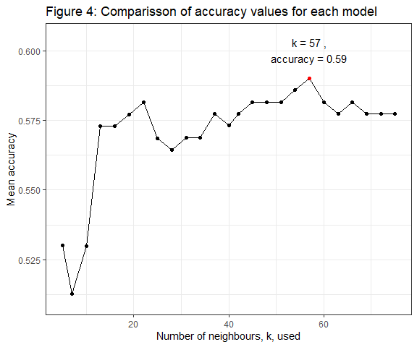

# Plotting the mean roc_auc for each value of k  
ggplot(roc_auc_df, aes(x = neighbors, y = mean)) +  
 geom_point() +  
 geom_line() +  
 ggtitle("Figure 5: Comparisson of the areas under the ROC curves for\n each model" ) +  
 xlab("Number of neighbours, k, used") +  
 ylab("Mean area under the curve") +  
 geom_text(data = filter(roc_auc_df, neighbors == 60),   
 aes(x = neighbors,  
 label = paste("k =",neighbors,",\nAUC =", round(mean, 4))),  
 nudge_y = 0.015,  
 size = 4) +   
 geom_point(data = filter(roc_auc_df, neighbors == 60),  
 aes(x = neighbors,y = mean), color = "red") +  
 scale_y_continuous(limits = c(0.54, 0.66)) +  
 theme_bw()+  
 theme(legend.position = "none")

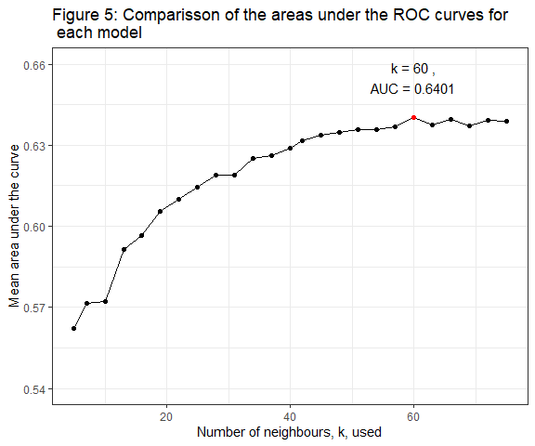

The best mean accuracy was when k = 57, the best mean area under the ROC curve was found at k = 60.

**Step 6:**

# These functions were also used to create the annotation above:  
highest_accuracy <- tune_k %>%  
 select_best(metric = "accuracy")  
highest_accuracy # best value was 57

highest_AUC <- tune_k %>%  
 select_best(metric = "roc_auc")  
highest_AUC # best value was 60

**Step 7:**

knn_final <-finalize_model(model_spec, highest_accuracy)  
knn_final

## K-Nearest Neighbor Model Specification (classification)  
##   
## Main Arguments:  
## neighbors = 57  
##   
## Computational engine: kknn

**Step 8:**

knn_final <- finalize_model(model_spec, highest_accuracy) %>%  
 fit(affair~., data = affair_training_prepro)

## 

## Evaluation

**Step 1:**

class_prediction <- knn_final %>%  
 predict(new_data = affair_test_prepro )   
knitr::kable(head(class_prediction, 6))

| .pred_class |
| --- |
| no |
| yes |
| no |
| no |
| no |
| no |

**Step 2:**

class_prediction <- class_prediction %>%  
 bind_cols(affair_test_prepro %>%   
 select( affair))  
knitr::kable(head(class_prediction, 6))

| .pred_class | affair |
| --- | --- |
| no | no |
| yes | no |
| no | no |
| no | no |
| no | no |
| no | no |

**Step 3:**

conf_matrix <- class_prediction %>%   
 conf_mat(truth = affair, estimate = .pred_class )   
conf_matrix

## Truth  
## Prediction no yes  
## no 74 18  
## yes 43 15

**Step 4:**

sens(class_prediction, affair, .pred_class)  
## 1 sens binary 0.632

The sensitivity of the model is 0.6325. Sensitivity is a measure of how accurately the model predicts a positive result. In this case, the model was able to predict a positive case (someone being disloyal) a little bit better than if you flipped a coin to decide. This will be detrimental as many of the people marked as disloyal by the model indicated that they had been loyal. Of course, disloyal people might be expected to lie on such a survey but we cannot assume the worst of people. That being the case, the model does not have the predictive power to fairly and compassionately determine the loyalty of a person.

spec(class_prediction, affair, .pred_class)  
## 1 spec binary 0.455

The sensitivity of the model was 0.4545. Specificity is a measure of how reliably the model can predict a negative case. Using this metric, the model appears to be about as good a classifier as flipping a coin to decide. It has less harmful impacts in reality as it doesn’t accuse anyone of being disloyal, but by the same token it also allows disloyal partners to potentially continue an affair.

**Step 5:**

class_prediction <- class_prediction %>%  
 bind_cols(predict(object = knn_final,  
 new_data = affair_test_prepro,  
 type = "prob"))   
knitr::kable(head(class_prediction, 6))

| .pred_class | affair | .pred_no | .pred_yes |
| --- | --- | --- | --- |
| no | no | 0.5847266 | 0.4152734 |
| yes | no | 0.4447313 | 0.5552687 |
| no | no | 0.8084423 | 0.1915577 |
| no | no | 0.5404249 | 0.4595751 |
| no | no | 0.5311186 | 0.4688814 |
| no | no | 0.6508665 | 0.3491335 |

**Step 6:**

class_prediction %>%  
 roc_curve(truth = affair, .pred_yes) %>%  
 autoplot() +  
 ggtitle("Figure 6: The ROC curve for the finalised \nmodel predicting disloyalty") +  
 theme(plot.title = element_text(size = 10))

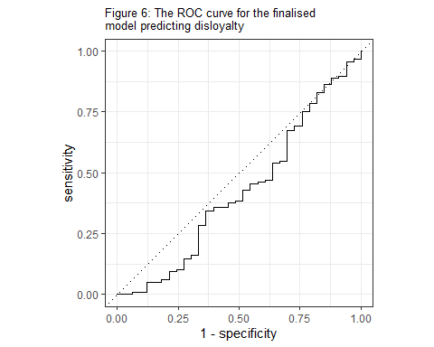

This model is not predicting disloyalty well. The line of y = x is the equivalent of a completely random classification. This figure indicates that the predictors do not provide enough information nor strong enough associations with the outcome variable to make meaningful predictions. Ideally, we would like to see the chart reach up to the top left where the true positive rate is high and the false positive rate is low. Even altering the chart to represent a model that predicts loyalty does not reach that area (figure 7).

class_prediction %>%  
 roc_curve(truth = affair, .pred_no) %>%  
 autoplot() +  
 ggtitle("Figure 7: The ROC curve for the finalised \nmodel predicting loyalty") +  
 theme(plot.title = element_text(size = 10))

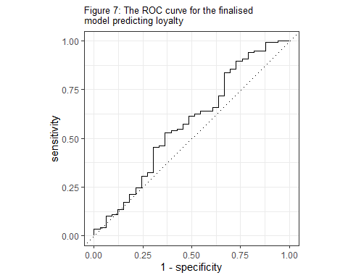

**Step 7:**

class_prediction %>%  
 roc_auc(truth = affair, .pred_yes)

## .metric .estimator .estimate  
## 1 roc_auc binary 0.424

class_prediction %>%  
 roc_auc(truth = affair, .pred_no)

## .metric .estimator .estimate  
## 1 roc_auc binary 0.576

A completely random classification model would produce an area under the curve of 0.5. This further demonstrates that this model (with an area under the ROC curve of 0.42) is lacking predictive power. The same model predicting instead for loyalty is better, at 0.58, but still lacking in predictive power.

**Step 8:**

# creating a tibble of the form seen in affairs_df  
#a)  
bono_prediction <- tibble(  
 sex = factor("male", levels=c("female", "male")),  
 age = 47,  
 ym = 15,  
 child = factor("no", levels = c("no", "yes")),  
 religious = factor("2", levels = c("1","2", "3", "4", "5", "6", "7")),  
 education = factor("20", levels = c("9","12","14","16","17","18","20")),  
 occupation = factor("6", levels = c("1","2","3","4","5","6","7")),  
 rate = factor("5", levels=c("1","2", "3", "4", "5")))  
  
knitr::kable(head(bono_prediction))

| sex | age | ym | child | religious | education | occupation | rate |
| --- | --- | --- | --- | --- | --- | --- | --- |
| male | 47 | 15 | no | 2 | 20 | 6 | 5 |

# b)  
bono_prepro <- affair_recipe %>%  
 bake(bono_prediction)  
knitr::kable(head(bono_prepro))

| age | ym | sex_female | child_yes | religious_X2 | religious_X3 | religious_X4 | religious_X5 | rate_X2 | rate_X3 | rate_X4 | rate_X5 | education_X12 | education_X14 | education_X16 | education_X17 | education_X18 | education_X20 | occupation_X2 | occupation_X3 | occupation_X4 | occupation_X5 | occupation_X6 | occupation_X7 |
| --- | --- | --- | --- | --- | --- | --- | --- | --- | --- | --- | --- | --- | --- | --- | --- | --- | --- | --- | --- | --- | --- | --- | --- |
| 1.613602 | 1.170197 | -1.032579 | -1.73825 | 1.609002 | -0.5859641 | -0.5925321 | -0.3294524 | -0.4531053 | -0.4254893 | -0.6920672 | 1.438771 | -0.2420168 | -0.5859641 | -0.4531053 | -0.4531053 | -0.4935942 | 2.462698 | -0.1474475 | -0.3373386 | -0.3971635 | -0.7192083 | 1.938911 | -0.1752291 |

# c)  
bono_pred <- knn_final %>%  
 predict(new_data = bono_prepro, type = "prob")  
knitr::kable(head(bono_pred))

|  |
| --- |
| .pred_no .pred_yes |
| 0.451819 0.548181 |
|  |

**Step 8.d)**

We have predicted that Bono is more likely to be disloyal. While we could ruin his partners day, we will not be telling them. The predictive power of this model was found to be insufficient given the accuracy and area under the curves. The model is quite competitive with a random classifier, certainly not something a data scientist wants to see nor a model they should boast about producing.

Furthermore, having the ability to predict something of this nature does not give us the right to create conflict unnecessarily. Our actions could very well make the situation worse, or even dangerous for that individual. To do so would be to leap into George Orwell’s 1984, where an organization has complete control of every outcome and there is no tolerance of emotion or privacy.

References:

Hetzel, A. M. and M. Cappetta (1971). "Marriages; trends and characteristics, United States."

Kuhn, M. (2015). "Caret: classification and regression training." Astrophysics Source Code Library: ascl: 1505.1003.

Kuhn, M., et al. (2019). "Rsample: General resampling infrastructure." R package version 0.0 5.

Kuhn, M. and H. Wickham (2020). "Tidymodels: a collection of packages for modeling and machine learning using tidyverse principles." Boston, MA, USA.[(accessed on 10 December 2020)].

Kuhn, M. and H. Wickham (2022). recipes: Preprocessing and Feature Engineering Steps for Modeling.

McNamara, A., et al. (2018). "skimr: Compact and flexible summaries of data." R package version 1(1).

Warnes, G. R., et al. (2018). "Package ‘gmodels’." Vienna: R Foundation for Statistical Computing.

Wickham, H., et al. (2019). "Welcome to the {tidyverse}." Journal of Open Source Software 4(43): 1686.

Wickham, H., et al. (2016). "ggplot2: Create elegant data visualisations using the grammar of graphics." R package version 2(1).

Xie, Y. (2013). "knitr: A general-purpose Tool for dynamic report generation in R." R package version 1(1).