Assessment 2 **–** Part B: Pre-Mortem Reflection

**Group 8.1**

Dylan Rohan

Reminder:

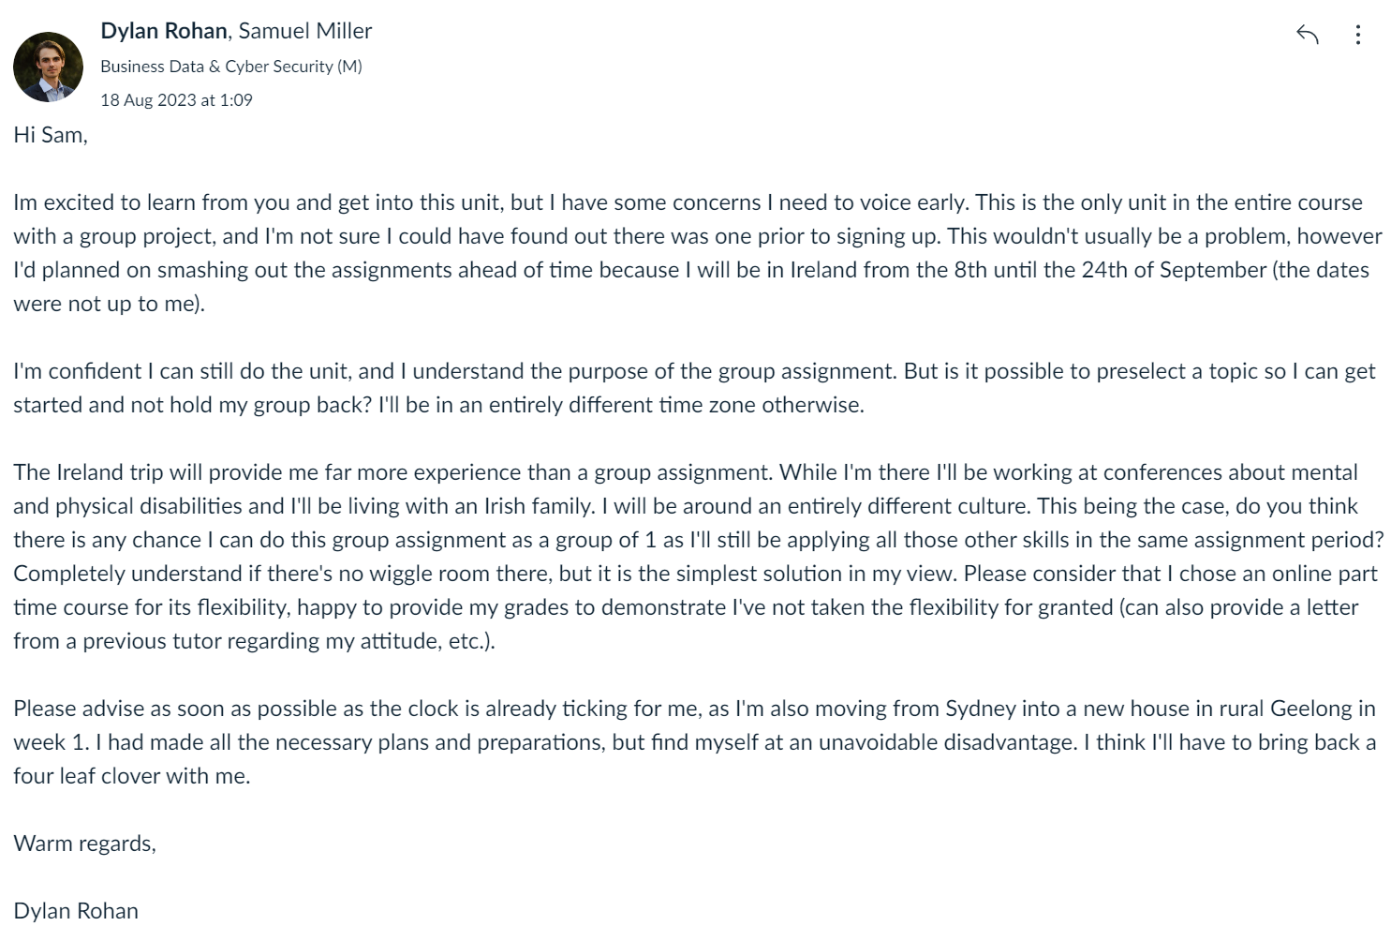

Written by Dylan Rohan

# Word Count: [~500 word]

Introduction

The topic I have selected is ‘Social engineering attacks getting smarter’. The primary objectives of this presentation are to provide listeners with:

* An understanding of what ‘Social engineering’ entails
* A timeline and explanation of motives behind some of these attacks.
* Advise and cyber hygiene that will improve cybersecurity

To achieve these goals, I will look to instil a sense of fear. While I do not want users to dread the threat, I do want them to retain the key information. This means providing succinct explanations of types of social engineering and relevant examples that are interesting, but still resonate with the audience. This will hopefully make it memorable, and result in proactive measures beyond the presentation (increased cyber hygiene or further learning). In terms of scope, I have elected to assume the audience has no previous knowledge (perhaps they are employees being given a crash course in cyber security). In this context, I are providing only the most informative information in the most compelling way I can. I hope that this enables employees to be cybersecure, take policy seriously, and improve cyber hygiene and cyber resilience.

Potential Hurdles

* **Solo performance**

This ‘group assignment’ is regrettably a solo assignment which means I need to do the work of a group independently.

* **Time constraints**

I have written up part A and C, and will complete Part B now to iteratively improve part C. I have 8 days with other commitments including travelling by car from Sydney to Melbourne. I am and will continue to be exhausted in the time I do have left.

* **Limited knowledge**

I have received spam emails, but that is the extent of my familiarity with this topic.

* **Technical issues**

Determining the best way to compile presentations can be difficult when there are many parts.

Potential solutions

* **Solo Performance**

The selection of topic and scope reduces the complexity of the research but there will be very real time constraints.

* **Time Constraints**

To manage this, I have started discussions with people in my life about these attacks to generate ideas to guide continued work on part C. Idea generation and presentation flow has greatly benefitted from these discussions.

* **Limited Knowledge**

Speaking about the topic casually evoked interesting questions that enabled me to become quite familiar with the topic and draw on others experiences with these attacks and preventative measures. I’ve also found several recent literature reviews which all have consistent and extensive information.

* **Technical issues**

I have elected to keep it simple using a screen recording technique with a power point presentation. I will use windows moviemaker but have access to more sophisticated programs on a mac if it is needed.

Conclusion

Through this assignment I hope to become more familiar with these styles of attack. Given the human factor is so often linked with successful cybercrimes, I would like to know how I can best protect myself and be in a position where I can advise others on the topic. While this has been a difficult period for me, I am being very proactive and flexing some organizational skills. I am really enjoying the process of writing a compelling cybersecurity talk and mimicking the balance between fear and dread I’ve seen AI talks incorporate to have a lasting impact.