**Violence Against Women and The Impact of Ideology**

A mock research paper

D.Rohan,

# **Abstract**

Violence against women (VAW) is a complex and multifaceted problem. In this paper, the history of the problem and some of its nuisances are described, and a link is put forward relating Ideological context to the tolerance of VAW, specifically eastern ideology and western ideology, via indoctrinated, misaligned, or inappropriate systems. A global survey was taken, and boundaries were selected in order to create two populations separated by ideology. With this separation technique, the populations were found to have no statistically significant difference through a z-test (p-value 0.05). These results highlight the importance of considering ideology in solving these problems, as boundaries are hard to determine and there is no single system that can fit every ideological context harmoniously. Some of the other survey findings, and points for improved/ additional future research were also provided.

# **Introduction**

Gender-based violence, and specifically violence against women (VAW), is a complex and pressing issue with significant global implications. According to the World Health Organization (**WHO**), almost 1 in 3 women will experience intimate partner violence or non-partner sexual violence in their life time (2021). These are the two biggest forms of Violence against women (**VAW**), but there are many other forms and victims not represented in that statistic. VAW is a complex issue with many contributing factors including mental health, substance abuse, socioeconomic and educational disparities, past experiences, and cultural norms (Lal, 2023). There also appears to be a connection that exists globally between this injustice and the patriarchy. These systems often put men in places of power over women, the historical classification of rape as a "crime against property" highlights this disparity (Gilmore, 2022). Men have always had ownership over their bodies in ways that women never have (e.g., abortion laws, vasectomy refusal by clinicians, sexualization of women in media). In Australia, Male parliamentarians initially struggled with addressing VAW, having greater concern about the possibility of false accusations or blackmail (Gilmore, 2022). In 1974, the use of the words ‘sexual assault’ was suggested in favour of ‘rape’ to liken the act to any other form of assault which delayed and redirected discussions away from ‘consent’ for years (Gilmore, 2022, Evatt et al., 1977, Penfold, 1979). It wasn’t until 1994 that all of Australia even recognised spousal rape as a crime (Gilmore, 2022). And it’s only recently that similar perceptions are changing in regards to sex workers (Sullivan, 2007).

Many countries still don’t have laws explicitly in place for VAW, indicating they don’t recognise VAW as a unique type of violence requiring a unique solution (Richards and Haglund, 2015). Even when laws are in place, there are instances where traditions and customs concurrently present a conflicting secondary law (Richards and Haglund, 2015, Maluleke, 2012). Where laws are in place, there are still negative outcomes for women. Many women choose not to seek help due to a lack of belief in their claims, a desire to remain with their abuser who is often a family member, a dependence on the perpetrator for financial support, or concerns about the well-being of their children (Dyer, 2014, Koss, 2000, Decker et al., 2020). Many are also manipulated into silence with fears of their children being taken from them, or with promises of change (Dyer, 2014). Furthermore, women seeking help often face a male-dominated system, including the potential for re-traumatization through the court process where an attorney interrupts and attempts to discredit their testimony in front of a jury of strangers (Lutze and Symons, 2003, Pierik, 2022, Javed and Chattu, 2021, Jordan, 2004, Gilmore, 2022, Dyer, 2014). The media also plays a role by disguising VAW, blaming the victim, or redirecting attention away from the perpetrator's actions (Dyer, 2014, Berns, 2017).

Despite the severity of the issue, there has been a shift towards action on VAW. According to the WHO, there were only 82 countries with a population-based survey on intimate partner violence prior to 2010, but for the period between 2000 and 2018 there were 161 countries with at least one population-based survey, indicating an increased global recognition of the issue (2021). This momentum has also been acknowledged by the United Nations (UN, 2006). In recent years, there have been more women in leadership positions, improved education around VAW, more male advocates/role models, and a recognition of VAW as a man's issue as well (Berns, 2017). Society has shifted its focus from solely educating women on avoiding victimization to recognizing the impact of all individuals' behaviours and attitudes towards VAW. Our upbringing and beliefs are fundamental in shaping our perception and acceptance of behaviour (Zmigrod et al., 2021, Abi Rached et al., 2021). But these are largely determined by the fundamental ideologies that have, for centuries, shaped our societal and cultural norms. Two of the most globally represented ideologies are somewhat colloquially termed *Western* and *Eastern* philosophy (Nakayama and Wan, 2019). These two ideologies present extremely different contexts, emphasising different values (*table 1*).

|  |  |
| --- | --- |
| *Table 1: A summary of differences between Eastern and Western ideologies* (Pae, 2020). | |
| Eastern Ideology | **Western Ideology** |
| * Shame/honour or fear/power cultural dynamic * Collectivism oriented * Respect for Hierarchy * Comfortable with mixed emotions * Long term group goals * Indirect communication * Pursuit of harmony | * Guilt/innocence cultural dynamic * Individualism oriented * Respect for Equality * Uncomfortable with negative emotions * Short term personal needs and goals * Direct communication * Pursuit of competition |

These are just two of any number of ideologies that may shape a societal context. And each will likely present a different cause for, or tolerance towards VAW and require a different solution that fits into that society’s context. The literature at our disposal appear to make a dangerous assumption. It assumes that every country exists within the same context when populations aren’t necessarily comparable. And it assumes research specific to one context is applicable to all contexts. While there are no doubt similarities worldwide, these comparisons may be dangerous as one solution may not fit all; particularly when values and philosophies are so varied. There is an appreciation that societal systems are failing women, but an assumption that these systems operate in similar ways despite the ideological differences that existed throughout their construction. However, it is important to recognize that the root causes and tolerance of VAW may differ across societies, each shaped by their respective ideologies and cultural norms. Simply assuming that the same solutions will work across different contexts could be a dangerous mistake.

To better understand the impact of ideology on VAW in married couples, a comprehensive global survey was conducted to explore regional VAW tolerance. The aim of this study is to shed light on the underlying ideologies (and the values/systems that represent them) that may contribute to the issue by comparing the proportion of responses from each ideology with z-scores. The need for culturally sensitive solutions to prevent harm to society as a whole will also be discussed. This is a crucial departure from previous research and a necessary step towards effectively addressing VAW globally.

# **Method**

In this survey, a systematic approach was taken to ensure accuracy and validity of the results. First, descriptive questions were utilized to categorize the participants into subpopulations based on characteristics such as age, gender, and education level. The use of closed-response questions with three options, "Agree", "Disagree", and "Unsure", was deemed more suitable for the next section as it reduces the time and effort required for participants, reduces the risk of researcher and non-response bias, and ensures that participants interpret the scale consistently. This format was specifically chosen to effectively distinguish between those who explicitly oppose and those who do not tolerate the issue of VAW.

In accordance with the Nuremberg Code, informed consent was obtained before conducting the survey, and participants were informed of their right to withdraw at any time. Trigger warnings were also displayed to protect victims from potential harm. To promote honesty and alleviate any fear of judgment, anonymity was emphasized and a web/contactless interaction was deemed most appropriate. Upon completion of the survey, appropriate helplines were provided as a means of support.

In order to have contactless participation that was wide reaching, multiple social networking services (Twitter, Facebook, WhatsApp, WeChat, etc.) were used to distribute the survey. To increase representativeness, partnerships with institutions and influencers that can reach older demographics, such as hospitals, senior citizen homes, and local clubs, were considered. As these behaviours are historically unyielding, the data collection period remained open for an extended period of time. The objective was to attain 1000 responses per country in order to have strong representation in each sub-group. To validate survey responses, recapture mechanisms, IP addresses and completion times will be used to rule out bot interference (Storozuk et al., 2020). Please note, this scale and form of survey may be challenging to reproduce. To maximize the data collected, a logistic regression analysis may be trained from complete data to predict the responses for incomplete surveys.

The survey was conducted in 70 different countries, with a total of 12,600 observations being made about the proportion of a subpopulation responding to a given question. The proportion of tolerance to VAW was measured for each subpopulation, and similar populations of differing ideology were compared. The geography was split into ‘eastern-like’ and ‘western-like’ groups with the assistance of ChatGPT (OpenAI, 2021). Although the map below shows the split, it is acknowledged that the reality is far more complex.

Philosophy

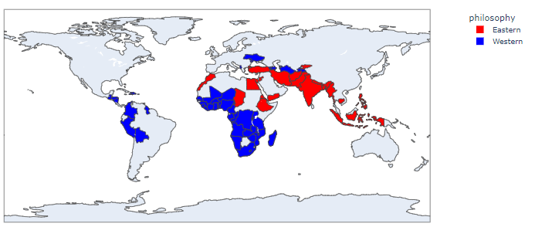

Figure 1: A depiction of how the sub-populations were divided into 'eastern-like' and 'western-like' populations.

*As this is a mock research paper, data was taken from Kaggle (CHAUHAN, 2022). Sub-populations are assumed to be representative, but no mention of participant count per country is provided (although best practices are assumed).

# **Results**

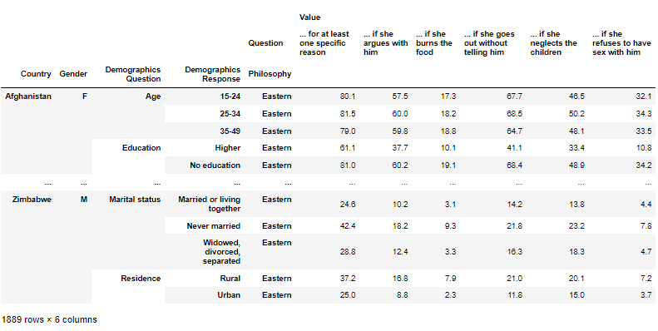

Figure : A snapshot of the clean dataset. Notice the population size has not been described, only the proportion. And the row count is misleading, as every country has five lines. This was not clear before I started the project.

The z-score was calculated for the two populations, eastern -like and western-like, for each question using all subpopulations (*Table 2*). A z-score of 1.96 corresponds to a p-value of 0.05, this was taken as the threshold required to be statistically significant. With a probability of occurrence threshold of 95%, the null hypothesis could be rejected with confidence. However, no question resulted in such a value.

|  |  |
| --- | --- |
| *Table 2: The z-scores calculated for Eastern-like and Western-like populations.* | |
| **“A husband is justified in hitting or beating his wife…”** | **z-score** |
| for at least one specific reason | 0.36 |
| if she argues with him | -0.27 |
| if she burns the food | 0.30 |
| if she goes out without telling him | 0.36 |
| if she neglects the children | 0.36 |
| if she refuses to have sex with him | 0.23 |

# **Discussion**

This research was inspired by recent studies that have noticed a link between health and diets that matched ethnicity versus diets that were geographically available (Santiago-Torres et al., 2017). These types of studies are noticing health consequences from consuming geographically accessible foods, rather than the food that an individual’s foreign ancestors were accustomed to. In a similar vein, perhaps there are foreign systems in places that are causing slight, but prolonged, disharmony resulting in negative mental health outcomes and inevitably VAW. According to the z-scores, the null hypothesis holds true and there is no statistically significant difference between groups that are ‘eastern-like’ or ‘western-like’ when it comes to the tolerance toward VAW. The classification technique implemented was polarizing, attempting to separate countries into groups that were closer to western or eastern ideology. This has highlighted the importance of the work of Robertson & Crittenden, particularly the notion that philosophies exist on a continuum (2003). With so much overlap existing in the context of each country in the dataset, eastern and western philosophies could not be purely or accurately represented. In future, a study of outlier countries that are heavily Eastern or Western influenced, such as China and America, may provide the best available representation of two distinct populations and yield better results (Sugarman and Frankel, 1996). Attempts were made to obtain data that were wider reaching, however, no such dataset is publicly available, further demonstrating the need for this type of research.

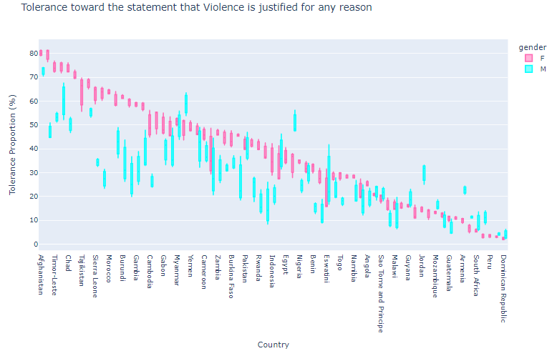While no statistically significant connection was established between eastern-like and western-like populations, the results still hold value. Previous studies that have compared countries based on geography alone may have assumed the ideology of the region is homogeneous, which represents a potential external validation error. The philosophical landscape is vast and diverse, making it challenging to perform statistically valid tests as the boundaries separating different perspectives are not well defined. This research indicates that a more effective approach to addressing violence against women may be to adopt a ‘bottom-up’ strategy. With this approach, individuals who have a deep understanding of ideological context can drive change and construct systems that are more harmonious with the prevailing values and ideologies of a specific context. As ideological boundaries are fluid and may not necessarily follow the borderlines between countries, this form of study may not be able to provide a statistically significant outcome, but it can provide insight into specific locations. Global organizations would do well to take these findings and work with individuals to drive the changes required on a case-by-case basis.

Figure : Boxplots for the proportion of male and female responses to the sentiment that husbands are justified in hitting their wives for any specific reason.

When it comes to the issue of domestic violence, the results of our survey indicate that in most countries, women tend to be more accepting of a wife being physically abused by their husbands for any specific reason compared to men. There didn’t appear to be a clear connection to marital status across populations, but there was a relationship between rural and urban populations, as well as levels of education (see appendix). Although these links seem consistent across countries, the contexts are likely to vary. In many cases, the context involves generational trauma resulting in part to a foreign ideology, and people, imposing on a pre-existing balance without any respect for the native population (Andrews et al., 2021, Fotheringham et al., 2021).

Interestingly, female participants appeared to be more accepting of wives being hit for neglecting their children, however, no specific form of ‘neglect’ was specified in the question. (Whether or not these women are answering with themselves in mind, and what their interpretation of ‘neglect’ might be, is unclear. Additionally, there is no measure of how many men are intolerant to violence while having a personal history of perpetrating VAW. These unknowns hold important information to policymakers and represent an informative area for further research).

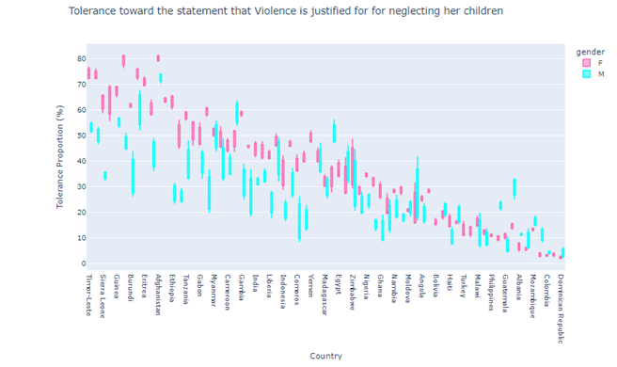As an example, to address VAW regarding child neglect systematically, organizations can consider the underlying causes of male-perceived child neglect, such as:

Figure : Boxplots for the proportion of male and female responses to the sentiment that husbands are justified in hitting their wives for neglecting their children.

* a lack of access to community-led child care or support resources,
* employment situations,
* perceived safety of the mother and/or children,
* paternal contribution, etc.

and work towards addressing appropriate systems. However, to effectively implement change, it is important to understand the cultural and philosophical context in which the population operates and develop a strategy that integrates seamlessly into that specific community. This consideration is important because a proven system in the wrong ideological context could easily become an ineffective or hazardous system. With men's mental health often being linked to violence against women, examining the underlying causes of poor health outcomes presents an opportunity to investigate the specific systems involved and their compatibility with the prevailing ideology (Schofield et al., 2000, Baker, 2018).

# **Conclusion**

Although the quality of the data was not as fit for purpose as it first appeared, this study has presented new insight to an old problem. The world is far too large to solve its problems with a single solution. This work highlighted how unique each context can be and demonstrated that ideological contexts and boundaries cannot be easily traced by hand. It demonstrated that in many places women will enable behaviours to a greater degree than men and provided a new way of perceiving an old problem.

It is important these findings reach the right people, so they will be preserved in popular podcasts such as Ally Ward’s *Ologies* series, styled into social media posters for women’s rights groups to share, and submitted as an application for presentation at the International Conference on Violence Against Women and the annual interpersonal Violence and Abuse Conference. To help society, this study must do more than rest on a shelf.

# **References**

ABI RACHED, M., HANKIR, A. & ZAMAN, R. 2021. Emotional Abuse in Women and Girls Mediated by Patriarchal Upbringing and Its Impact on Sexism and Mental Health: A Narrative Review. *Psychiatr Danub,* 33**,** 137-144.

ANDREWS, S., GALLANT, D., HUMPHREYS, C., ELLIS, D., BAMBLETT, A., BRIGGS, R. & HARRISON, W. 2021. Holistic programme developments and responses to Aboriginal men who use violence against women. *International Social Work,* 64**,** 59-73.

BAKER, P. 2018. Men’s health: time for a new approach. *Physical Therapy Reviews,* 23**,** 144-150.

BERNS, N. 2017. *Framing the Victim*, Routledge.

CHAUHAN, A. 2022. Violence Against Women & Girls. *In:* PROGRAM, T. D. A. H. S. (ed.). <https://www.kaggle.com/datasets/whenamancodes/violence-against-women-girls?select=Violence+Against+Women++Girls+Data.csv>.

DECKER, M. R., HOLLIDAY, C. N., HAMEEDUDDIN, Z., SHAH, R., MILLER, J., DANTZLER, J. & GOODMARK, L. 2020. Defining Justice: Restorative and Retributive Justice Goals Among Intimate Partner Violence Survivors. *Journal of Interpersonal Violence,* 37**,** NP2844-NP2867.

DYER, C. 2014. Addressing violence against women globally. *In:* TEDX (ed.) *TEDxSMU.* Texas: TedX.

EVATT, E., ARNOTT, F. & DEVESON, A. 1977. Royal commission on human relationships.

FOTHERINGHAM, S., WELLS, L. & GOULET, S. 2021. Strengthening the circle: An international review of government domestic violence prevention plans and inclusion of Indigenous peoples. *Violence against women,* 27**,** 425-446.

GILMORE, J. 2022. Rape is rape. *Meanjin,* 81**,** 80-89.

JAVED, S. & CHATTU, V. K. 2021. Patriarchy at the helm of gender-based violence during COVID-19. *AIMS Public Health,* 8**,** 32-35.

JORDAN, C. E. 2004. Intimate partner violence and the justice system: An examination of the interface. *Journal of interpersonal violence,* 19**,** 1412-1434.

KOSS, M. P. 2000. Blame, shame, and community: Justice responses to violence against women. *American psychologist,* 55**,** 1332.

LAL, B. S. 2023. Violence against Women-Issues, Challenges and Solutions. *International Journal of Science and Research,* 12**,** 105-110.

LUTZE, F. E. & SYMONS, M. L. 2003. THE EVOLUTION OF DOMESTIC VIOLENCE POLICY THROUGH MASCULINE INSTITUTIONS: FROM DISCIPLINE TO PROTECTION TO COLLABORATIVE EMPOWERMENT. *Criminology & Public Policy,* 2**,** 319-328.

MALULEKE, M. J. 2012. Culture, tradition, custom, law and gender equality. *Potchefstroom Electronic Law Journal/Potchefstroomse Elektroniese Regsblad,* 15.

NAKAYAMA, M. & WAN, Y. 2019. The cultural impact on social commerce: A sentiment analysis on Yelp ethnic restaurant reviews. *Information & Management,* 56**,** 271-279.

OPENAI. 2021. *OpenAI - Artificial Intelligence Research* [Online]. Available: <https://openai.com/> [Accessed 20 June 2021].

PAE, H. K. 2020. The East and the West. *Literacy Studies.* Springer International Publishing.

PENFOLD, L. 1979. Rape-The Need For Law Reform. *Current Affairs Bulletin,* 56**,** 24-32.

PIERIK, B. 2022. Patriarchal power as a conceptual tool for gender history. *Rethinking History,* 26**,** 71-92.

RICHARDS, D. L. & HAGLUND, J. 2015. *Violence Against Women and the Law*, Routledge.

ROBERTSON, C. J. & CRITTENDEN, W. F. 2003. Mapping moral philosophies: strategic implications for multinational firms. *Strategic Management Journal,* 24**,** 385-392.

SANTIAGO-TORRES, M., DE DIEU TAPSOBA, J., KRATZ, M., LAMPE, J. W., BREYMEYER, K. L., LEVY, L., SONG, X., VILLASEÑOR, A., WANG, C. Y., FEJERMAN, L., NEUHOUSER, M. L. & CARLSON, C. S. 2017. Genetic ancestry in relation to the metabolic response to a US versus traditional Mexican diet: a randomized crossover feeding trial among women of Mexican descent. *European Journal of Clinical Nutrition,* 71**,** 395-401.

SCHOFIELD, T., CONNELL, R. W., WALKER, L., WOOD, J. F. & BUTLAND, D. L. 2000. Understanding Men's Health and Illness: A Gender-relations Approach to Policy, Research, and Practice. *Journal of American College Health,* 48**,** 247-256.

STOROZUK, A., ASHLEY, M., DELAGE, V. & MALONEY, E. A. 2020. Got bots? Practical recommendations to protect online survey data from bot attacks. *The Quantitative Methods for Psychology,* 16**,** 472-481.

SUGARMAN, D. B. & FRANKEL, S. L. 1996. Patriarchal ideology and wife-assault: A meta-analytic review. *Journal of Family Violence,* 11**,** 13-40.

SULLIVAN, B. 2007. Rape, Prostitution and Consent. *Australian & New Zealand Journal of Criminology,* 40**,** 127-142.

UN, S.-G. 2006. In-depth study on all forms of violence against women: report of the Secretary-General.

WHO 2021. *Violence against women prevalence estimates, 2018: global, regional and national prevalence estimates for intimate partner violence against women and global and regional prevalence estimates for non-partner sexual violence against women*, World Health Organization.

ZMIGROD, L., EISENBERG, I. W., BISSETT, P. G., ROBBINS, T. W. & POLDRACK, R. A. 2021. The cognitive and perceptual correlates of ideological attitudes: a data-driven approach. *Philosophical Transactions of the Royal Society B: Biological Sciences,* 376**,** 20200424.

**Appendix**

Figure : Boxplots for the proportion of responses to the sentiment that husbands are justified in hitting their wives for any specific reason separated by marital status.

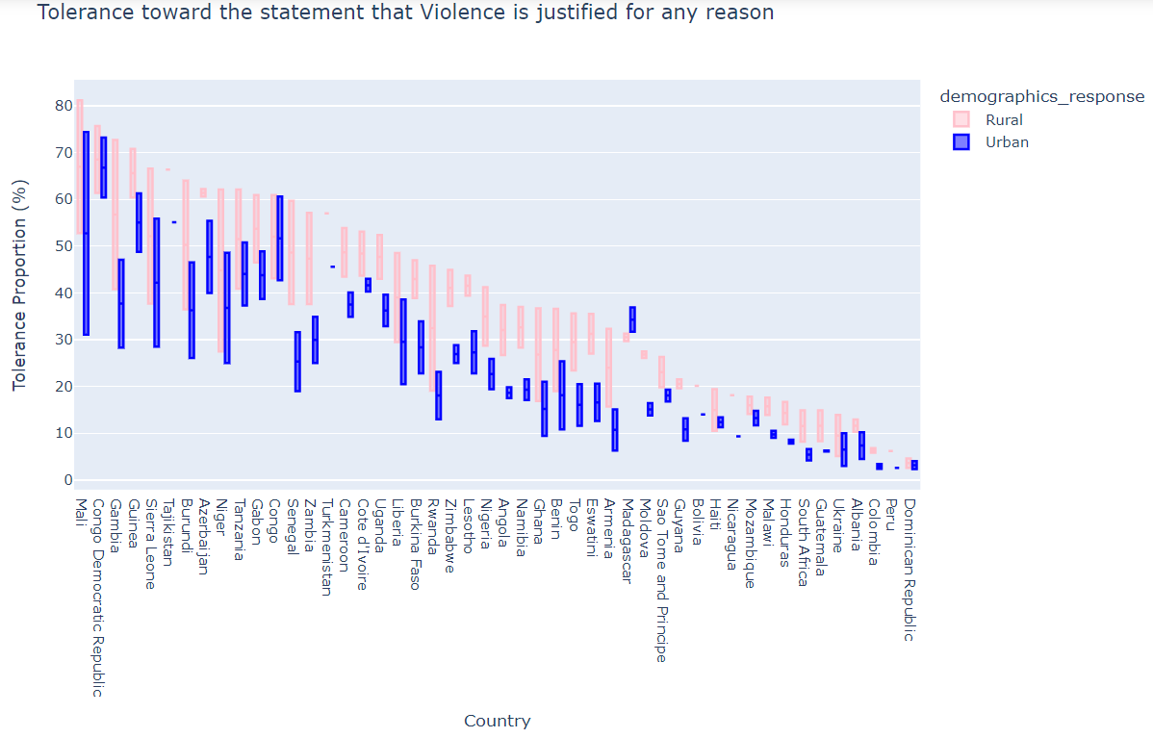

Figure : Boxplots for the proportion of urban and rural responses to the sentiment that husbands are justified in hitting their wives for any specific reason.

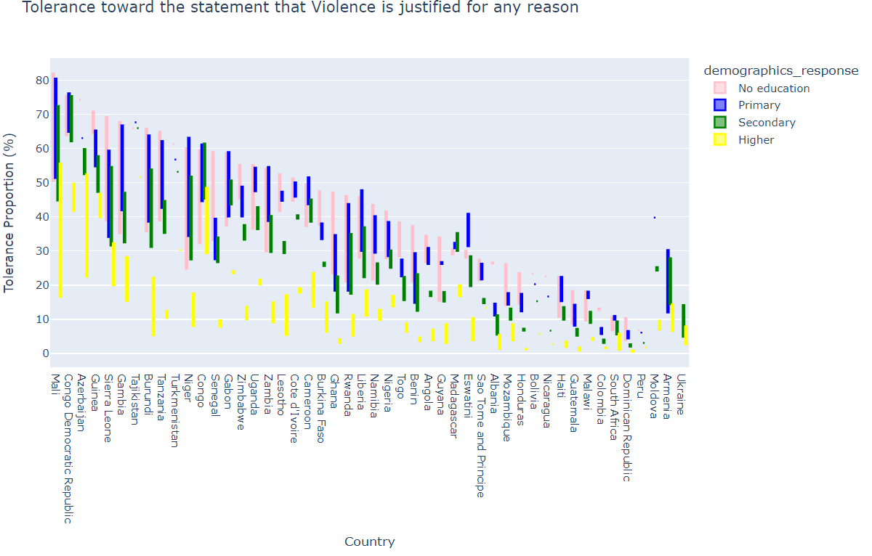

Figure : Boxplots for the proportion of responses to the sentiment that husbands are justified in hitting their wives for any specific reason separated by education level.