1. Login to the jupyter notebook of your cloud instance
2. Upload the following files from the course GitHub to your cloud instance:

< https://github.com/utsabigdata/bigdata/tree/master/assignment/1>

1. Presidents.xls - This dataset contains a list of US presidents, associated parties, profession and more
2. assignment1.ipynb

3) Run the program

4) Print assignment1.ipynb program and submit the hardcopy

**Note:** Here is the instruction for Installing python packages on your cloud instance using your Jupyter notebook terminal:

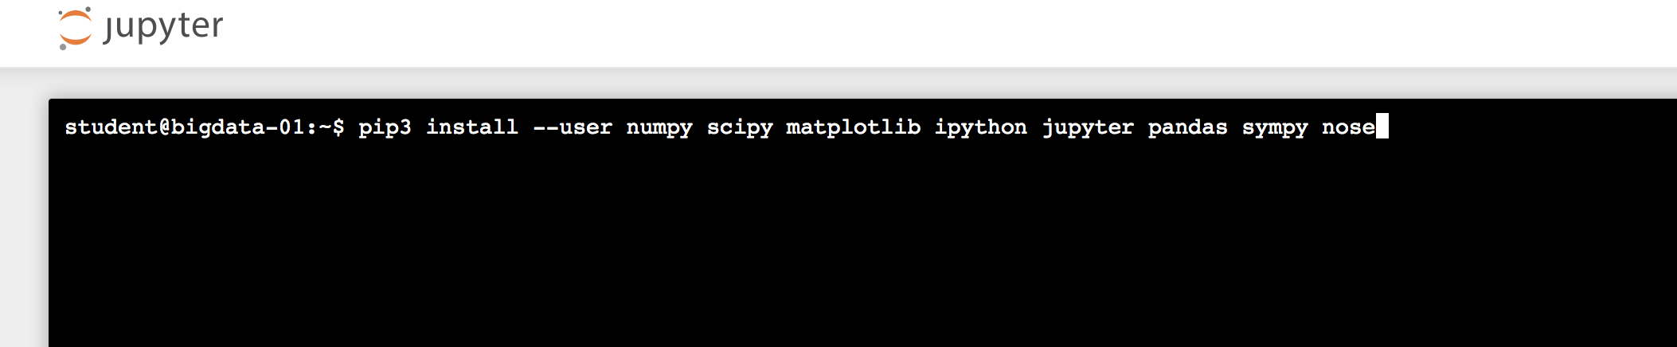

pip install --user numpy scipy matplotlib ipython jupyter pandas sympy nose xlrd

pip3 install --user numpy scipy matplotlib ipython jupyter pandas sympy nose xlrd