* **Name:**
* **Student ID:**

1. Login to your Hadoop cluster <http://149.165.168.141:8080>

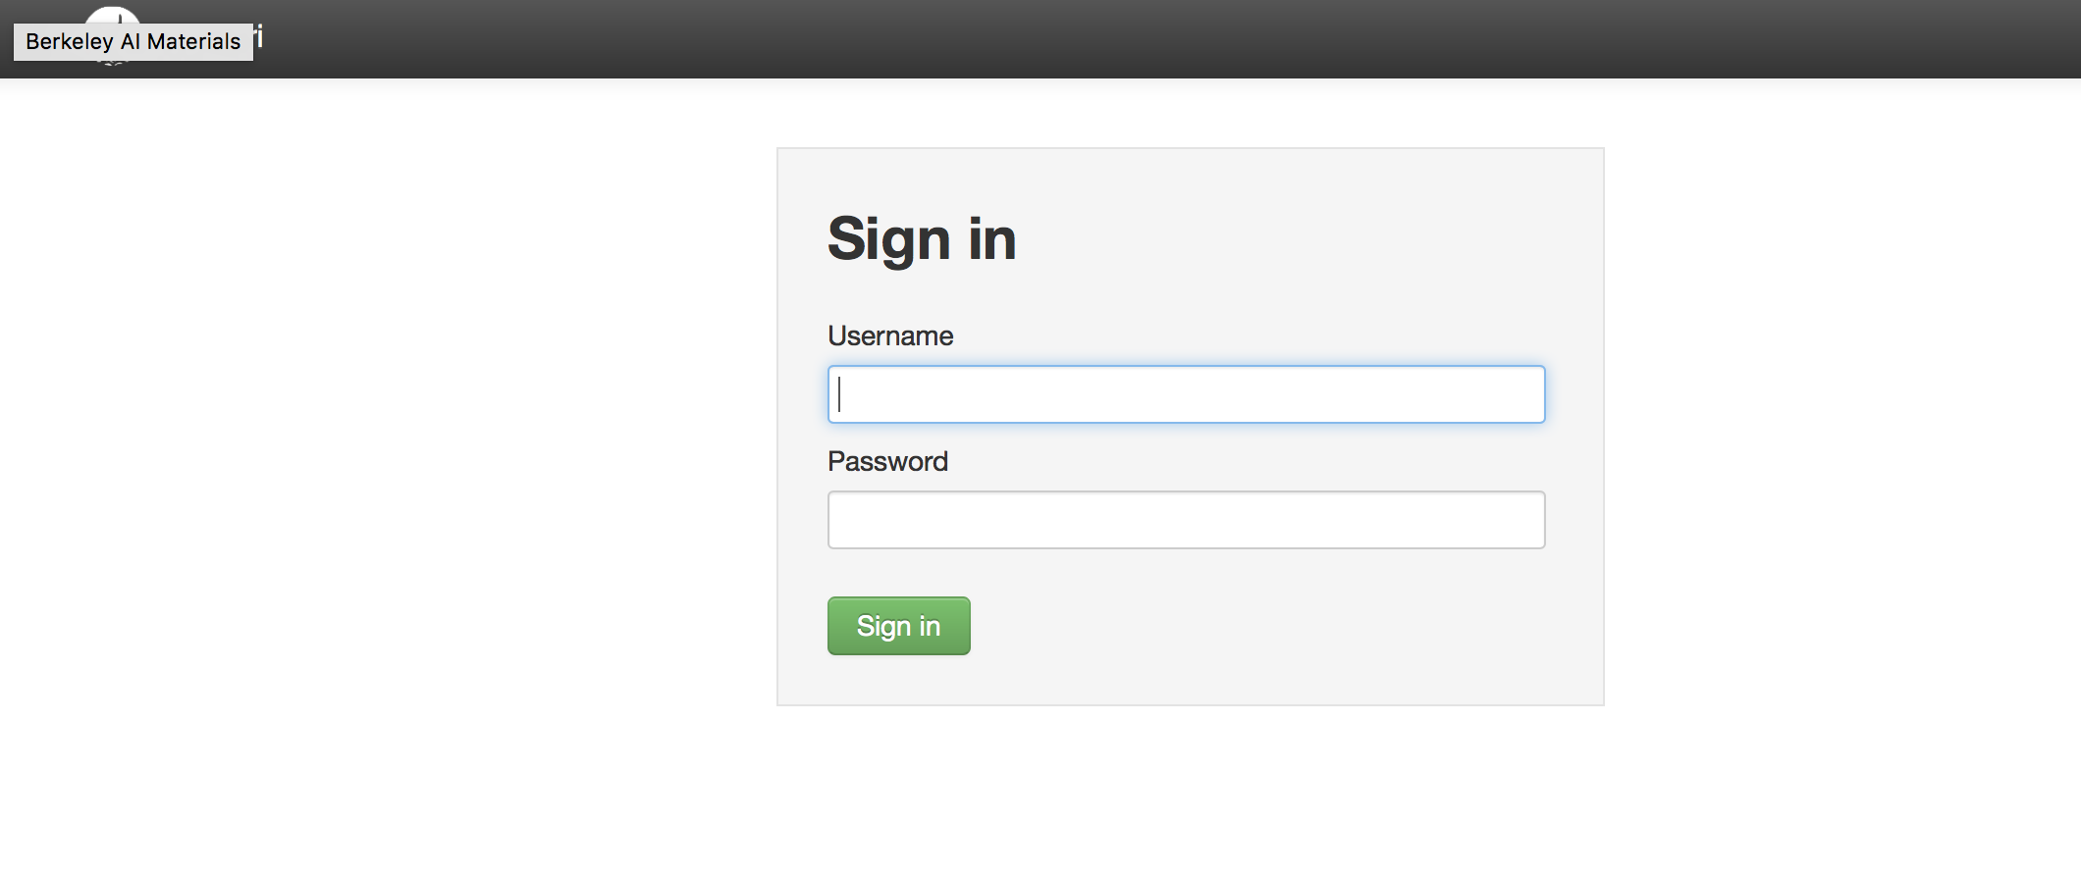

username/password

maria_dev/maria_dev

1. Click on “Hive View 2.0”

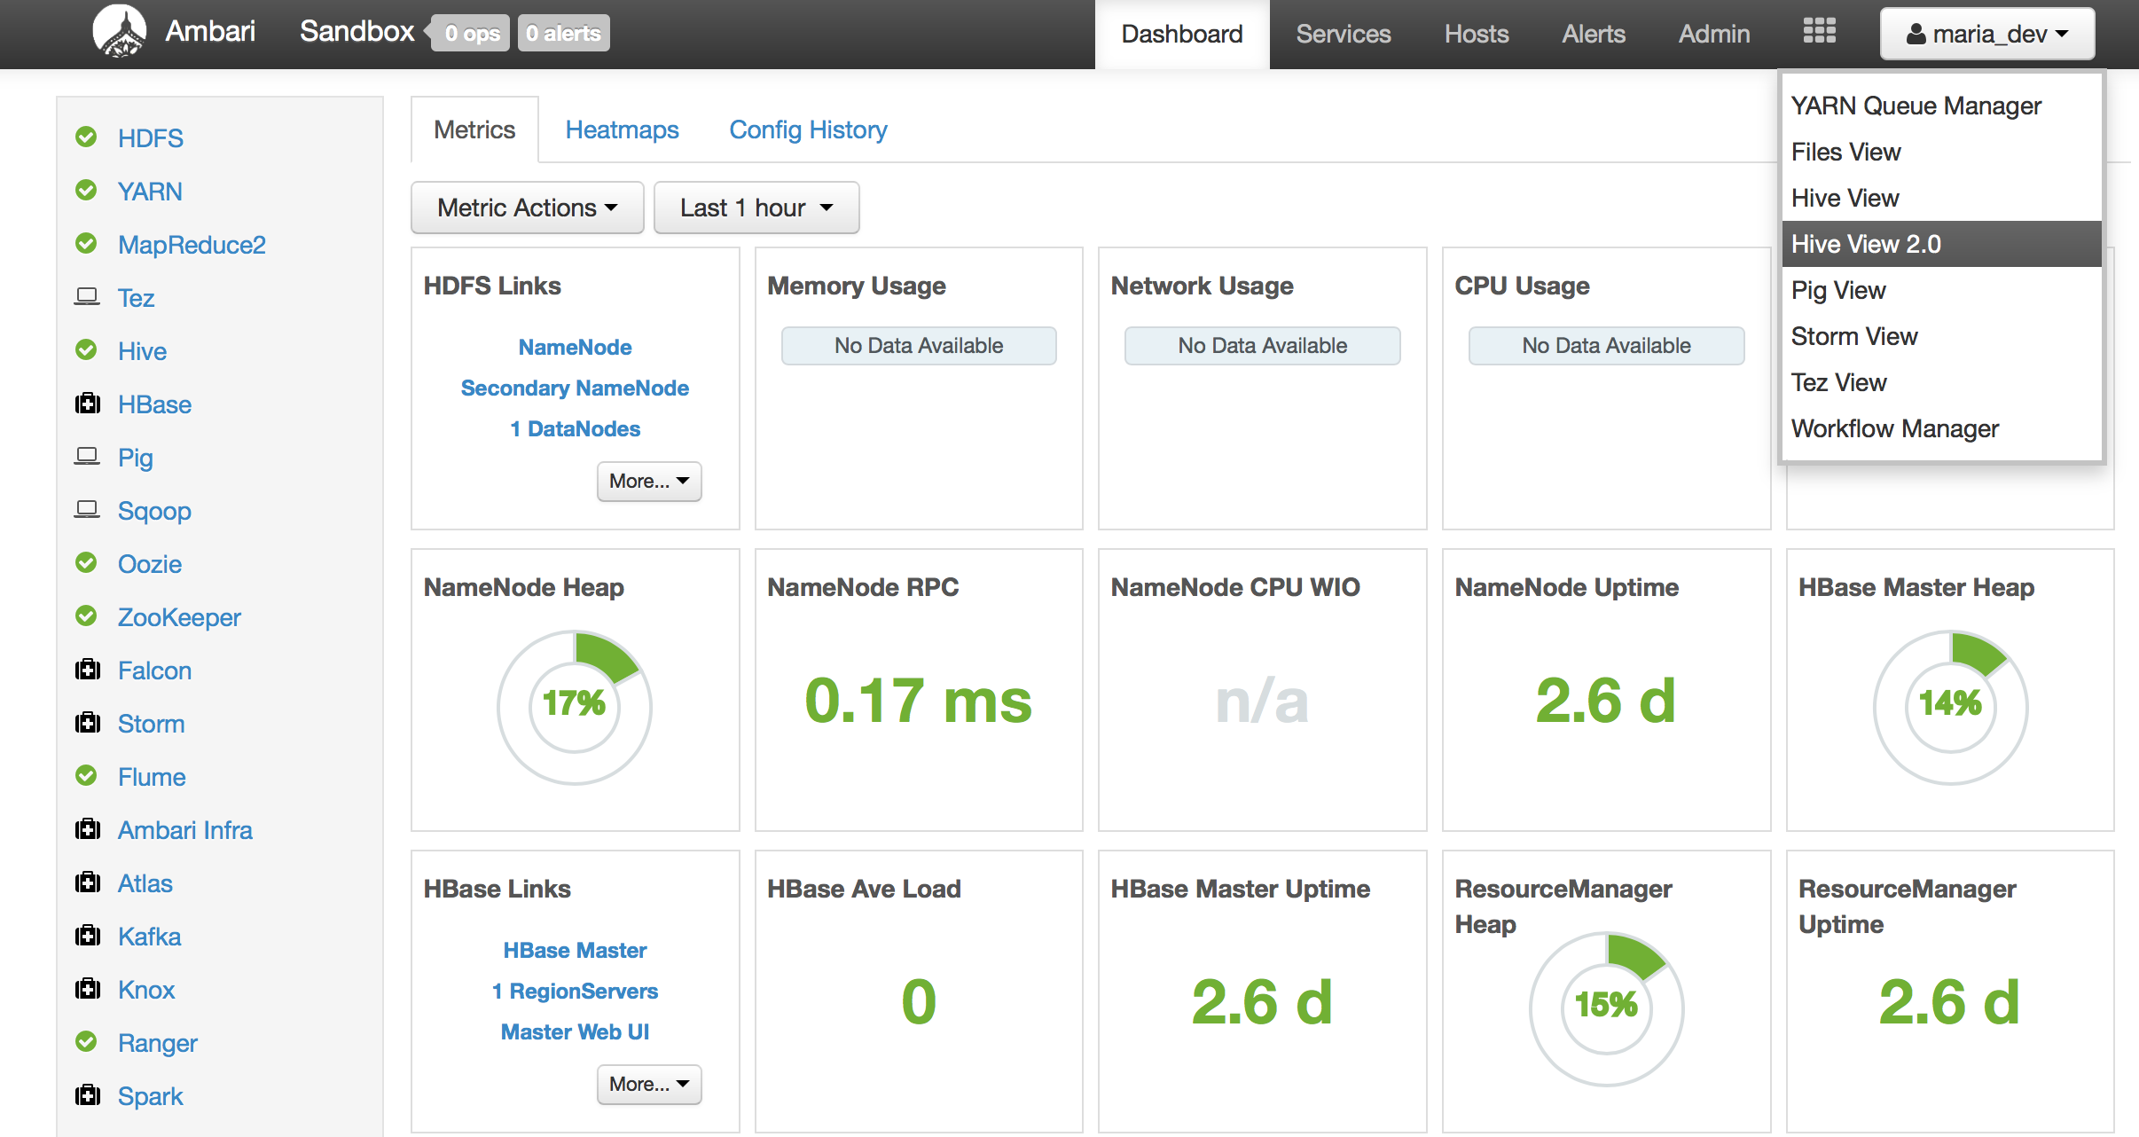

1. Select Database: **foodmart**

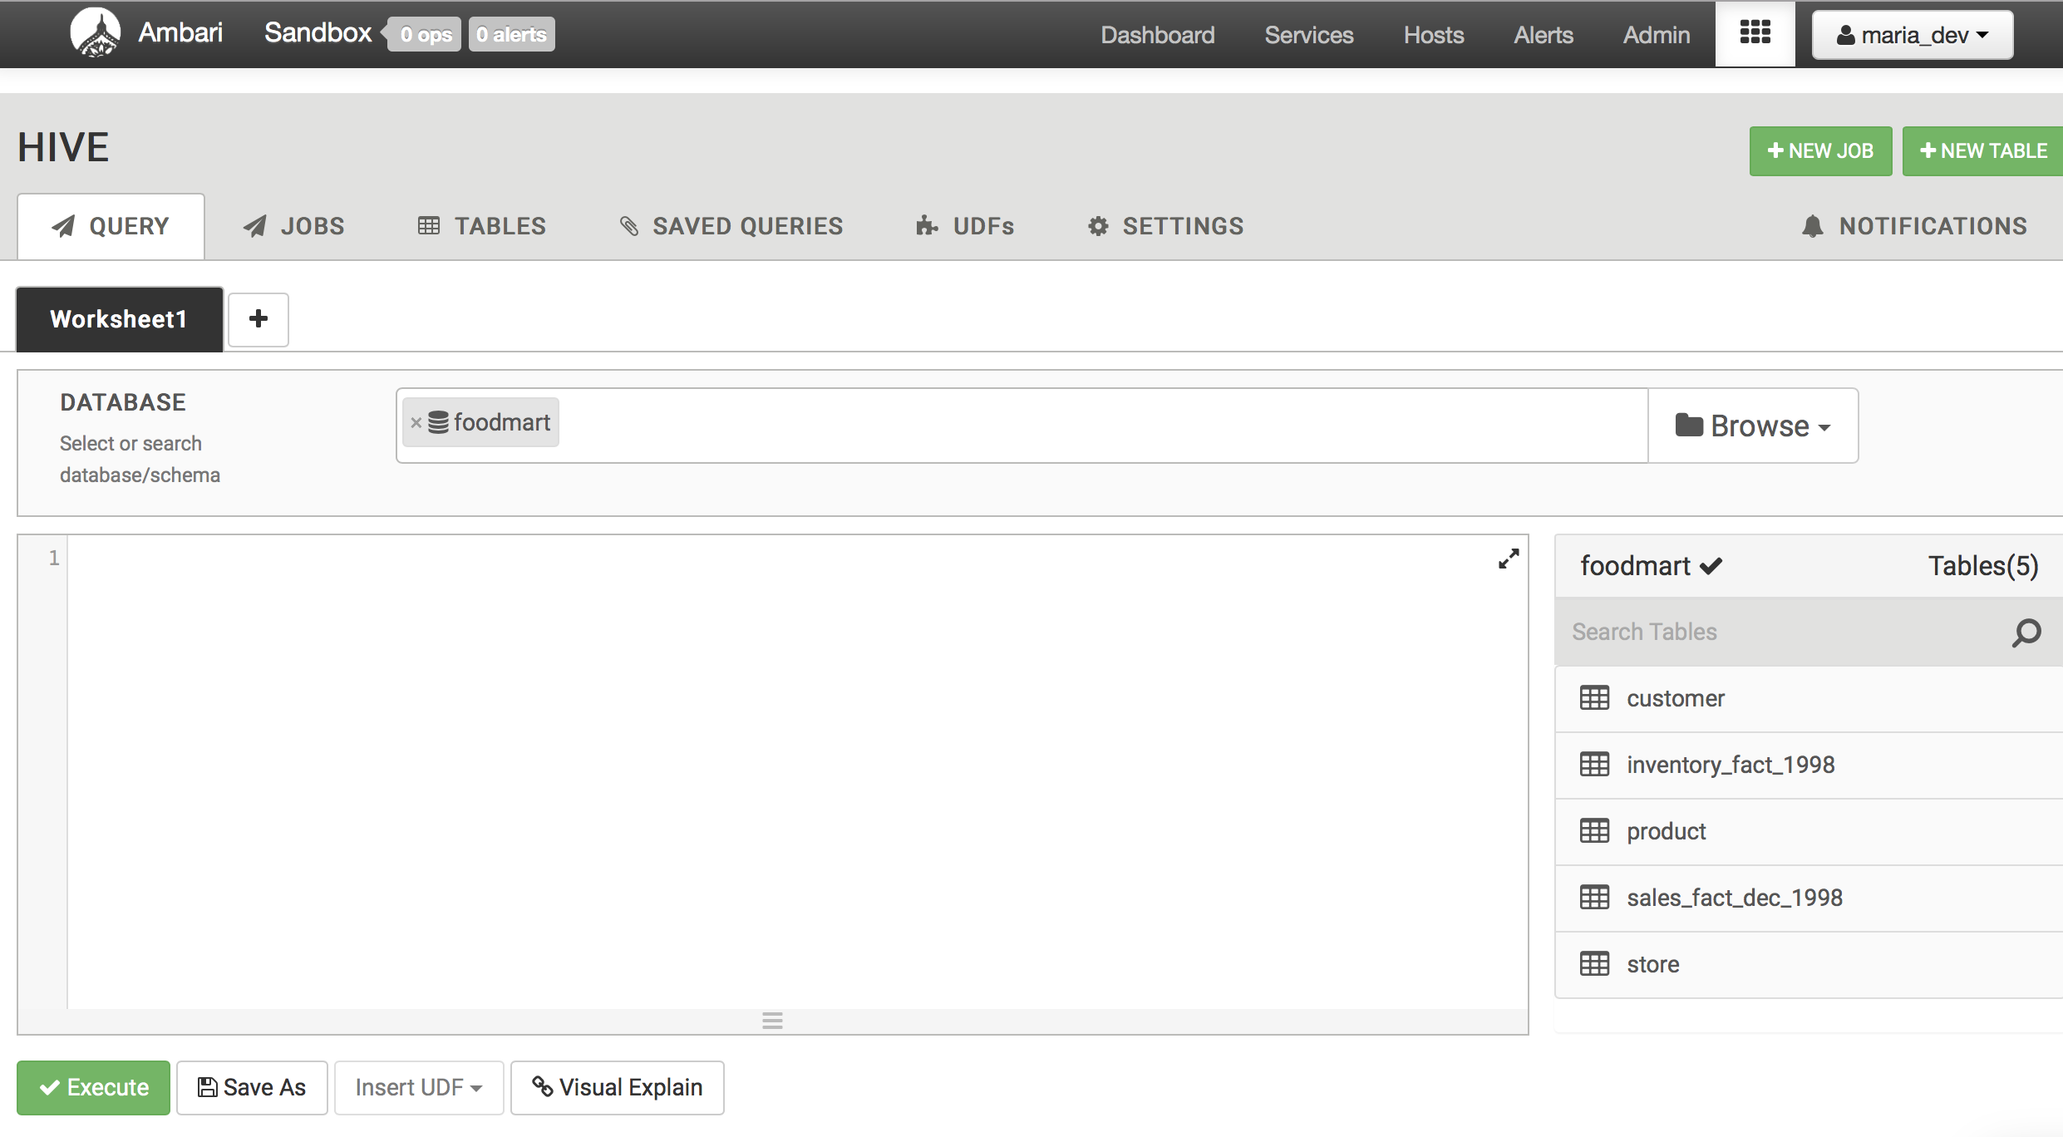

1. Write a SQL program to find the Top **10 selling products** from sales_fact_dec_1998 Table.
2. Print the SQL program