Assignment 6

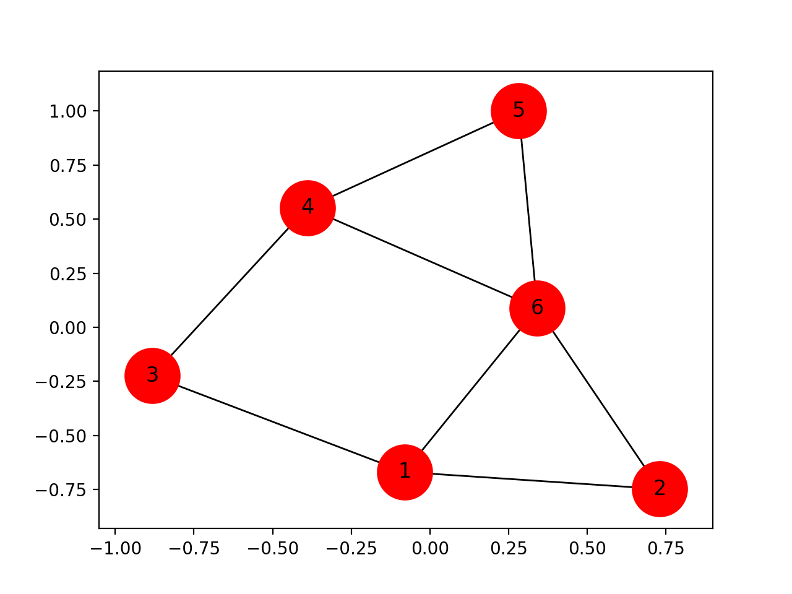

2.1) Calculate by hand

* Degree Centrality
* Betweeness Centrality
* Closeness Centrality

2.2) What is the diameter of this network?

2.3) Who would you target for collection? And why?

2.4 Who would you target for capture? Why?

3. Write a Python program using Networkx to build the above graph and compute:

* Degree Centrality
* Betweeness Centrality
* Closeness Centrality