1. **Five Room House puzzle**

The object of the puzzle is to draw a continuous path through the walls of all 5 rooms, without going through any wall twice, and without crossing any path.

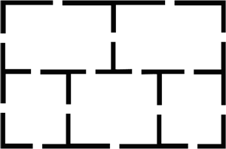

1. Knight Tours Is it possible for a knight on a chessboard to visit every square once and exactly once?
2. Robotic Path Planning