A Project Report on

## PC VOICE ASSISTANT

Submitted in partial fulfillment of the requirements

in

**COMPUTER DEPARTMENT**

by

### DEEPAK YADAV(17102054)

### JASH VORA(17102042)

### RONAK JAIN(17102028)

Under the Guidance of

### Prof. JAYA GUPTA



#### Department of Computer Engineering

#### A.P. Shah Institute of Technology G.B.Road,Kasarvadavli, Thane(W), Mumbai-400615

UNIVERSITY OF MUMBAI

#### Academic Year 2020-2021

**Approval Sheet**

This Project Report entitled ***“PC Voice Assistant”*** Submitted by ***“Deepak Yadav”(17102054),“Jash Vora ”(17102042),“Ronak Jain”(17102028)***is approved for the partial fulfillment of the requirement in ***Computer Department*** from ***University of Mumbai*** .

(Prof. Jaya Gupta)

Guide

Prof. S.H.Malave

Head, Computer Engineering Department

Place: A.P. Shah Institute of Technology, Thane

Date:18/12/2020

### CERTIFICATE

This is to certify that the project entitled ***“PC Voice Assistant”*** submitted by ***“Deepak Yadav”(17102054),“Jash Vora” (17102042),“Ronak Jain” (17102028)*** for the partial fulfillment of the requirement for award of a degree ***Bachelor of Engineering*** in ***Computer Department.***,to the University of Mumbai,is a bonafide work carried out during the academic year 2020-2021.

(Prof. Jaya Gupta)

Guide

Prof. S.H.Malave Dr. Uttam D.Kolekar Head, Computer Engineering Department Principal

External Examiner

Place: A.P. Shah Institute of Technology, Thane Date:18/12/2020

### Declaration

We declare that this written submission represents our ideas in our own words and where others’ ideas or words have been included, We have adequately cited and referenced the original sources. We also declare that We have adhered to all principles of academic honesty and integrity and have not misrepresented or fabricated or falsified any idea/data/fact/source in our submission. We understand that any violation of the above will be cause for disciplinary action by the Institute and can also evoke penal action from the sources which have thus not been properly cited or from whom proper permission has not been taken when needed.

———————————————

(Signature)

———————————————

(Deepak Yadav,17102054)

(Jash Vora, 17102042)

(Ronak Jain,17102028)

Date:18/12/2020

# Contents

**1.prject conception and initiation**

1.1 Abstract

1.2 Objectives

1.3 Literature review

1.4 Problem Definition

1.5 Scope

1.6 Technology stack

1.7 Benefits for environment and society

**2.Project Design**

2.1 Proposed system

2.2 Design(flow of modules)

2.3 Class diagram

2.4 module-1

module-2.....

....module-n

**3.Planning for next semester**

planning

**1.Project Conception- and Initiation**

* 1. Abstract

The project aims to develop a personal-assistant for Computer. PC Personal Assistant draws its inspiration from virtual assistants like Google Assistant for Android, Siri for iOS. It has been designed to provide a user-friendly interface for carrying out a variety of tasks by employing certain well- defined commands. Users can interact with the assistant through voice commands. As a personal assistant, it assists the end-user with day-to-day activities like general human conversation, searching queries, reading latest news, translating words, live weather conditions, sending mail through voice. The software uses a device’s microphone to receive voice requests while the voice output takes place at the speaker. But the most exciting thing happens between these two actions. It is a combination of several different technologies: voice recognition, voice analysis and language processing. PC Personal assistant is build mainly using python.

1.2 Objectives

Our digital life is determined by innovations. Especially in recent years, more innovative technologies were developed to facilitate our professional and everyday life. Intelligent Personal Assistant are proved to be most important innovations in terms of easing our life and providing hands-free experience. We are building a PC Personal Assistant that works on voice commands and executes the user query.

1.3 Literature review

A. Speech Synthesis

Speech synthesis is the artificial production of human speech. Speech synthesis produces audio stream as output. A speech recognizer on the other hand does opposite. It takes an audio stream as input and thus turns it into text transcription. A computer system used for speech synthesis is called a speech synthesizer, and can be implemented in software or hardware products. Synthesized speech can be created by concatenating pieces of recorder speech that are stored in a database. A text-to-speech (TTS system converts normal language text into speech; other systems render symbolic linguistic representations like phonetic transcriptions into speech.

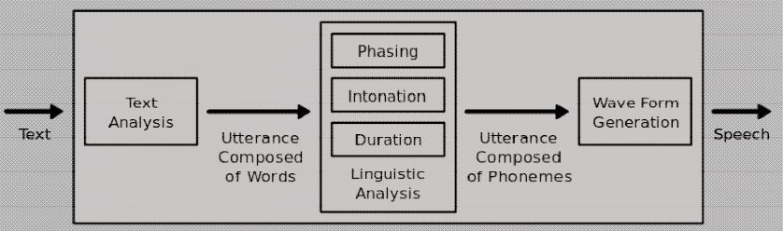

Figure 1 : How a typical text-to-speech system works

The quality of speech synthesizer is judged by its similarity to human voice and by its ability to be understood clearly. The most important qualities of a speech synthesis system are naturalness and intelligibility. Naturalness describes how closely the output sounds like human speech, while intelligibility is the ease with which the output is understood. The ideal speech synthesizer is both natural and intelligible. Speech synthesis systems usually try to maximize both characteristics.

B. Synthesizer Technologies

The two primary technologies generating synthetic speech waveforms are concatenative synthesis and formant synthesis. Each technology has strengths and weaknesses, and the intended uses of a synthesis system will typically determine which approach is used. Some popular speech recognition systems are Siri, Cortana, Google Now, etc.

1.4 Problem Definition

We are all well aware about Cortana, Siri, Google Assistant and many other virtual assistants which are designed to aid the tasks of users in Windows, Android and iOS platforms. In this virtual assistant systems if user asks web query the system redirects the user to web page and user has to manually search thereafter this can be havoc sometimes, so our Pc Voice Assistant will solve this problem by answering the web query in user interface of our app itself.

1.5 Scope

Presently, Jarvis is being developed as an automation tool and virtual assistant. Among the Various roles played by Jarvis are:

1. Search Engine with voice interactions

2. Alarm.

3. Reminder and To-Do application.

4. Vocabulary App to show meanings and correct spelling errors.

5. Weather Forecasting Application.

6.Translating word or sentence from one language to another language.

1.6 Technology stack

Front End Framework(User Interface)

* Tkinter
* Pygame

Main FrameWork

* Python
* Machine learning

1.7 Benefits for environment and society

1. User have a wealth of knowledge at their fingertips and can automate many time consuming activities with just a sentence or two.

2. Voice assistants can break down barriers for people with disabilities, whether sensory, physical or cognitive. Voice interaction is especially useful for those with visual impairments.

3. Virtual assistants can deliver a conversational experience that includes tone of voice – a main ingredient in building effective communication and emotional connection.

4. People genuinely enjoy speaking to home assistants, showing that a human-to-machine bond that can be created through voice.

**2.Project Design**

2.1 Proposed system

Based on the study of the present system, the proposed system aims to simplify basic operations for the user, users with faulty hardware, users who might be too busy to perform certain operations themselves, elderly people and even users with sight or motor disabilities.

For example a lecturer might be scoring exam papers and remembers that he needs to book a flight, instead of leaving the work he is doing he could simply tell the Voice Assistant application to help him “find nearby airports” and the application will help him open his browser and find airports close to him and other flight details, inherently nullifying the need for him to do all these himself. The application will also allow him (in best case scenarios) perform this task significantly faster than he would have done otherwise. The application also possesses speech synthesizing capabilities to give the user the impression that he is actually talking and working with an actual assistant.

Speech Recognizer will take an input data as a voice and given a output data will complete the task. This feature is specially design for Blind Persons who wish to use the Laptop or computer devices but are unable to connect this technology. Also Native user who barely knows to on laptop can easily open this application and using voice commands in their local languages as per need. It responds to basic commands like, Open Applications, Close Applications, Connect Google Send Mail to respective person , Run any media file, Start various services like Hotspot, WiFi, Bluetooth, Music , Youtube and various Services from the respective Notification Panel. All this can be performed on the voice commands of the end user without internet connectivity.

2.2 Design (Flow of Modules)

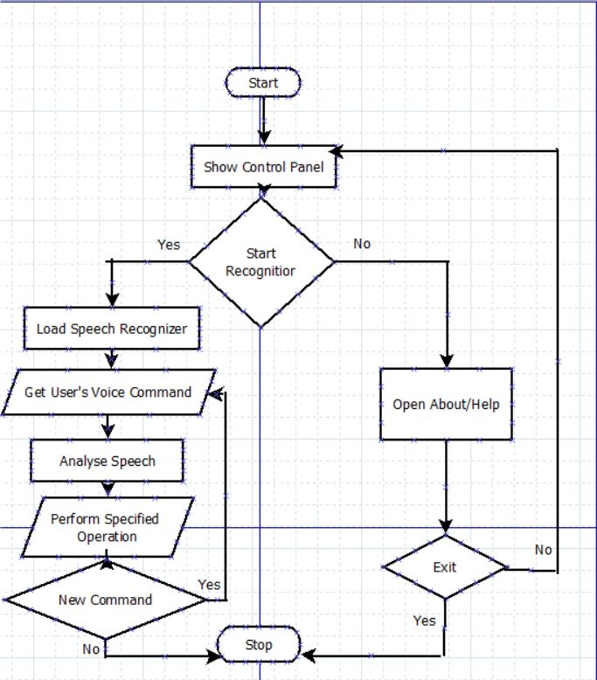

Figure 2 : Flow Chart of our Project

2.3 Class Diagram

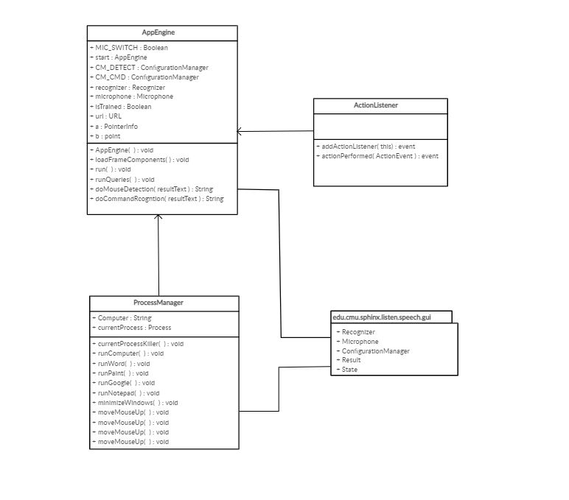

Figure 3: Class Diagram

2.4 Modules

Module -1 Speech Recognition

Speech recognition , or speech-to-text, is the ability for a machine or program to identify words spoken aloud and convert them into readable text.Since we’re building an Application of voice assistant, one of the most important things in this is that your assistant recognizes your voice so for that Speech Recognition module is important.

Module -2 Wikipedia Module

Wikipedia is a Python library that makes it easy to access and parse data from Wikipedia.As we all know Wikipedia is a great source of knowledge just like GeeksforGeeks we have used Wikipedia module to get information from Wikipedia or to perform Wikipedia search.

Module -3 Subprocess Module

Subprocess module is used for getting system subprocess details which are used in various commands i.e Shutdown, Sleep, etc.

Module - 4 Pyttsx3 Module

Pyttsx3 module is used for conversion of text to speech in a program and it works offline.

**3.Planning for next semester**

Implementation

* Reminder(To-do-list)
* Opening Application
* Accessing Youtube Video
* Creating User Interface