Data Profiling Report

Basic Statistics

Raw Counts
Name | Value
Rows | 1,148
Columns | 31
Discrete columns | 1
Continuous columns | 30
All missing columns | 0
Missing observations | 1,290
Complete Rows | 104
Total observations | 35,588
Memory allocation | 254.1 Kb

Percentages
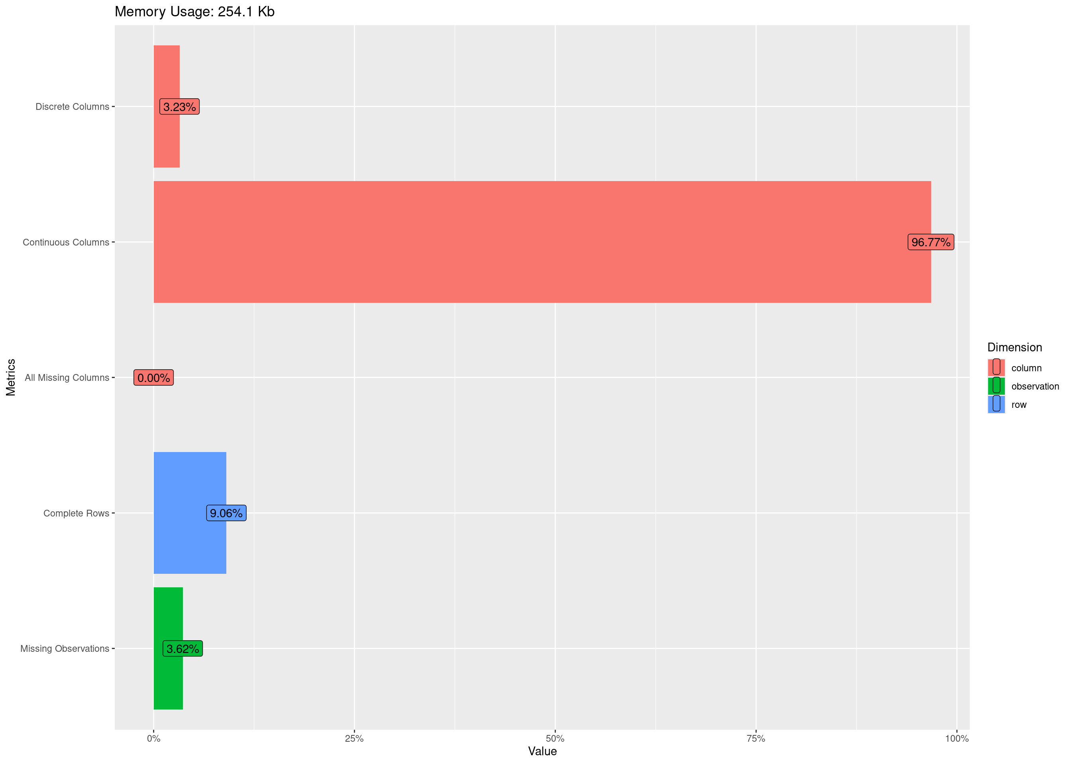

Data Structure

Missing Data Profile
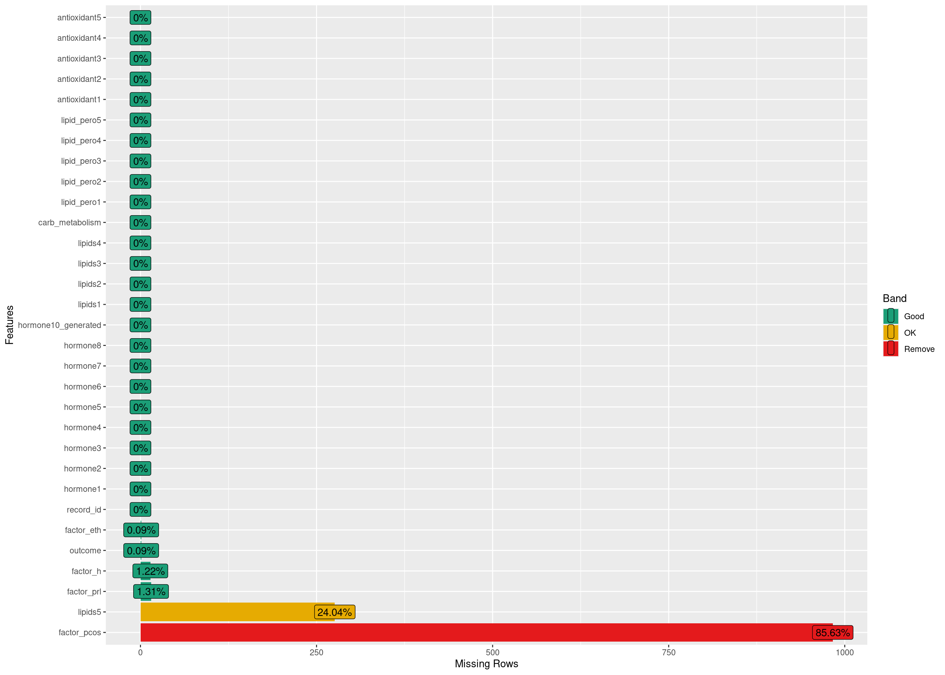

Univariate Distribution

Histogram
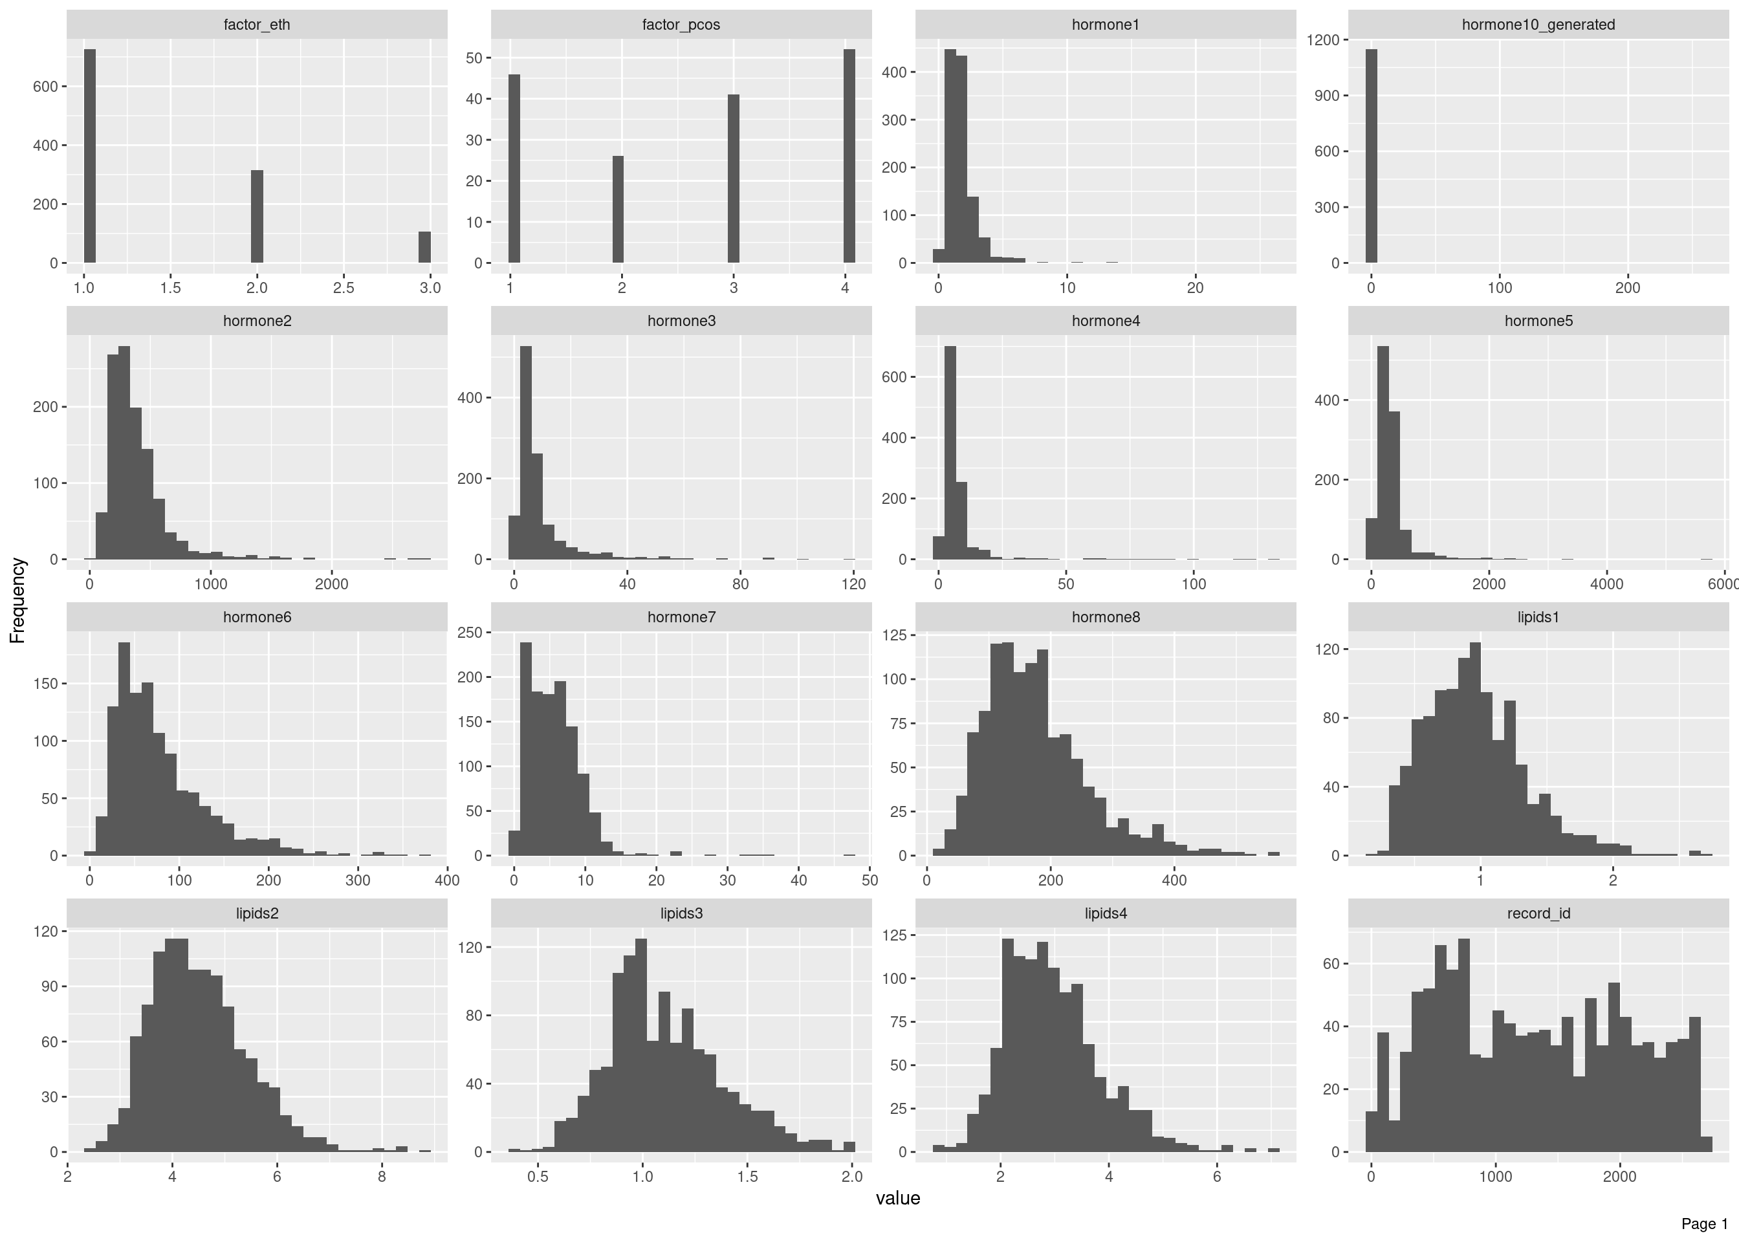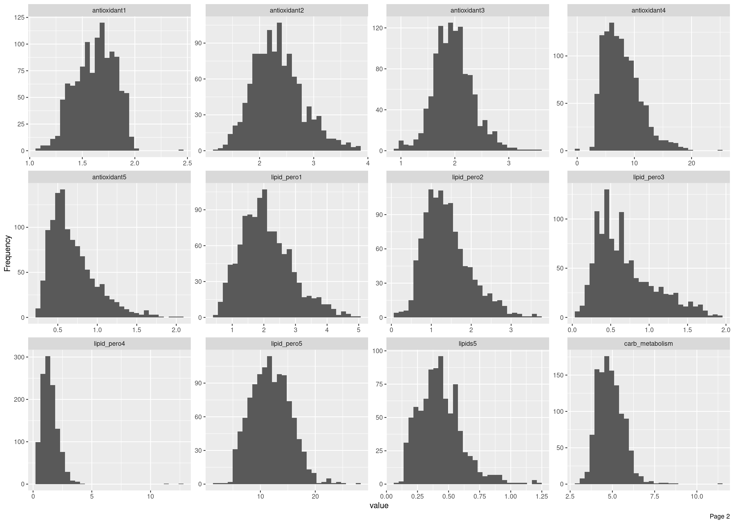

Bar Chart (with frequency)
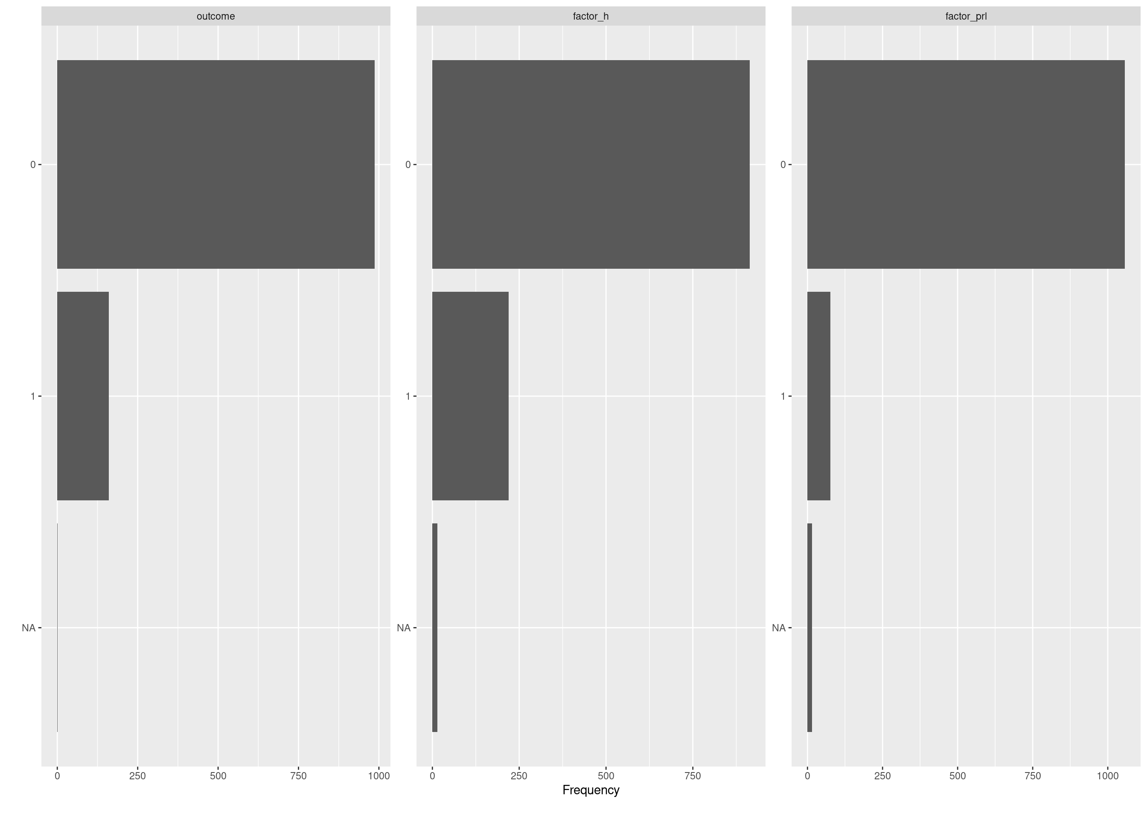

QQ Plot
## Warning: Removed 889 rows containing non-finite outside the scale range (`stat_qq()`).
## Warning: Removed 889 rows containing non-finite outside the scale range (`stat_qq_line()`).
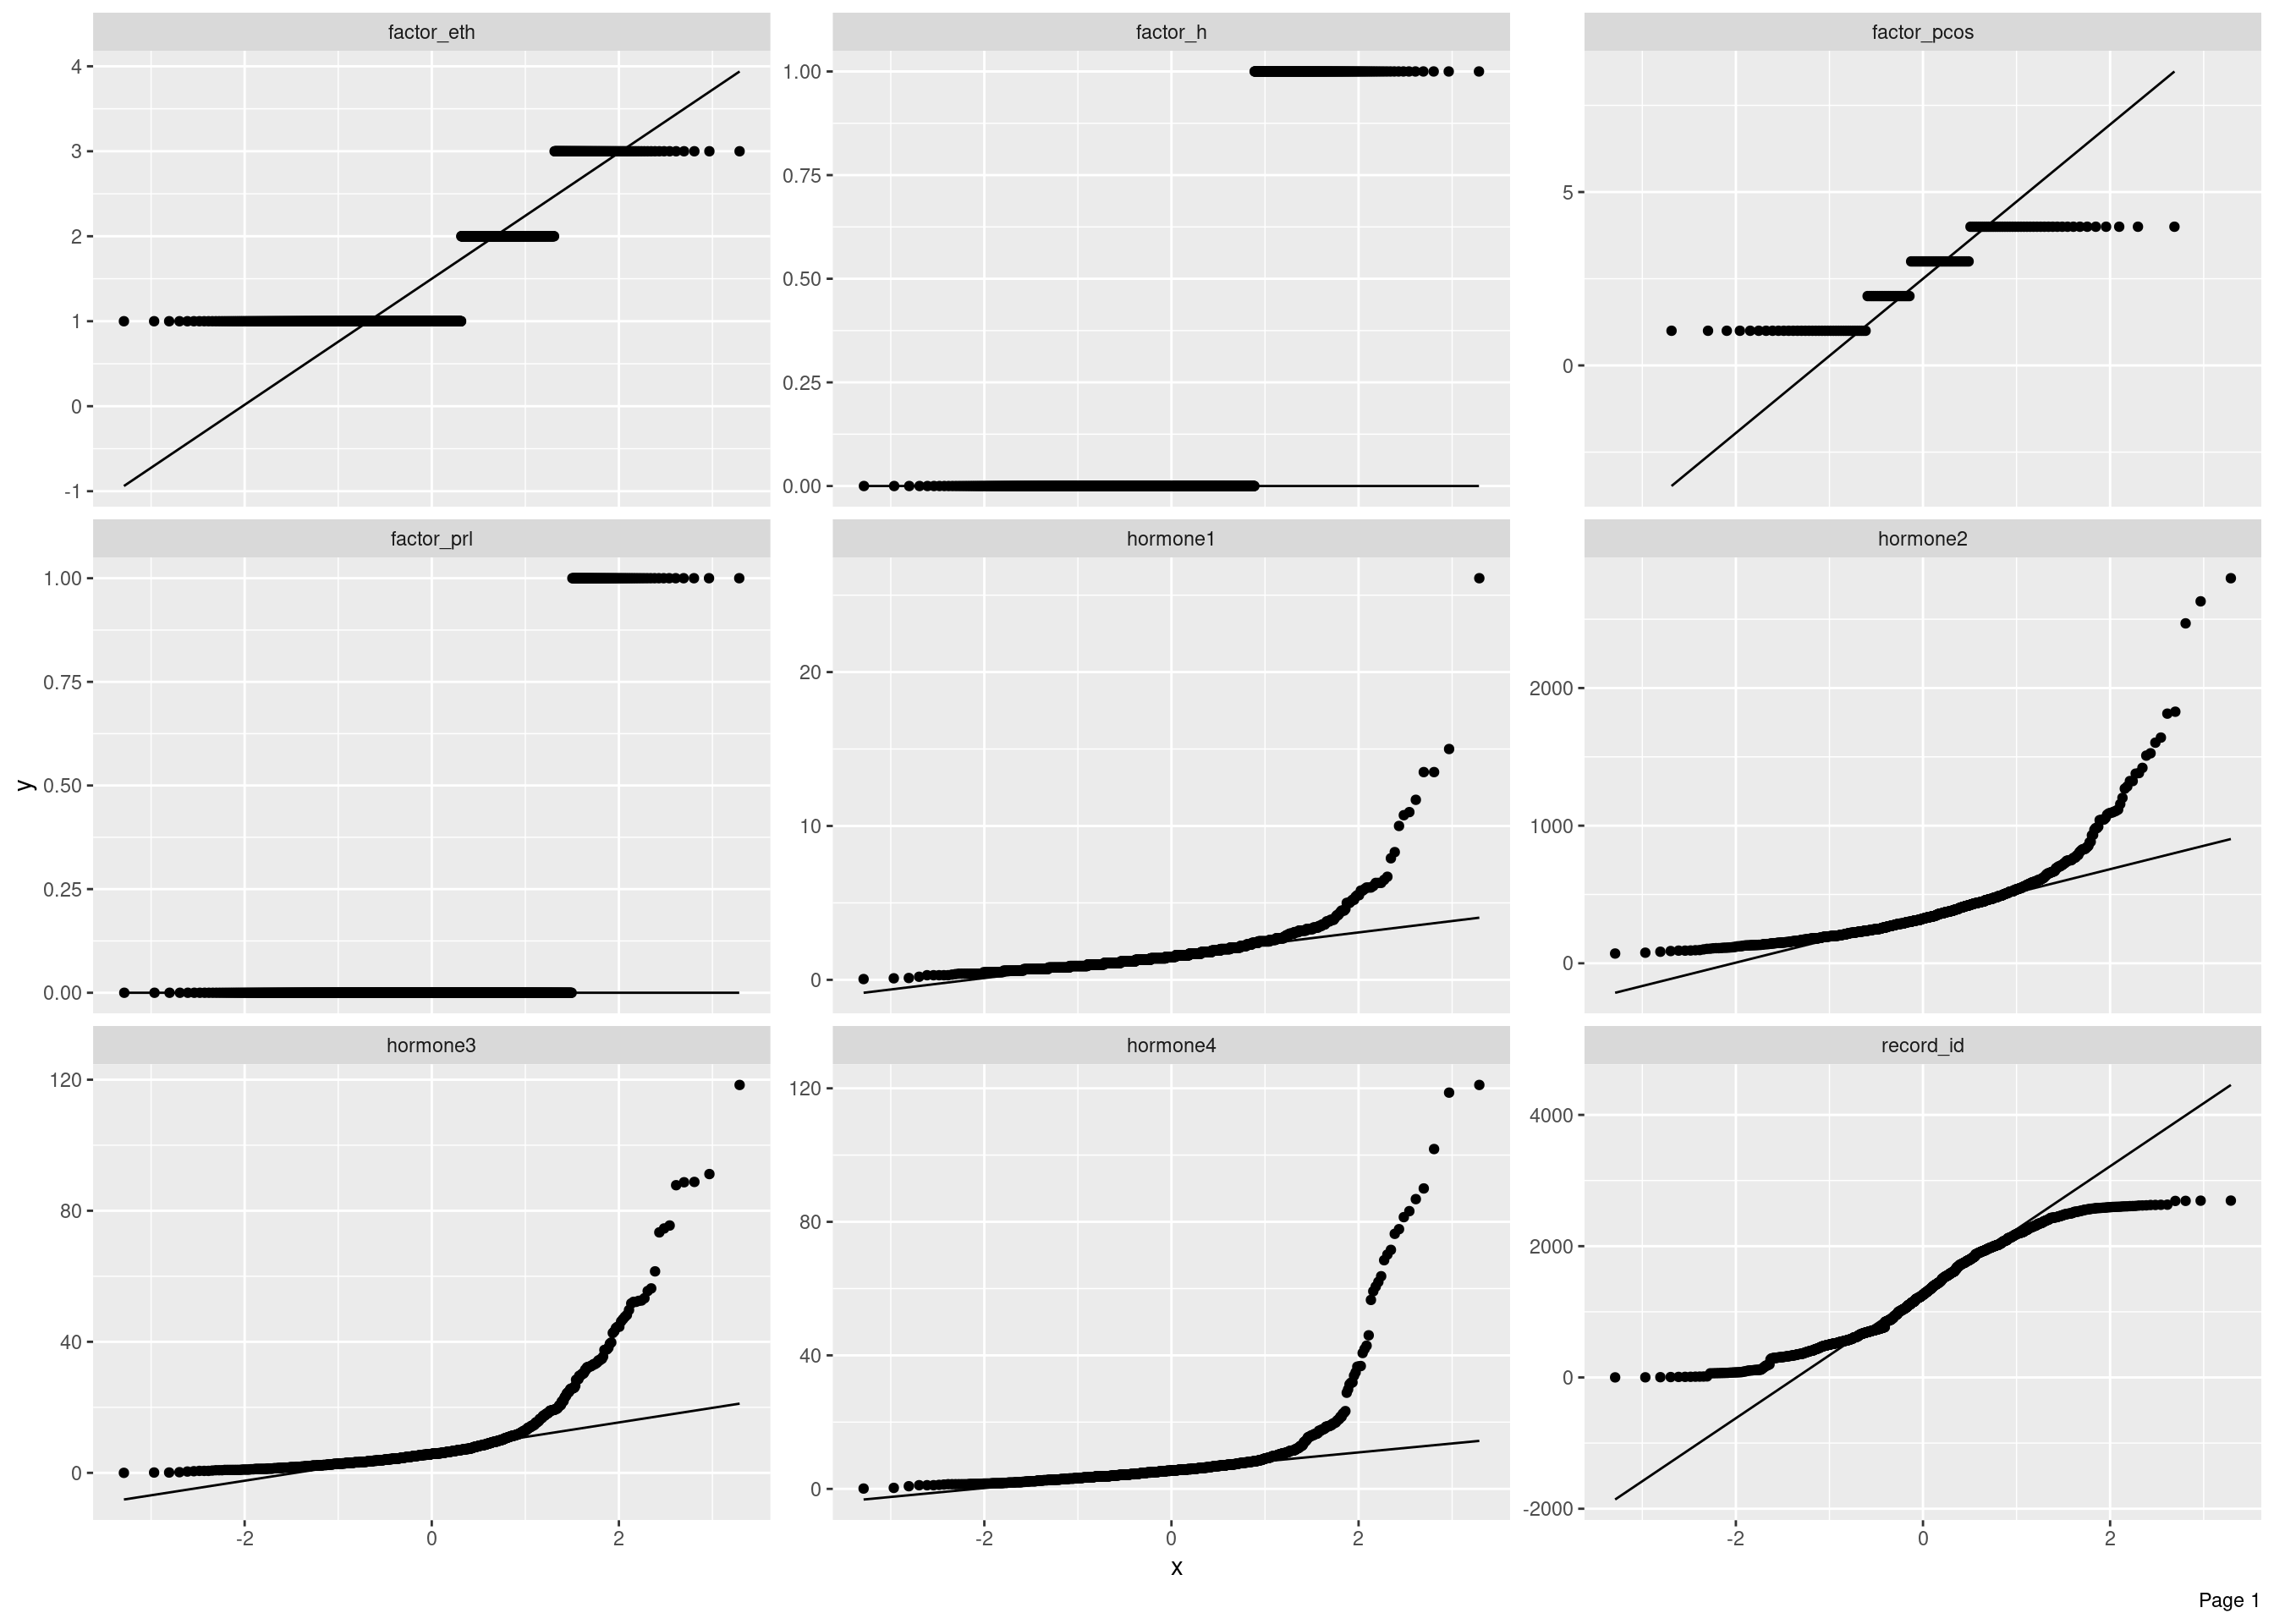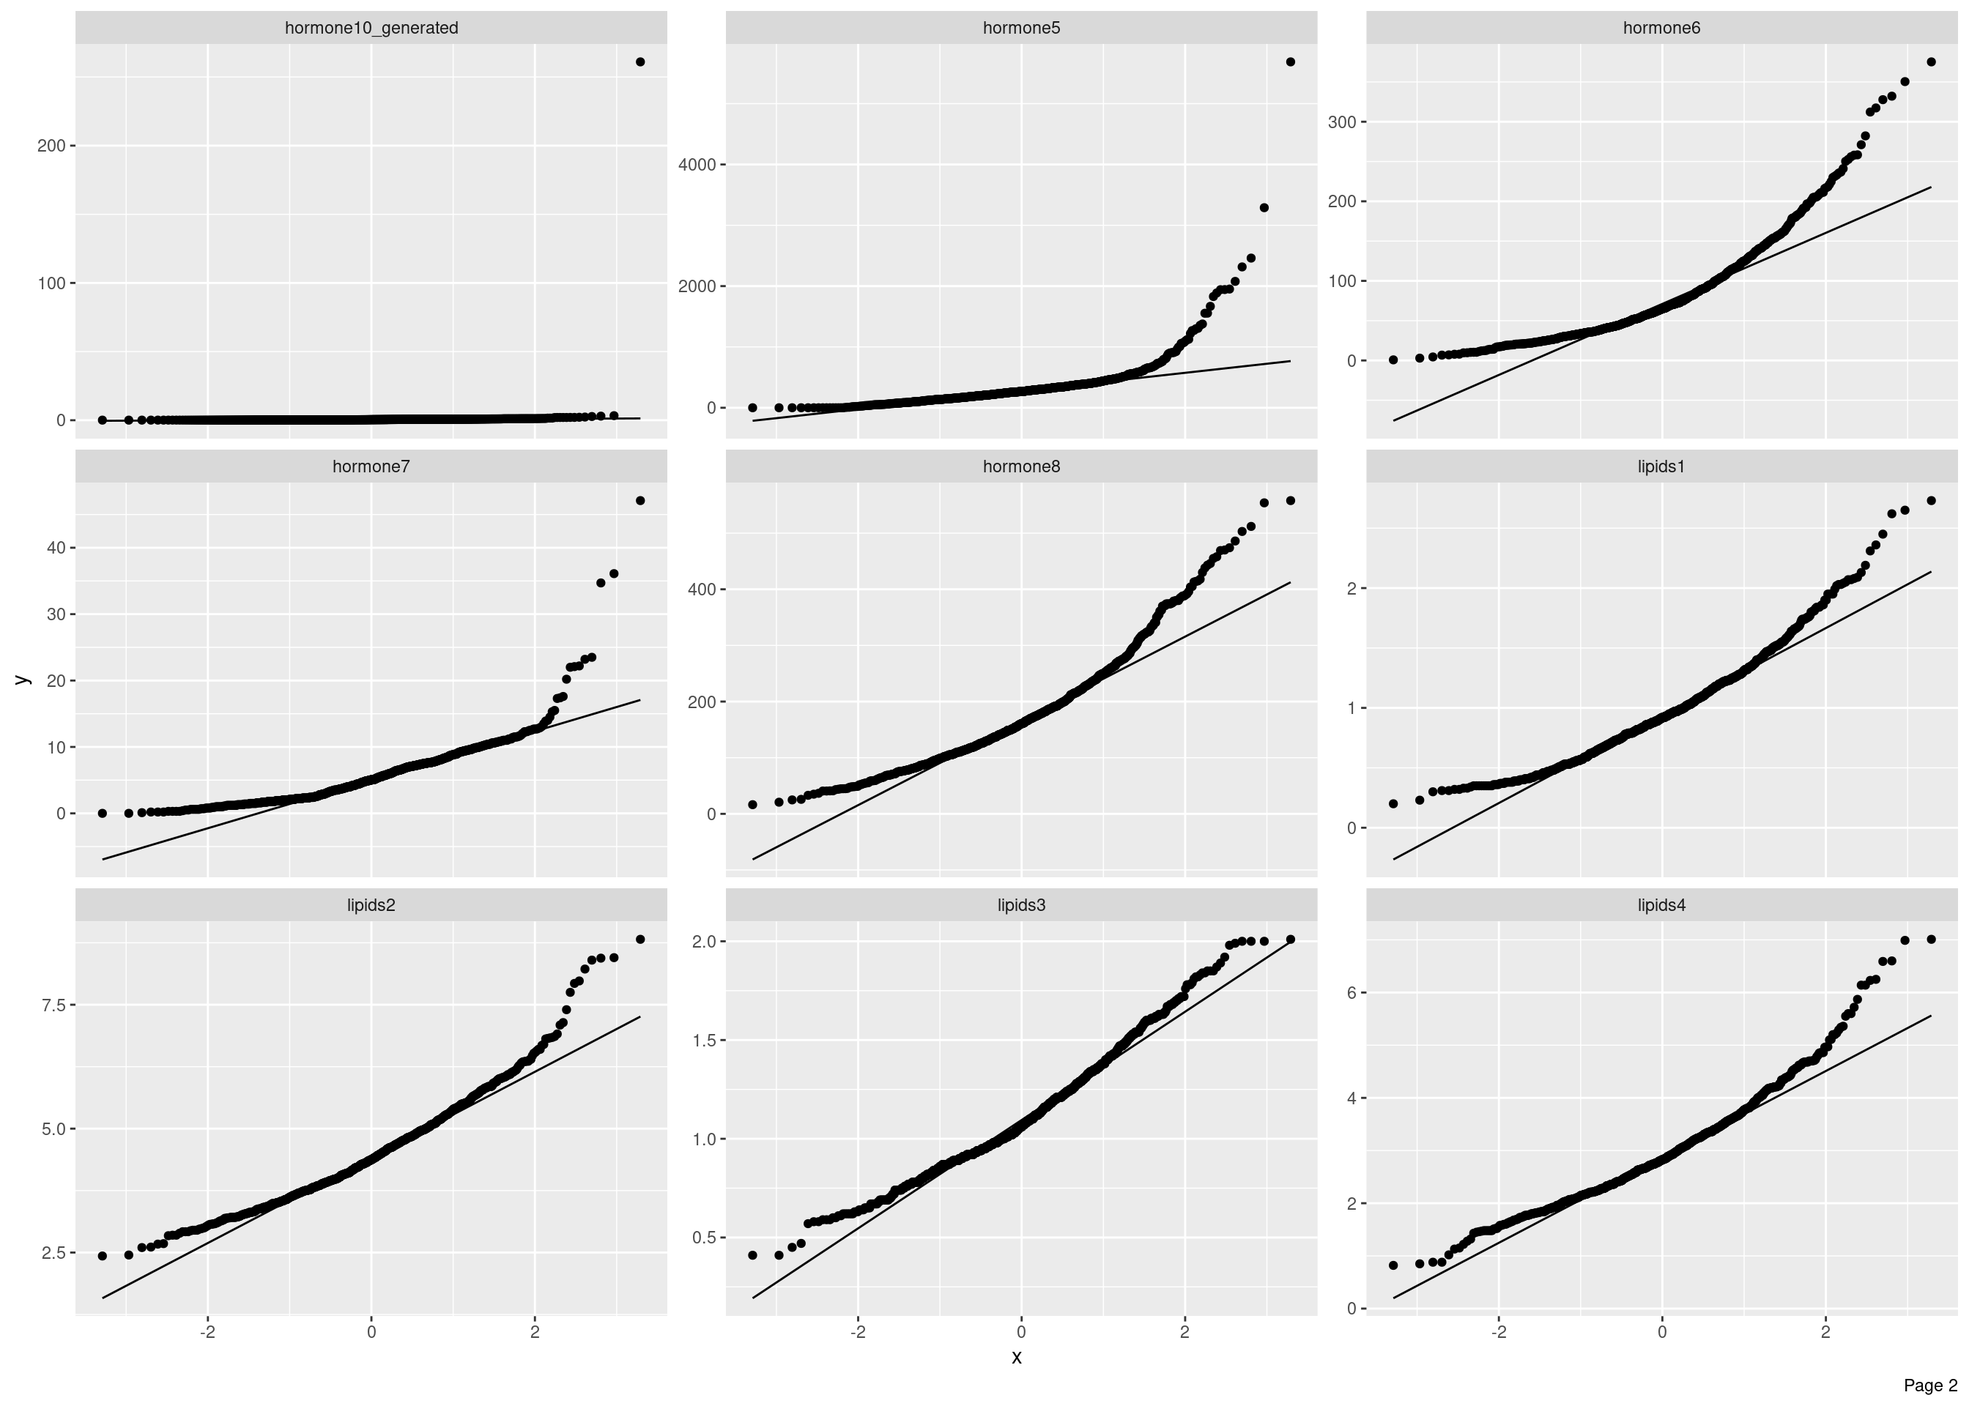
## Warning: Removed 241 rows containing non-finite outside the scale range (`stat_qq()`).
## Warning: Removed 241 rows containing non-finite outside the scale range (`stat_qq_line()`).
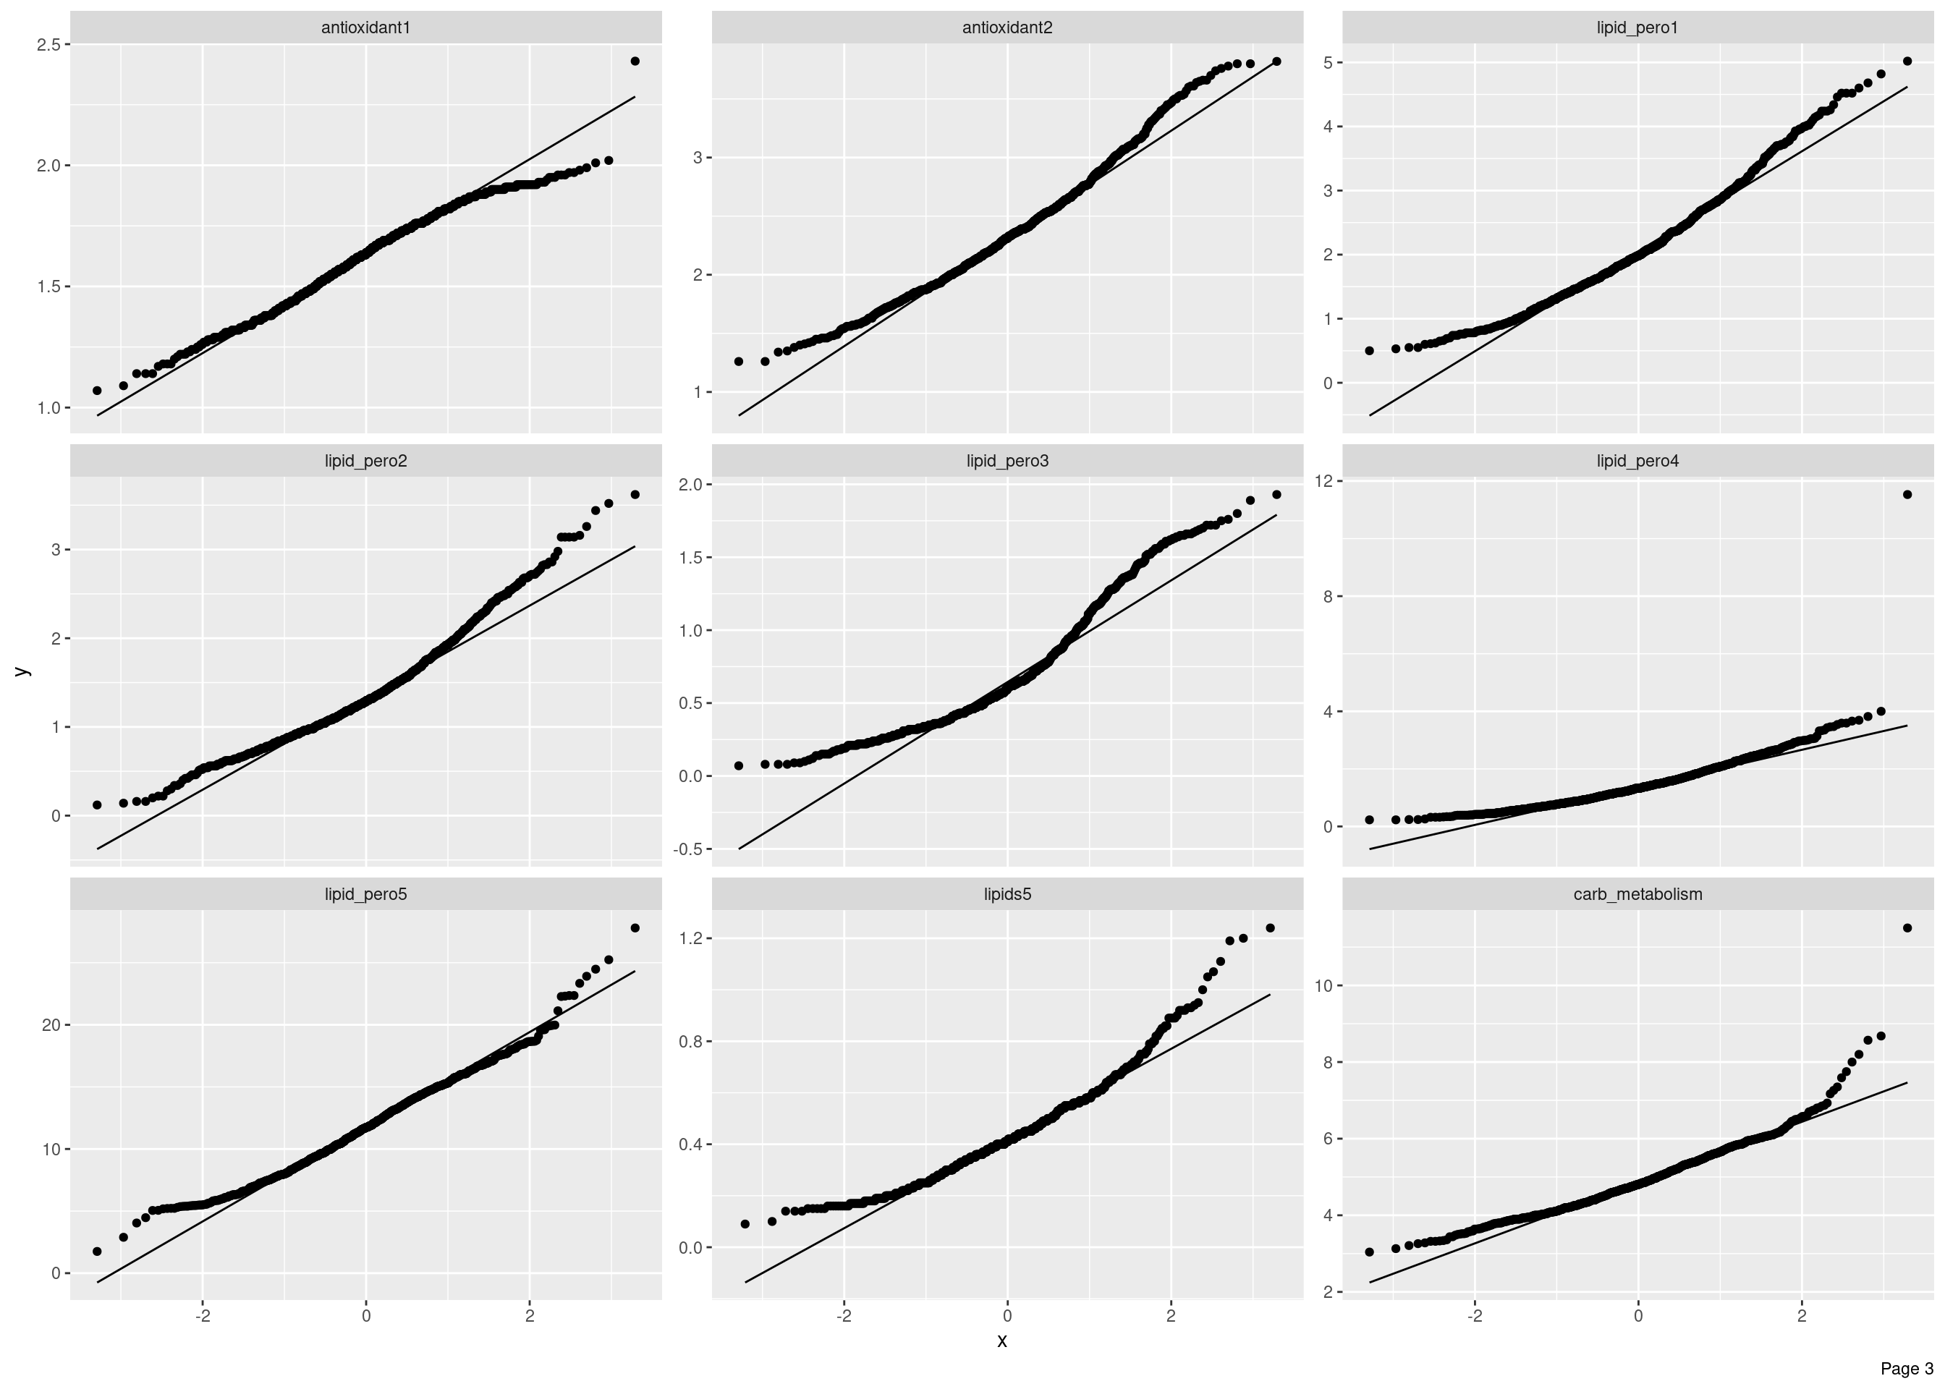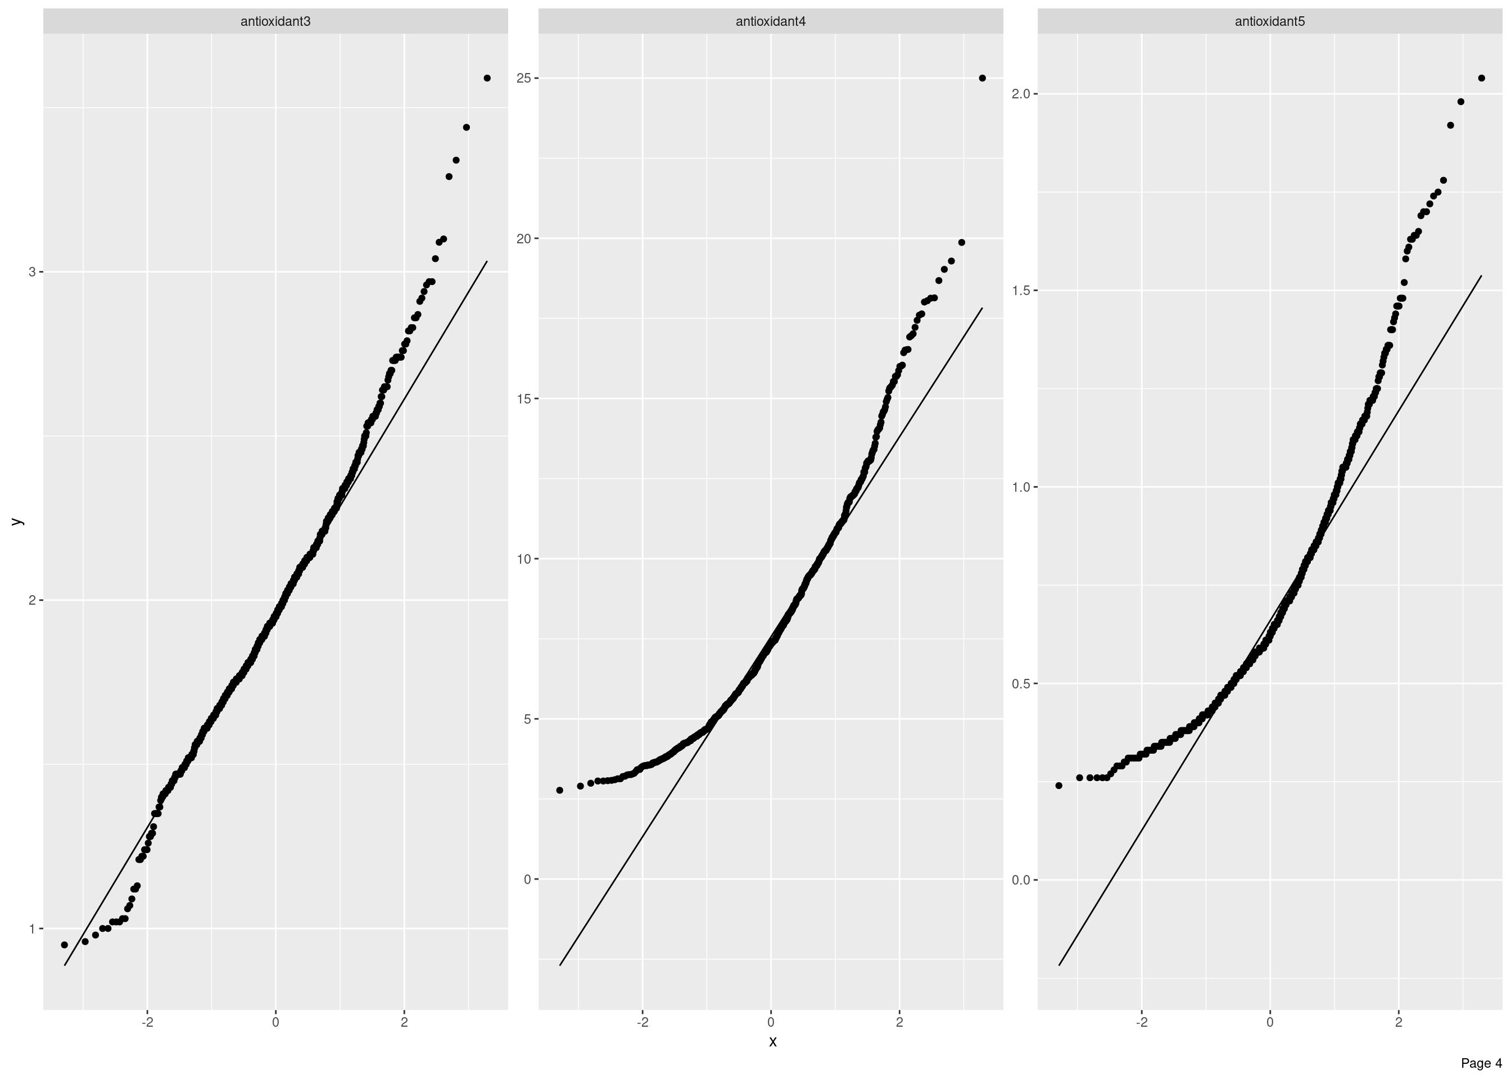

Correlation Analysis
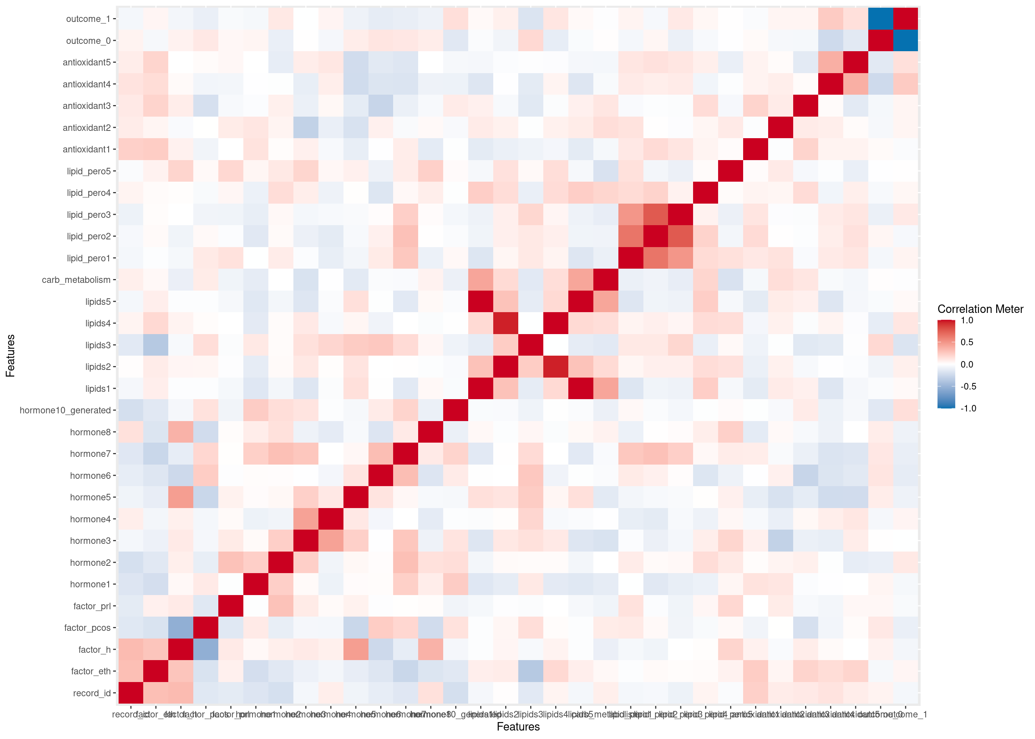

Principal Component Analysis
