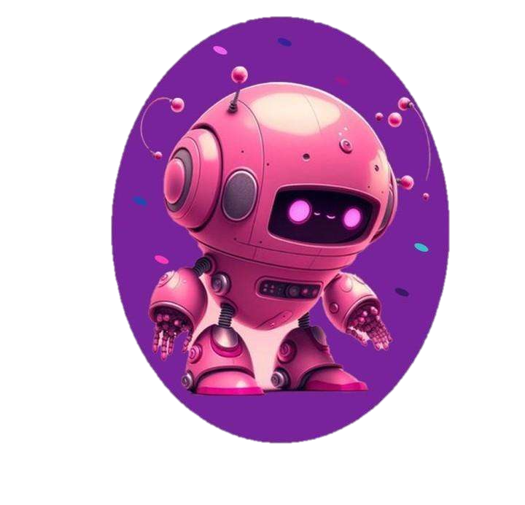**“Robotics in the tourism”**

**Documentation**

**Contents**

**Team members3**

**Introduction3,4**

**About the responsibilities of the members4,5**

**Used Technologies5**

Team Members:

|  |
| --- |
| Dimitar – Front-end developer |
| Yoana - Designer |

Kristiyana – Front-end developer

|  |
| --- |
| Dariq – SCRUM trainer |

Introduction:

Welcome to Robotics In The Tourism, your destination for exploring the fascinating intersection of robotics in the tourism industry. In an era of technological advancements, where automation and artificial intelligence are transforming various sectors, the field of tourism is also experiencing an exciting revolution. Our website serves as a comprehensive resource, providing insights, updates, and a wealth of knowledge about the innovative role that robots play in shaping the future of travel and hospitality.

About the responsibilities of the members:

1. Dimitar – our first Front-end developer, did the “About us” page, added information sources…
2. Yoana – our Designer, did the logo of our team, the design of our website.
3. Kristiyana -our second Front-end developer, added the nav bar, footer page and created documents.
4. Dariq – SCRUM trainer, edited the README.md, added the SECURITY.md and CODE-OF-CONDUCT.md files, added milestones for all the weeks , made more labels and made all the issues we all had to work on.

Used Technologies:

1. Visual Studio Code- updating the README.md and making the SECURITY.md file. Also, for making html and CSS codes.
2. Discord, Teams - for communicating, discussions and meetings.
3. Figma- for our site design