New Deep Learning Technique for Deeper Analysis of Medical Imaging

Doron Yospa
Computer Science Department
Georgia State University
Atlanta, Georgia
dyospa1@student.gsu.edu

Abstract—Recent advances in artificial intelligence have led to the increased use of deep learning techniques in medical imaging analysis. Medical imaging, such as X-rays, CT scans, and MRIs, plays an important role in diagnosing patients, but human error can occur when analysis relies solely on manual review. This project implements a Convolutional Neural Network (CNN) combined with Gradient-weighted Class Activation Mapping (Grad-CAM) to analyze medical images and improve interpretability. CNNs effectively preserve spatial relationships and identify localized features, while Grad-CAM provides visual explanations by highlighting image regions that influence predictions. The model was trained and evaluated on medical imaging datasets, achieving strong classification performance while providing consistent and meaningful visual explanations. This approach demonstrates the potential for a unified system capable of analyzing multiple types of medical images with high accuracy.
Keywords—Artificial Intelligence, Deep Learning, Medical Imaging

Introduction
Medical imaging technologies such as X-rays, CT scans, and MRIs are widely used in modern healthcare to support diagnosis and treatment decisions. As imaging data continues to grow in both size and complexity, accurately analyzing these images has become more challenging for medical professionals. From 1996 to 2010, CT, MRI, and PET usage increased significantly, highlighting the growing reliance on medical imaging technologies [3]. This increase has led to greater interest in using deep learning techniques to assist with medical image analysis.
Deep learning models, particularly convolutional neural networks (CNNs), have become the most common approach for medical image analysis because they preserve spatial relationships and learn meaningful features directly from image data [3]. However, many deep learning models lack transparency in how decisions are made. To address this issue, this project integrates Grad-CAM with CNNs to improve interpretability by highlighting the regions of an image that most influence predictions. The goal is to create a system that is both accurate and explainable across multiple imaging modalities.

Methodology
This project uses a convolutional neural network (CNN) combined with Gradient-weighted Class Activation Mapping (Grad-CAM) to analyze medical images such as X-rays, CT scans, and MRIs. The dataset was organized by imaging modality to ensure consistent input during training.
The CNN model was trained using supervised learning to classify images and identify relevant features. Grad-CAM was then applied to generate heatmap visualizations, allowing for a better understanding of how the model makes decisions. These visualizations highlight clinically relevant regions, such as fractures in X-ray images or damaged tissue in MRI scans.
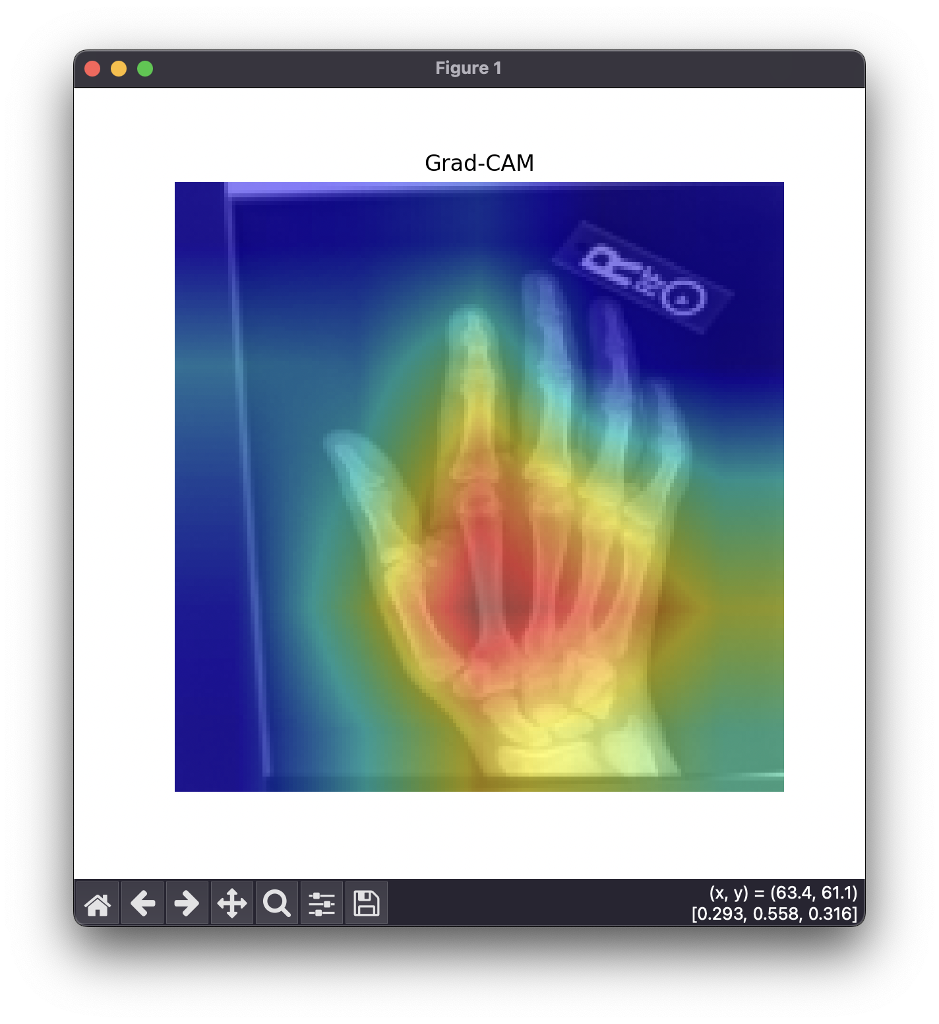
Figure 1. Grad-CAM visualization highlighting regions influencing prediction.
Additionally, exploratory analysis was conducted to evaluate how the model responds to unseen data. The combination of CNN classification and Grad-CAM visualization ensures that the model not only performs well but also provides interpretable results.

Results
The model was trained on a dataset consisting of two classes: abnormal and normal, with a total of 24,597 training samples, 3,646 validation samples, and 7,289 test samples. The dataset maintained a relatively balanced distribution across both classes, ensuring stable learning.
During the initial training phase, performance remained near baseline levels, with validation accuracy around 54–57%. After unfreezing the DenseNet backbone at epoch 6, the model showed a significant improvement in performance. Validation accuracy increased rapidly to over 70%, and continued to improve throughout training.
By the final epoch, the model achieved:
- Test Accuracy: 78.17%
- Validation Accuracy: 78.50%
The classification report shows:
- Abnormal: Precision = 0.76, Recall = 0.66, F1-score = 0.71
- Normal: Precision = 0.79, Recall = 0.86, F1-score = 0.82
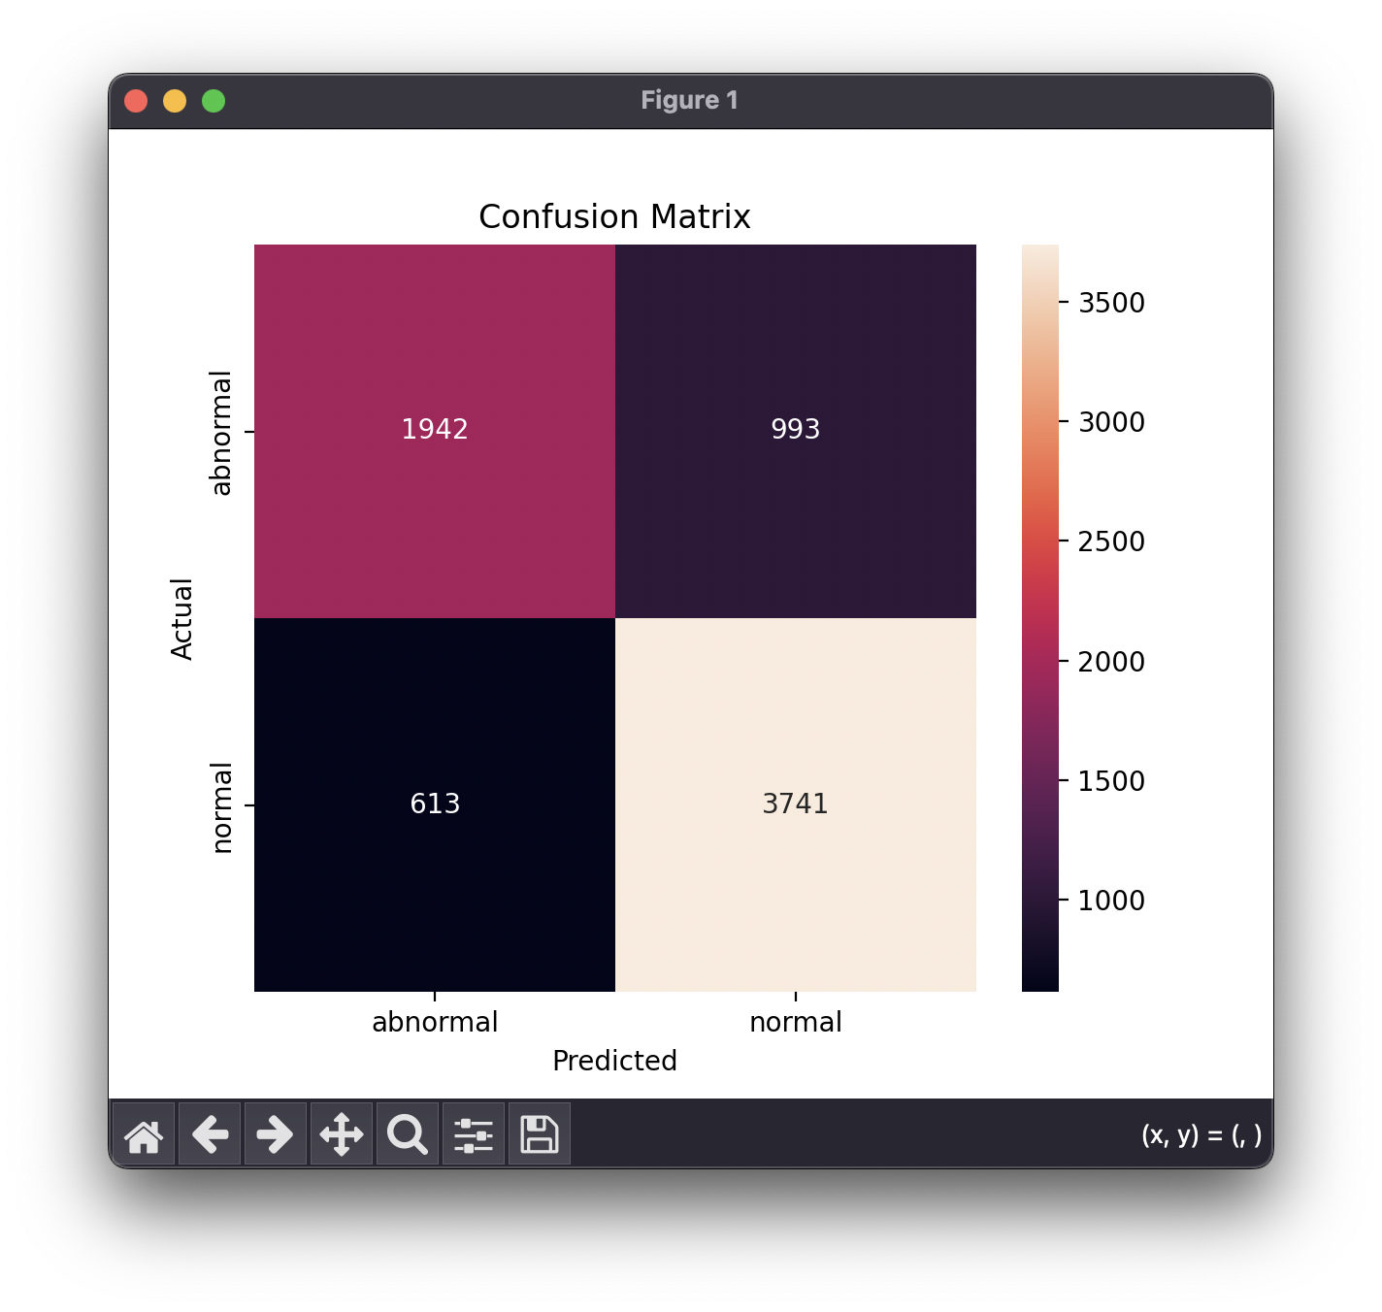
Figure 2. Confusion matrix showing classification performance.
The model performed better on the normal class, achieving higher recall and F1-score, while performance on the abnormal class was slightly lower, particularly in recall.

Discussion
The results demonstrate that the model successfully learned meaningful patterns from the medical imaging data, particularly after fine-tuning the DenseNet backbone. The sharp increase in accuracy after unfreezing indicates that transfer learning played a critical role in improving performance.

The model achieved strong overall accuracy (~78%), but performance differences between classes reveal an important limitation. The lower recall for the abnormal class suggests that the model occasionally fails to detect abnormal cases, which is a critical concern in medical applications. This imbalance indicates that the model is more conservative and tends to predict the normal class more confidently.

Despite this limitation, the integration of Grad-CAM provides an important advantage by improving interpretability. The generated heatmaps allow visualization of the regions influencing predictions, helping validate whether the model is focusing on clinically relevant areas rather than noise.

Future improvements could include:
- Using a larger and more diverse dataset
- Applying class balancing techniques (e.g., weighted loss or oversampling)
- Further tuning of the model architecture

Conclusion
This project developed a deep learning system for medical image analysis using a convolutional neural network (CNN) combined with Grad-CAM for interpretability. The model was trained to classify images into abnormal and normal categories and achieved approximately 78% accuracy on the test dataset. Results showed that the model was able to learn meaningful visual patterns while providing clear heatmap visualizations highlighting important regions of the images.
The integration of Grad-CAM improved transparency by allowing insight into how predictions were made, which is critical for medical applications. While the model performed well overall, performance on abnormal cases was lower, indicating a need for improvement in detecting critical conditions.
Future work will focus on improving accuracy through larger datasets, better class balancing techniques, and further optimization of the model architecture. Expanding the system for real-time clinical use and testing on more diverse medical datasets could further enhance its reliability and impact.

References

- A. Tamizifar, S. Berenjkoub and M. Amiri, "Deep Learning Meets Explainable AI: A Robust Framework for X-Ray Fracture Detection," 2025 33rd International Conference on Electrical Engineering (ICEE), Isfahan, Iran, Islamic Republic of, 2025, pp. 1-5
- G. Tummalapalli, O. Gurrapu, K. N. Kumar, J. Venkata Suman, A. V. Rao and M. Prabhu, "Deep Learning Approaches for Enhancing Image Classification Accuracy in Medical Imaging," 2025 Devices for Integrated Circuit (DevIC), Kalyani, India, 2025, pp. 16-21
- J. Ker, L. Wang, J. Rao and T. Lim, "Deep Learning Applications in Medical Image Analysis," in IEEE Access, vol. 6, pp. 9375-9389, 2018
- M. Jamshidi et al., "Artificial Intelligence and COVID-19: Deep Learning Approaches for Diagnosis and Treatment," in IEEE Access, vol. 8, pp. 109581-109595
- P. Rastogi, V. Singh and M. Yadav, "Deep Learning and Big DataTechnologies in Medical Image Analysis," 2018 Fifth International Conference on Parallel, Distributed and Grid Computing (PDGC), Solan, India, 2018, pp. 60-63
- Y. He, "Diving Deep: The Role of Deep Learning in Medical Image Analysis, Today and Tomorrow," 2024 9th International Conference on Intelligent Informatics and Biomedical Sciences (ICIIBMS), Okinawa, Japan, 2024, pp. 537-540

