ML LAB-07 23/09/2025

# Support Vector Regression (SVR)
# Importing the libraries
import pandas as pd
import matplotlib.pyplot as plt
import numpy as np

# Importing the dataset
dataset = pd.read_csv("Position_Salaries.csv")
x = dataset.iloc[:, 1:-1].values
y = dataset.iloc[:, -1].values
print(x)
print(y)

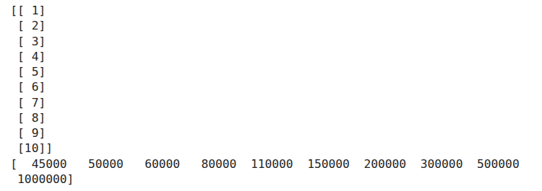
from sklearn.preprocessing import StandardScaler
y = y.reshape(len(y), 1)
print(y)
sc_x = StandardScaler()
sc_y = StandardScaler()
x = sc_x.fit_transform(x)
y = sc_y.fit_transform(y)
print(x)
print(y)

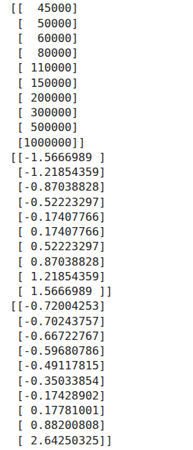

# Training the SVR model on the whole dataset
from sklearn.svm import SVR
regressor = SVR(kernel = 'rbf')
regressor.fit(x, y)
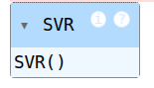

#Predicting the new result
print(sc_y.inverse_transform(regressor.predict(sc_x.transform([[6.5]])).reshape(1,1)))

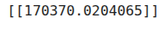

pred = sc_y.inverse_transform((regressor.predict(x)).reshape(len(y),1))
print(pred)
print(sc_y.inverse_transform(y))

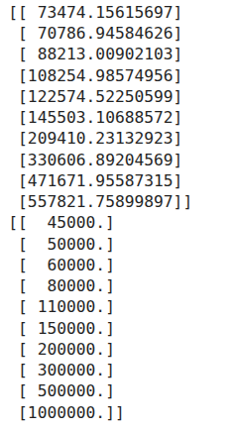

# Visualizing the SVR results
plt.scatter(sc_x.inverse_transform(x), sc_y.inverse_transform(y), color='red')
plt.plot(sc_x.inverse_transform(x), pred, color='blue')
plt.title('Truth or Bluff(SVR)')
plt.xlabel('Position Level')
plt.ylabel('Salary')
plt.show()

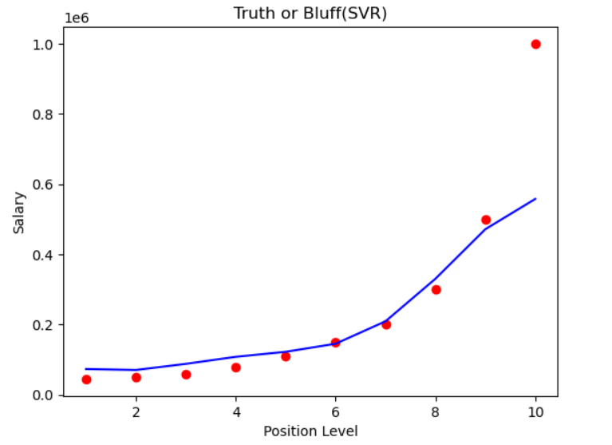
pred_norm = regressor.predict(x)
print(pred_norm)

from sklearn.metrics import mean_absolute_error
print(mean_absolute_error(pred_norm, y))

