**AA_Lab_07_Assignment**

**CE_054**

Aim :- Implementation of Convex-Hull Algorithm using Graham Scan Algorithm.

Code :

'''

Author : Dhruv B Kakadiya

GScan Algo

'''

import matplotlib.pyplot as plt

import math as m

import random as r

anchor = None

def randome_point_creation(no_points, min_ = 0, max_ = 70 ):

    return [[r.randint(min_, max_), r.randint(min_, max_)] for i in range(no_points)]

def view_graph(points, convex = None):

    x, y = zip(*points)

    plt.scatter(x, y, edgecolors="green")

    if (convex != None):

        for i in range(1, len(convex) + 1):

            if (i == len(convex)):

                i = 0

            p0, p1 = convex[i-1], convex[i]

            plt.plot((p0[0], p1[0]), (p0[1], p1[1]), 'g')

    plt.show()

def angle(p0, p1 = None):

    if (p1 == None):

        p1 = anchor

    y, x = p0[1] - p1[1], p0[0] - p1[0]

    return (m.atan2(y, x))

def distance(p0, p1 = None):

    if (p1 == None):

        p1 = anchor

    y, x = p0[1] - p1[1], p0[0] - p1[0]

    return (pow(y, 2) + pow(x, 2))

def find_distance(p1, p2, p3):

    return ((p2[0] - p1[0]) * (p3[1] - p1[1]) - (p2[1] - p1[1]) * (p3[0] - p1[0]))

def sorting_points(P):

    if (len(P) <= 1):

        return P

    small, eql, large =[], [], []

    pivot = angle(P[r.randint(0, len(P) - 1)])

    for p in P:

        ang = angle(p)

        if (ang < pivot):

            small.append(p)

        elif (ang > pivot):

            large.append(p)

        else:

            small.append(p)

    return (sorting_points(small) + sorted(eql, key=distance) + sorting_points(large))

def GscanAlgo(points, process = False):

    global anchor

    min_index = 0

    for i, (x, y) in enumerate(points):

        if (min_index == None or y < points[min_index][1]):

            min_index = i

        if (x < points[min_index][0] < y == points[min_index][1]):

            min_index = i

    anchor = points[min_index]

    sorted_points = sorting_points(points)

    del sorted_points[sorted_points.index(anchor)]

    hull = [anchor, sorted_points[0]]

    for p in sorted_points[1:]:

        while (find_distance(hull[-2], hull[-1], p) <= 0):

            del hull[-1]

        hull.append(p)

        if (process):

            view_graph(points, hull)

    return hull

pt = randome_point_creation(15)

print(pt)

hull = GscanAlgo(pt, True)

view_graph(pt, hull)

Outputs :-

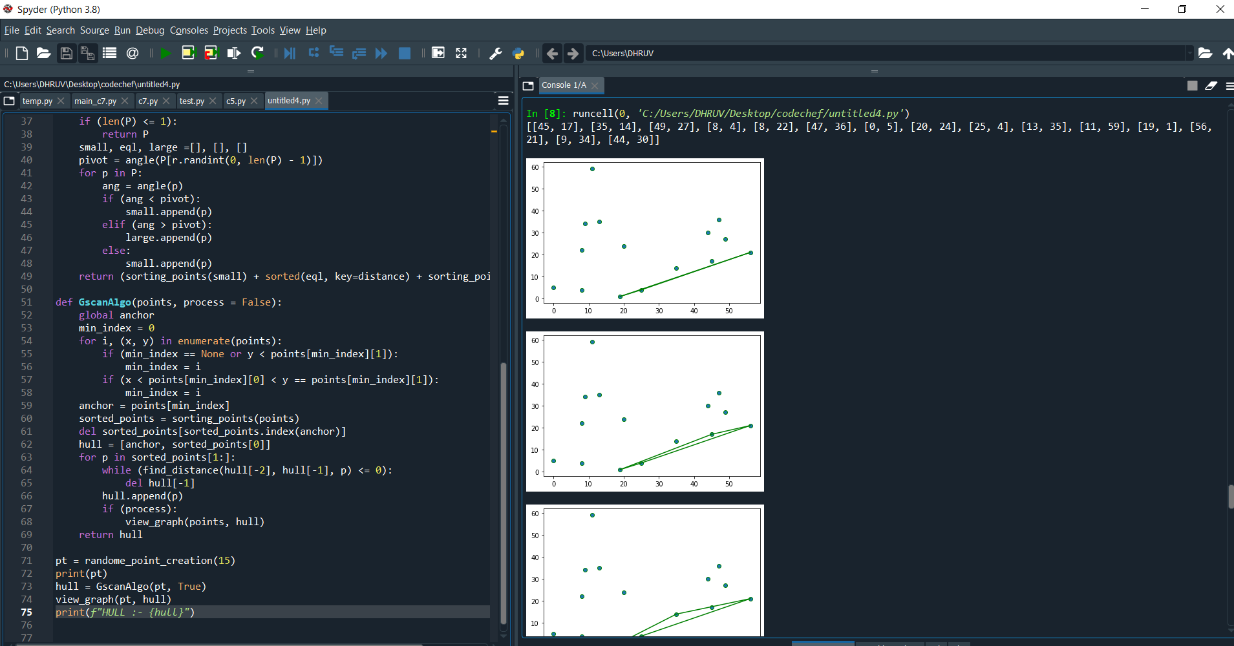

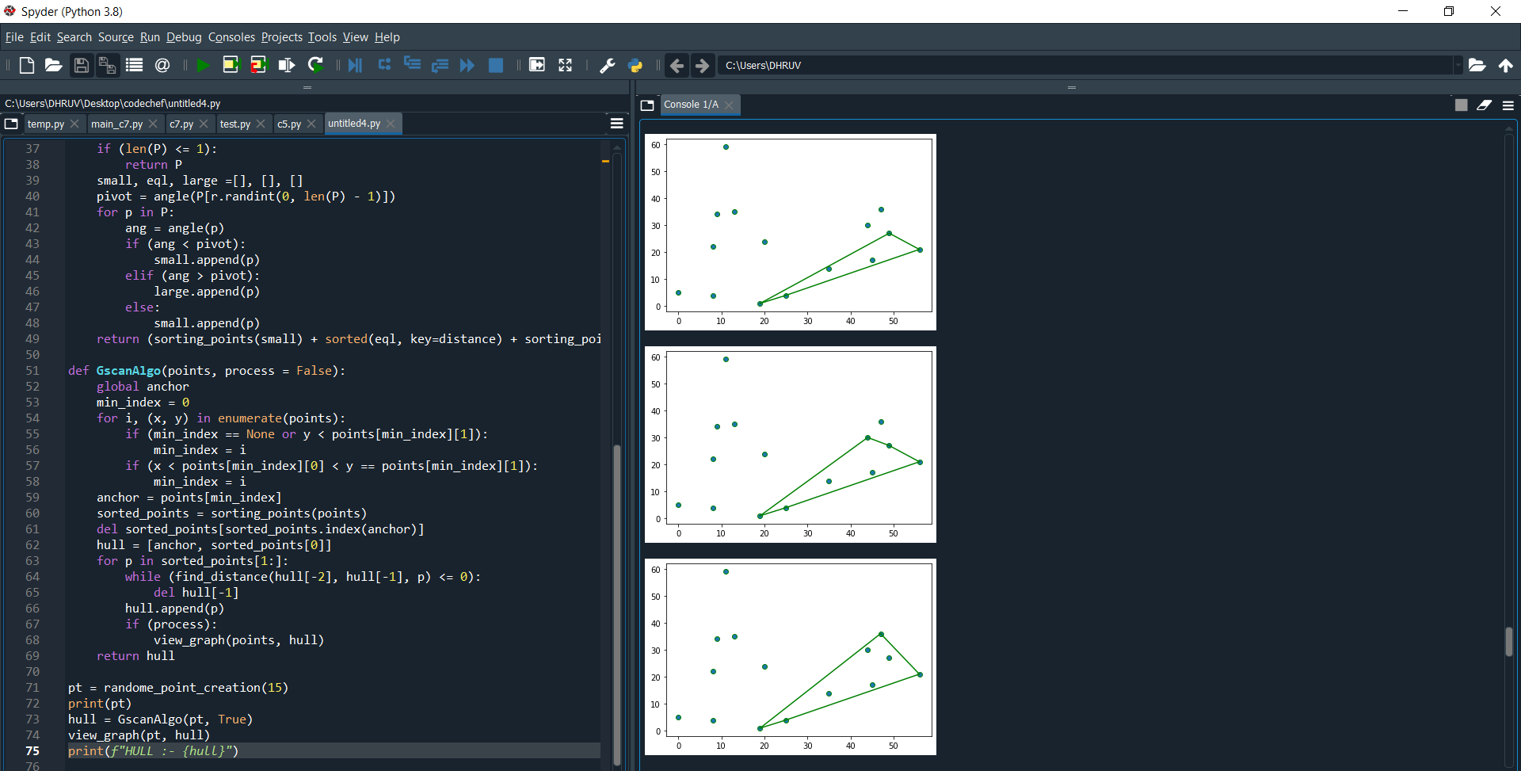

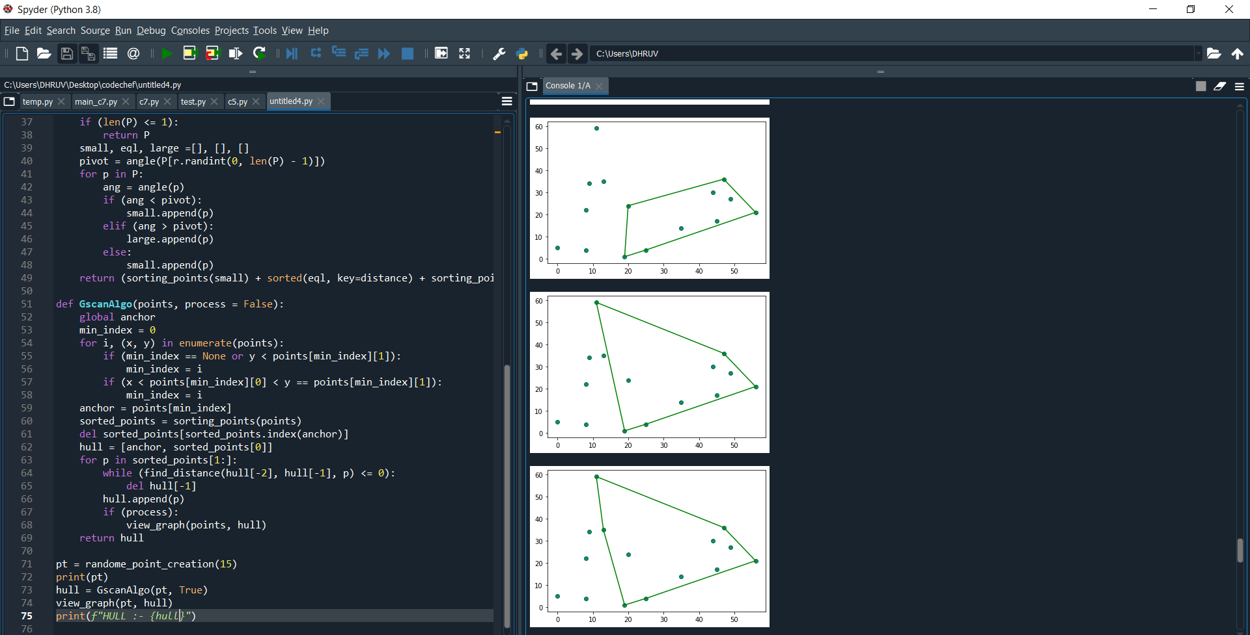

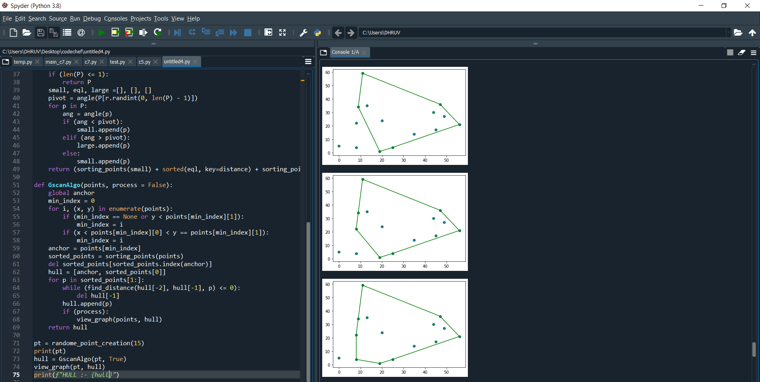

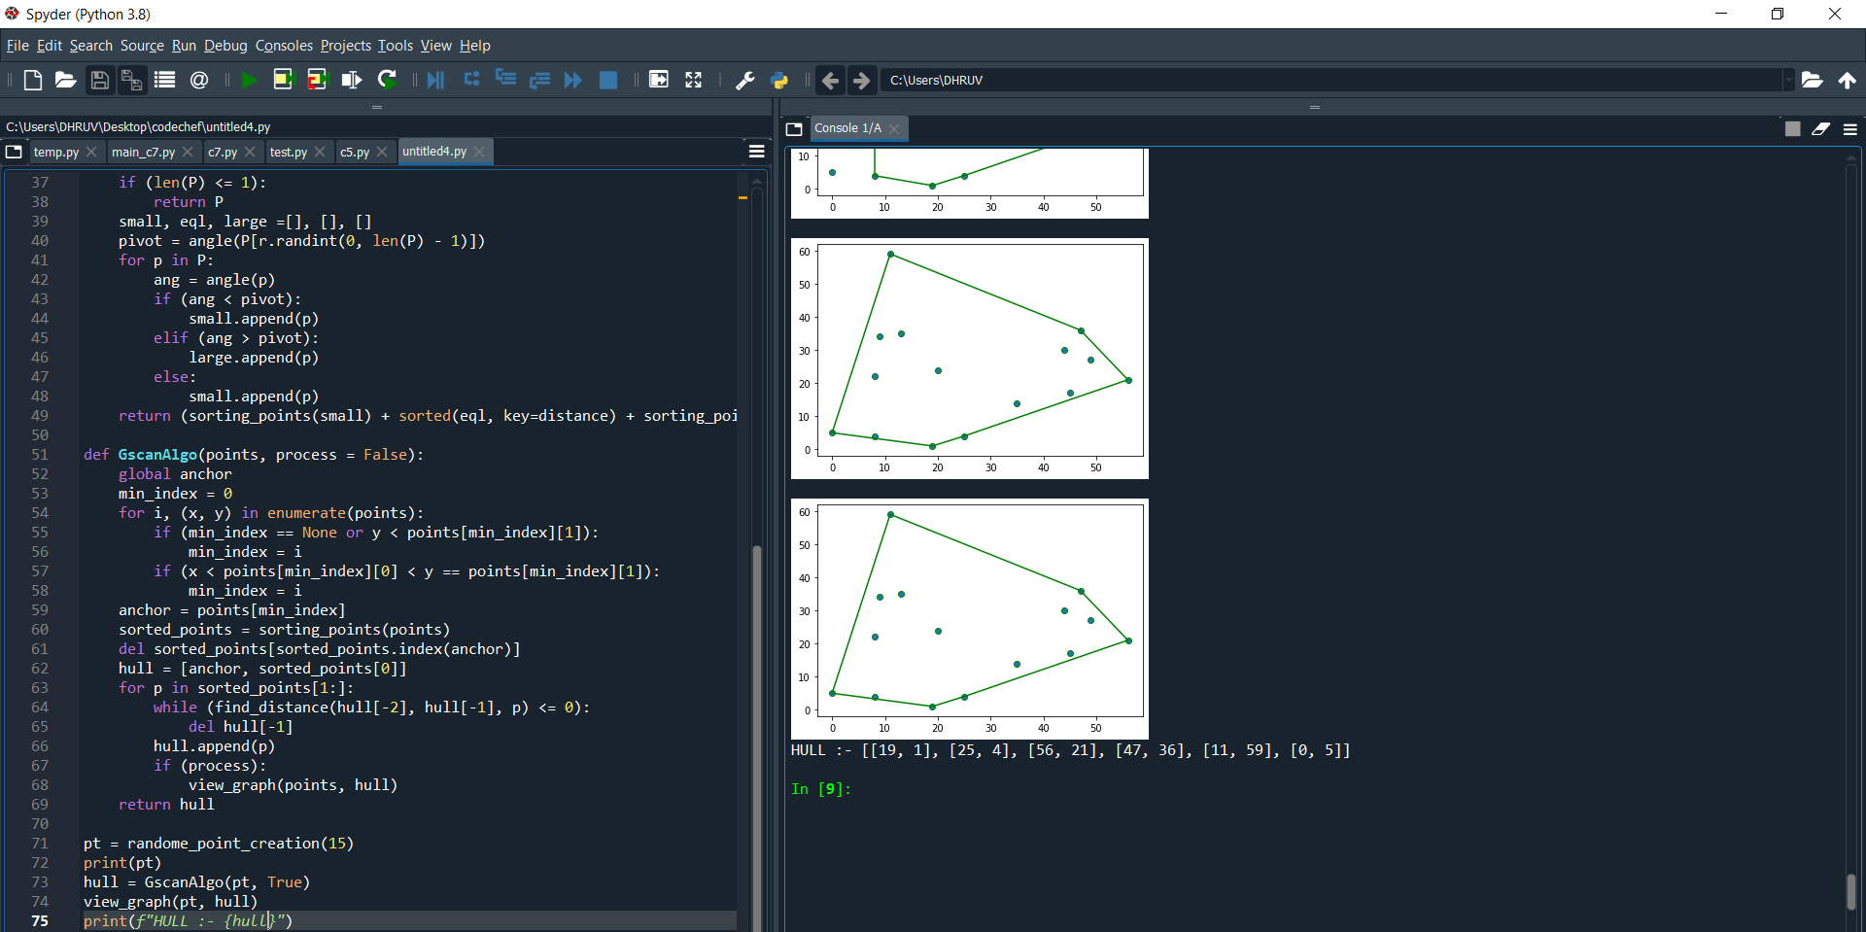

Theory :-

The convex hull is the minimum closed area which can cover all given data points.

Graham’s Scan algorithm will find the corner points of the convex hull. In this algorithm, at first, the lowest point is chosen. That point is the starting point of the convex hull. Remaining n-1 vertices are sorted based on the anti-clockwise direction from the start point. If two or more points are forming the same angle, then remove all points of the same angle except the farthest point from start.

Using Graham’s scan algorithm, we can find Convex Hull in O(nLogn) time.

Jarvis’s Algorithm  for Convex Hull. The worst case time complexity of Jarvis’s Algorithm is O(n^2).