**CN_LAB_1_Assignment**

**CE_055**

**Aim** :- Brief overview regarding various type of Topologies, Cisco package Tracer its Interface, menu, difference between cross connection and straight connection, configuration IP.

1. Introduction of Cisco Package Tracer.

* Cisco Packet Tracer, created by Cisco Systems, is a simulation tool that allows us to logically create a network topology without even implementing it physically. It can be used to understand all the basic concepts of computer networking. We can also use it to make simple and complex network topologies as well.
* The devices like Switches and Routers are very expensive so with the use of this package tracer tool we can create, configure network with almost unlimited devices.

1. Interface of Package Tracer.

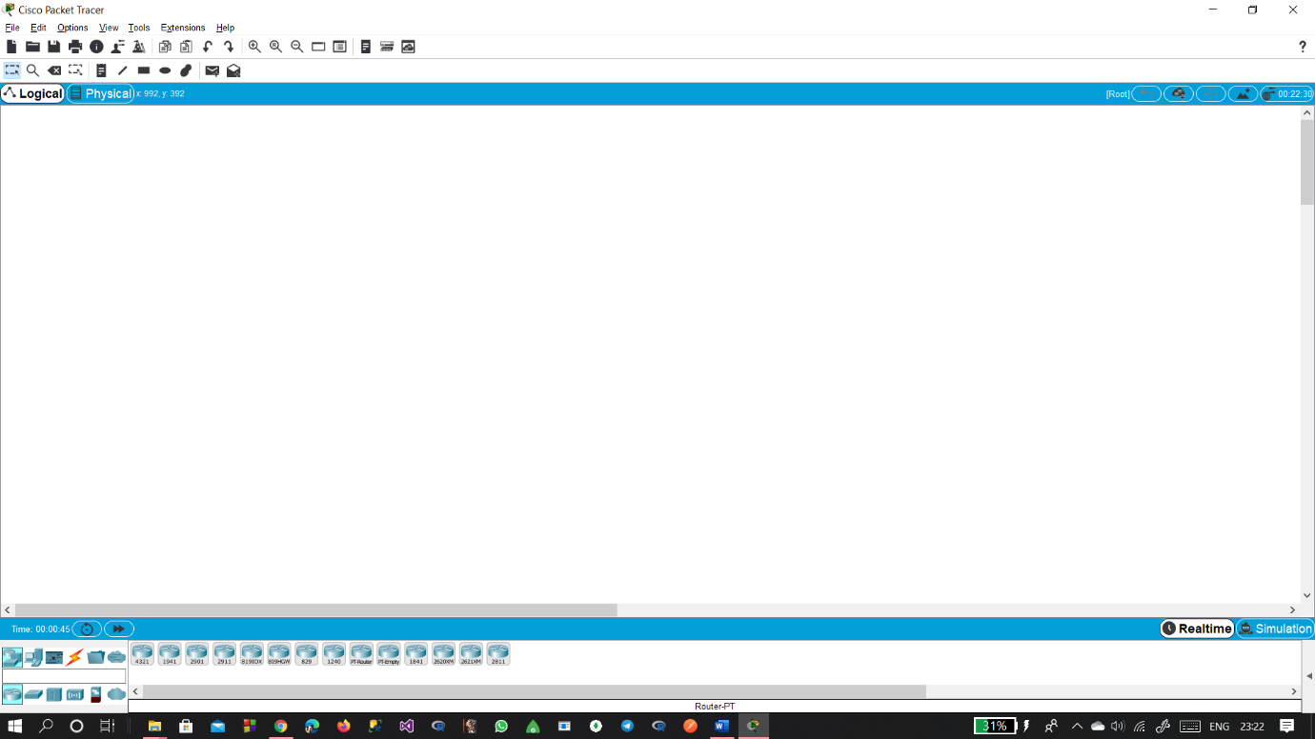

1. Menu:

* Network Device :-
* This menu represents various type of versions of Switches, Hubs, Bridges, Routers etc.
* Connections :-
* This menu represents different types of connections like copper-cross, copper-straight, phone, fiber etc.
* End Devices :-
* This menu represents different types of end devices like printer, desktop, server.

1. Difference between cross connection and straight connection.

* Cross connection :-
* Connection between two different types of devices together.
* Connect a router's LAN port to a switch/hub's normal port.
* Purpose of this cross cable is receiving terminal, connects to transmitting of one pc to another PC and vice versa.
* Connect two switches/hubs by using normal port in both switches/hubs.
* Straight Connection :-
* Connection between computer to a switch or hub’s normal port.
* Connection a router's WAN port to a cable modem's LAN port.
* Connection between two switches with one of the switch using an uplink port and the other one using normal port.
* A straight cable will not work to connect two computers together.

1. Network Topologies.

* Basically network topology represents arrangement of nodes of a computer Network.
* That means topology = layout of the network.
* Topology can be viewed as two parts
* 1. Physical topology :- placement of various nodes
* 2. Logical topology :- deals with data flow in the network.
* There are different types of topologies.
* Bus topology :-
* All data transmitted between nodes in the network is transmitted over this common transmission medium and is able to be received by the nodes in the network simultaneously.
* A signal containing the address of the intended receiving machine travels from a source machine in both direction to all machines connected to the bus until it finds the intended recipient.
* Advantages :-

The cost of cable is less compare to other topologies.

If there are N devices connected then the need of cable is only 1. Known as a backbone cable.

* Disadvantages :-

If the Network traffics increases then the lots of collision increases in the network.

If common wire fail then whole system fails.

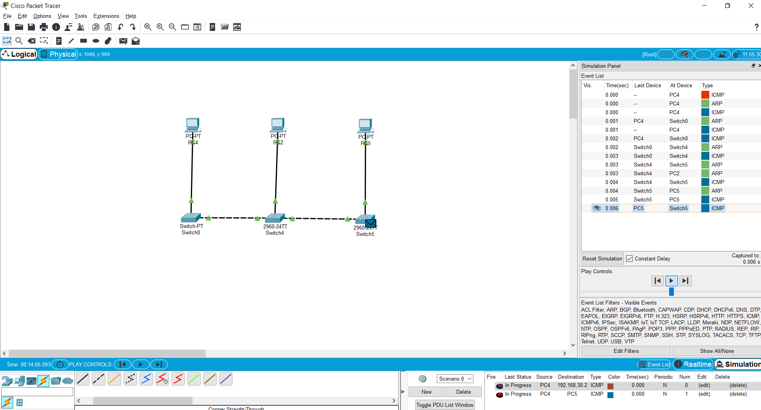

* Ring topology :-
* Same as bus topology in a close loop. It is peer to peer LAN topology, it is unidirectional, the sending and receiving data takes place with the help of a token.
* Advantages :-

Better performance then bus topology.

Cause bottleneck due to weak links.

All nodes with equal access.

* Disadvantages :-

Single point of failure affect the entire network.

No security.

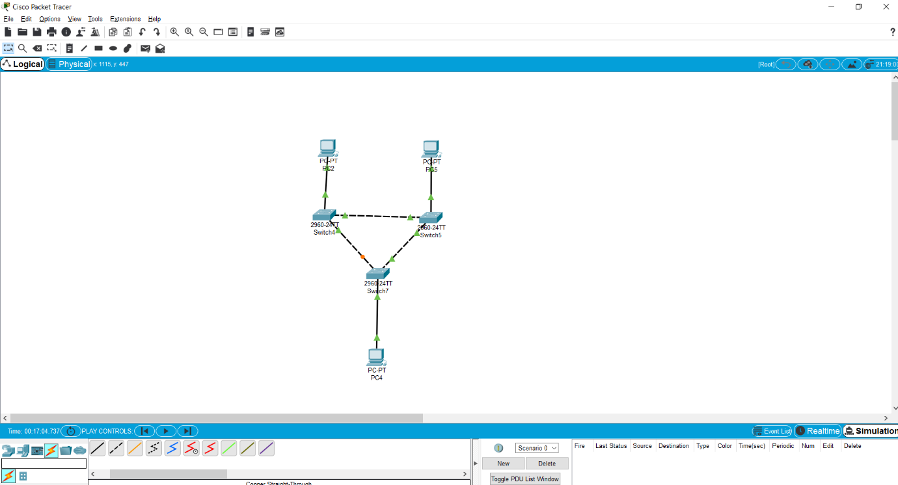

* Star topology :-
* Every node is connected with the central node called hub, In this topology there is centralize management, all the traffic of the network passes through the hub or switch.
* Advantages :-

Easy to implement and design.

Centralized administration.

* Disadvantages :-

Single point of failure affect whole network.

Bottleneck due to overloaded switch or hub.

Increase in cost due to switch because switch is expensive.

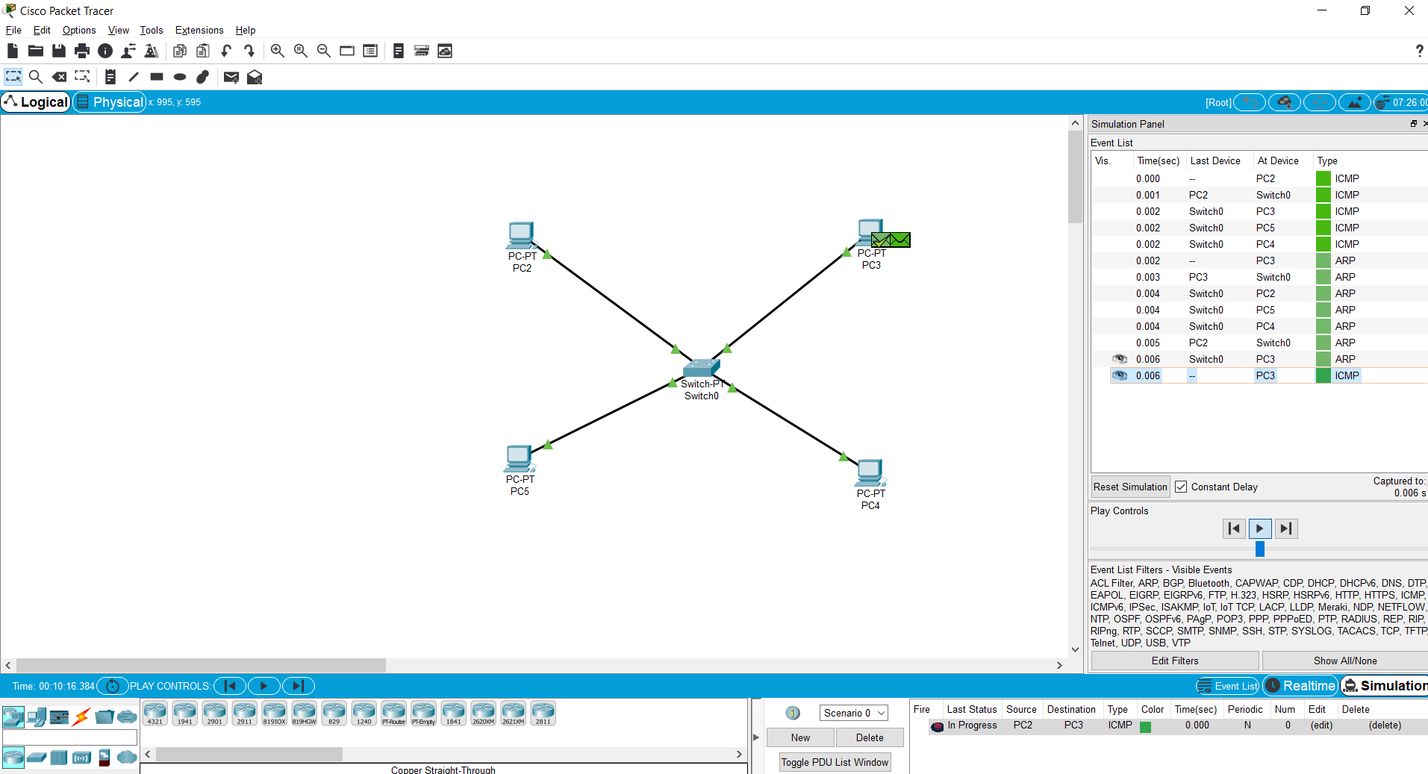

* Mesh topology :-
* Each and every nodes directly connected to the every other nodes in the network, if there is n devices are connected in the network then there is n-1 number of ports are there. And total number of dedicated links requires to connect them is nC2.
* Advantages :-

Fault tolerant.

Provides security and privacy.

* Disadvantages :-

Cost of maintenance is very high compare to other.

Issue with broadcasting messages.

Expensive and impractical for large network.

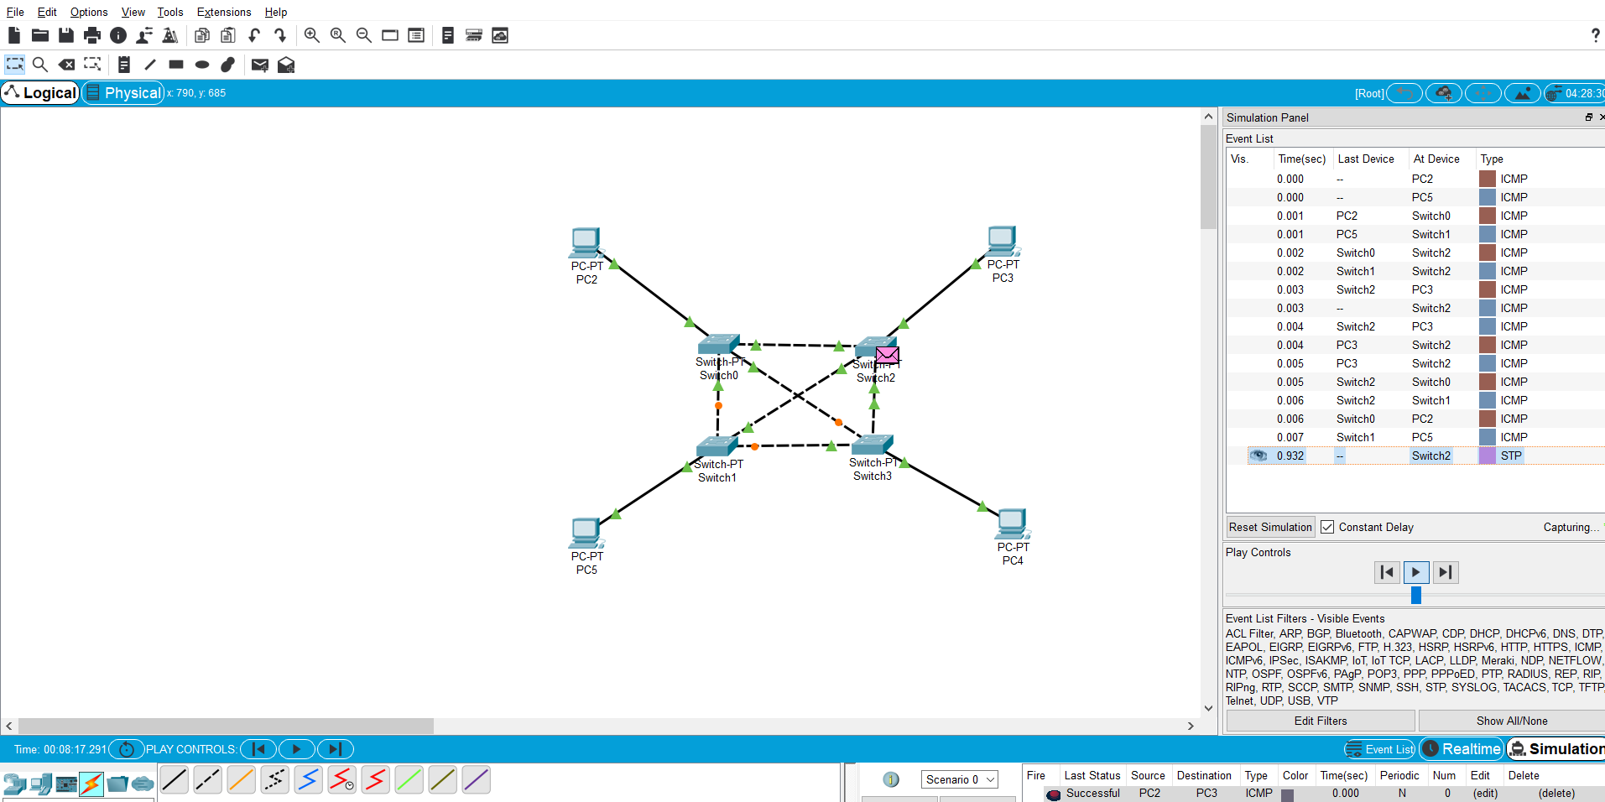

* Tree topology :-
* This topology is various or extended of star topology.
* Connections like from the central hub to secondary hub then to the devices in any order i.e secondary hub to the central hub.
* Advantages :-

Allows more devices to be connect to the single central hub.

* Disadvantages :-

If central hub fails then entire system fails.

Cost is high because of more number of cables.

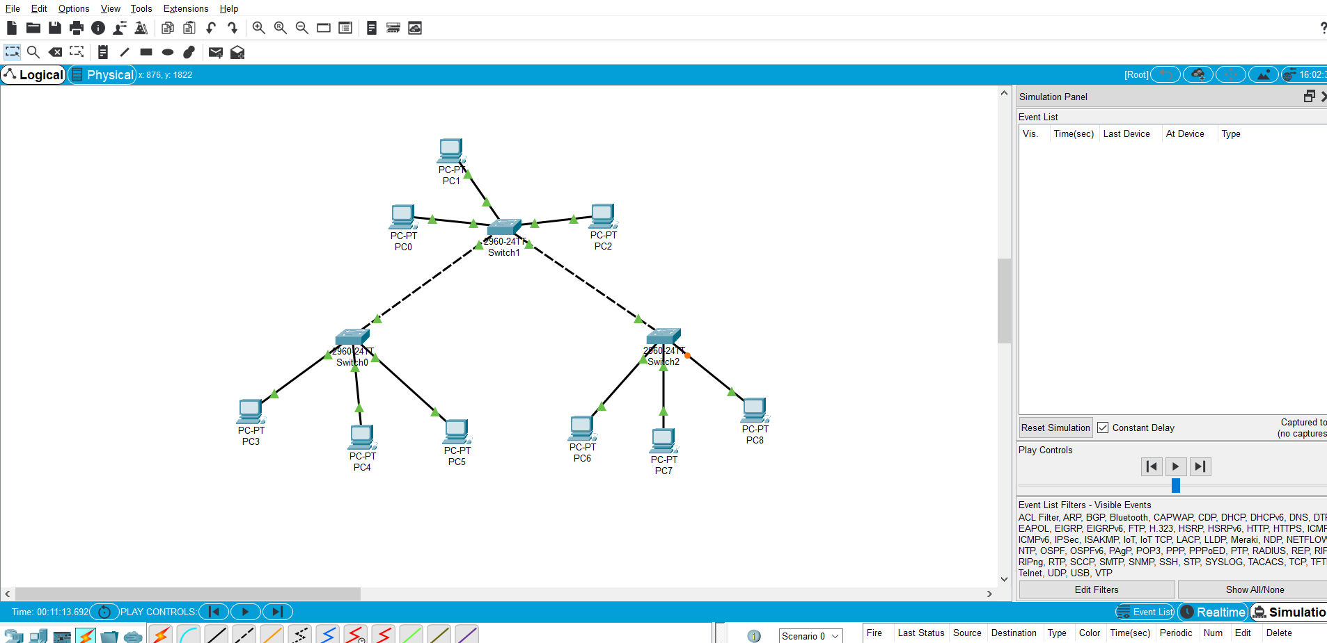

1. Constructing two node network and configuring IP for devices.

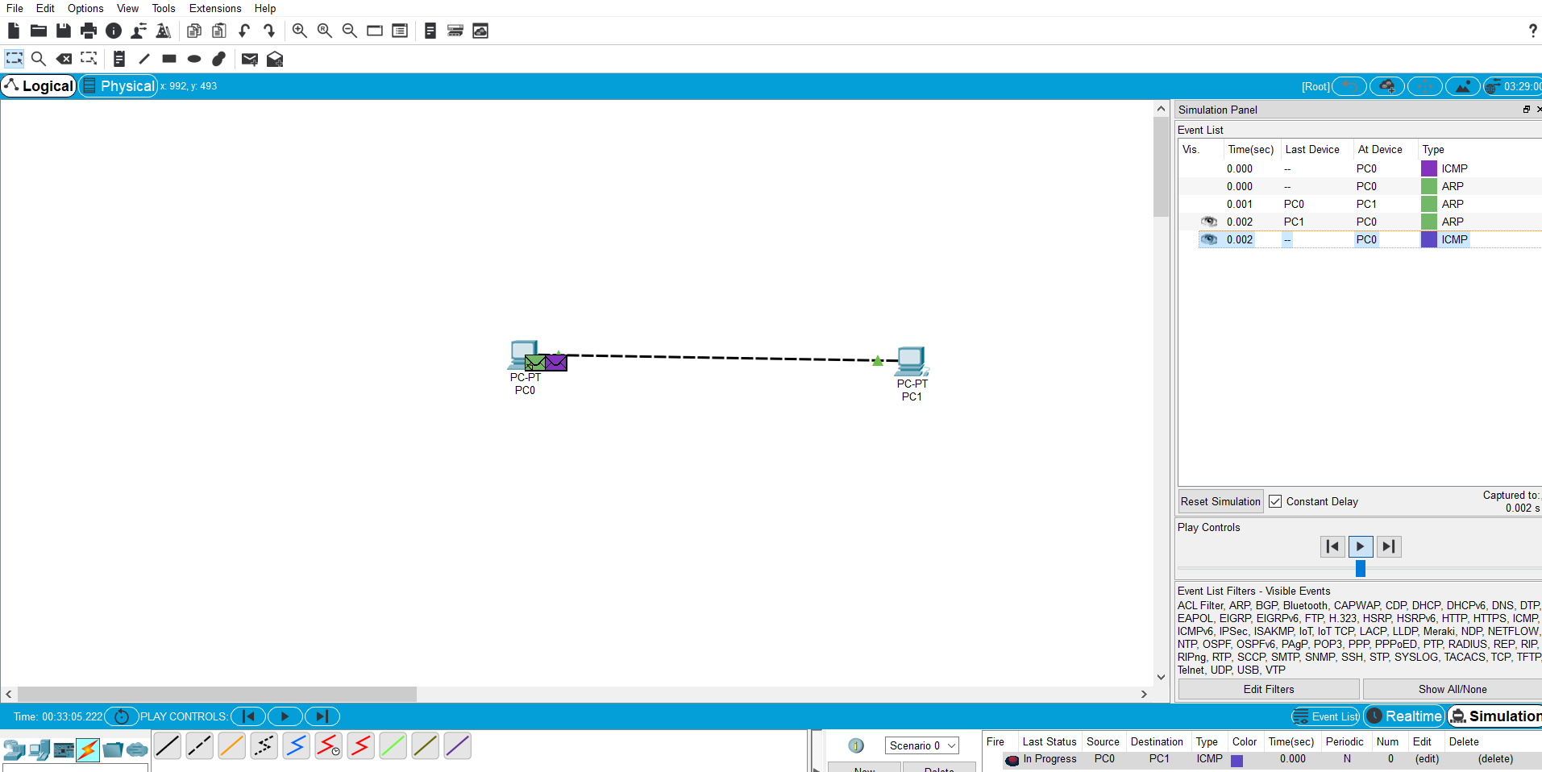

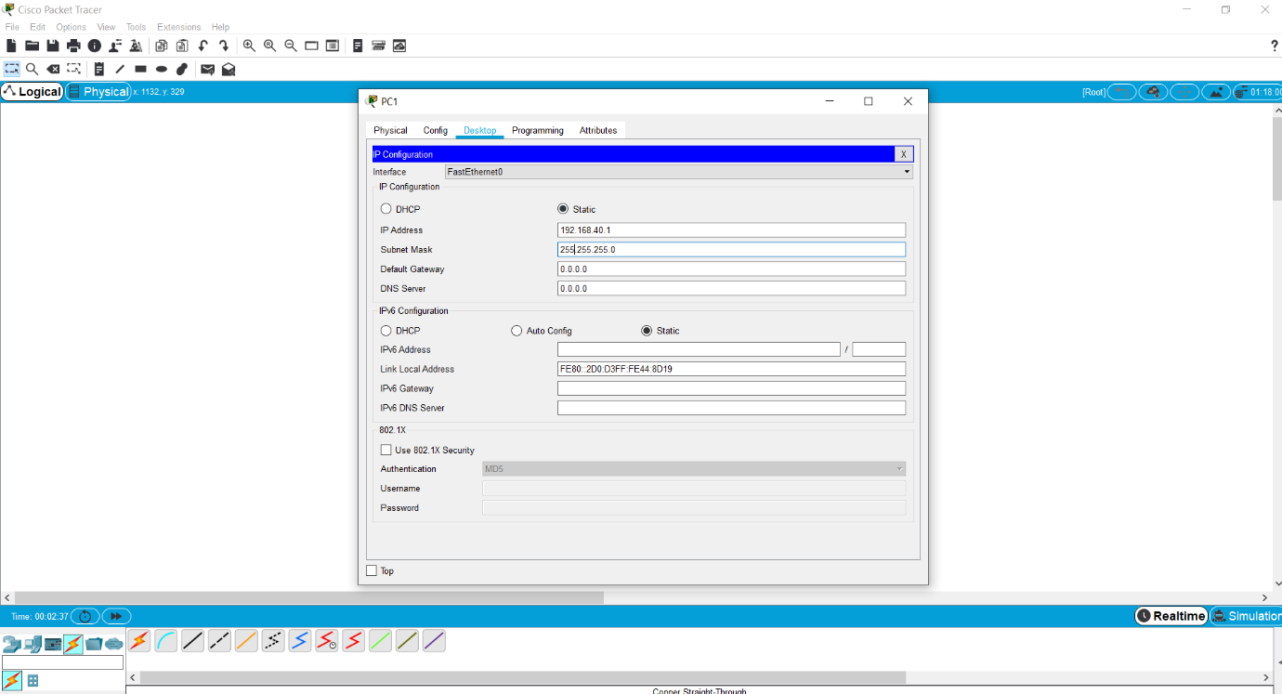

1. Difference between switch and hubs.

* Hub :-
* Connect all of our network devices together on an internal network.
* It’s a device that has multiple port that accepts ethernet connections from network devices.
* Hub is not to be intelligence as to where the data is suppose to be sent.
* When data comes to the one of the port of the hub then hub copied that data or rebroadcast that data to every port that has a device connected to it.
* Switch :-
* Switch is similar like hub.
* Its also a device that has multiple port that accepts ethernet connections from network devices.
* Switch is intelligence because switch stored all the addresses called MAC

Addresses into the table so when a data sent to a switch its only directed to the intended destination port. When hub rebroadcast data on every port.