**LAB_2_CN_Assignment**

**CE_055**

**Aim :-** the aim is to learn routing process, forwarding process and default routing process.

* Introduction about Router :-
* A router is a networking device that forwards data packets between computer networks.
* A router is connected to at least two network, commonly two LANs or WANs or a LAN and its ISP’s network.
* It is a layer 3 device (Network layer).
* Routers stores routing table.
* How many IP address needed to configure a router?
* Assign at least two IP address.
* First is public (WAN : wide area network) and second is private.
* The public side of the router is available on internet.
* Although to configure router we need to assign IP address of all the interfaces.
* How to decide two host are in same network or not?
* Here comes the concept of mask.
* We need mask to decide whether two host are in same network or not.
* For example,

Assume we have IP address of two host

1. Host_1 :- 192.168.29.4 / 24
2. Host_2 :- 192.168.29.8 / 24

Here 24 represents bits of mask so, we have 24 bit mask

255.255.255.0 => 11111111.11111111.11111111.00000000

To get network id perform ‘and’ operation between mask and Host

1. Host_1 n/w ID : 192.168.29.0
2. Host_2 n/w ID : 192.168.29.0

* We can see that both the host are on same network because network id is same.
* If n/w id is different then they both are in different host.
* Fields of routing table :-
* Destination:

The IP address of packet’s final destination.

* Next hop:

The IP address to which the packet is forwarded.

* Interface:

The outgoing interface the device should use when forwarding the packet to the next hop.

* Metric:

Assigns cost to each available route so that the most cost-effective path can be chosen.

* Routes:

Includes directly attached subnets, indirect subnets are not attached to the device but can be access by one or more hops.

* Flags:

U :- Route is up (valid).

G :- Gateway ( the route is to a gateway ), if this flag is not present then route is to a directly connected destination.

H :- Hostname for a specific host.

* Example of routing table with Networks.

1. Connection with one router.

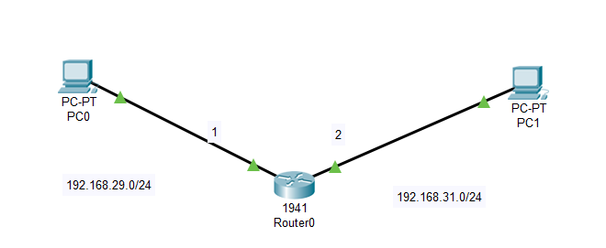

|  |  |  |  |
| --- | --- | --- | --- |
| Interface | Network ID | Mask | Next hop |
| 1 | 192.168.29.0 | 255.255.255.0 | - |
| 2 | 192.168.31.0 | 255.255.255.0 | - |

1. Connection of two routers.

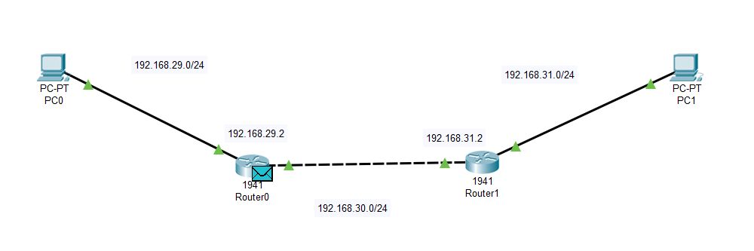

For router 0

|  |  |  |  |
| --- | --- | --- | --- |
| Interface | Network id | mask | Next hop |
| 1 | 192.168.29.0 | 255.255.255.0 | - |
| 2 | 192.168.30.0 | 255.255.255.0 | - |
| 3 | 192.168.31.0 | 255.255.255.0 | 192.168.30.2 |

For router 1

|  |  |  |  |
| --- | --- | --- | --- |
| Interface | Network id | mask | Next hop |
| 1 | 192.168.31.0 | 255.255.255.0 | - |
| 2 | 192.168.30.0 | 255.255.255.0 | - |
| 3 | 192.168.29.0 | 255.255.255.0 | 192.168.30.1 |

* Commands of CLI configuration for router :-
* enable :- to enable the specific router.
* config t :- to configure the terminal.
* interface GigabitEthernet0/1 :- use to configure specific interface.
* ip address [ip_for router] [mask] :- configure ip address
* show ip route connected :- it will show all connected interfaces
* show ip route static :- it will show all static value.
* no shutdown :- used to open (activate) connection
* ip route [destination address] [mask] [hop] :- to provide hop
* example :-

n/w id => 192.168.31.0

mask => 255.255.255.0

hop => 192.168.30.2

ip route 192.168.31.0 255.255.255.0 192.168.30.2

* Default routing :-
* A default router protocol is configured for unknown destinations
* Generally use in the internet where the destinations are unknown.
* It is the last preferred routing.
* Also can be used at end locations.
* For example :-

Network 2 routerA ----------------------------- routerB

( routerA : 192.168.30.1 ) (n/w id : 192.168.31.0)

(routerB : 192.168.30.2 )

* Possible scenario is host doesn’t know all network id in this scenario host will send packets to default router, in routing table we have to specify n/w id : 0.0.0.0, mask : 0.0.0.0, hop : 192.168.30.1.
* For routerB :-

|  |  |  |  |
| --- | --- | --- | --- |
| Interface | Network id | mask | hop |
| 2 | 0.0.0.0 | 0.0.0.0 | 192.168.30.1 |

* Packet Forwarding procedure :-
* Packets are transferred between source interface and destination interface. The interface with the destination IP address that is specified in the packet headers then retrieves the packets. If the destination address is not on the local network the packets are then forwarded to the next adjacent network or hop.

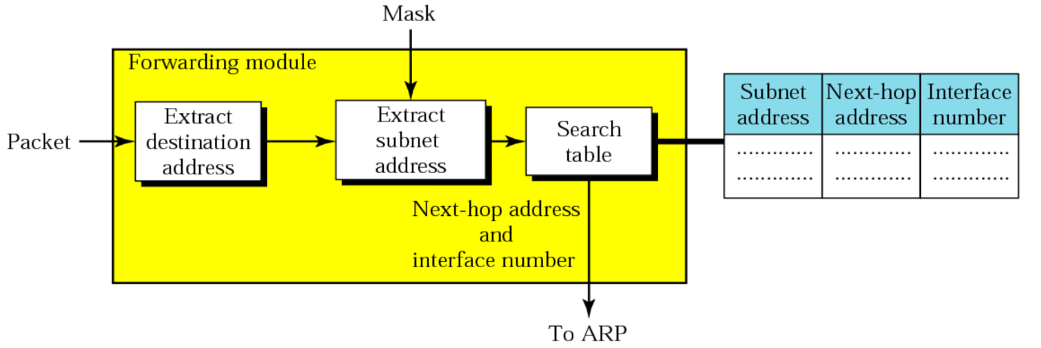

* Simulation of different network :-

1. Two routers :- message from pc0 to pc3

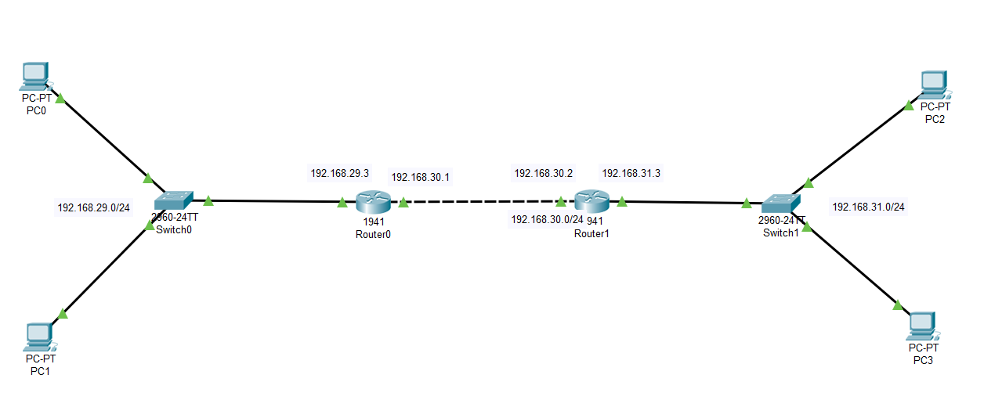

* Configuration process for router0 :-

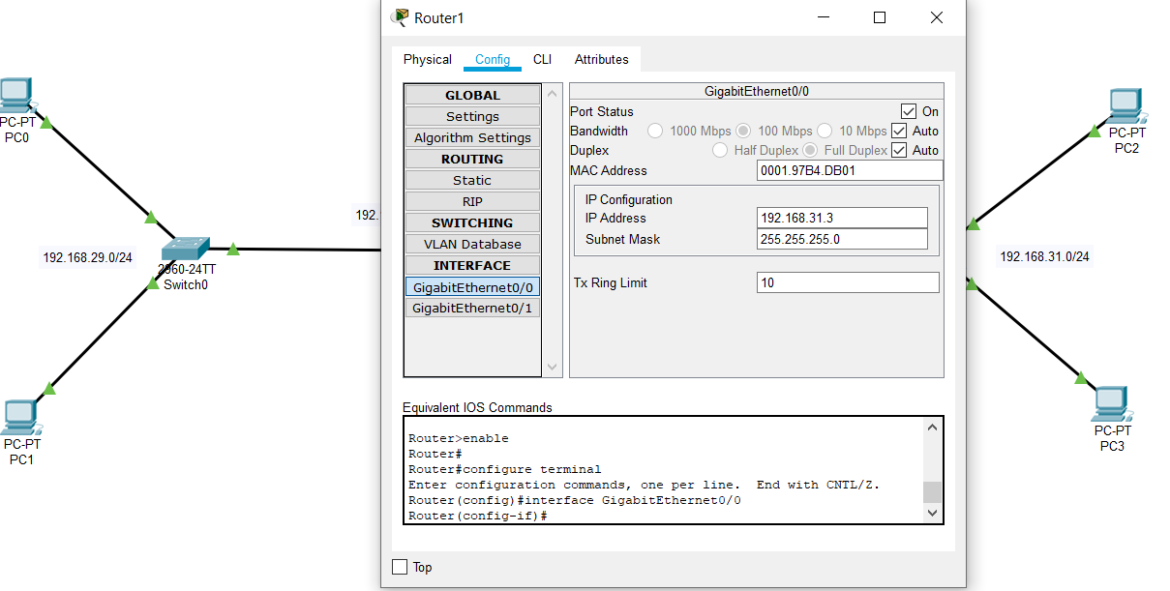

* Static

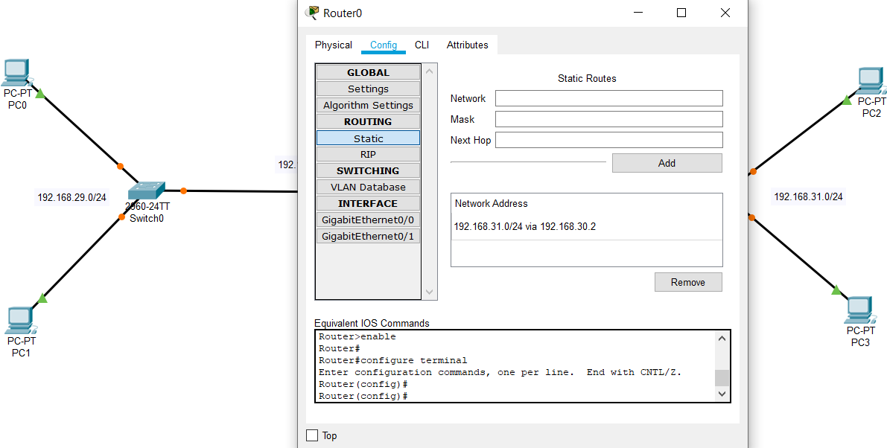

* Configuration process for router1 :-

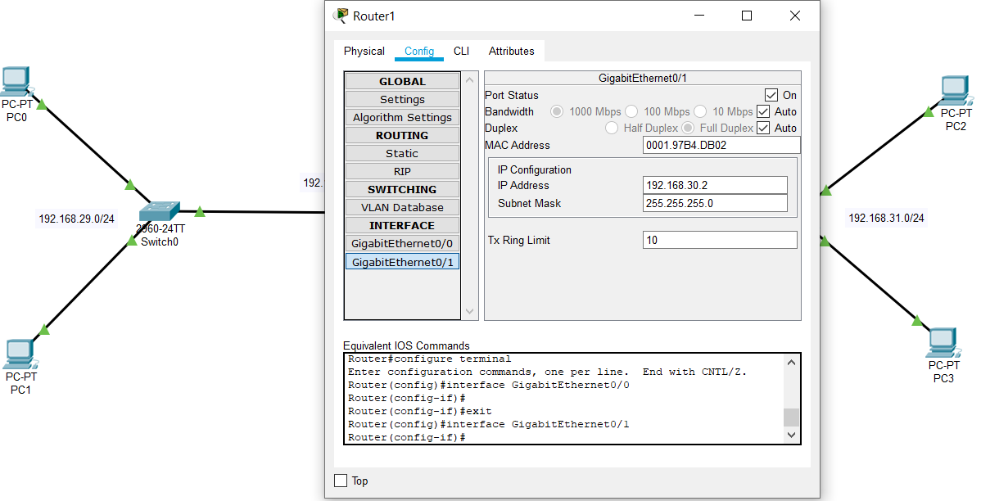

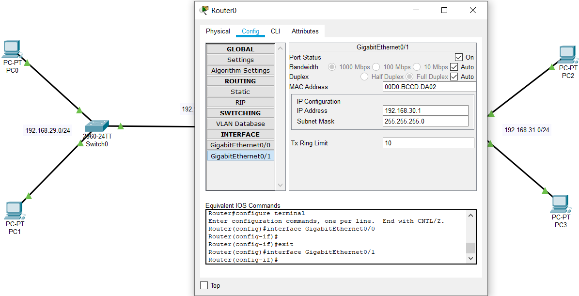

* Static

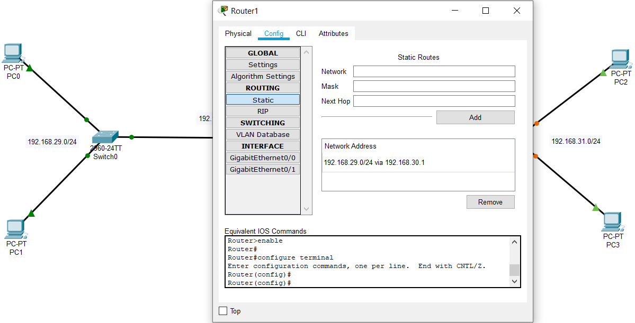

* Message : Pc0 to switch0 :-

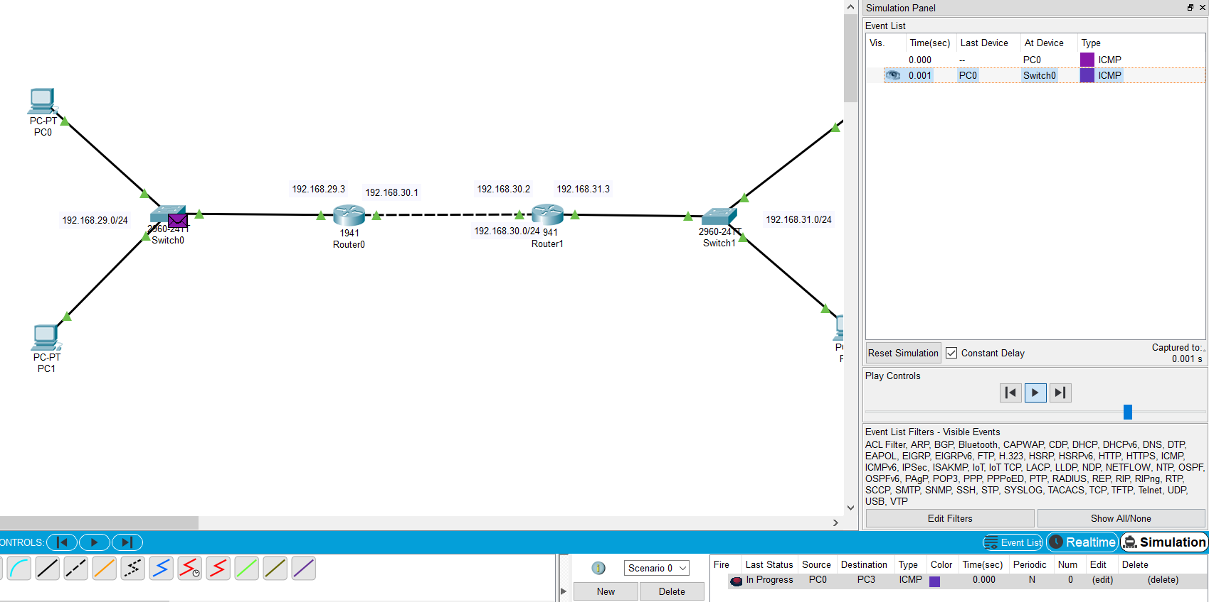

* Switch0 to router0 :-
* Router0 to router1 :-
* Router1 to pc3 :-

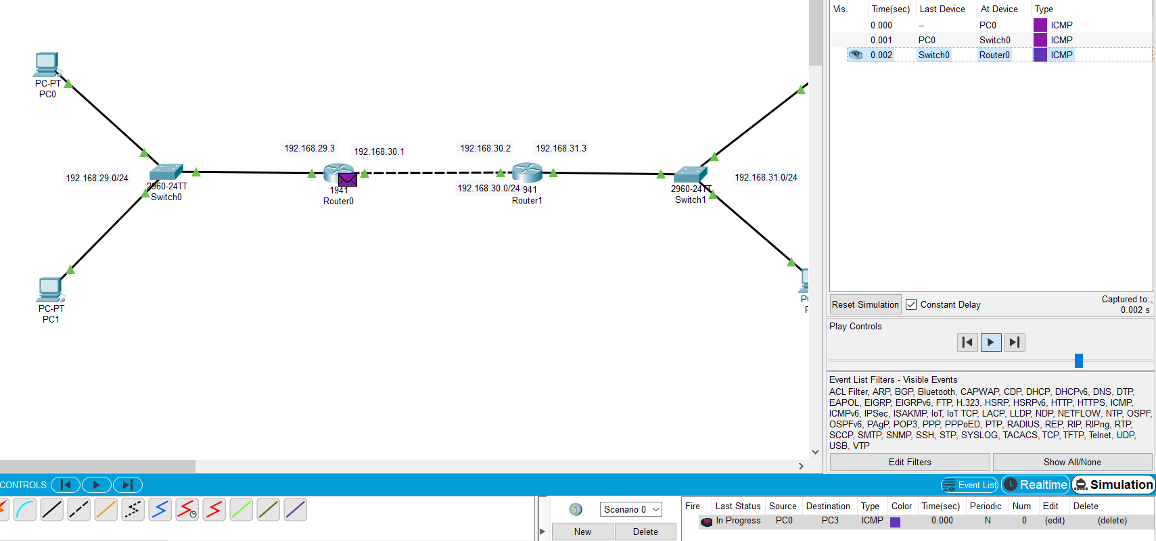

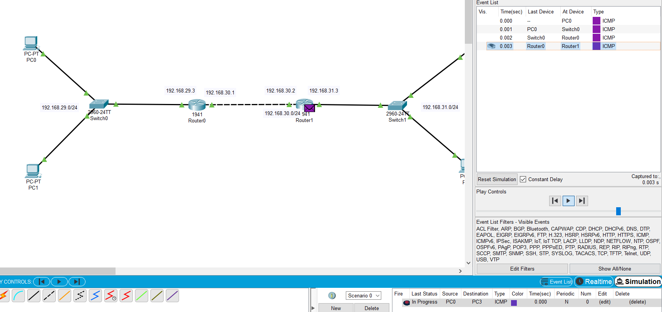

* Return with success :-

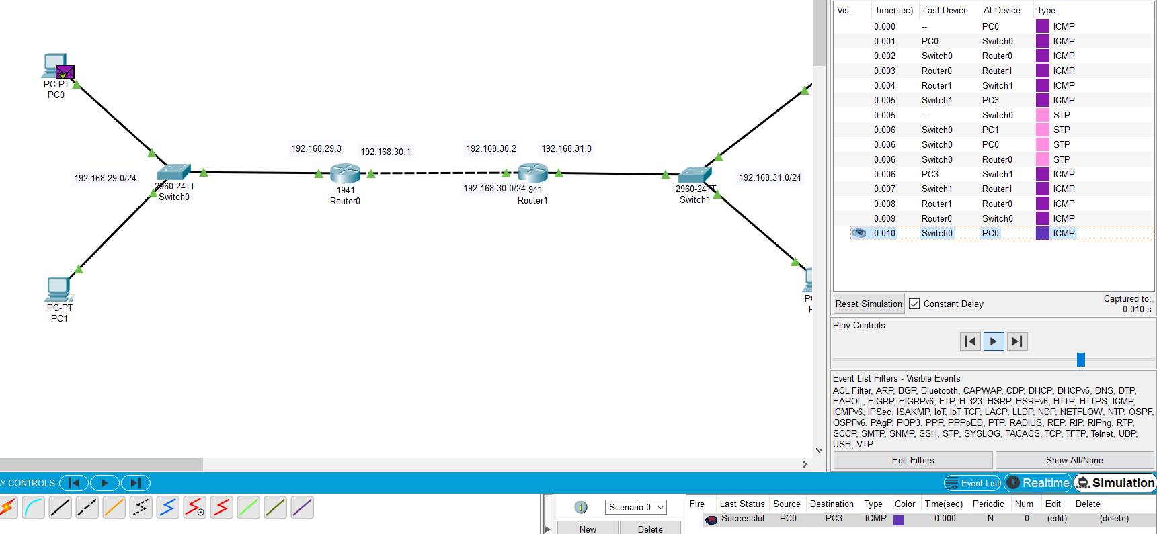

1. three routers :- pc0 to pc5

* pc0 to switch0
* switch0 to router0
* router0 to router2
* router2 to pc5
* return with success
* configuration for router0 :-

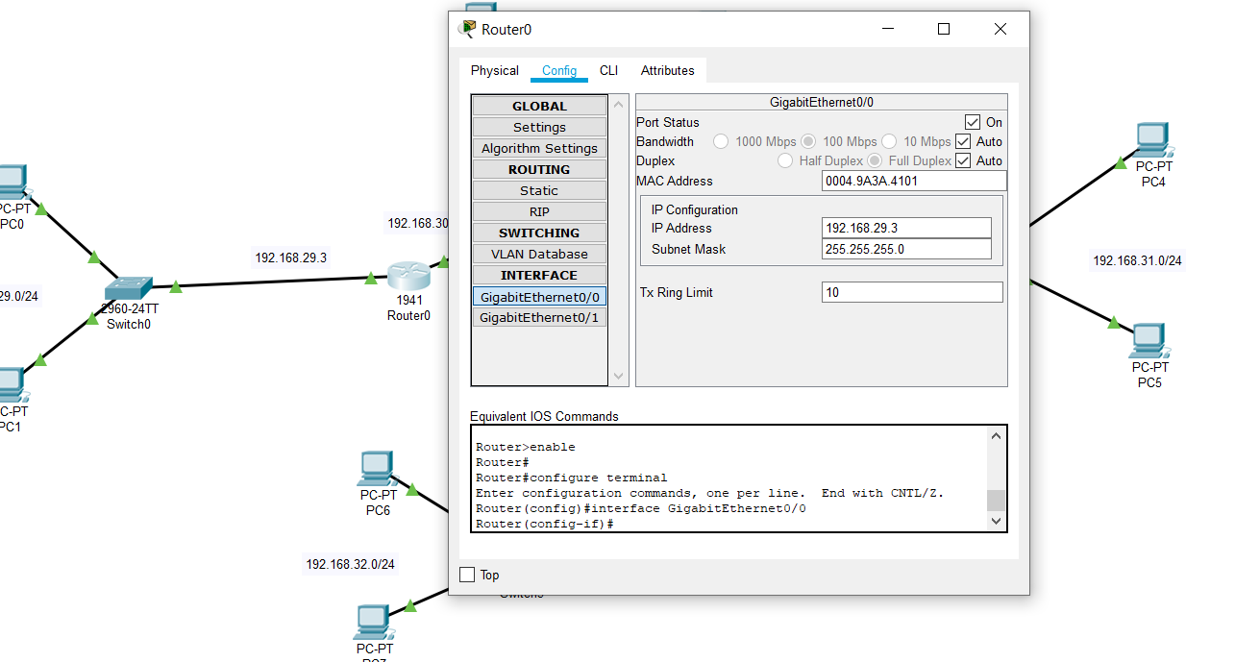

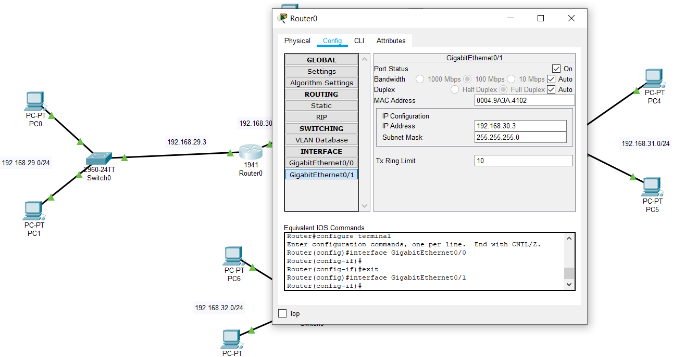

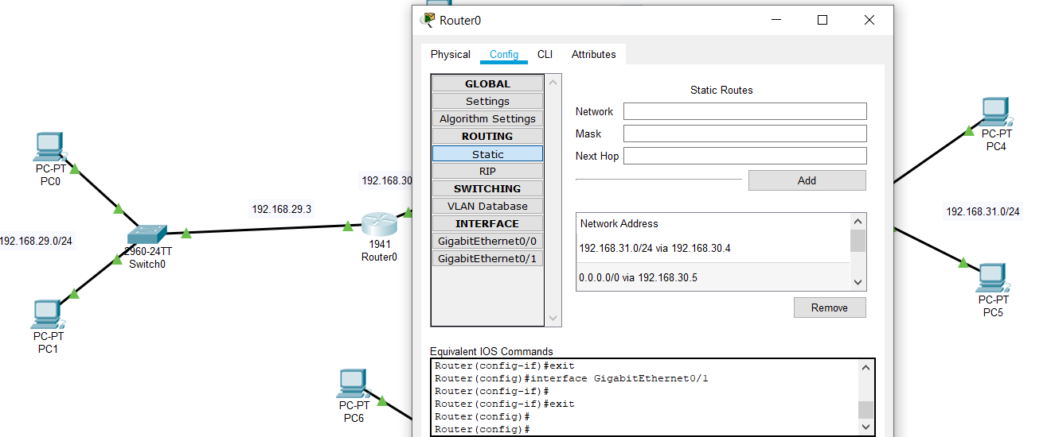

* configuration of router2 :-

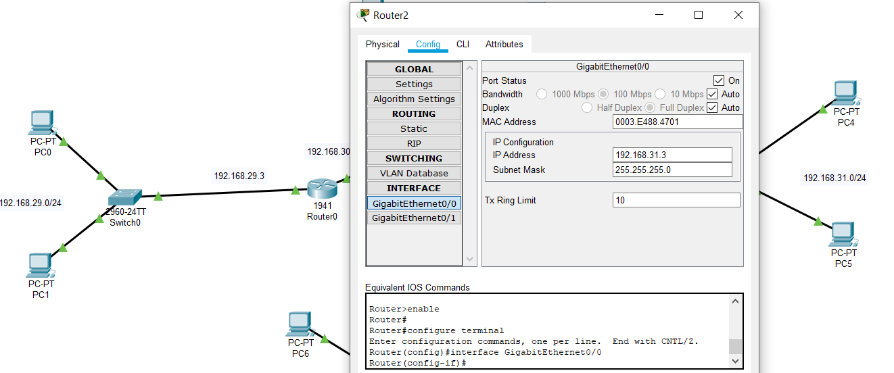

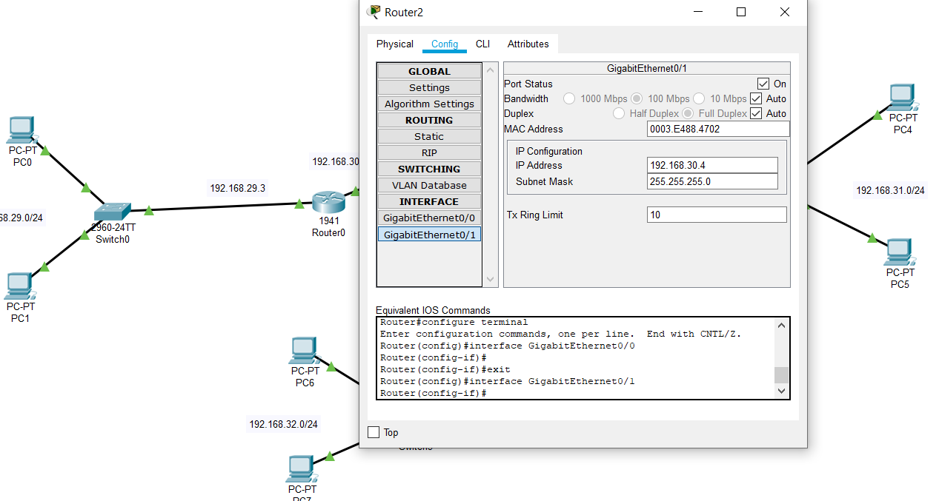

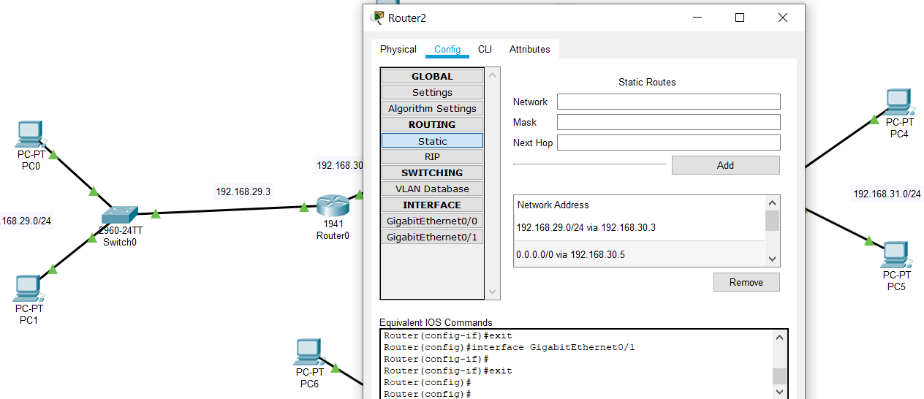

* configuration of router3 :-

