**CN_LAB_3_Assignment**

**CE_055**

Aim:- To learn IP subnetting, Address Aggregation.

* Task1:-

The starting granted block of addresses is 14.24.74.0/24.

Suppose we need 3 sub-block of addresses to use three subnet.

* First block:- 120 addresses
* Second block:- 60 addresses
* Third block:- 10 addresses

Allocated total addresses:- 256

First address:- 14.24.74.0/24 Last address:- 14.24.74.255/24

First block:-

120 addresses => near 128 => 2^7 => ( 32 – 7 ) => 25 bit mask

First address:- 14.24.74.0/25 Last address:- 14.24.74.127/25

Second block:-

60 addresses => near 64 => 2^6 => ( 32 – 6 ) => 26 bit mask

First address:- 14.24.74.128/26 Last address:- 14.24.74.191/26

Third block:-

10 addresses => near 16 => 2^4 => ( 32 – 4 ) => 28 bit mask

First address:- 14.24.74.192/28 Last address:- 14.24.74.207/28

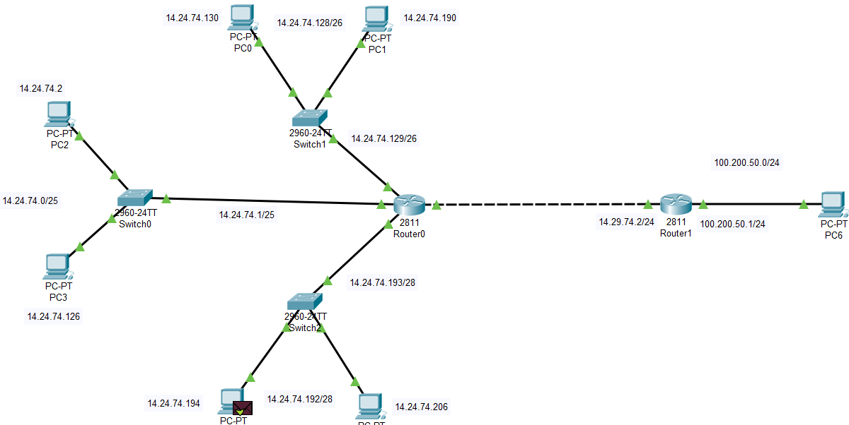

* Message transmission from pc4 to pc6:-

Pc4 => swtch2 => router0 => router1 => pc6 => return pc4

Routing table for router1 and router0 respectively:-

|  |  |  |  |
| --- | --- | --- | --- |
| Interface | Network id | Mask | Next hop |
| 1 | 14.24.74.0 | 255.255.255.128 | 14.29.74.1 |
| 2 | 14.24.74.128 | 255.255.255.192 | 14.29.74.1 |
| 3 | 14.24.74.192 | 255.255.255.240 | 14.29.74.1 |

Router0:-

|  |  |  |  |
| --- | --- | --- | --- |
| Interface | Network id | mask | Next hop |
| 4 | 100.200.50.0 | 255.255.255.0 | 14.29.74.2 |

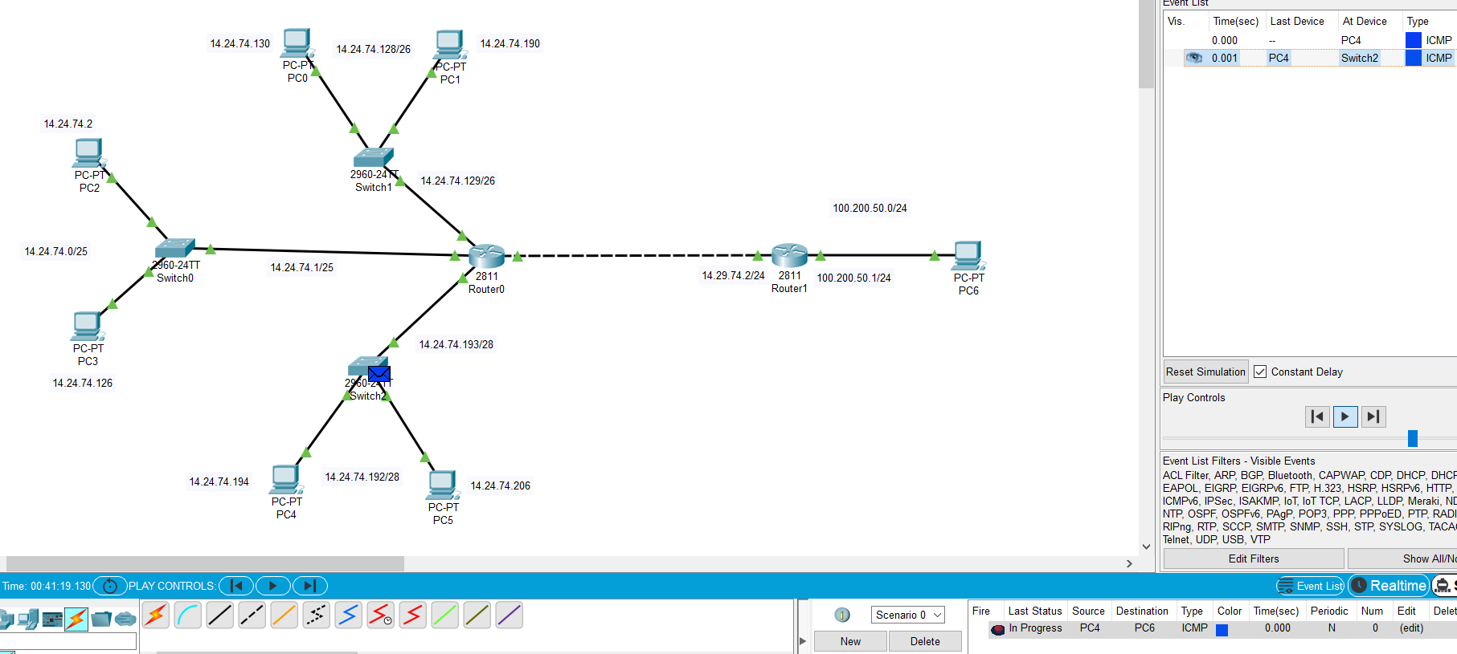

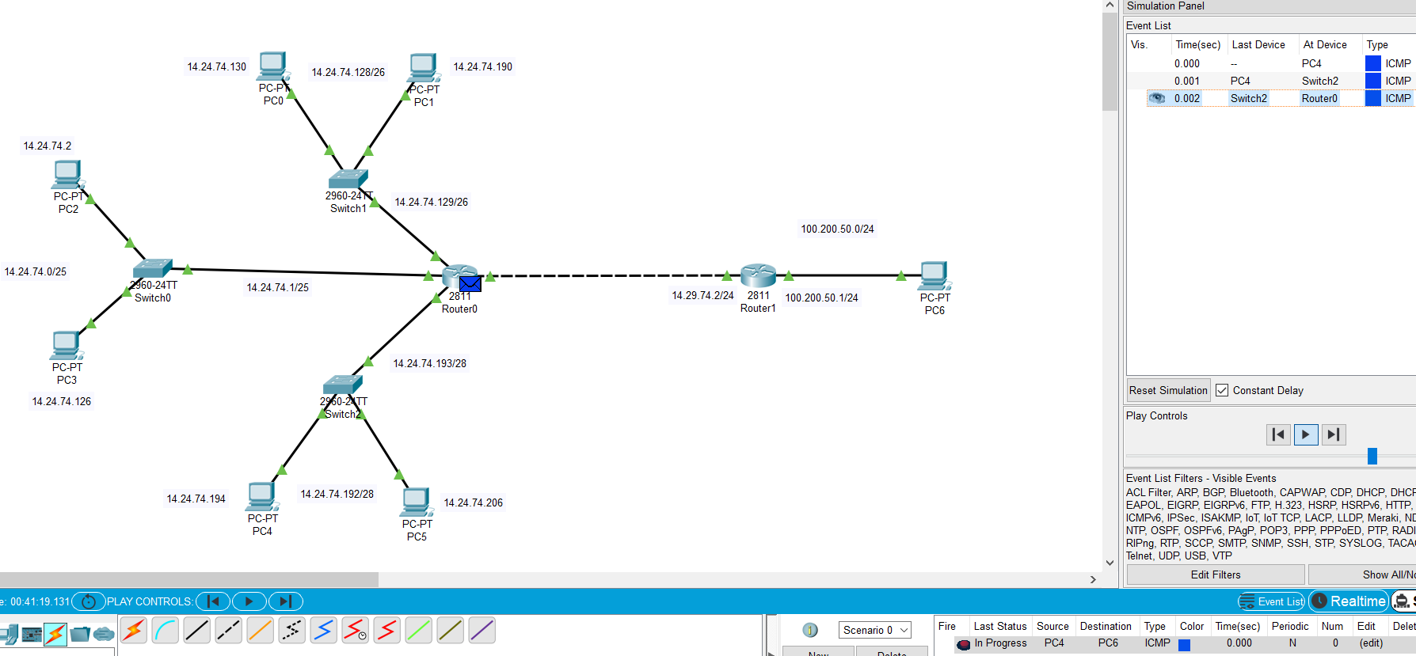

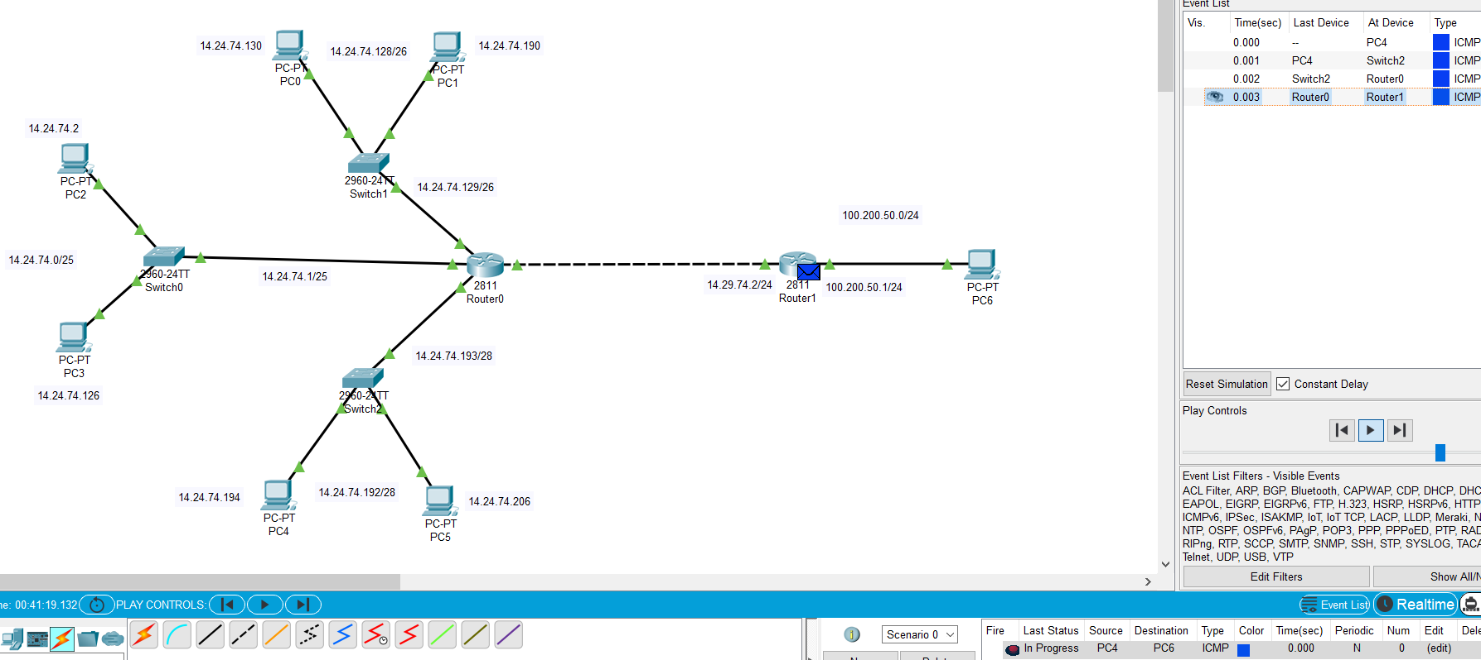

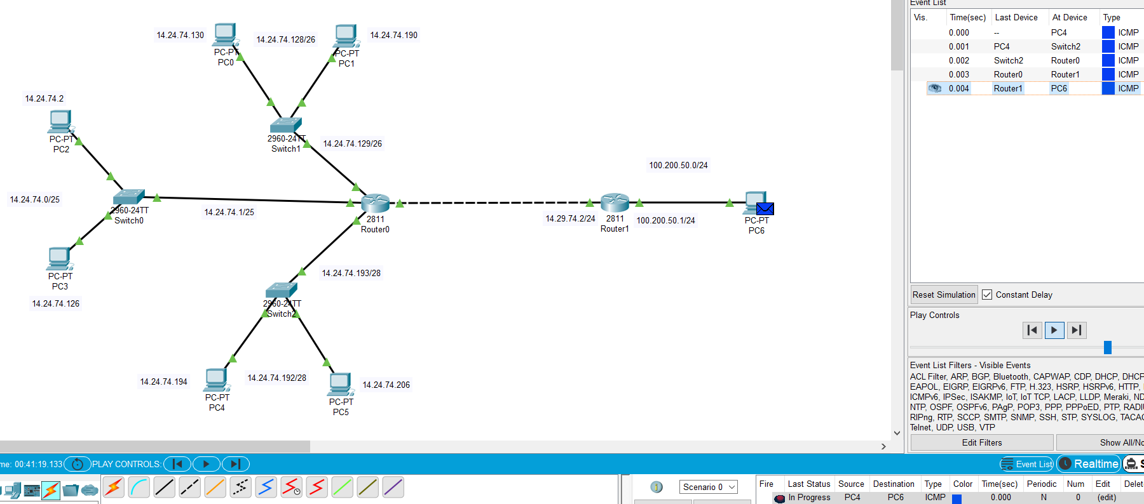

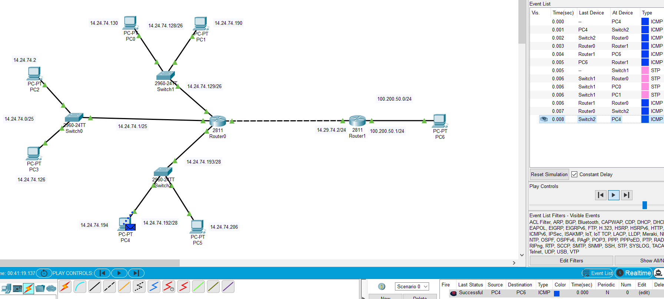

* Message transmission from pc6 to pc2:-

Pc6 to router1

Router1 to router0

Router0 to switch0

Switch0 to pc2

Return success

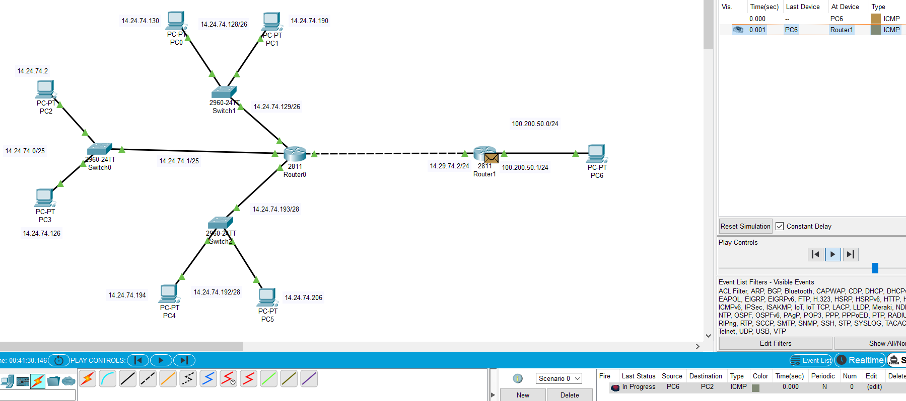

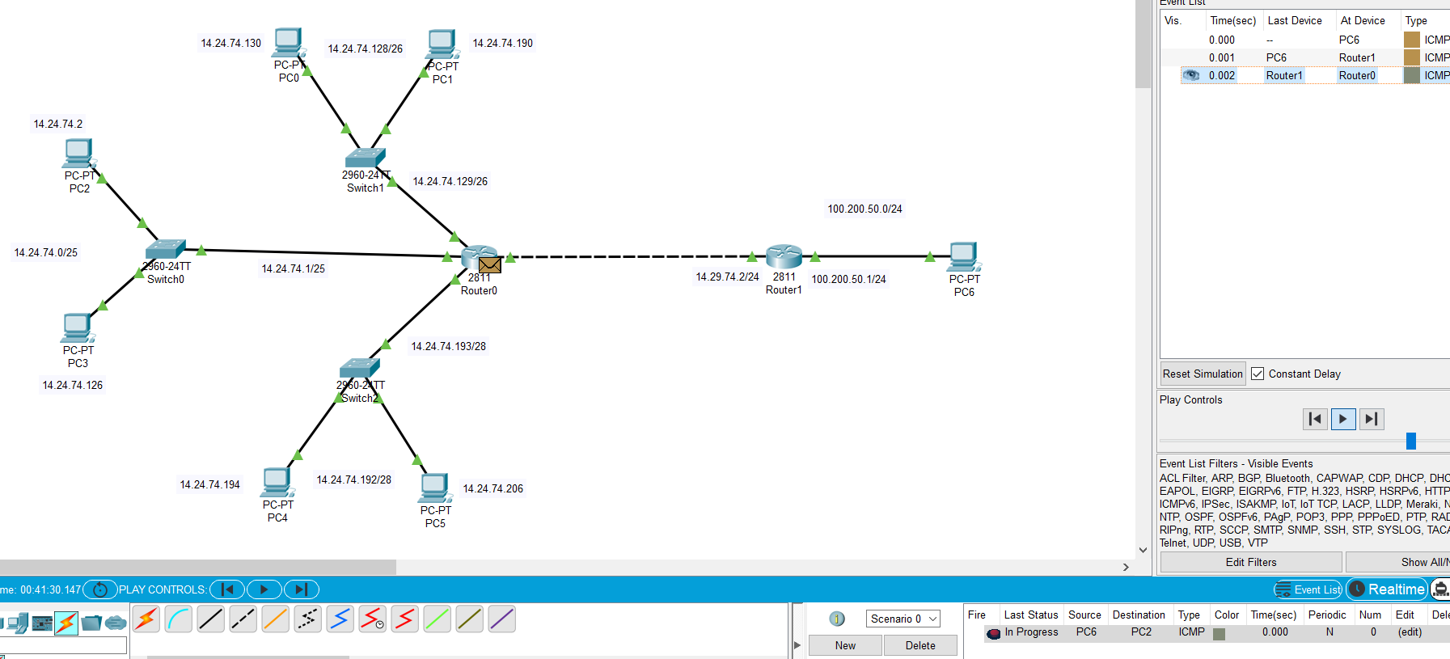

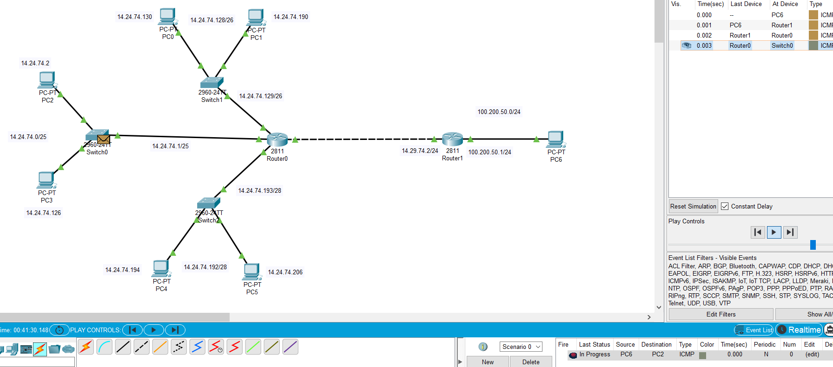

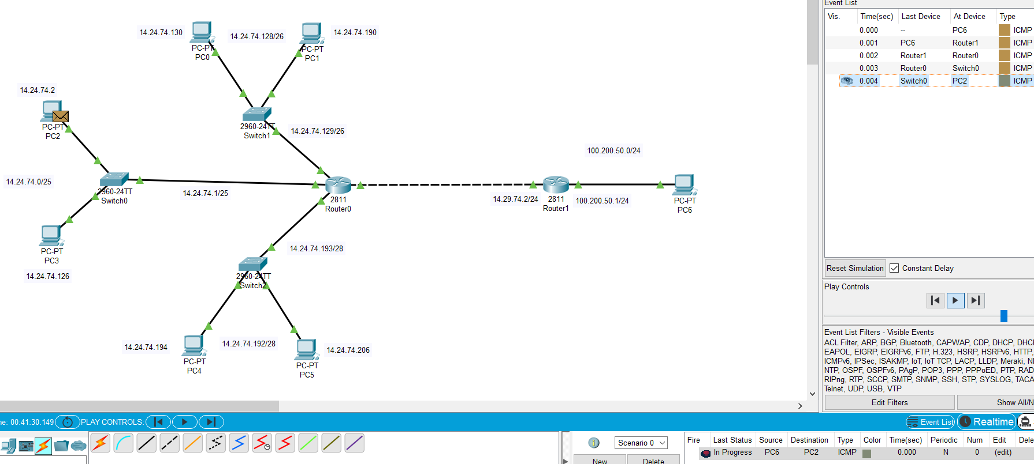

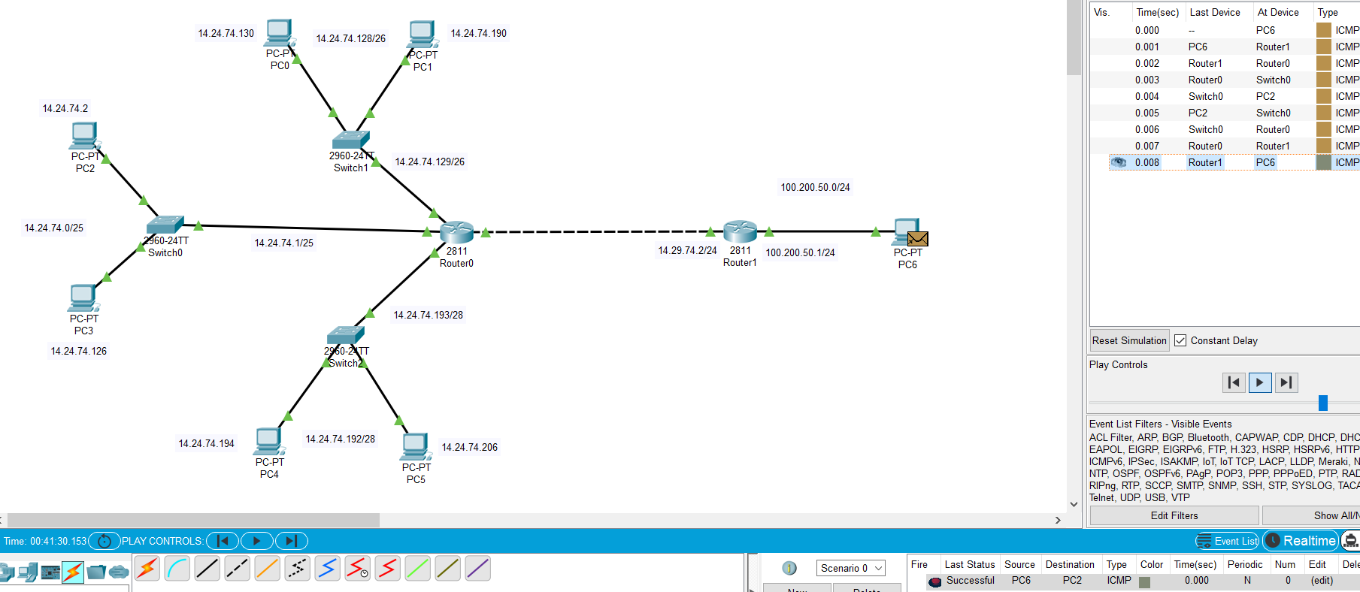

* Task2:- Address Aggregation

Aggregation joins multiple IP prefixes into a single larger prefix to reduce routing table.

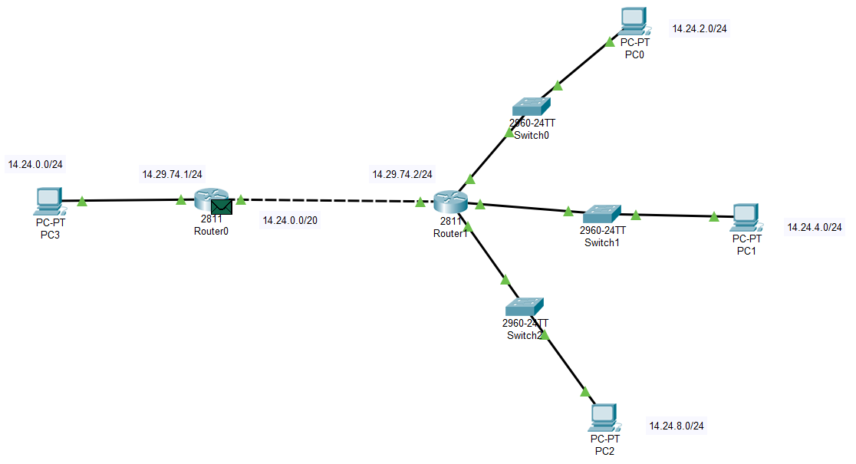

* Pc0:- IP 14.24.2.2/24, Pc1:- IP 14.24.4.4/24, Pc2:- IP 14.24.8.8/24
* In Pc0:- 14.24.00000010.2
* In Pc1:- 14.24.00000100.4
* In Pc2:- 14.24.00001000.8
* From the left side we can see that there are 8 + 8 + 4 => 20 bits common.
* So for the message transmission event from pc3 to pc0 or pc1 or pc2 there is 20 bit mask.

255.255.240.0

- if we perform ‘&’ operation between pc0/1/2 ip and mask we get:-

Entry point:- 14.24.0.0/20

* Routing table for router0:-

|  |  |  |  |
| --- | --- | --- | --- |
| Interface | Network id | Mask | Next hop |
| - | 14.24.0.0 | 255.255.240.0 | 14.29.74.2 |

* Message transmission from pc3 to pc0:-

Pc3 => router0 => router1 => swtch0 => pc0 => return success



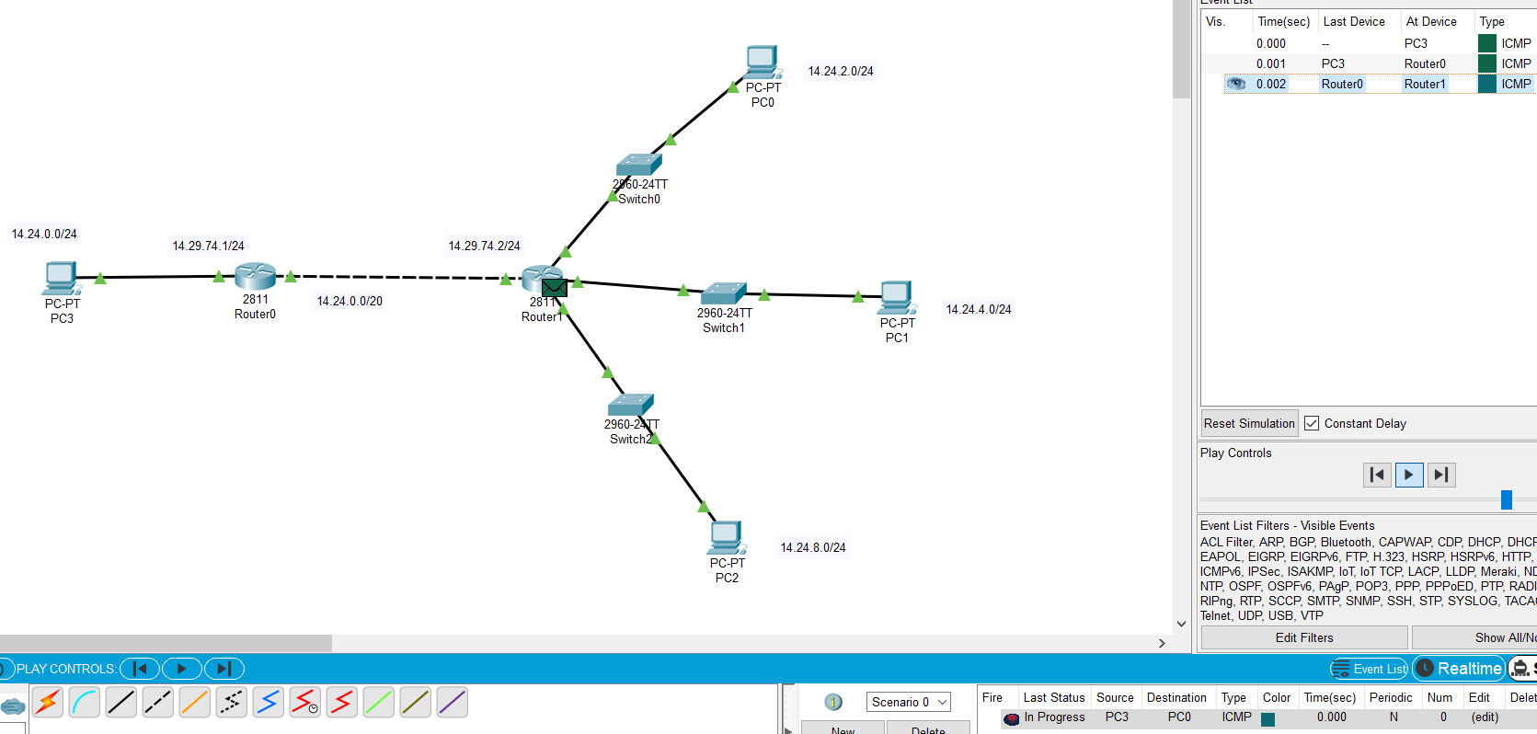

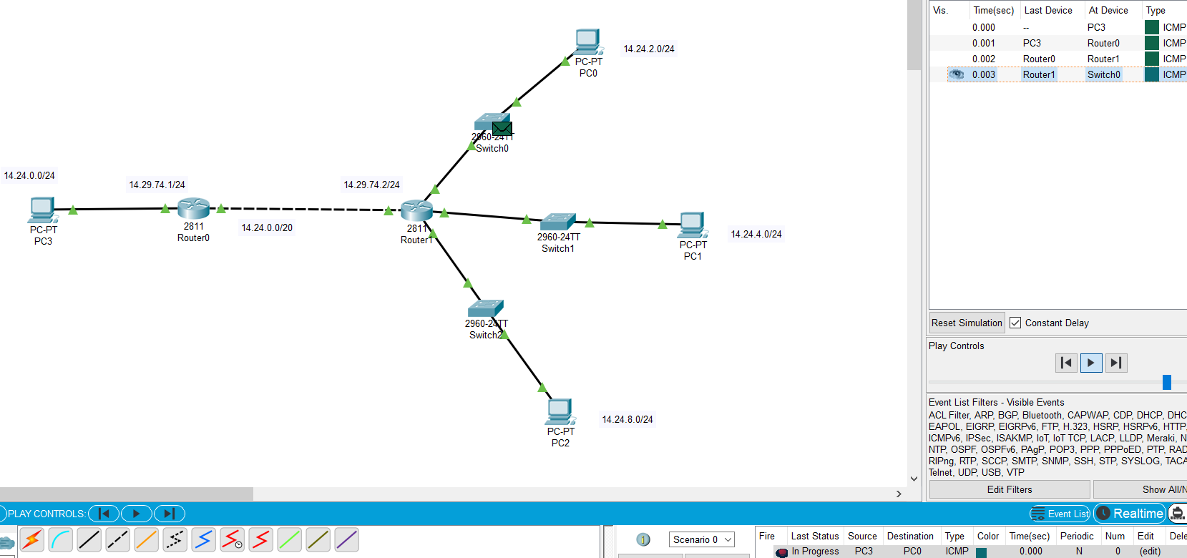

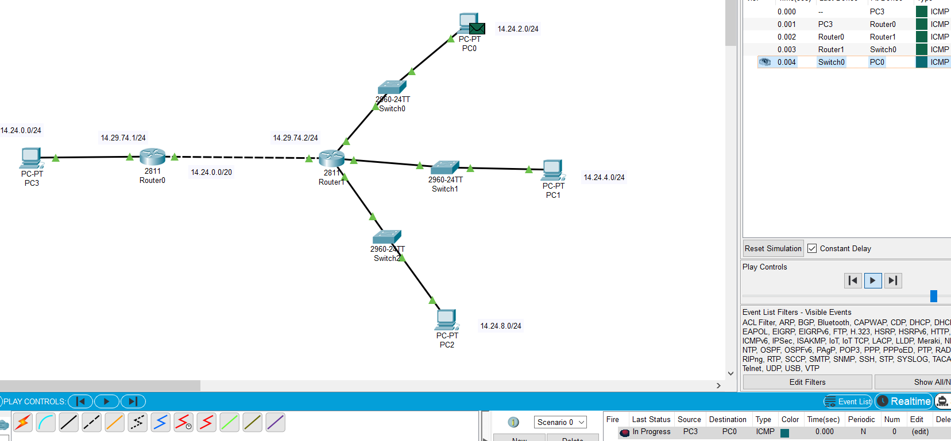

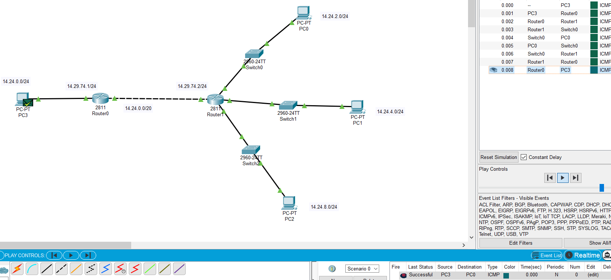

* Task3:- Unsolved example 40 from chapter-5

Que:- A large number of consecutive IP address are available starting at 198.16.0.0. Suppose that four organizations, A, B, C, and D, request 4000, 2000, 4000, and 8000 addresses, respectively, and in that order. For each of these, give the first IP address assigned, the last IP address assigned, and the mask in the w.x.y.z/s notation.

Ans:-

Large consecutive IP address starting with 198.16.0.0

There are 4 organization:-

* A:- request 4000 addresses
* B:- request 2000 addresses
* C:- request 4000 addresses
* D:- request 8000 addresses
* **For A:-**

Request 4000 addresses the round this number => 4096

Take log base2 ( 4096 ) => 12

So, 12 are host bits and remaining ( 32 – 12 ) => 20 bits are network bits

So, from network bit subnet mask have 20 bits

198.16.0.0/20

IP of A / starting IP:-

198.16.0.0 and mask:- 255.255.240.0

11000110.00010000.0000 – 0000.00000000

11111111.11111111.1111 – 0000.00000000

12 bits of right hand side for host this bits are free to change so the last IP is => when they all last 12 bits are 1.

11000110.00010000.0000 – 1111.11111111 => 198.16.15.255

First IP:- 198.16.0.0, Last IP:- 198.16.15.255, 198.16.0.0/20

* **For B:-**

Request 2000 addresses the round this number => 2048

Take log base2 ( 2048 ) => 11

So, 11 are host bits and remaining ( 32 – 11 ) => 21 bits are network bits

So, from network bit subnet mask have 21 bits

First IP of B should be bigger by al least 1 than last IP of A.

Last IP A:- 11000110.00010000.00001111.11111111

+ 1

-------------------------------------------------

First IP B:- 11000110.00010000.00010000.00000000 => 198.16.16.0

IP of B / starting IP:-

198.16.16.0 and mask:- 255.255.248.0

11000110.00010000.00010 - 000.00000000

11111111.11111111.11111 - 000.00000000

11 bits of right hand side for host this bits are free to change so the last IP is => when they all last 11 bits are 1.

11000110.00010000.00010 - 111.11111111 => 198.16.23.255

First IP:- 198.16.16.0, Last IP:- 198.16.23.255, 198.16.16.0/21

* **For C:-**

Request 4000 addresses the round this number => 4096

Take log base2 ( 4096 ) => 12

So, 12 are host bits and remaining ( 32 – 12 ) => 20 bits are network bits

So, from network bit subnet mask have 20 bits

First IP of C should be bigger by al least 1 than last IP of B.

Last IP B:- 11000110.00010000.00010111.11111111

+ 1

-------------------------------------------------

11000110.00010000.00011000.00000000

Apply 20 bit mask:-

11000110.00010000.0001 - 1000.00000000

11111111.11111111.1111 - 0000.00000000

There is a problem we have 1 in out host bit. There for we can not use all 12 bit but can use only 11 bits => 2048 addresses. If we turn 1 into 0 then we collide with ip address which is provided to organization B.

So, push 1 into the network side by incrementing.

n/w ID:- 11000110.00010000.0001

+ 1

--------------------------------

11000110.00010000.0010

First IP of C:- 11000110.00010000.00100000.00000000 => 198.16.32.0

12 bits of right hand side for host this bits are free to change so the last IP is => when they all last 12 bits are 1.

11000110.00010000.0010 - 1111.11111111 => 198.16.47.255

First IP:- 198.16.32.0, Last IP:- 198.16.47.255, 198.16.32.0/20

* **For D:-**

Request 8000 addresses the round this number => 8192

Take log base2 ( 8192 ) => 13

So, 13 are host bits and remaining ( 32 – 13 ) => 19 bits are network bits

So, from network bit subnet mask have 19 bits

First IP of D should be bigger by al least 1 than last IP of C.

Last IP C:- 11000110.00010000.00101111.11111111

+ 1

-------------------------------------------------

11000110.00010000.00110000.00000000

Apply 19 bit mask

11000110.00010000.001 - 10000.00000000

11111111.11111111.111 - 00000.00000000

There is a problem we have 1 in out host bit. There for we can not use all 13 bit but can use only 12 bits => 4096 addresses. If we turn 1 into 0 then we collide with ip address which is provided to organization C.

So, push 1 into the network side by incrementing.

n/w ID:- 11000110.00010000.001

+ 1

--------------------------------

11000110.00010000.010

First IP of D:- 11000110.00010000.01000000.00000000 => 198.16.64.0

13 bits of right hand side for host this bits are free to change so the last IP is => when they all last 13 bits are 1.

11000110.00010000.010 - 11111.11111111 => 198.16.95.255

First IP:- 198.16.64.0, Last IP:- 198.16.95.255, 198.16.64.0/19