**NIS_LAB_1_Assignment**

**CE_055**

**Aim :-** Aim is to develop the simple Caesar Cipher and Substitution Cipher.

1. Additive Cipher or Caesar Cipher.

Code:-

'''

Author : Dhruv B Kakadiya

'''

# Additive Cipher Algorithm or Ceasor Cipher Algorithm

mod = 26

# encryption function for encrypt the plain text into the cipher text

def encryption (plain_text, key):

    encrypted_text = ""

    for letter in plain_text:

        if (letter.isupper()):

            encrypted_text += chr((ord(letter) - 65 + key) % mod + 65)

        elif (letter.islower()):

            encrypted_text += chr((ord(letter) - 97 + key) % mod + 97)

        else:

            encrypted_text += letter

    return encrypted_text

# depcryption function for decode the encrypted text

def decryption (encrypted_text, key):

    decrypted_text = ""

    for letter in encrypted_text:

        if (letter.isupper()):

            decrypted_text += chr((ord(letter) - 65 - key) % mod + 65)

        elif (letter.islower()):

            decrypted_text += chr((ord(letter) - 97 - key) % mod + 97)

        else:

            decrypted_text += letter

    return decrypted_text

# crypt analysis function for attackers to find the appropriate text matching

def crypt_analysis (encrypted_text):

    try_match_text_list = []

    for key in range(1, 26):

        try_match_text = ""

        for letter in encrypted_text:

            if (letter.isupper()):

                try_match_text += chr((ord(letter) - 65 - key) % mod + 65)

            else:

                try_match_text += chr((ord(letter) - 97 - key) % mod + 97)

        try_match_text_list.append(try_match_text)

    return try_match_text_list

if __name__ == "__main__":

    plain_text = input("\nEnter the plain text : ")

    key = int(input("\nEnter the encryption key : "))

    cipher_text = encryption(plain_text, key)

    print(f"\nplain text is => {plain_text}")

    print(f"\nThe cipher text is => {cipher_text}")

    decrypted_text = decryption(cipher_text, key)

    print(f"\nAfter the decryption the text is => {decrypted_text}")

Output:

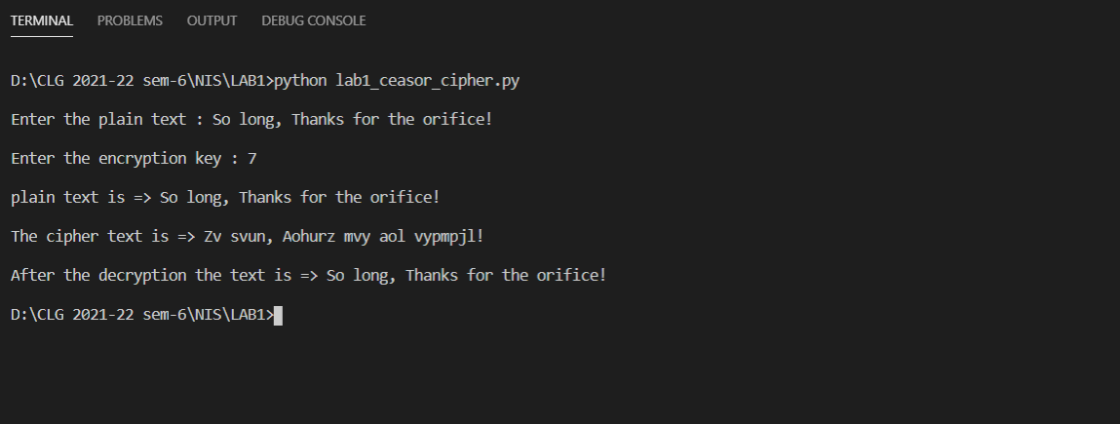

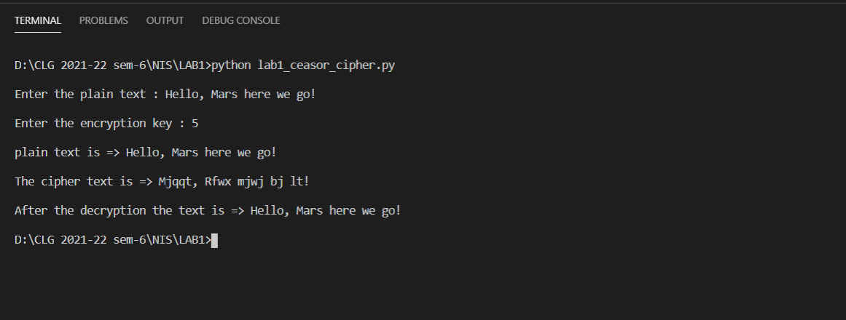

1. Monoalphabetic Cipher or Substitution Cipher.

Code :

'''

Author : Dhruv B Kakadiya

'''

# Substitution Cipher Algorithm or Monoalphabetic Cipher Algorithm

Organized_key = "ABCDEFGHIJKLMNOPQRSTUVWXYZ"

shuffled_key = "QWERTYUIOPASDFGHJKLZXCVBNM"

def encrypt_decrypt_text(input_text, key, mode = None):

    converted_text = ""

    org = Organized_key

    shuff = key

    if (mode == "decryption"):

        org, shuff = shuff, org

    for letter in input_text:

        if (letter.upper() in org):

            if (letter.isupper()):

                converted_text += shuff[org.find(letter.upper())].upper()

            else:

                converted_text += shuff[org.find(letter.upper())].lower()

        else:

            converted_text += letter

    return converted_text

if __name__ == "__main__":

    input_text = input("\nEnter the text : ")

    print("\n1. encryption\n2. decryption")

    mode = input("\nchoose mode : ")

    if (mode == "encryption"):

        result = encrypt_decrypt_text(input_text, shuffled_key, mode)

    else:

        result = encrypt_decrypt_text(input_text, shuffled_key, mode)

    print(f"\nthe input text is => {input_text}")

    print(f"\nAfter the mode => '{mode}' the text is => '{result}'")

Output:

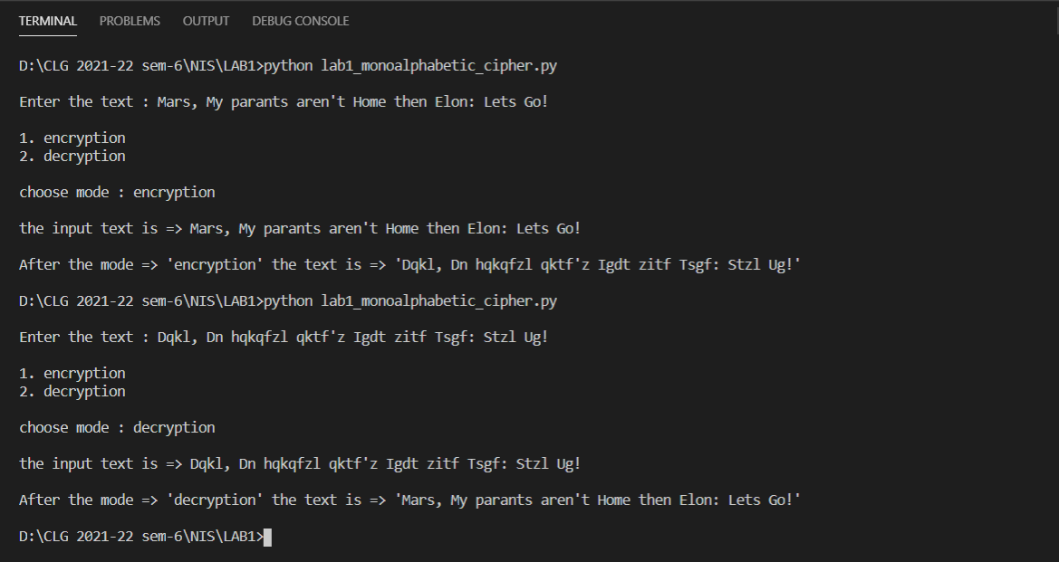

Description:

1. Additive Cipher / Caesar Cipher :

* This is a most common algorithm for encryption purpose and it is very easily to decrypt it using brute force method.
* In this algorithm we have chosen key as a number and define every alphabet with respect to number like a-1, b-2, c-3…, and put the encrypted value of each and every letter in some string according to case sensitively.
* The formula for this algorithm is

E(x) = (x + n) mod 26

D(x) = (x - n) mod 26

* That is why this algorithm is not strong. because there are only 26 possibilities for key.

1. Monoalphabetic Cipher / Substitution Cipher:

* In this algorithm the key is randomly shuffle alphabets that’s why we assign each and every character of plain text with the unique alphabet using index inside the key.
* So, the first letter of plain text has 26 possibilities next has 25 and so on, that’s why there is 26! Possibilities to decrypt the encrypted text.
* This Algorithm is much better than Caesar cipher but this algo is not too Strong.