CE054_LAB_03_Assignment

Aim : Process Creation and Termination (Use of fork, wait, getpid, and getppid System

Calls).

Theory:

1. Fork System Call :

fork() creates a new process by duplicating the calling process. The new process, referred to as the child, is an exact duplicate of the calling process, referred to as the parent, except for the following points:

* The child has its own unique process ID, and this PID does not match the ID of any existing process group.
* The child's parent process ID is the same as the parent's process ID.

Syntax:

#include<unistd.h>

pid_t fork(void);

* On success, the PID of the child process is returned in the parent, and 0 is returned in the child.
* On failure, -1 is returned in the parent, no child process is created, and errno is set

appropriately.

* Zombie Process :
* A process which has finished the execution but still has entry in the process table to report to its parent process is known as a zombie process.
* A child process always first becomes a zombie before being removed from the process table. The parent process reads the exit status of the child process which reaps off the child process entry from the process table.
* Orphan Process :
* A process whose parent process no more exists i.e. either finished or terminated without waiting for its child process to terminate is called an orphan process.

1. Getpid() and Getppid System Call:

* getpid() returns the process ID of the calling process.

Syntax:

pid_t getpid(void);

* getppid() returns the process ID of the parent of the calling process.

Sysntax:

pid_t getppid(void);

1. Wait System Call :

* wait system call is used to wait for state changes in a child of the calling process, and obtain information about the child whose state has changed.
* In the case of a terminated child, performing a wait allows the system to release the resources associated with the child; if a wait is not performed, then the terminated child remains in a "zombie" state.
* If a child has already changed state, then this call returns immediately. Otherwise it blocks until either a child changes state or a signal handler interrupts the call.
* On success, returns the process ID of the terminated child; on error, -1 is returned.

Syntax:

#include <sys/types.h>

#include <sys/wait.h>

pid_t wait(int *status);

1. Programs:

Task1 :

1. Call fork ones, observe and interpret outcomes.

#include<sys/types.h>

#include<unistd.h>

#include<stdio.h>

int main()

{

fork();

printf("Hello\n");

return 0;

}

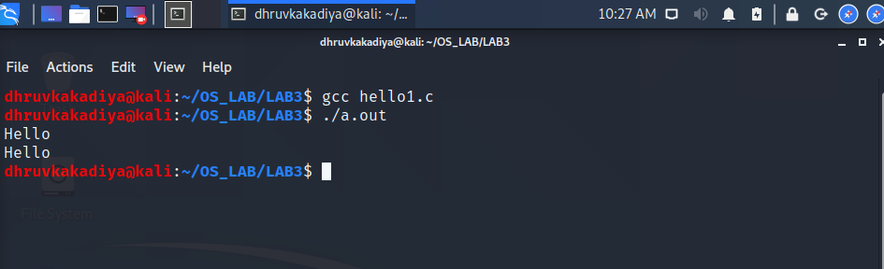

1. Call fork twice. Observe and interpret outcomes.

#include<sys/types.h>

#include<unistd.h>

#include<stdio.h>

int main()

{

fork();

fork();

printf("Hello\n");

return 0;

}

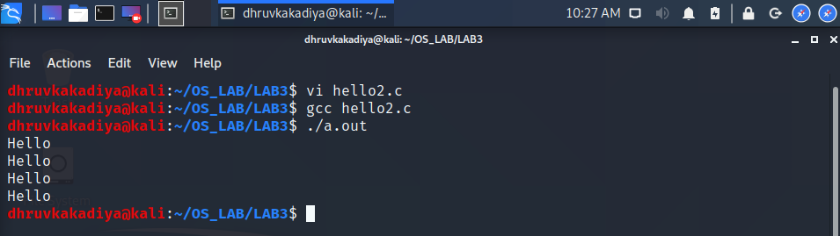

1. Call fork thrice, observe and interpret outcomes.

#include<sys/types.h>

#include<unistd.h>

#include<stdio.h>

int main()

{

fork();

fork();

fork();

printf("Hello\n");

return 0;

}

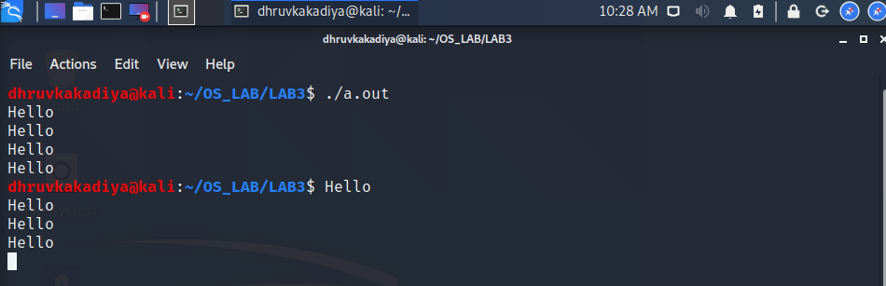

* Fork tree for 3 fork call:

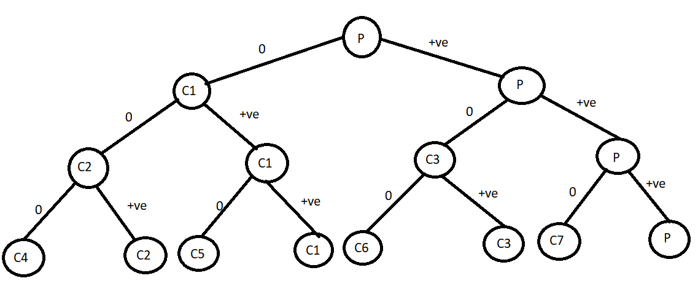

Task2 :

1. Print PID and PPID for parent and child processes. Observe and interpret the outcomes.

#include<sys/types.h>

#include<unistd.h>

#include<stdio.h>

int main()

{

int pid;

pid = fork();

if(pid == -1)

printf("Error!\n");

else if(pid > 0)

printf(" Parent\t PID : %d\t PPID : %d\n",getpid(),getppid());

else

printf(" Child\t PID : %d\t PPID : %d\n",getpid(),getppid());

return 0;

}

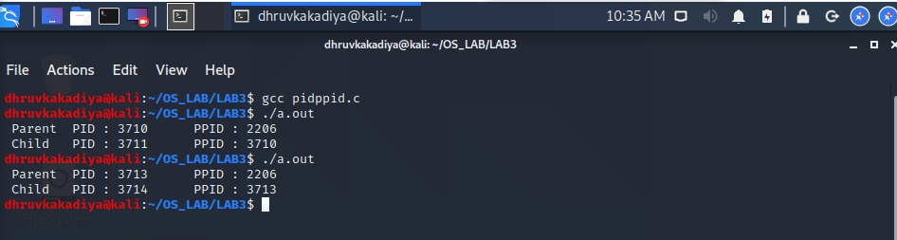

Task3 :

1. Add wait to the code of task 2. Observe and interpret the outcomes.

#include<sys/types.h>

#include<unistd.h>

#include<stdio.h>

#include<sys/wait.h>

int main()

{

int pid,status;

pid = fork();

if(pid == -1)

printf("Error!\n");

else if(pid > 0){

wait(&status);

printf(" Parent :\t Parent : %d\t Child : %d \n", getpid(),pid);

}

else

printf(" Child :\t Child : %d\t Parent : %d\t \n",getpid(),getppid());

return 0;

}

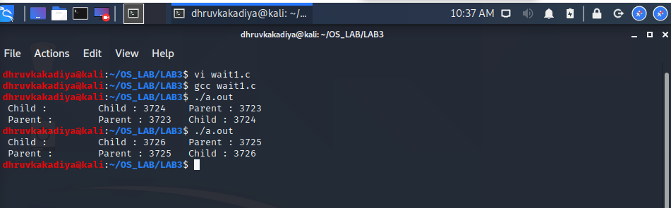

Assignment :

1. Write a program to implement fan of n processes.

#include<sys/types.h>

#include<unistd.h>

#include<stdio.h>

#include<sys/wait.h>

int main()

{

int pid,status;

pid = getpid();

for(int i= 0; i<4; i++)

if( pid > 0 ){

pid = fork();

wait(&status);

if (pid == 0)

printf("Child %d :\t id : %d\tParent : %d\n",i+1, getpid(), getppid());

}

return 0;

}

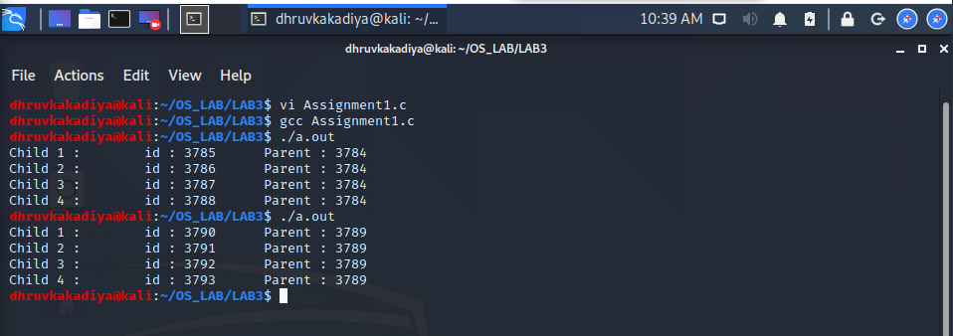

1. Write a program to implement chain of n processes.

#include<sys/types.h>

#include<unistd.h>

#include<stdio.h>

#include<sys/wait.h>

int main()

{

int pid,status;

pid = 0;

for(int i= 0; i<4; i++)

if( pid==0 ){

pid = fork();

wait(&status);

if (pid == 0)

printf("Child %d :\t id : %d\tParent : %d\n",i+1,getpid(),getppid());

}

return 0;

}

